**Lab Experiment-7**

* **Creating manager and worker network using Docker Swarm.**

Docker swarm is a group of physical or virtual machines that are configured to work together. This concept comes in handy when we have to run a docker application across different machines. One of the machines act as the manager and manages other machines that work as workers.

Docker swarm is a popular container orchestration tool and is used to manage containers running across different machines.

Here, we are going to initialize docker swarm on a manager node and then we will add a worker node to that swarm.

Prerequisite: Two different machines should be running on the system.

The steps that need to be followed are:

**1.** Go to the terminal of the machine that you want to use as a manager node. Initialize docker swarm on this machine.

Command: docker swarm init

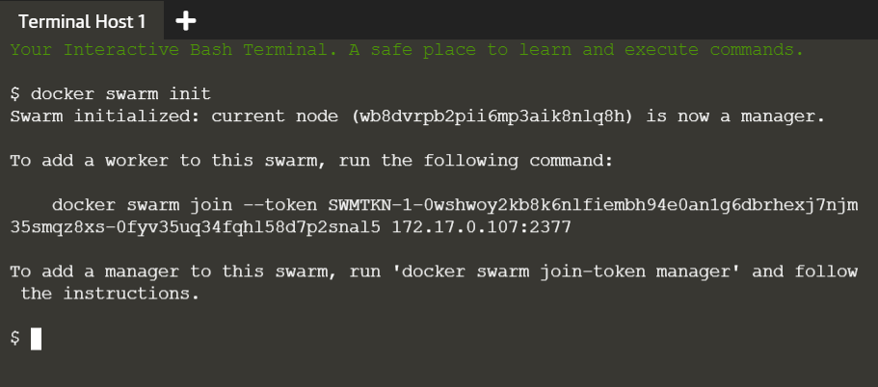

The successful execution of this step, as shown above, creates a swarm with the current node as the manager of the swarm. Each swarm has a token id associated with it and worker nodes can join the swarm using the token id corresponding to the swarm.

Now, we are ready to add worker node in the swarm.

**2.** Now, go to the terminal of the machine that is to be connected as worker in the swarm. To make this node join the above created swarm, use the token id of the swarm.

Command: docker swarm join --token <token-id>

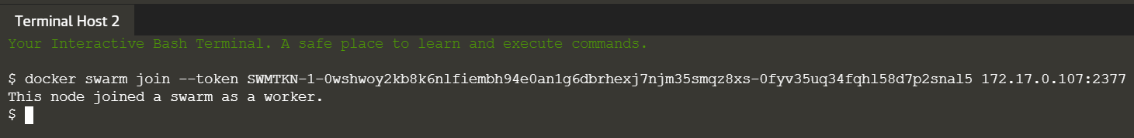

**3.** We can list the nodes in the swarm from manager node.

Command: docker swarm node ls

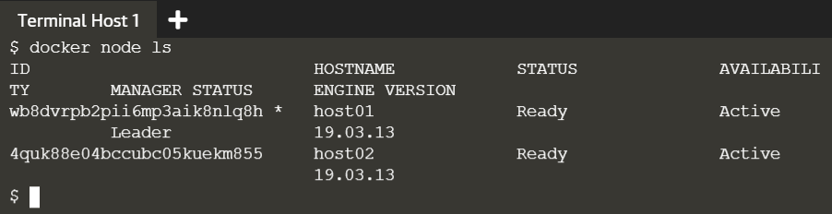

Note: This command will not work on worker nodes.

