**Lab Experiment-8**

* **Running an application across multiple containers using Docker Swarm.**

Docker swarm mode provides a means to deploy containers across multiple Docker hosts. It uses overlay networks for discovering services and provides a built-in load balancer for scaling the services.

We will create swarm cluster and deploy containers. Then we will also scale the application.

Prerequisite: Having two different instances of Docker.

The steps that need to be followed are:

**1.** Initialize Docker swarm on the node that is to be treated as manager.

Command: docker swarm init

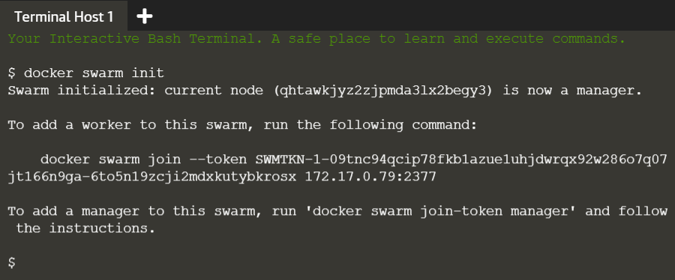

**2.** Add a worker node to this swarm using the token generated in the above step.

Command: docker swarm join --token <token-id>

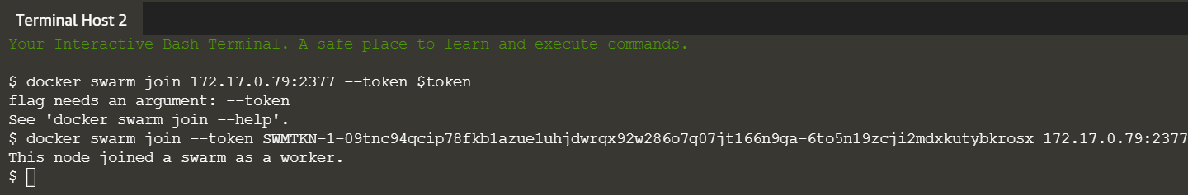

The available nodes in the cluster can be listed from manager node.

Command: docker node ls

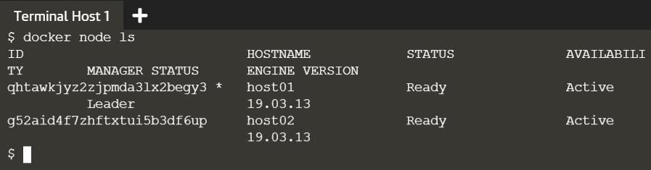

**3.** Now we will create an overlay network over which the containers across different hosts can communicate. We are creating a network named overlay. Run the following command on the manager node.

Command: docker network create –d overlay skynet

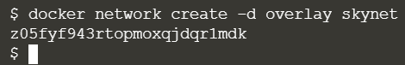

**4.** Now we will deploy the service in the form of containers on these nodes. Here we are using the image katacoda/docker-http-server and we are providing it a name http. The service will be attached to the network created in the above step and we are creating two replicas of this service.

Command: docker service create --name http --network skynet --replicas 2 -p 80:80 katacoda/docker-http-server

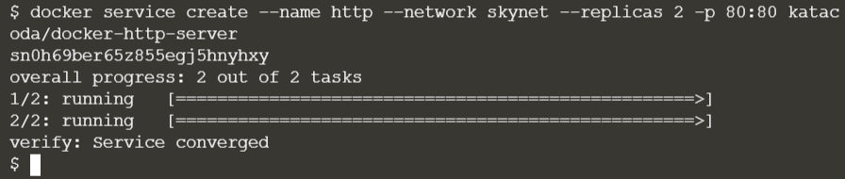

We can view the services running on swarm cluster as follows on the manager node.

Command: docker service ls

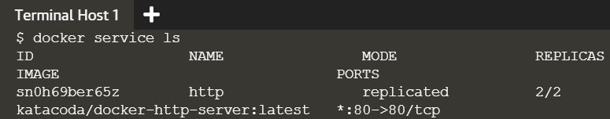

**5.** Above step created two replicas of the service. One replica will run on the manager node and the other replica of the service will run on the worker node. We can verify this by running the following command on manager and worker node.

Command: docker ps

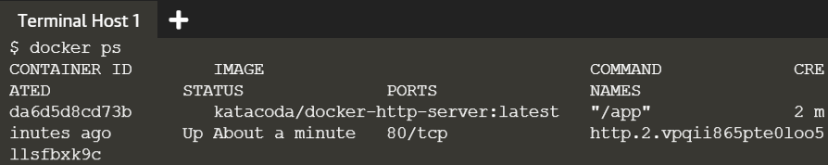

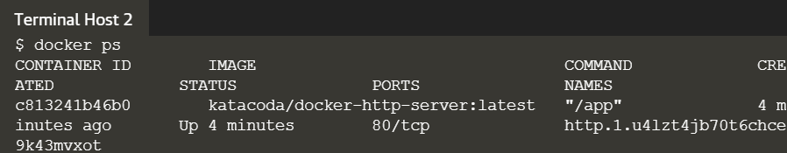

Now, if we issue a request to the public port, it will be processed by either of the containers.

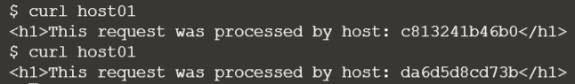

The list of services and their tasks running across the cluster can be seen as follows in the manager node.

Command: docker service ps <service-name>

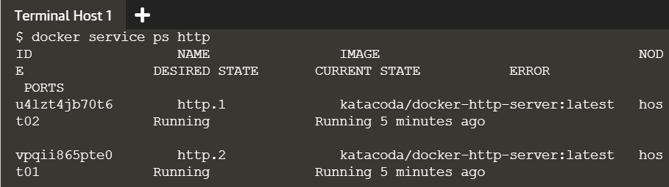

**6.** At present we have two replicas in total, with one running on each of the two nodes. Let us scale our service to have total five containers running across the nodes.

Command: docker service scale http=5

