**Experiment 1**: Vagrant installation and setting a virtual machine

1. Install Virtualbox and Vagrant in your system.

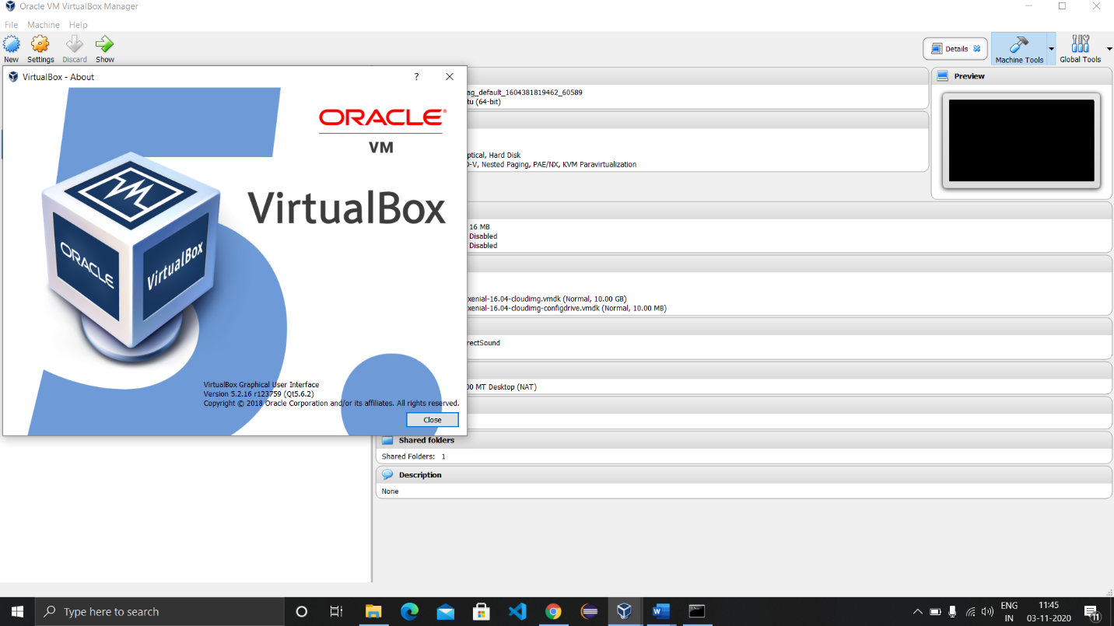

1. Check the version of Vigrant using cmd with the help of command “vagrant --version”.

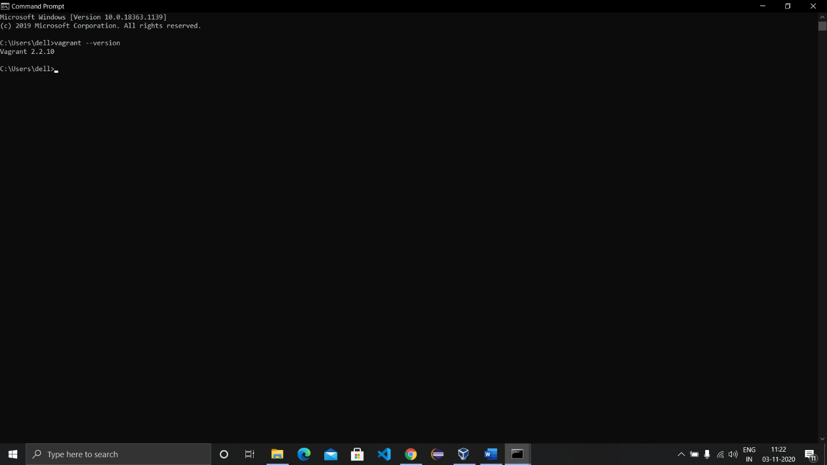

1. Now create a new folder in the working directory and enter it and initialize Vagrant using “vagrant init”.

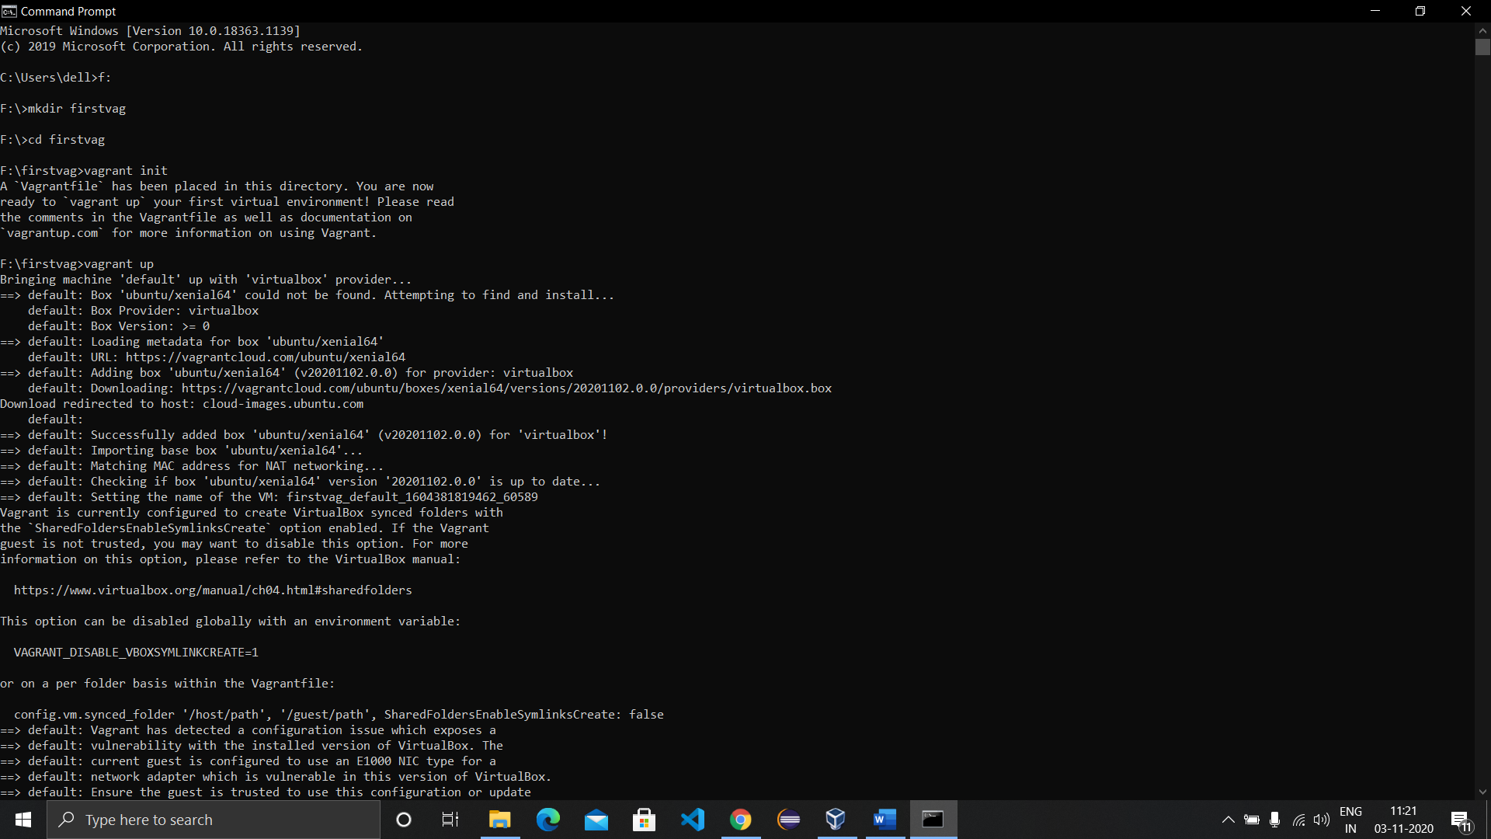

1. A file named ‘Vagrantfile’ will be created in the folder, open the file with a text editor and edit the following field: ‘config.vm.box = "ubuntu/xenial64"’. Save the file and head back to the command prompt and run the command “vagrant up”.

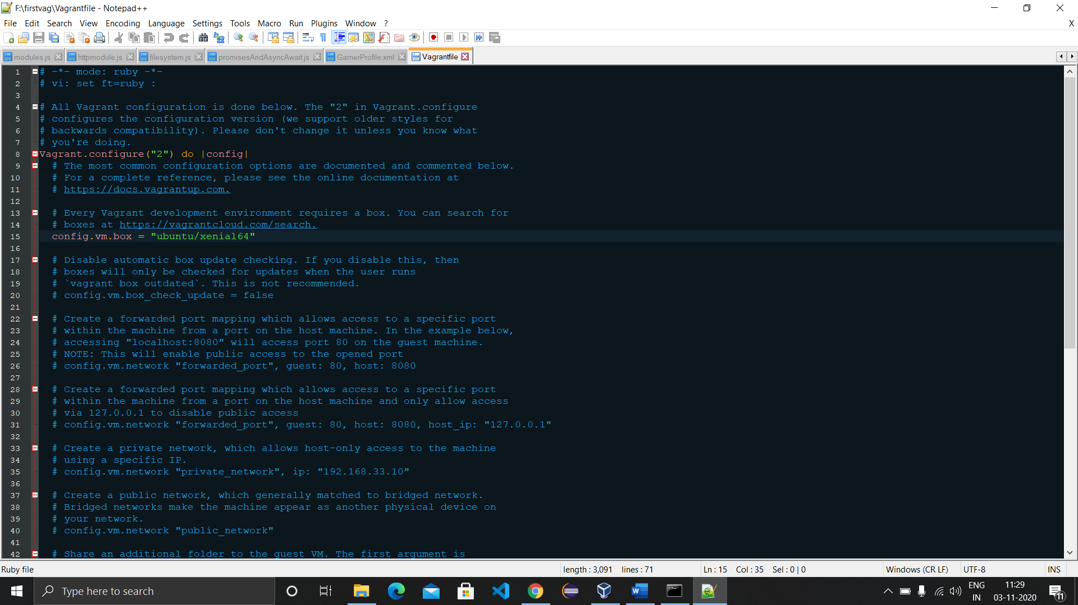

The virtual machine image will start download and provide the default username and password which is ‘vagrant’ in this case.



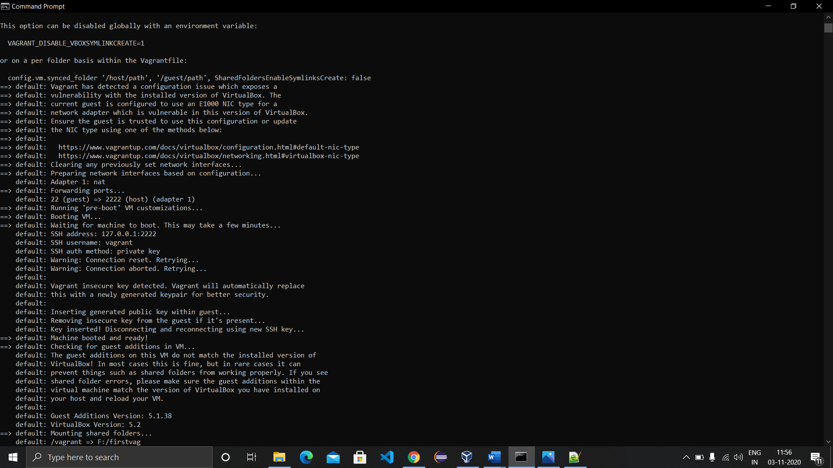

1. After the successful run of command, folder will look like this:

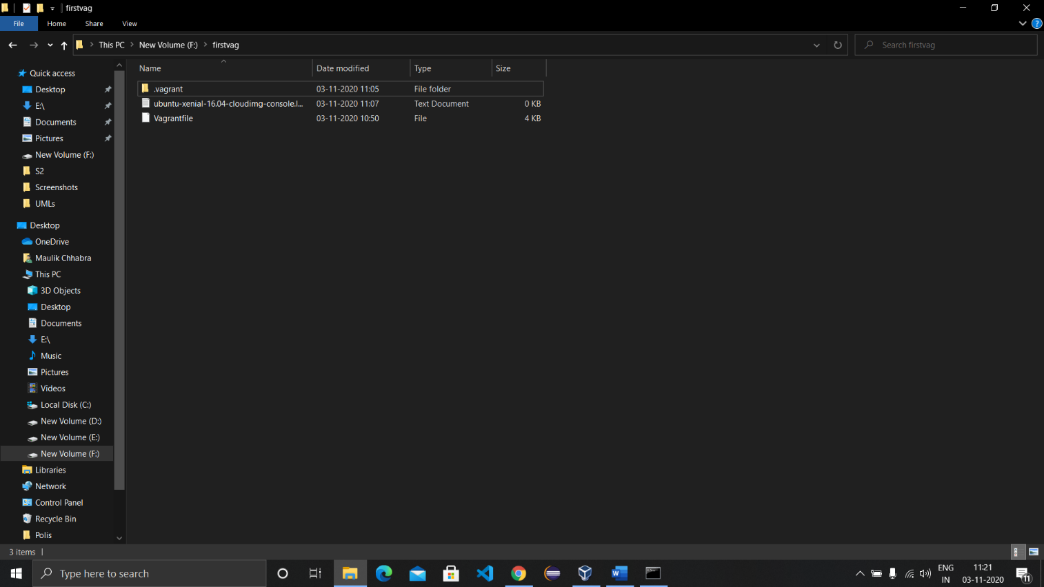

1. Now head to the command prompt and run the command ‘vagrant ssh’ to open the virtual machine on the command prompt.

