**Experiment 10:** Prepare and implement Docker container restart policy and working with log file using Docker.

1. Docker container restart policy
2. Check of there is any current running or previously running containers.
3. Launch an instance using the command ‘docker run -d --name restart-default scrapbook/docker-restart-example’. This will launch a instance with name restart-default. And check again for the containers now running or stopped latest.

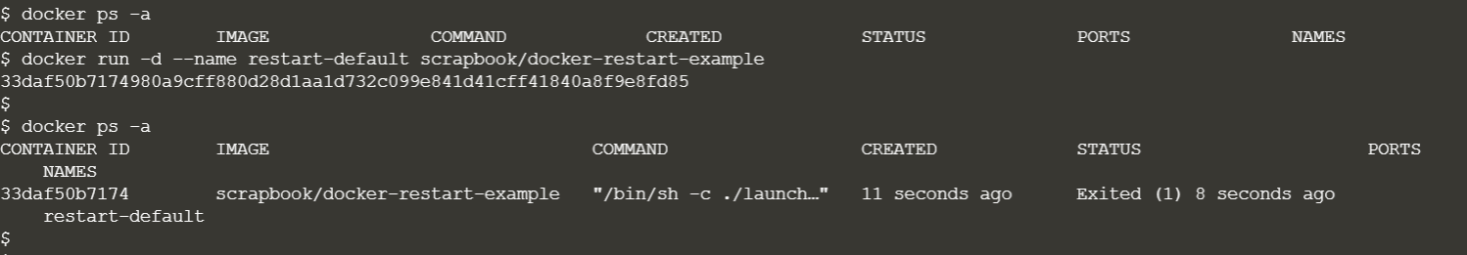

1. To check the logs about a specific container, use the command ‘docker logs <container-name>’. Here, container name is restart-default.
2. Now run another container with names restart-3 and on failure:3.

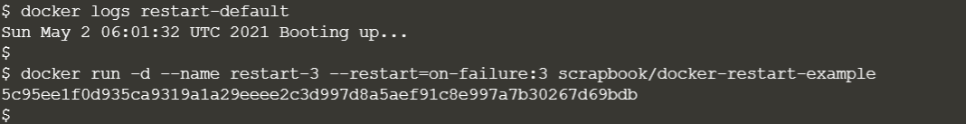

1. Check the logs for restart-3, the list will show 3 entries.

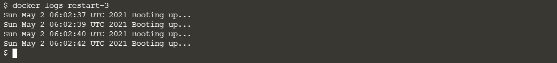

1. Now run another container with name restart-always and restart tag set to always.



1. Check the logs of this container, the list will be as shown.

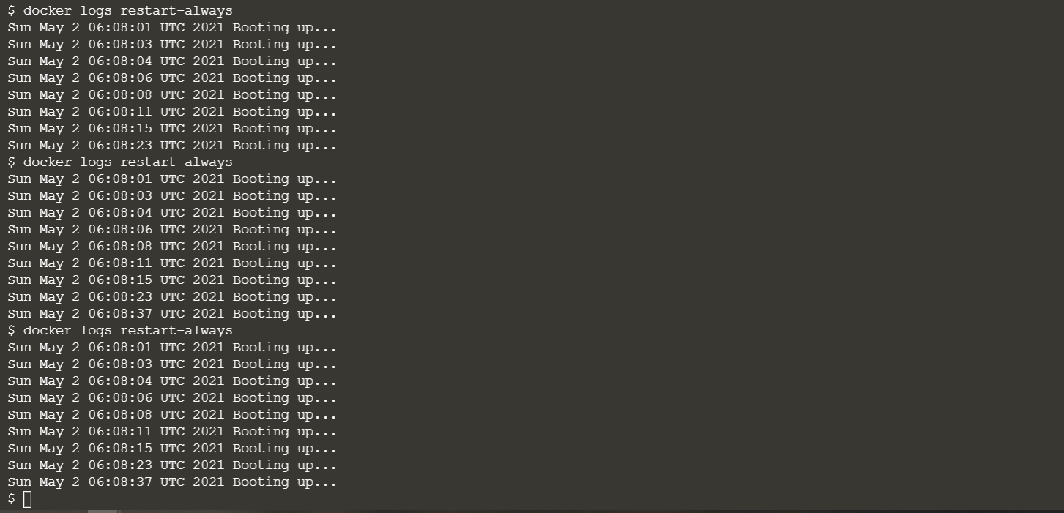

1. Working with Log file using Docker
2. Run a redis image by docker run command with name as redis-server.
3. Check the logs of the container using ‘docker logs <container-name>’ command.

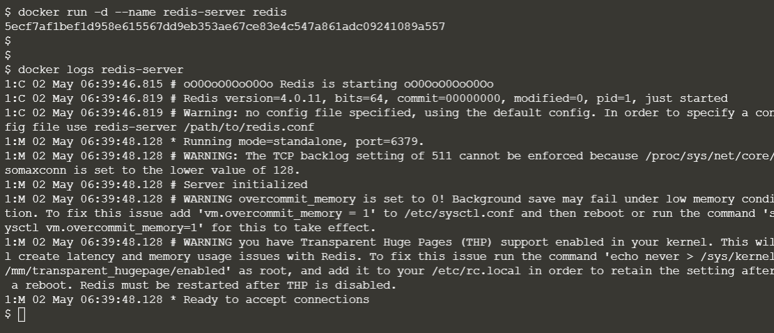

1. Now run another redis container named as redis-syslog and log-driver tag set to syslog so that normal docker log cannot access the logs of the container.
2. Now check the logs, here the terminal will throw an error because the logs are inaccessible to the docker log command, it can only be accessed with default syslog commands.

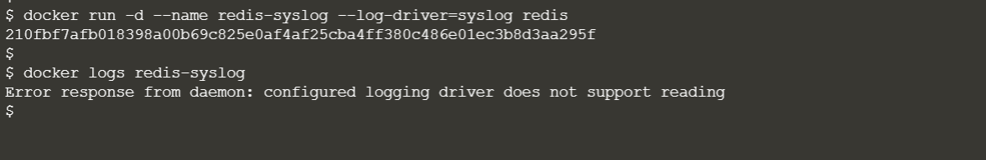

1. Run another container with log-driver tag as none and inspect the format of all the containers using the command “docker inspect –format ‘{{ .HostConfig.LogConfig}}’ <container-name>”.

