**Experiment 2:** Basic Docker commands and Docker volume

1. First log on to the vagrant vm by starting the vm using “vagrant up” and opening its terminal using “vagrant ssh”.

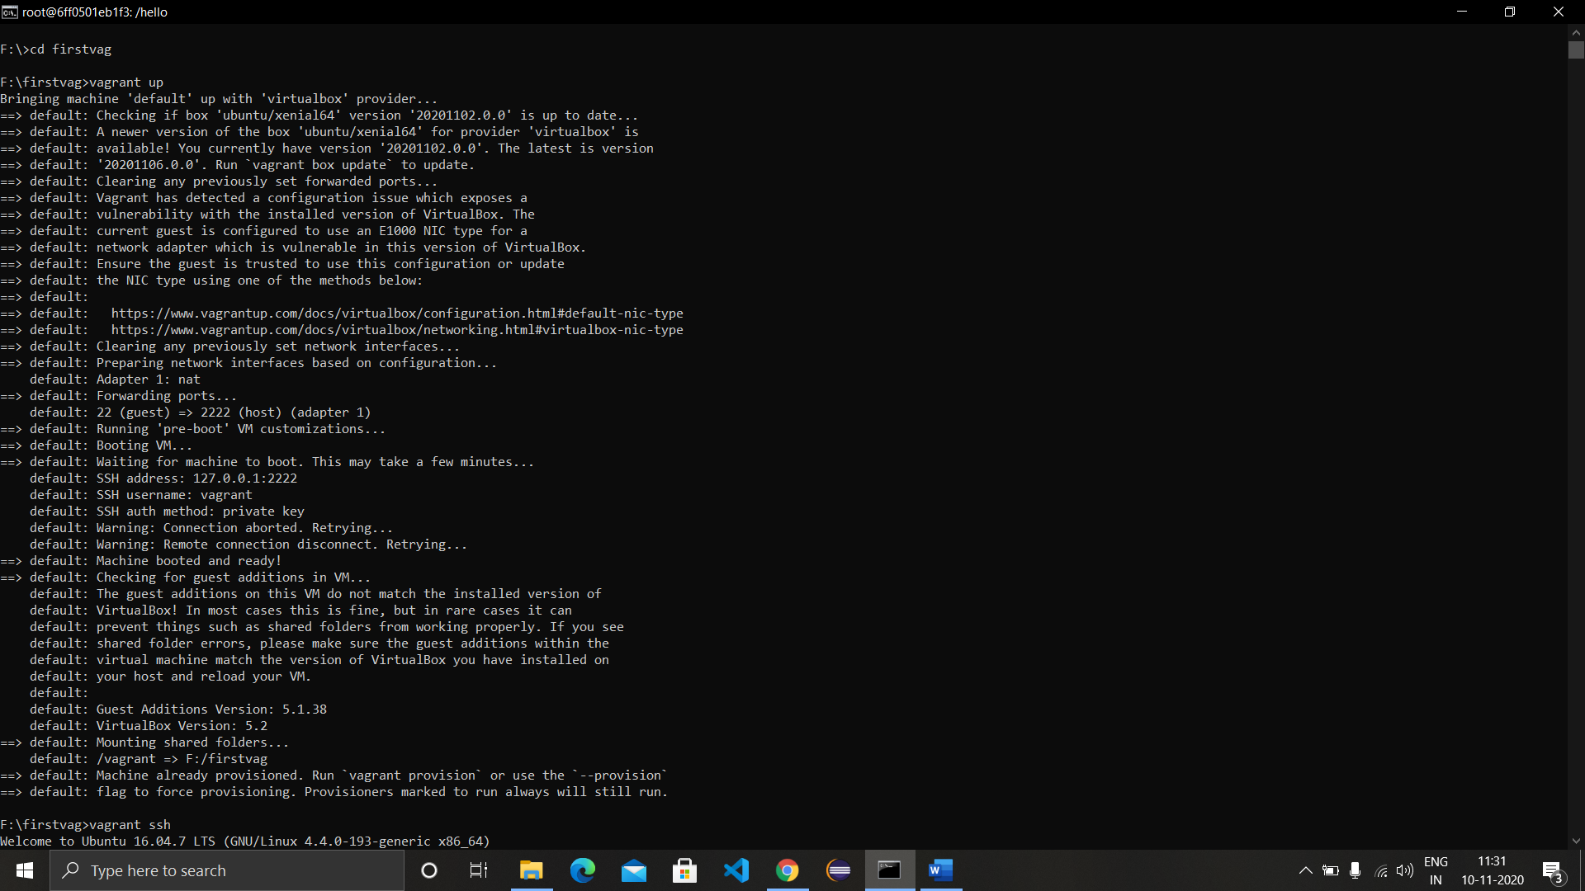

1. Now search for a docker image ‘redis’ using the command “docker search redis”.

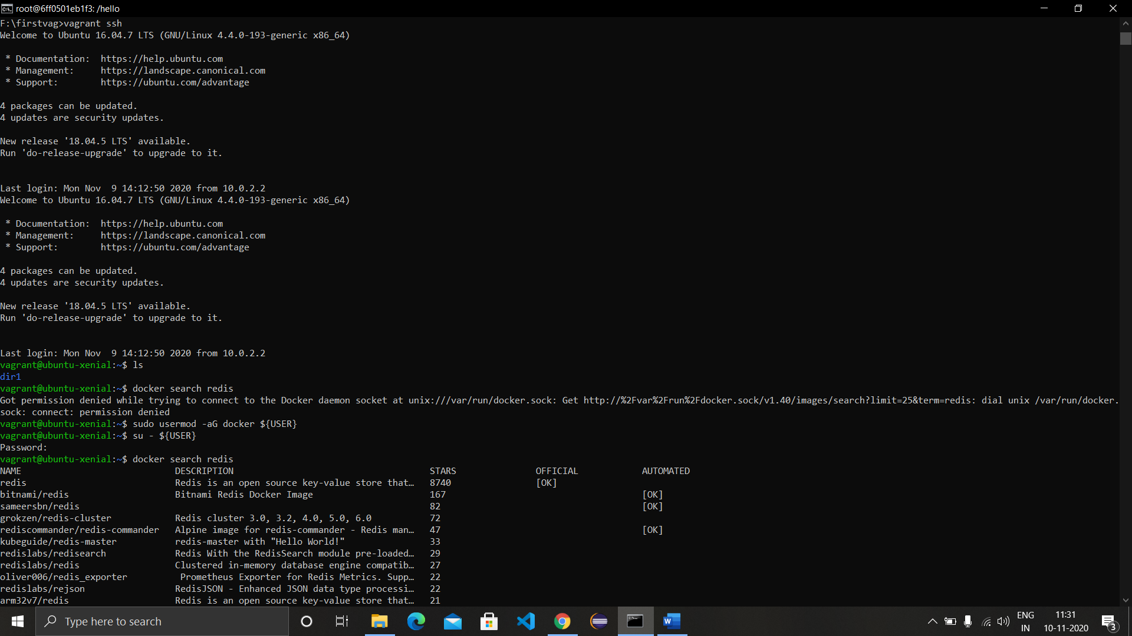

1. Pull the image to the local repository using ‘docker pull redis’.

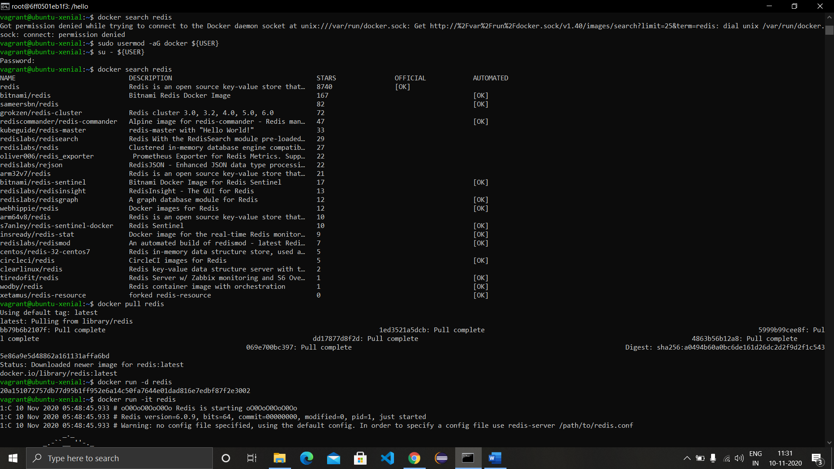

1. Run the image using the command ‘docker run -d redis’ in detached mode.
2. Run the redis image in interactive mode using the command ‘docker run-it redis’. Come out of the terminal using ctrl+c.

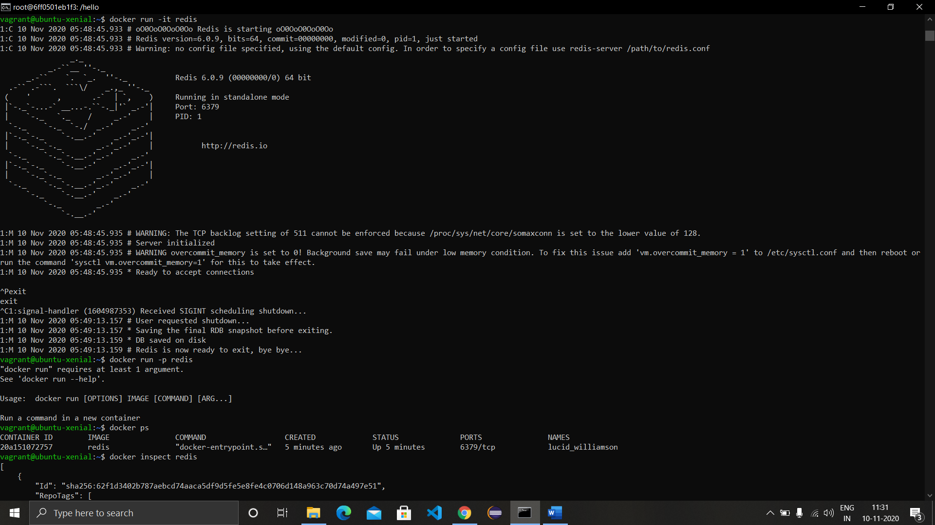

1. Inspect the redis image using the command ‘docker inspect redis’ or with container id of redis as ‘docker inspect CONT_ID’.

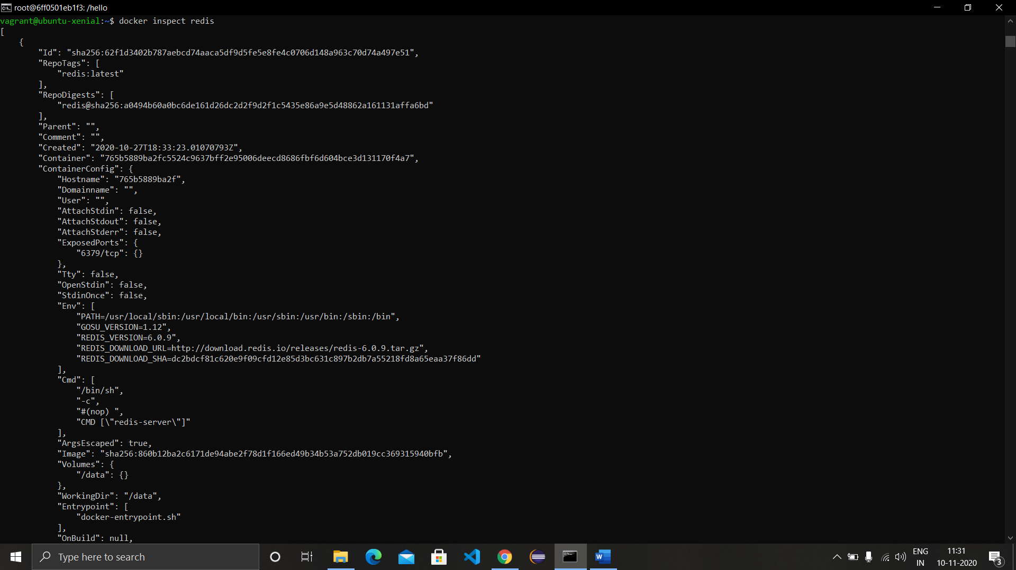

1. Run the redis image in background with the name and port specified.
2. See all the active images using the command ‘docker ps’ and all images (active or not) using ‘docker ps -a’.
3. Run an ubuntu image bash using the command ‘docker run -it ubuntu bash’.

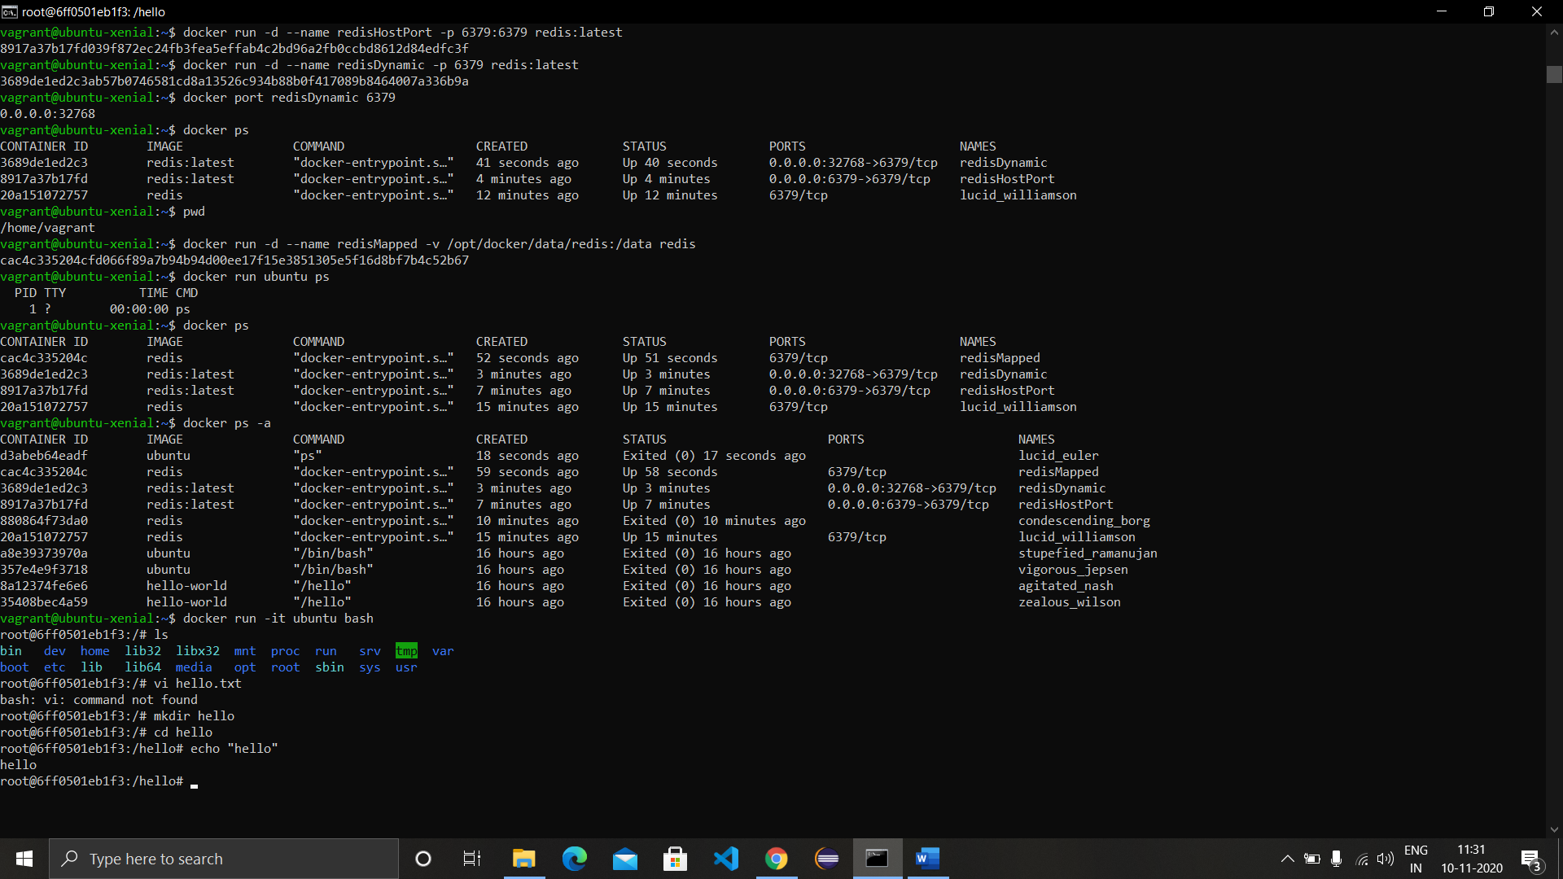

1. As we came across that a container can be in any of the 5 states, there are commands for starting and stopping the specified container. The docker start command starts the container and returns the container ID as output and docker stop command stops the container.

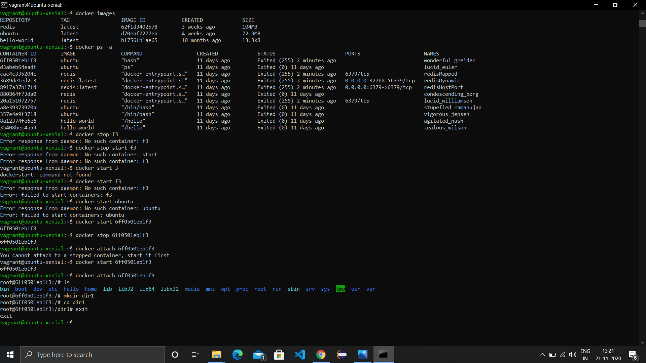

1. Run a ‘alpine’ container using the command ‘docker run alpine’ and check its state using the commands ‘docker ps’ and ‘docker ps -a’.

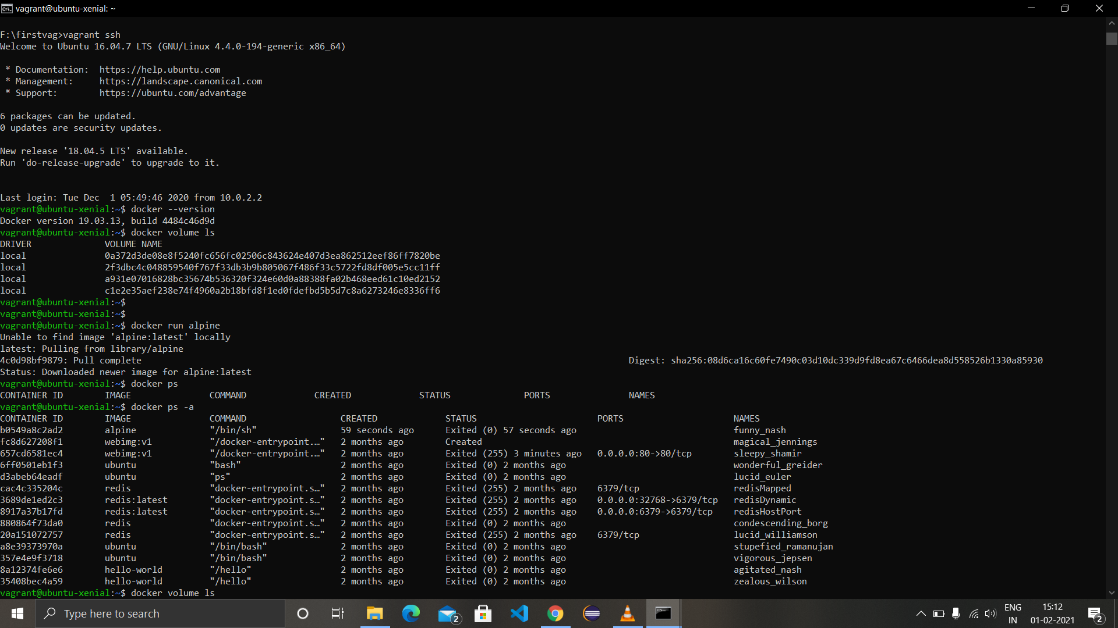

1. Run ‘docker volume ls’ command to view all the volumes available in the machine.

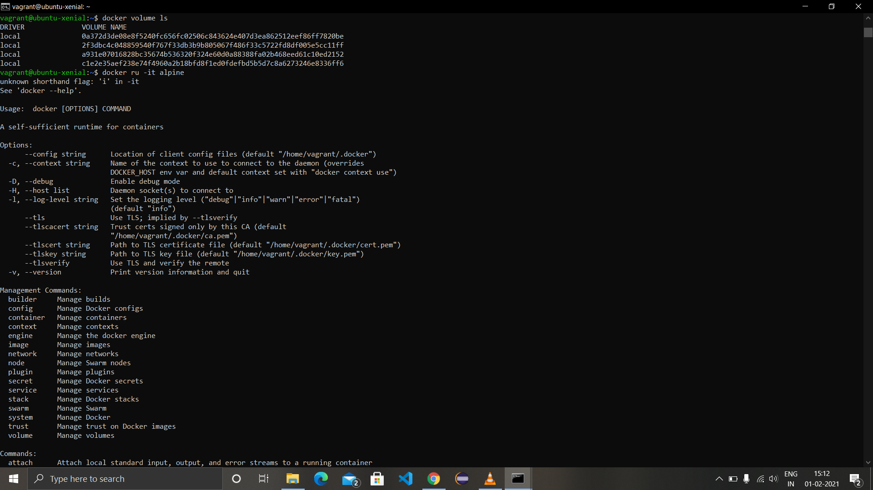

1. Run an alpine container in interactive mode by the command ‘docker run -it alpine’. Enter the folder ‘mnt’ in the alpine container by ‘cd’ command and create some files using ‘touch’ command. Log out of the container using ‘exit’ command.
2. Run another alpine container in interactive mode and view the contents of the ‘mnt’ folder.
3. Run alpine container by linking it with a volume ‘myvol’ using -v flag in the command and perform the same creation of files in the mnt folder and exit from the container. Create a new container with same volume and view the contents of ‘mnt’ folder.

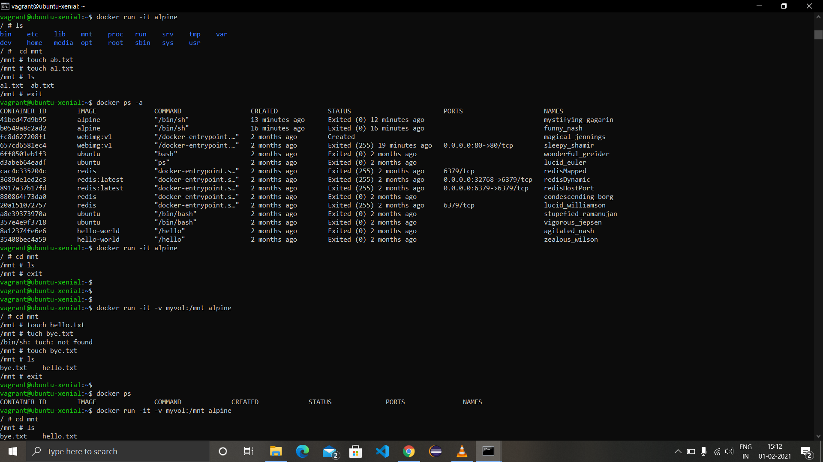

1. To list all the volumes available in the machine use ‘docker volume ls’ and for inspecting a particular volume use the command ‘docker volume inspect volume-name’ in this case ‘docker volume inspect myvol.’ The result of inspect command will include mountpoint where the data we created in volume is stored. Listing contents of that will show all the data created in the volume.
2. Now run a new container and open a new instance of command prompt, running ‘docker ps’ in new cmd will show the running container in previous cmd showing volume can share data between instances.

