**Experiment 3**: Using Docker Network to ping a container from another container

1. Log into a virtual machine using vagrant.

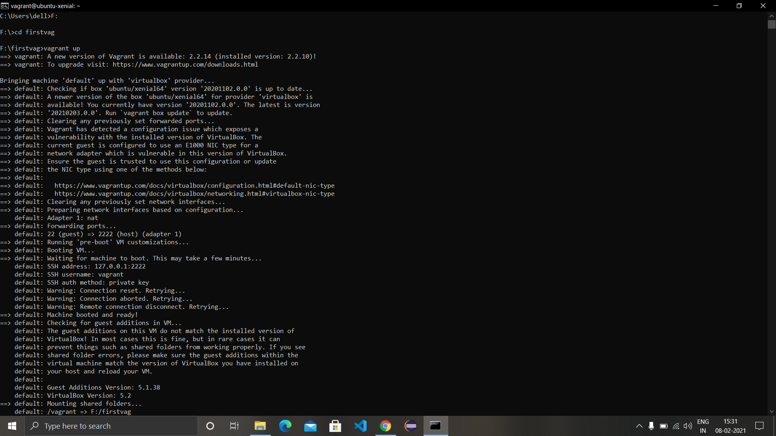

1. Create a network in the virtual machine using the command ‘docker network create <network-name>’.
2. View all the existing networks in the virtual machine using the command ‘docker network ls’.

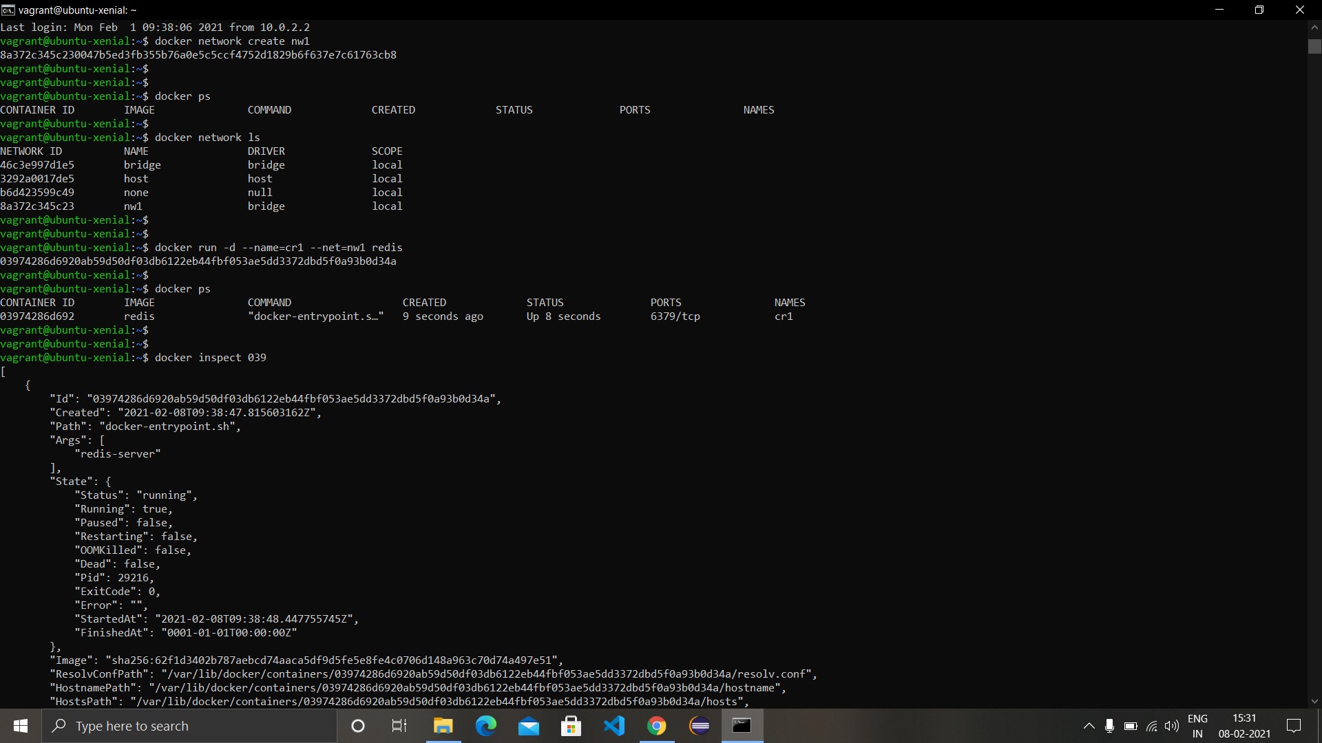

1. Create a container in detached mode with its name as cr1 and network as the network we created ‘nw1’ and inspect it after creation. The ‘Networks’ tag in the whole information for container will have nw1 written in it.

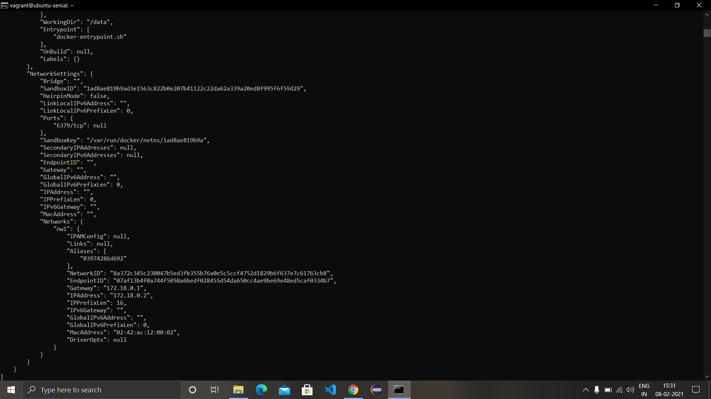

1. Create another container with name ‘cr2’ and network ‘nw1’ and perform inspection for the same.

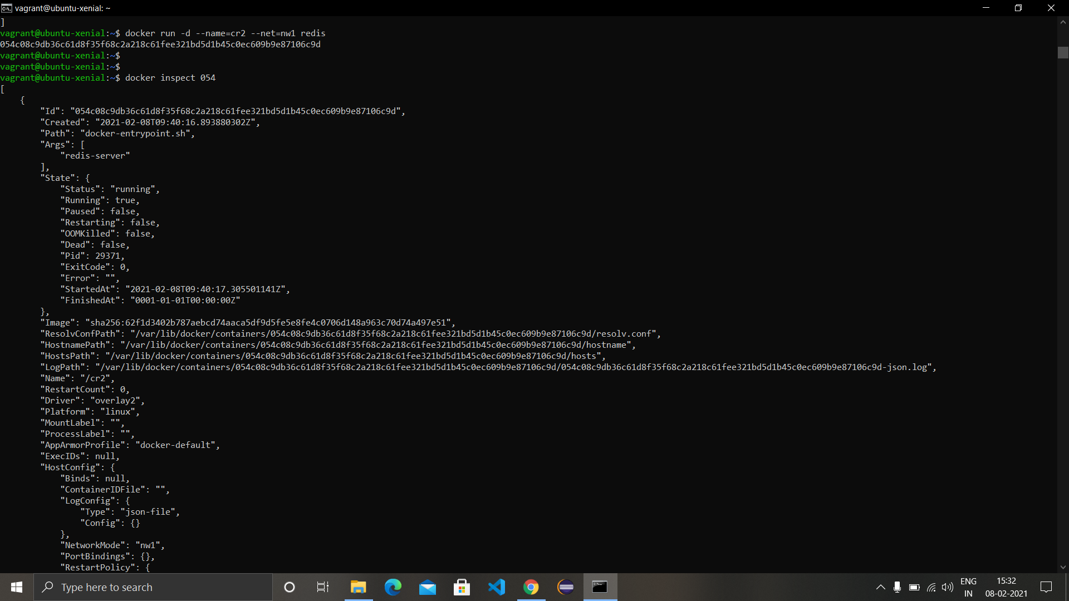

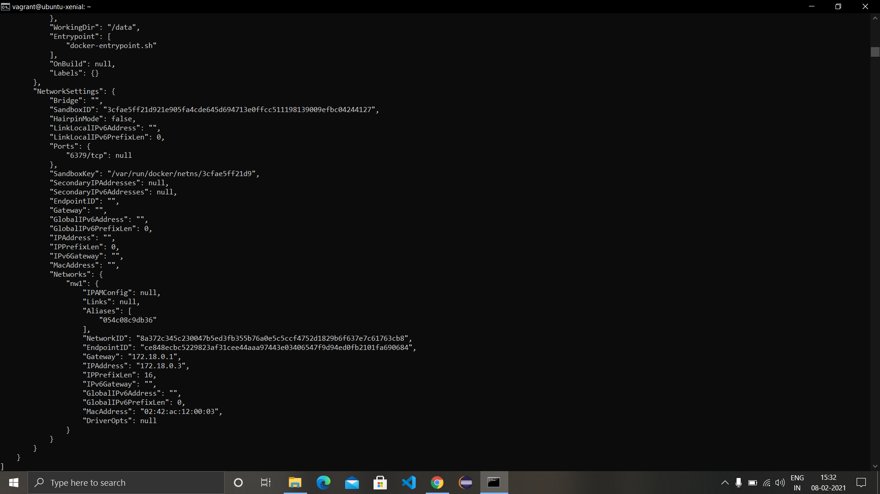

1. While creating another container in same network, also ping the containers previously created by the ‘ping <container-name>’ tag in the end.
2. For pinging a container while being in a container, first start a container in interactive mode and simply type ‘ping <container-name>’ in the terminal of the container.

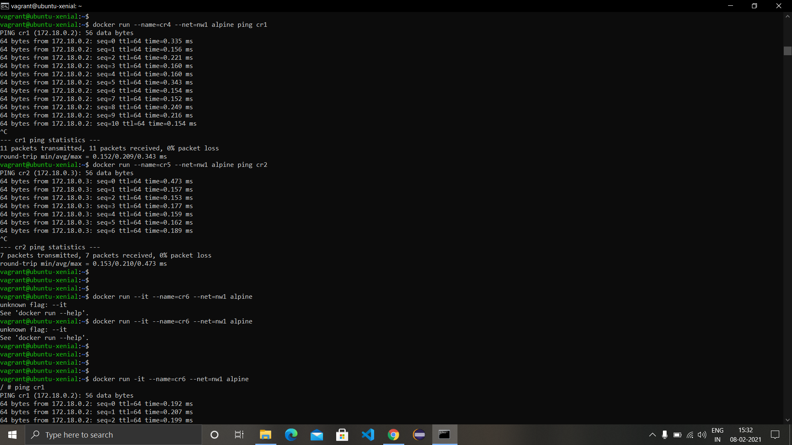

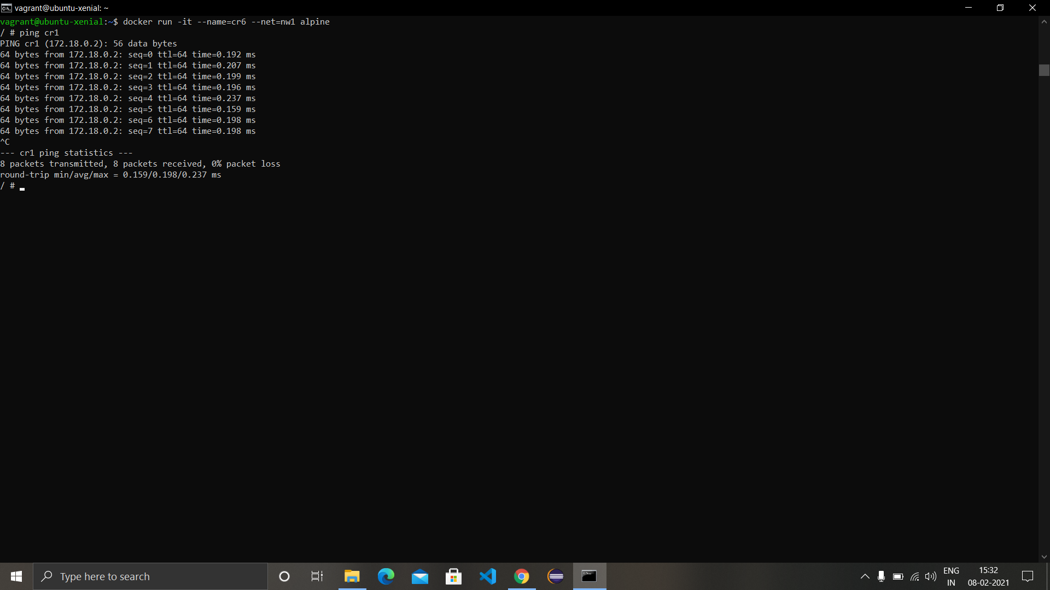

1. Create another network ‘nw2’ and create a new container in this network while trying to ping container in ‘nw1’ container from this container. The ping command will return bad request as the container is not in ‘nw2’ network.

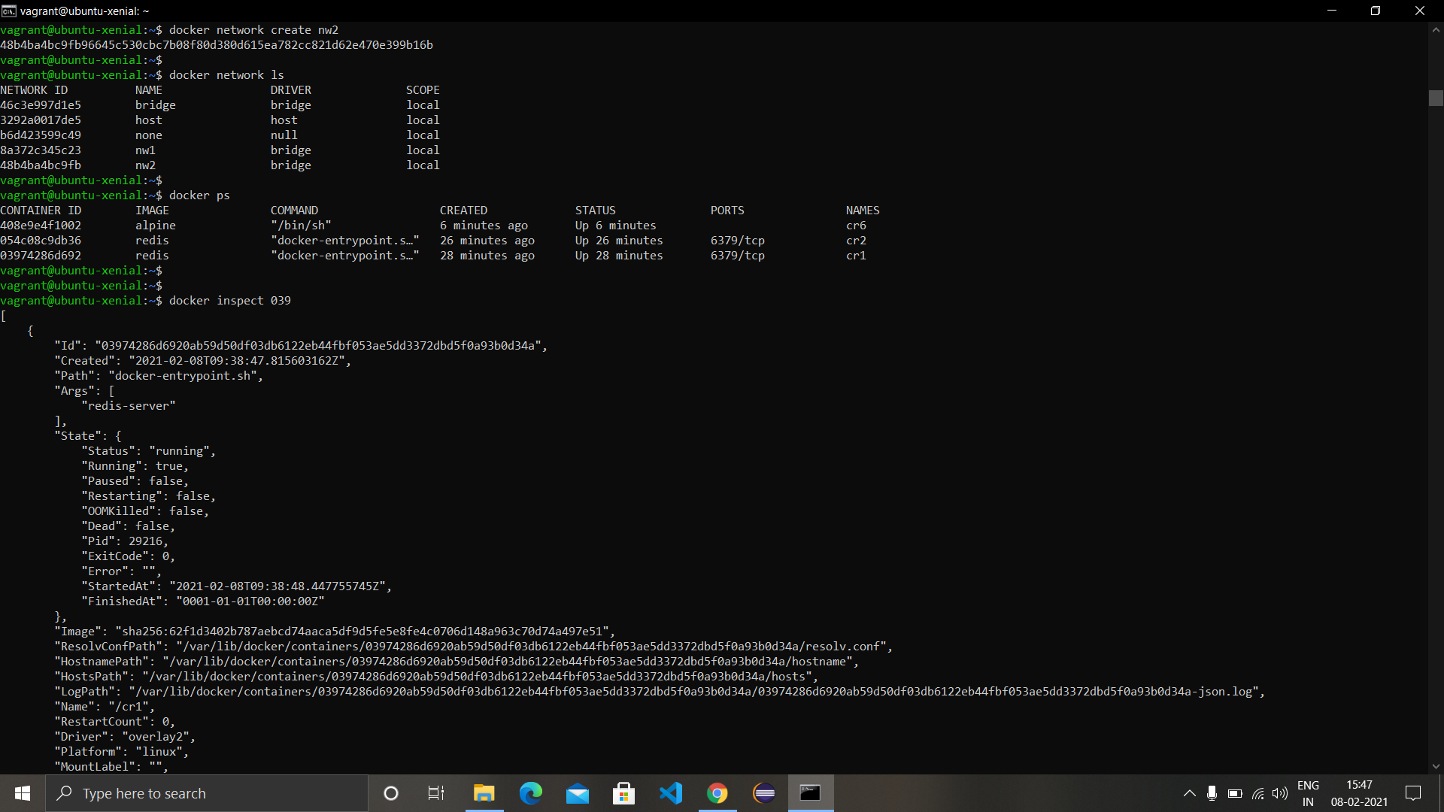

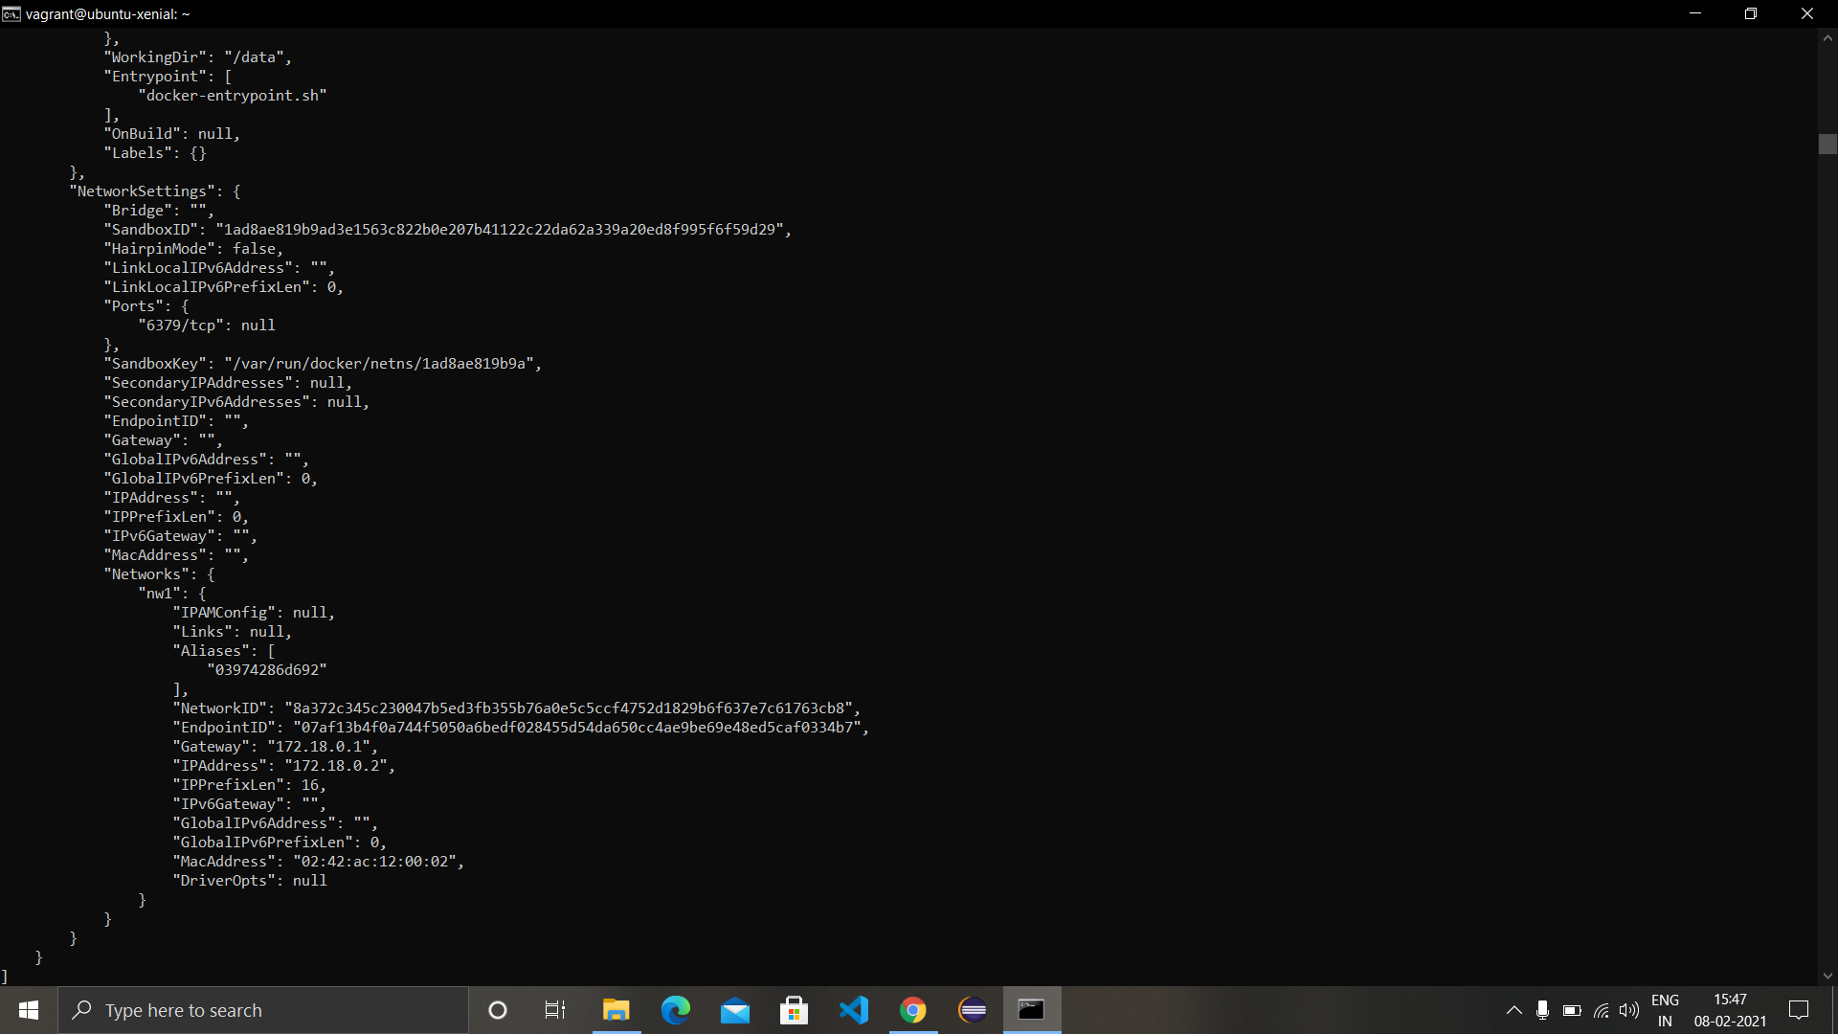

1. Now connect the container in ‘nw1’ with network ‘nw2’ also using the command:

‘docker network connect <network with which you want to connect> <container name to connect>’

Example: docker network connect nw2 cr1

1. Perform pinging between the containers again and now the request will be successfully working.

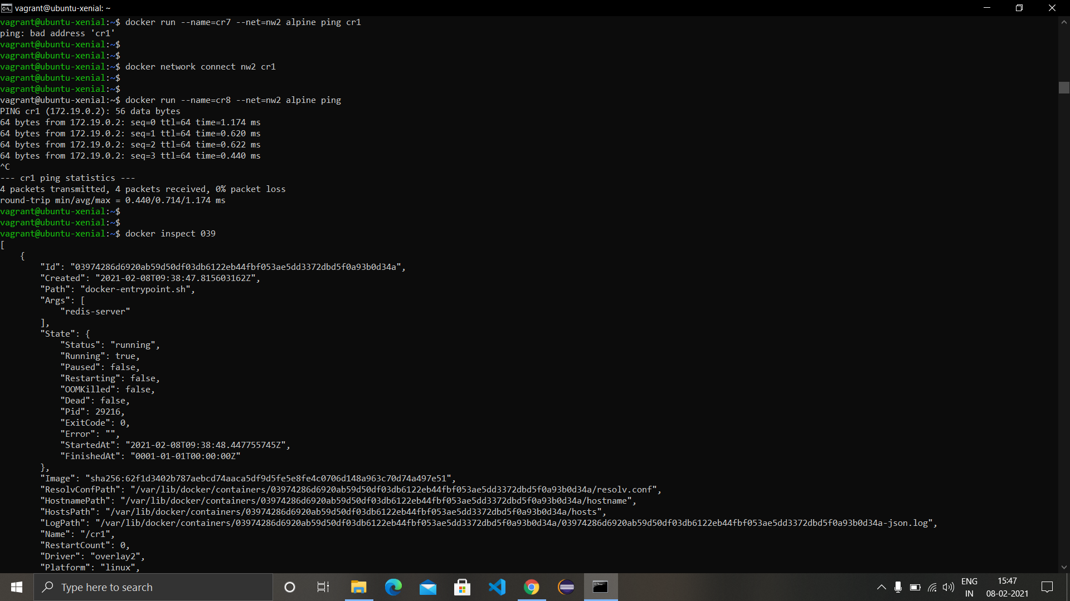

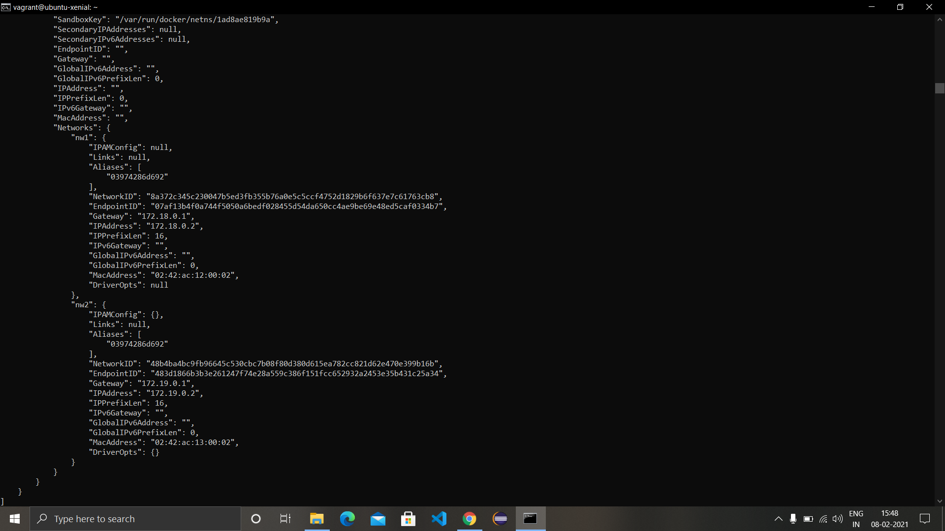

1. To disconnect the container from a network use the command:

‘docker network disconnect <network with which you want to connect> <container name to connect>’

Example: docker network disconnect nw2 cr1

