**Experiment 4**: Creating and Pushing a Docker image to DockerHub

1. Create a Dockerfile using touch command and place the commands you want docker to perform. Dockerfile will include the image name for which you want to create a container, and then commands to run using RUN, exposing the port with EXPOSE <port-number>.

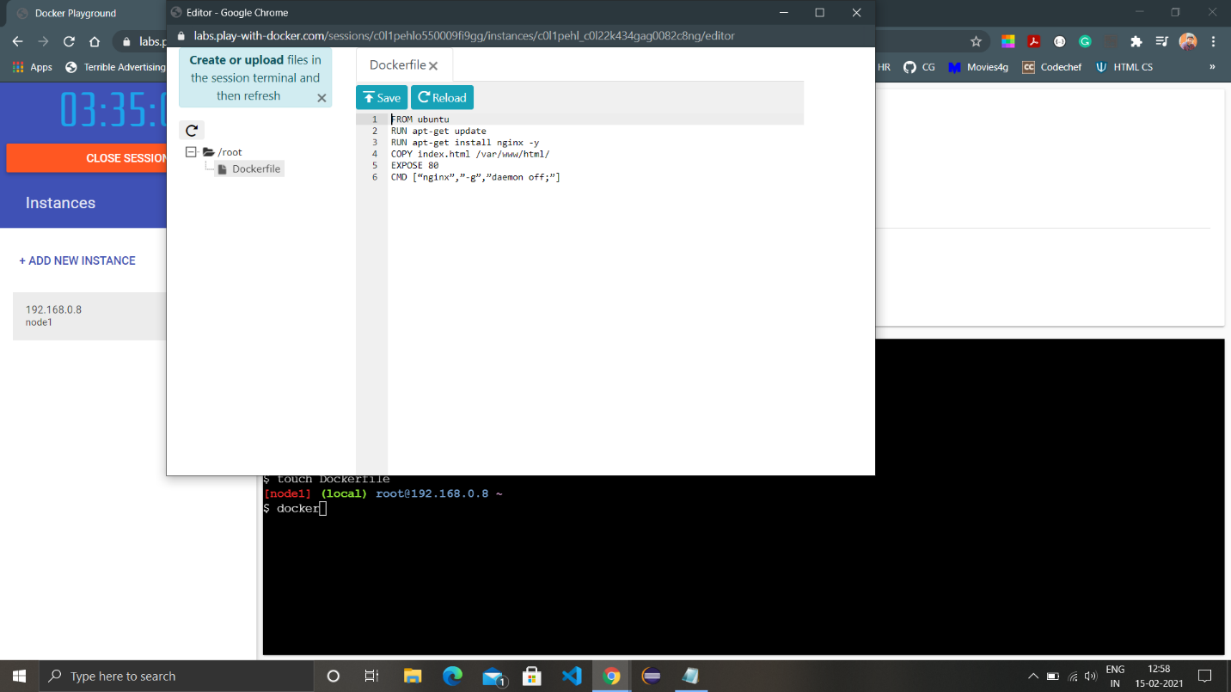

1. Once the Dockerfile is all set up, run the command ‘docker build -t <image-name>:<tag>’. Keep in mind that image name should be all in lowercase.

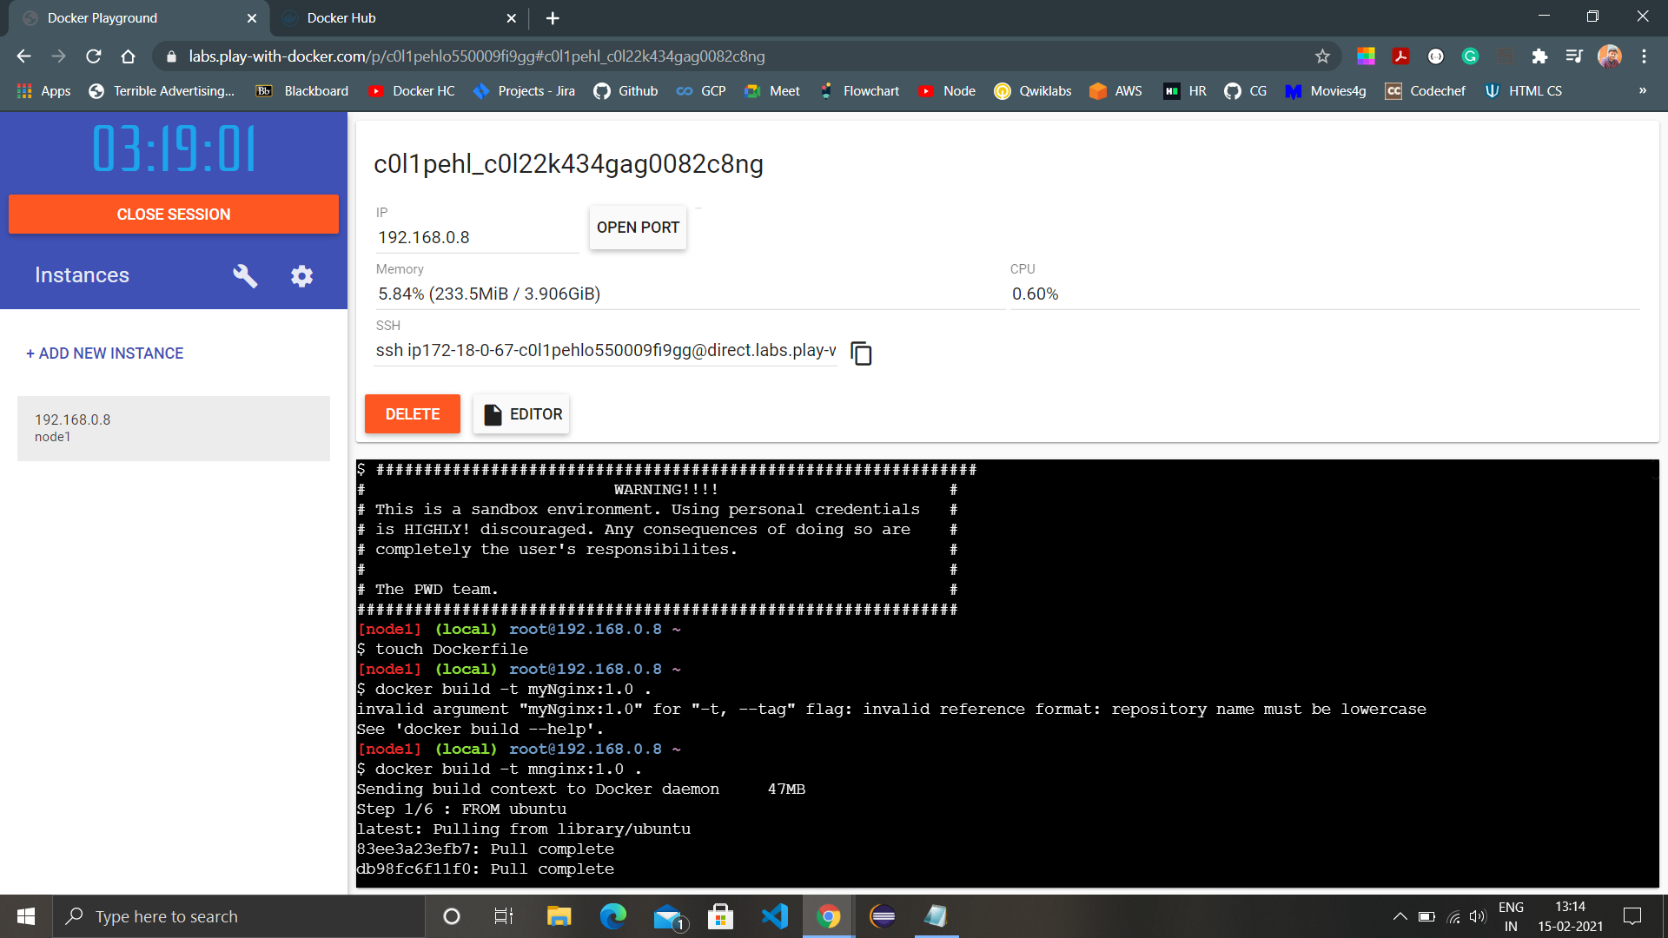

Each line written in Dockerfile will act as a layer during the build and and the build will execute layerwise.

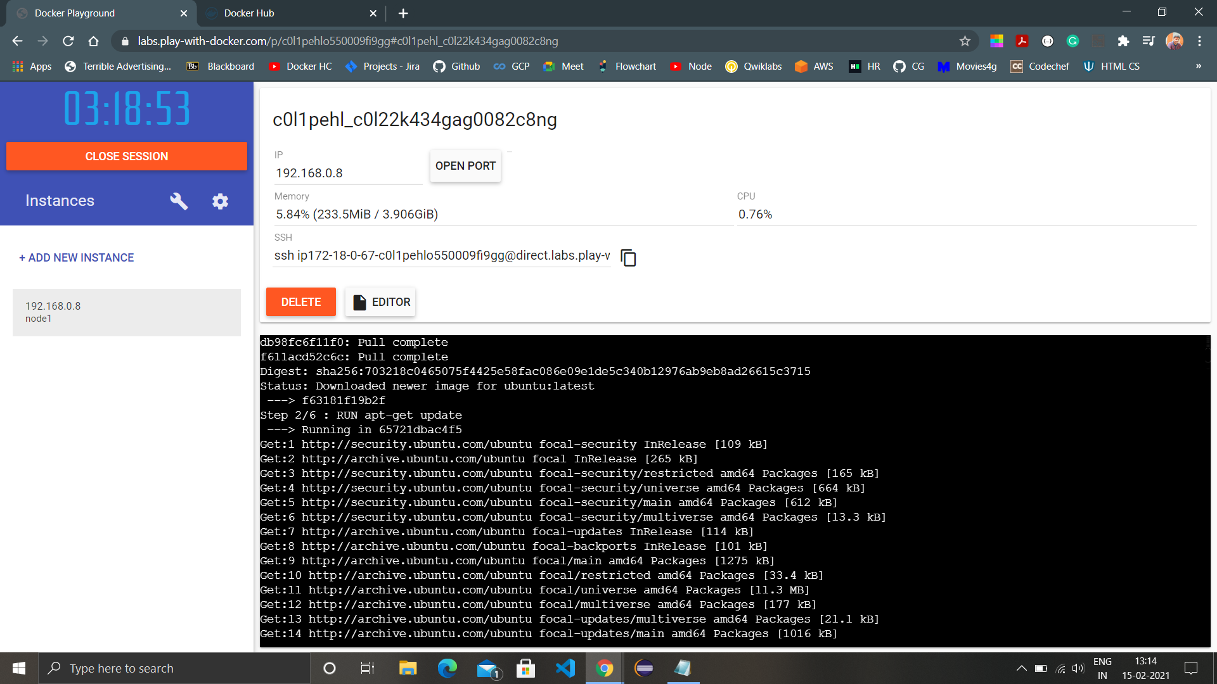

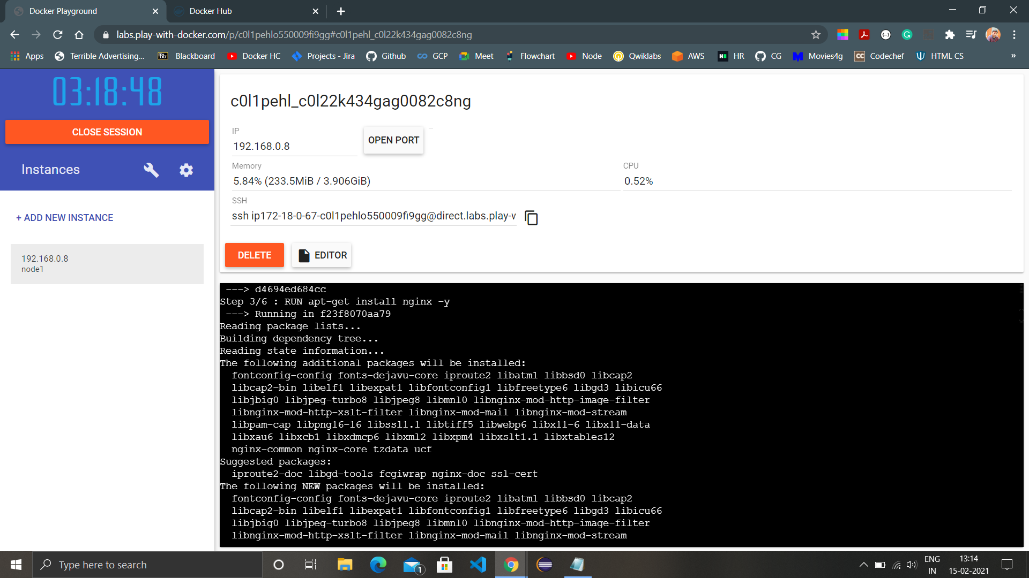

1. As the Dockerfile contain copying from a index.html file, we have to create an index.html file too.

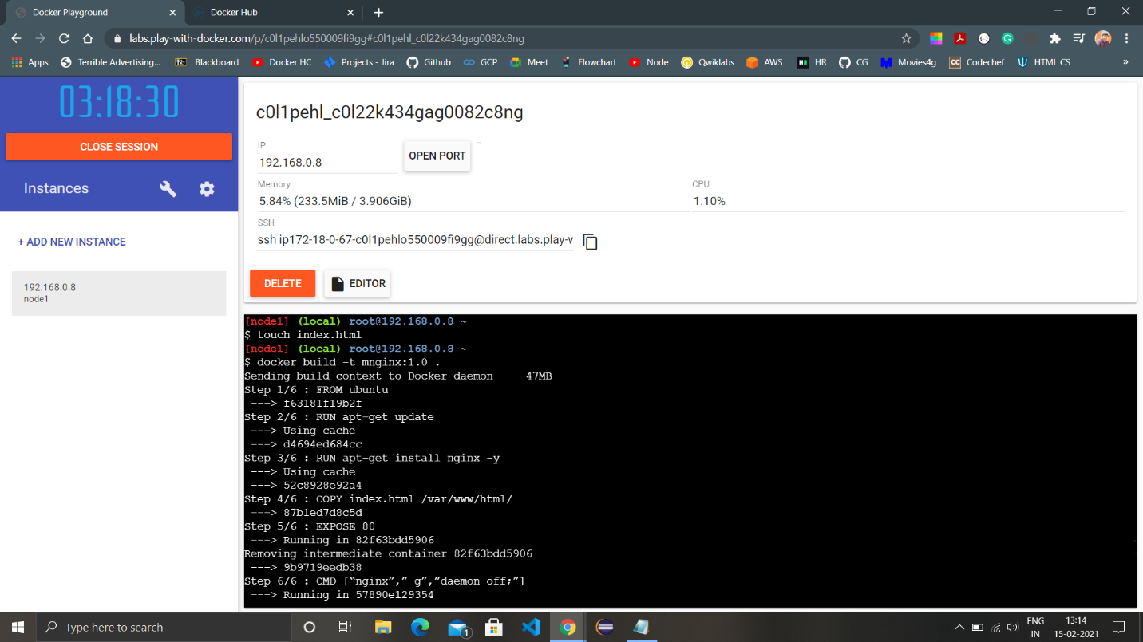

1. View all images by ‘docker images’ and run the newly created image using the image ID.
2. View the new container using ‘docker ps’ and ‘docker ps -a’.

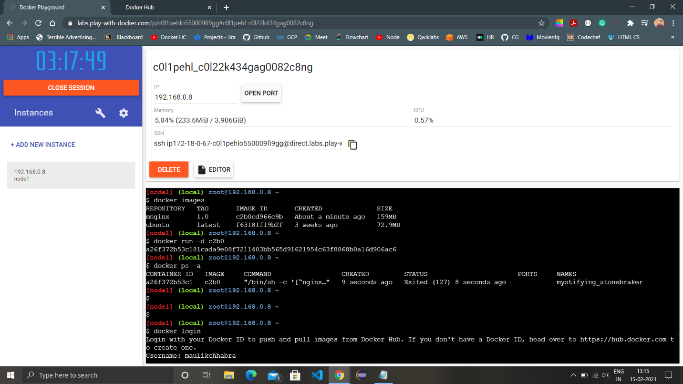

1. Login to the Docker profile to push the image to DockerHub.
2. Create a new repository on Dockerhub.

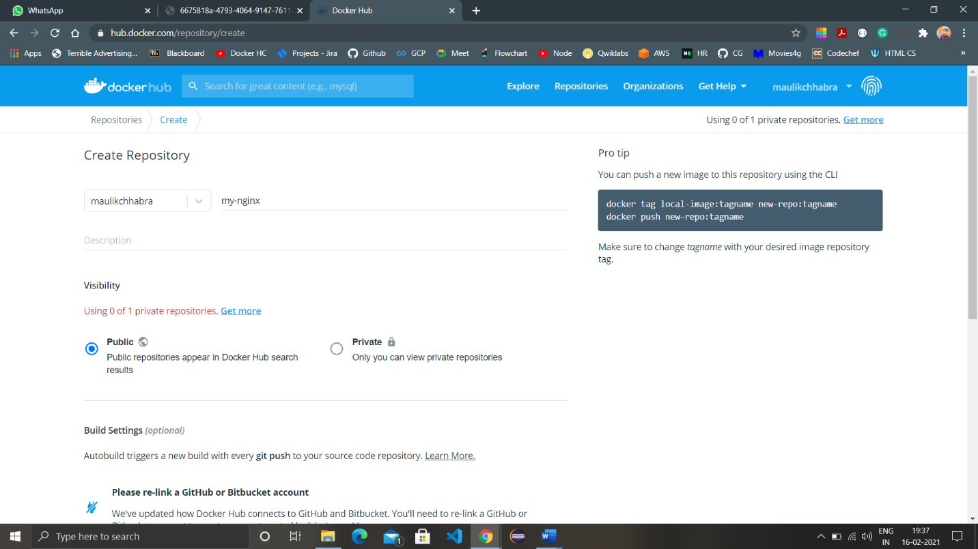

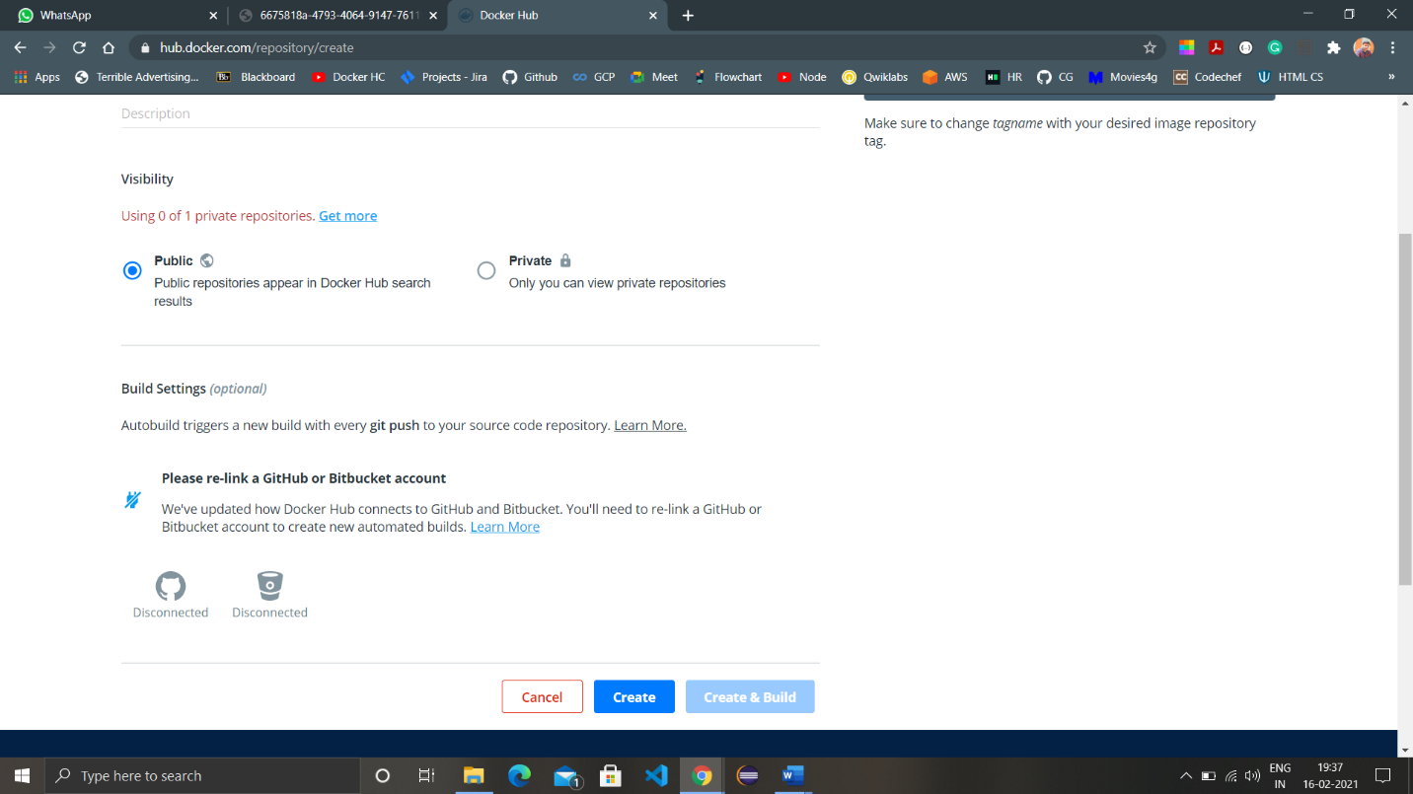

After creation, the repository will be available on main dashboard.

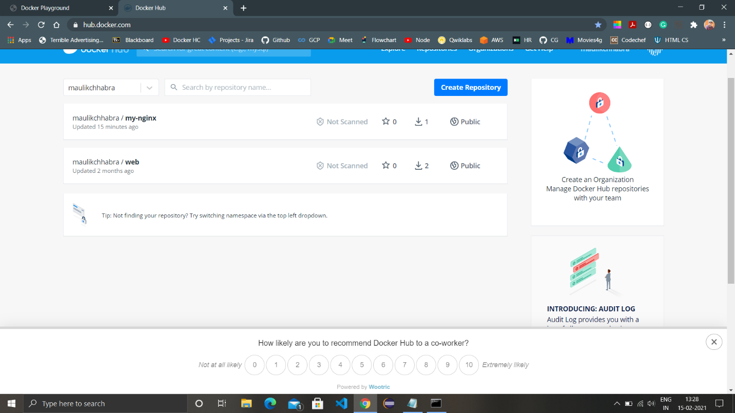

1. Tag the repository created on Dockerhub with the image you created using the command ‘docker tag <image-name> <repository-name>’ and check all images with ‘docker images’

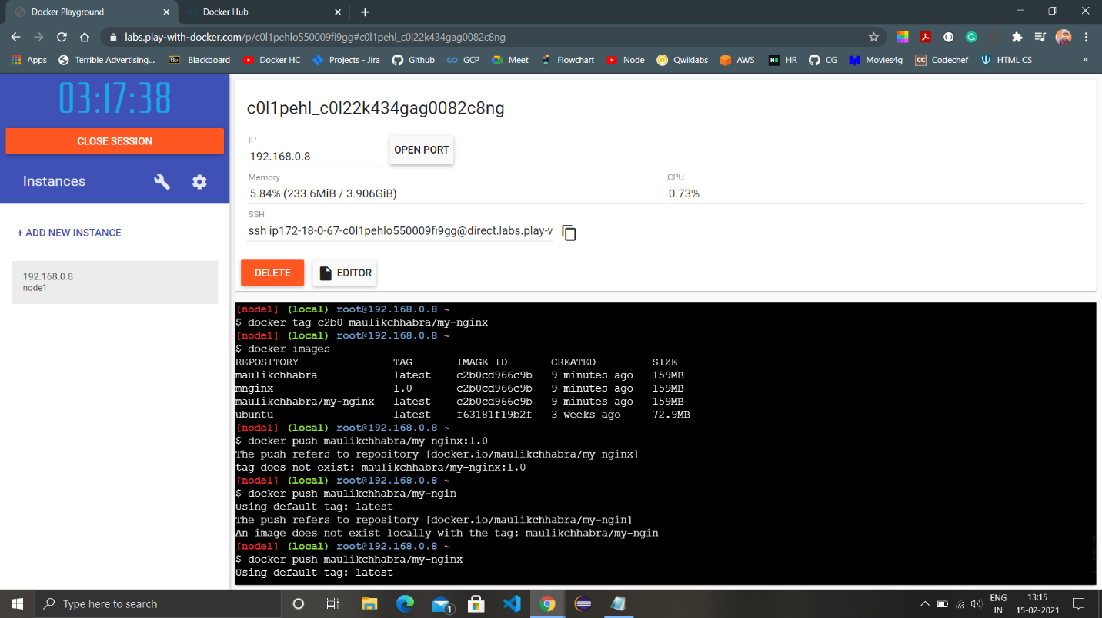

1. Push the image on Dockerhub using the command ‘docker push <image-name>.

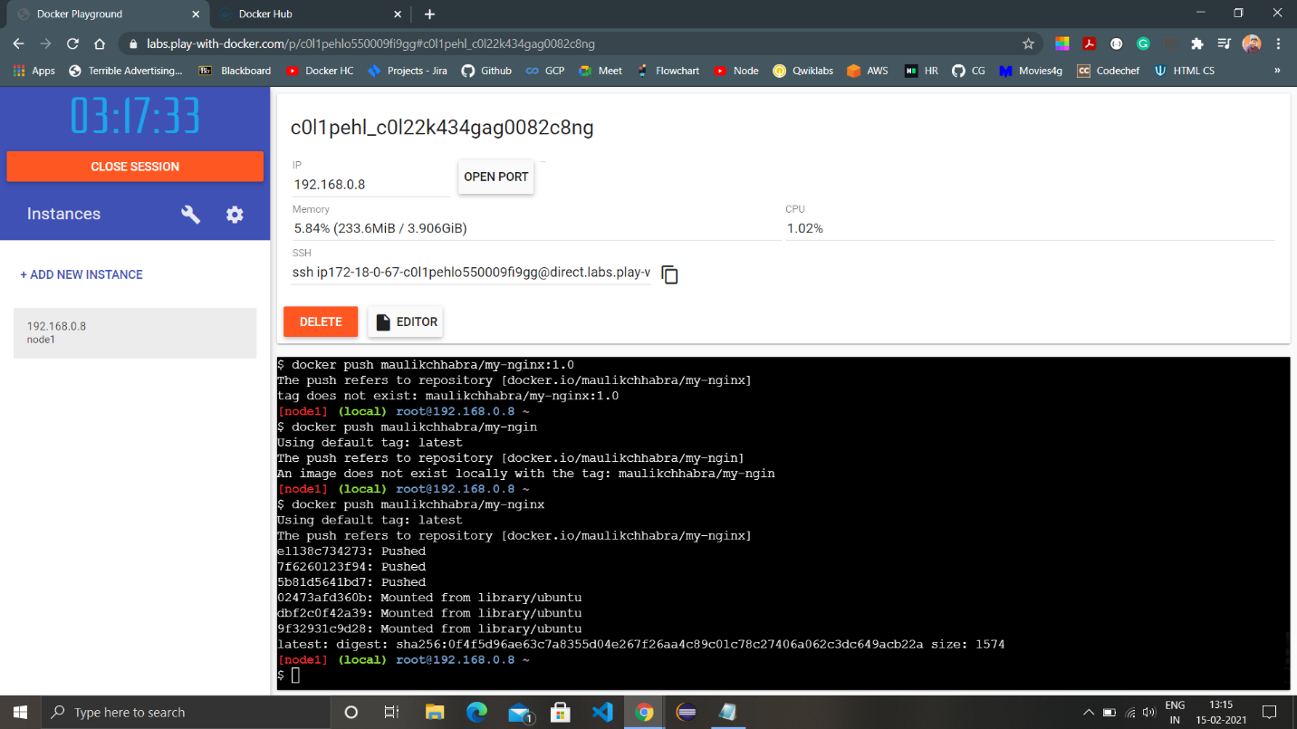

1. Start a new instance and pull the image you just created and run a container with the image and provide a port on which we can view the index.html page.

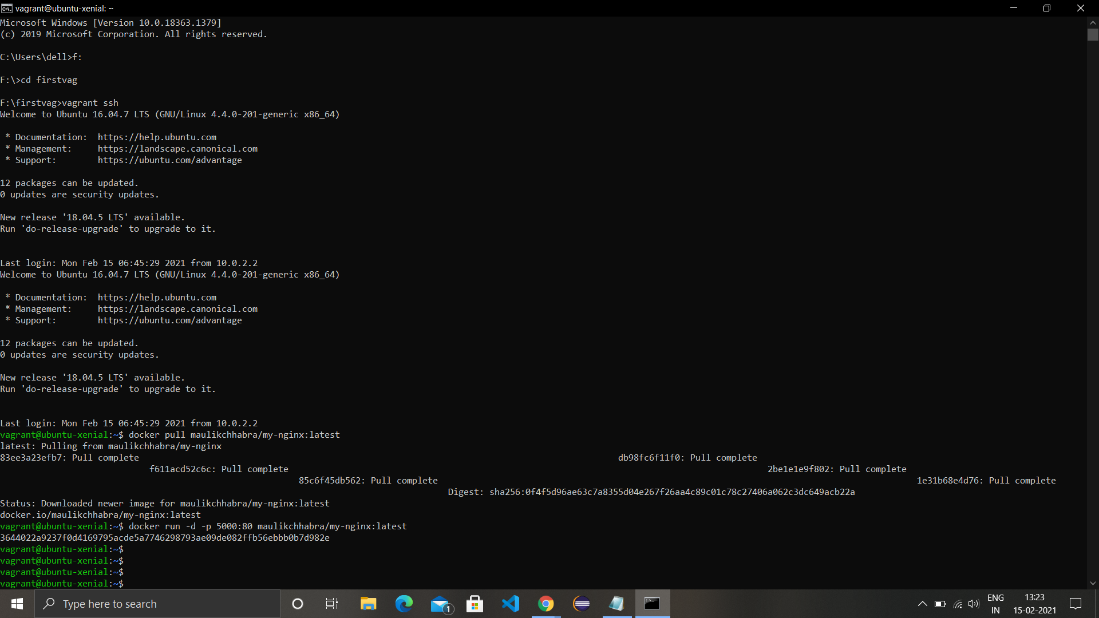

Command for downloading the image: docker pull maulikchhabra/my-nginx:latest

URL to image: https://hub.docker.com/r/maulikchhabra/my-nginx