**Experiment 5:** Docker Compose Usage

1. Logon to Docker playground and create a new instance in the playground.
2. Check if the system has docker-compose preinstalled in it or not, if not install docker-compose using the command:

‘sudo curl -L https://github.com/docker/compose/releases/download/1.21.2/docker-compose-$(uname -s)-$(uname -m) -o /usr/local/bin/docker-compose’

‘sudo chmod +x /usr/local/bin/docker-compose’

1. Create two files –

* credentials.env
* docker-compose.yml
* credentials.env will contain all the username, password, keys for different containers.
* docker-compose.yml will list all the images for which we want containers and container’s configurations.

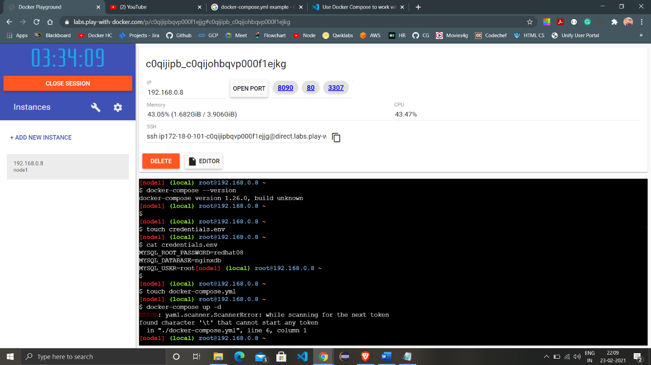

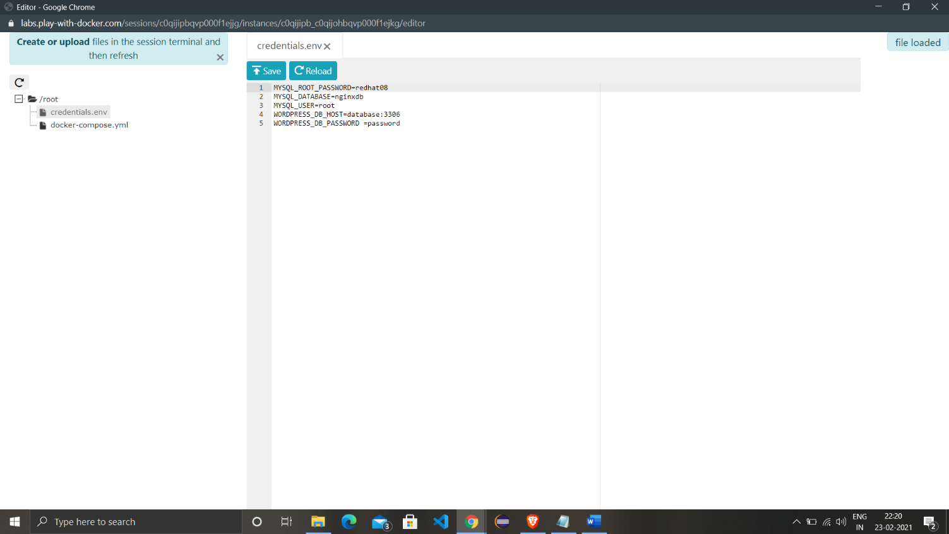

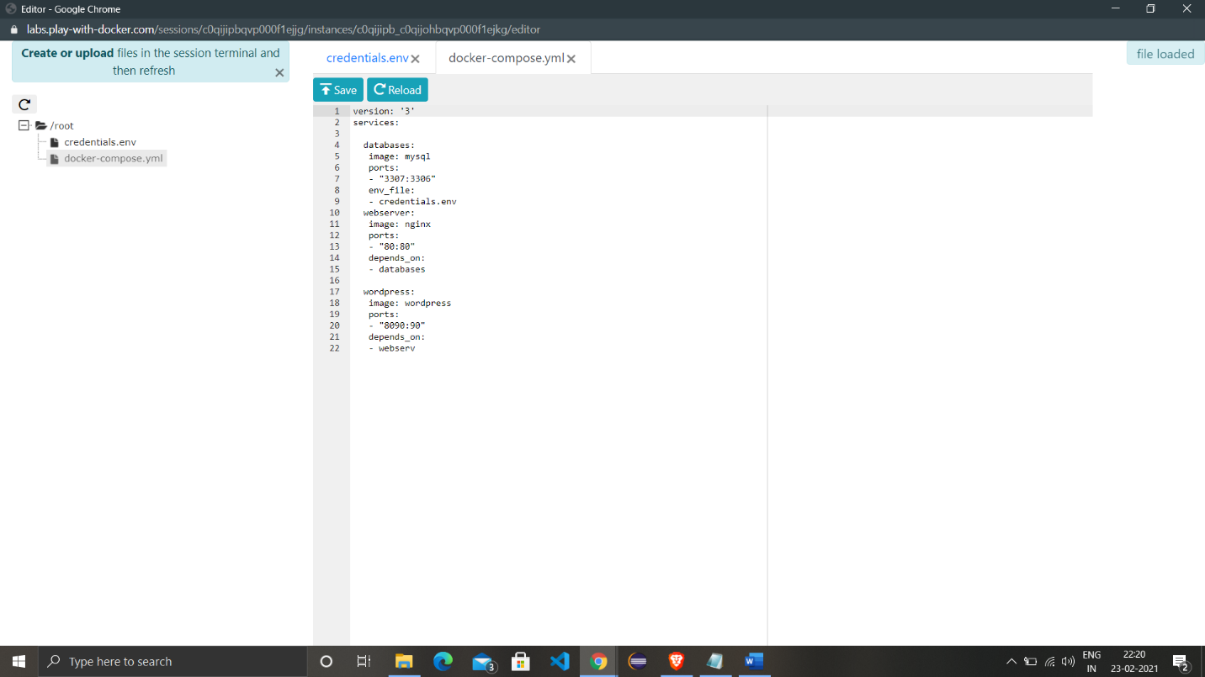

1. Check whether the instance have some containers pre-running or not.
2. Run the command ‘docker-compose up -d’ to install all images and create containers of it in detached mode.

MySQL image installation:

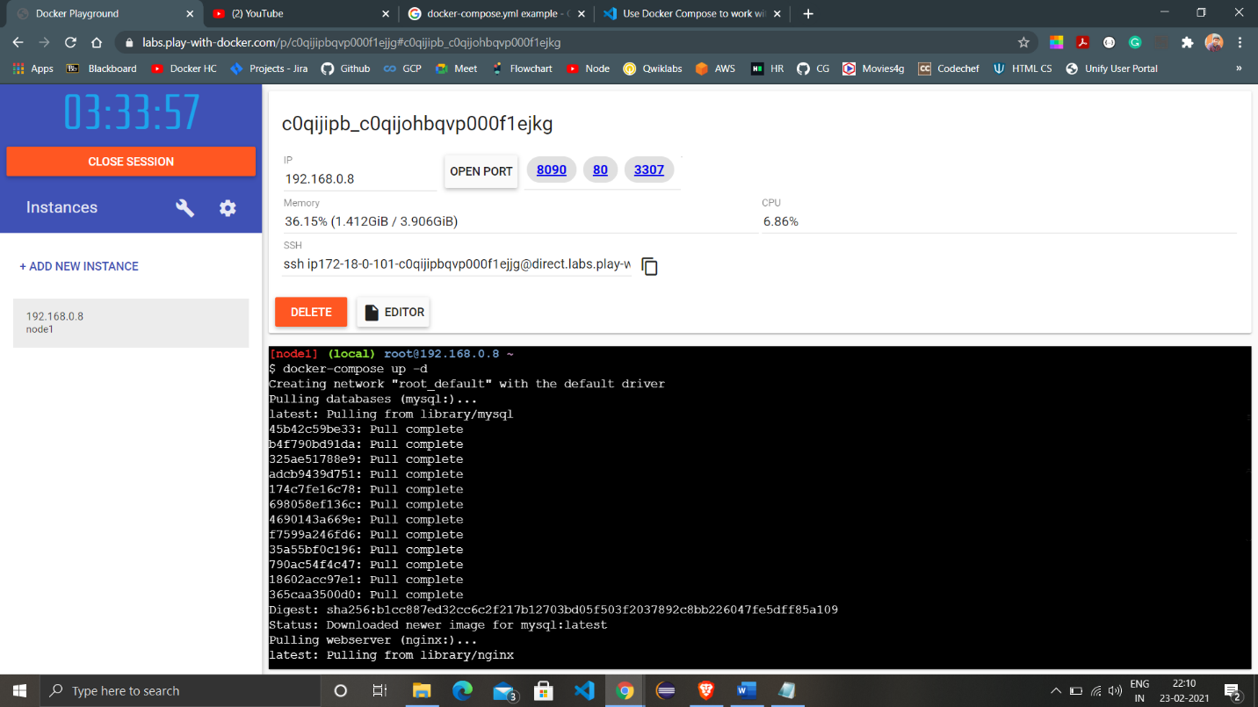

NGINX and WORDPRESS images installation:

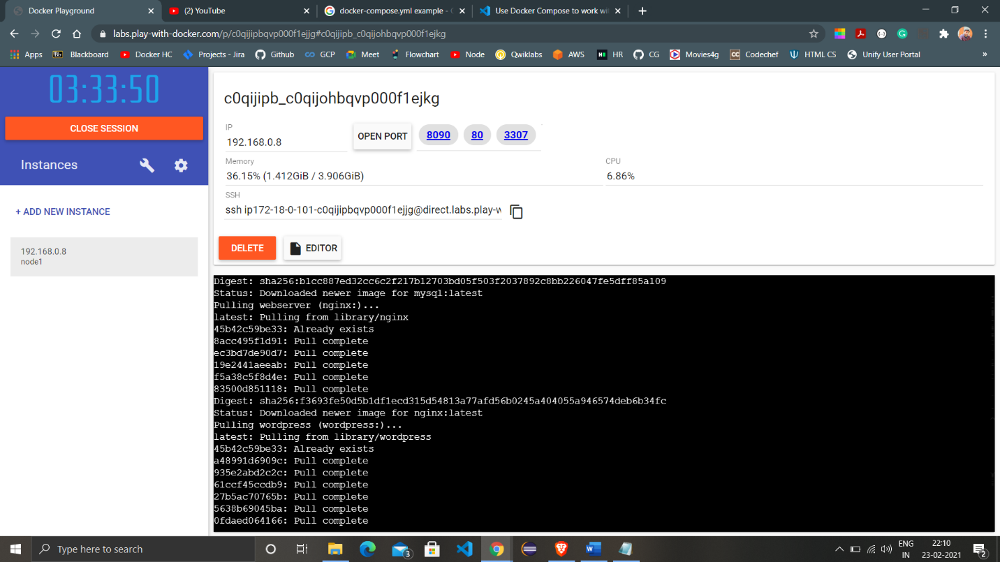

Creation of containers of all images downloaded:

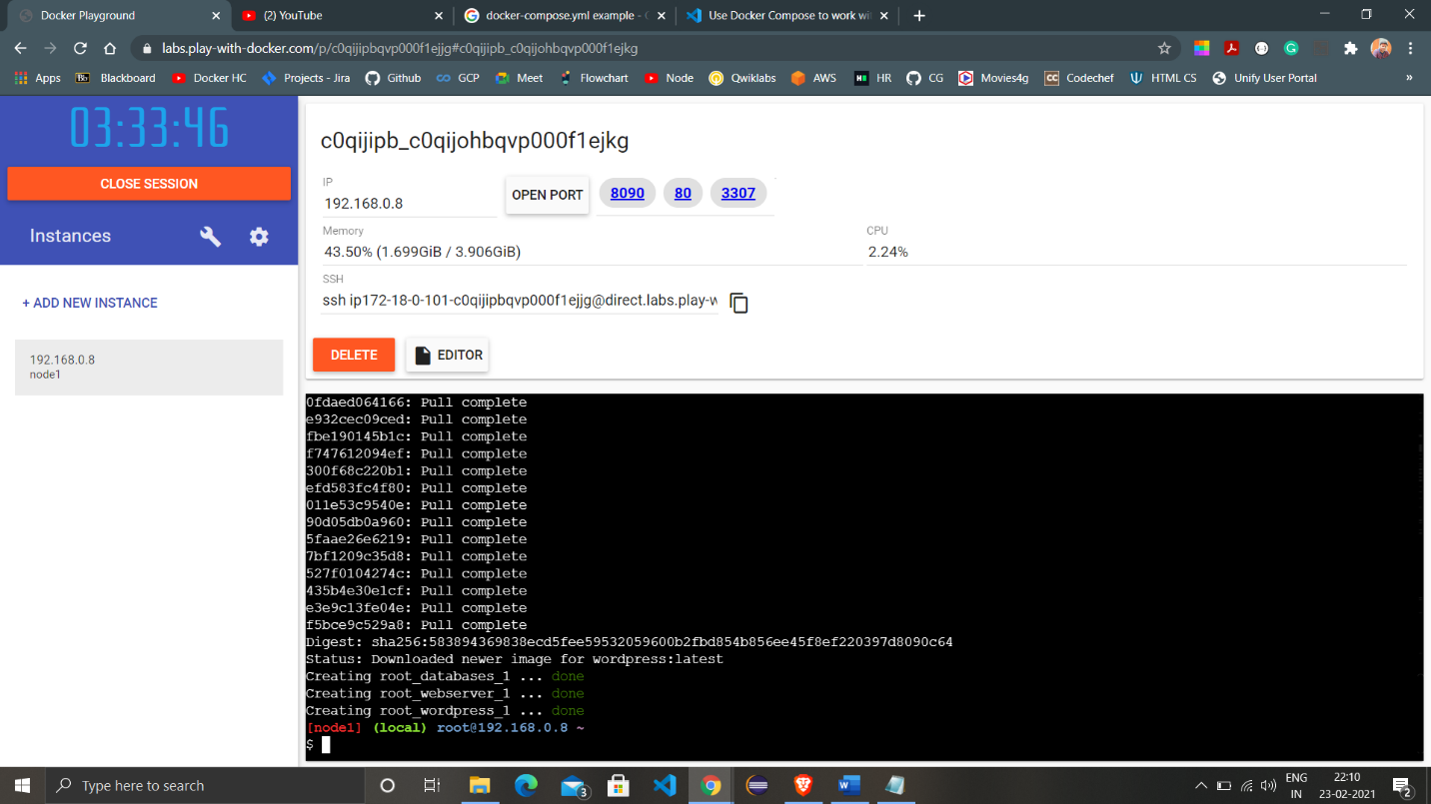

1. Visit the ports on which the containers are working to see their homepage.

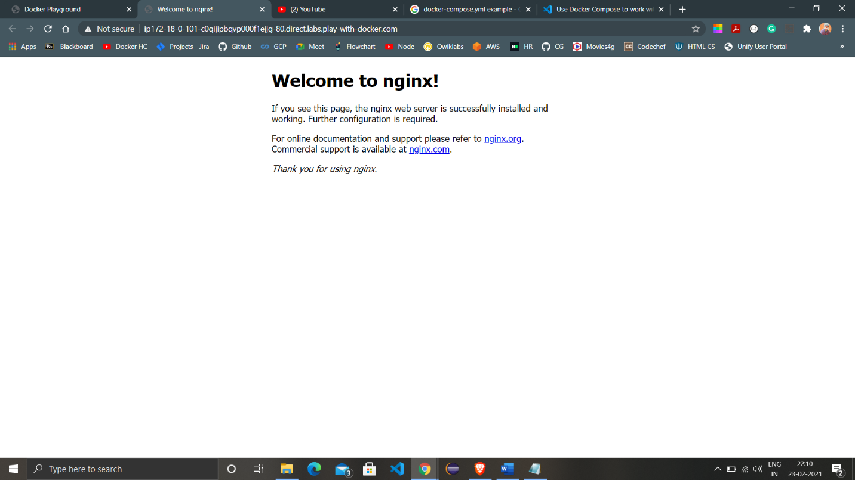

1. Check all the containers created by the command using ‘docker ps’ command.

