**Experiment-1**

**Vagrant**

**Step 1: Install Vagrant and VirtualBox on Your System**

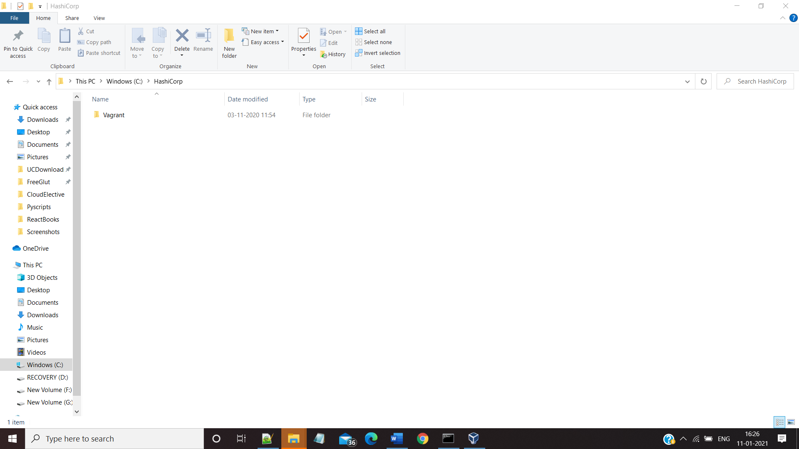

**Step2: Run the following Commands from the Command Prompt**

**1>Mkdir <Name_of_the_Directory>**

**2>cd <Name_of_the_Directory>**

**3>Vagrant init (This will Create a Vagrant File inside the Directory)**

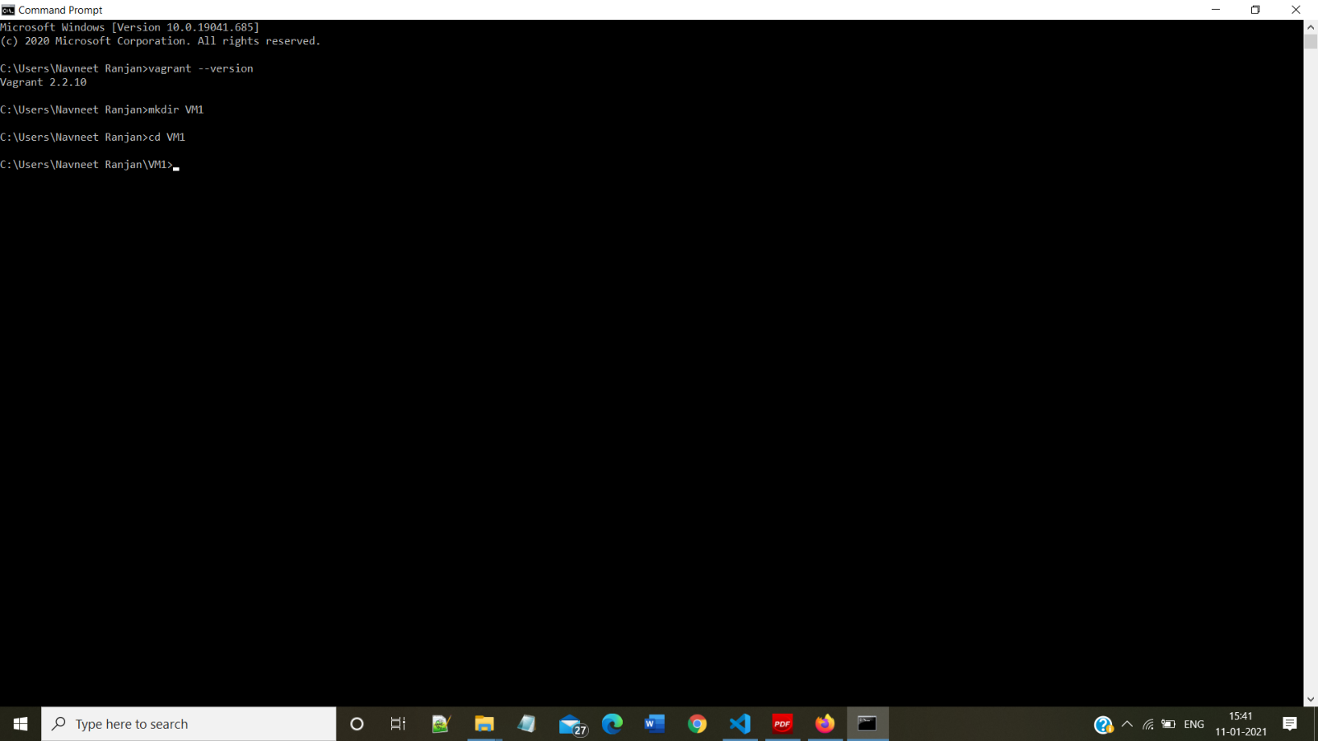

**Step 3: Edit the Vagrant File for Base Configuration**

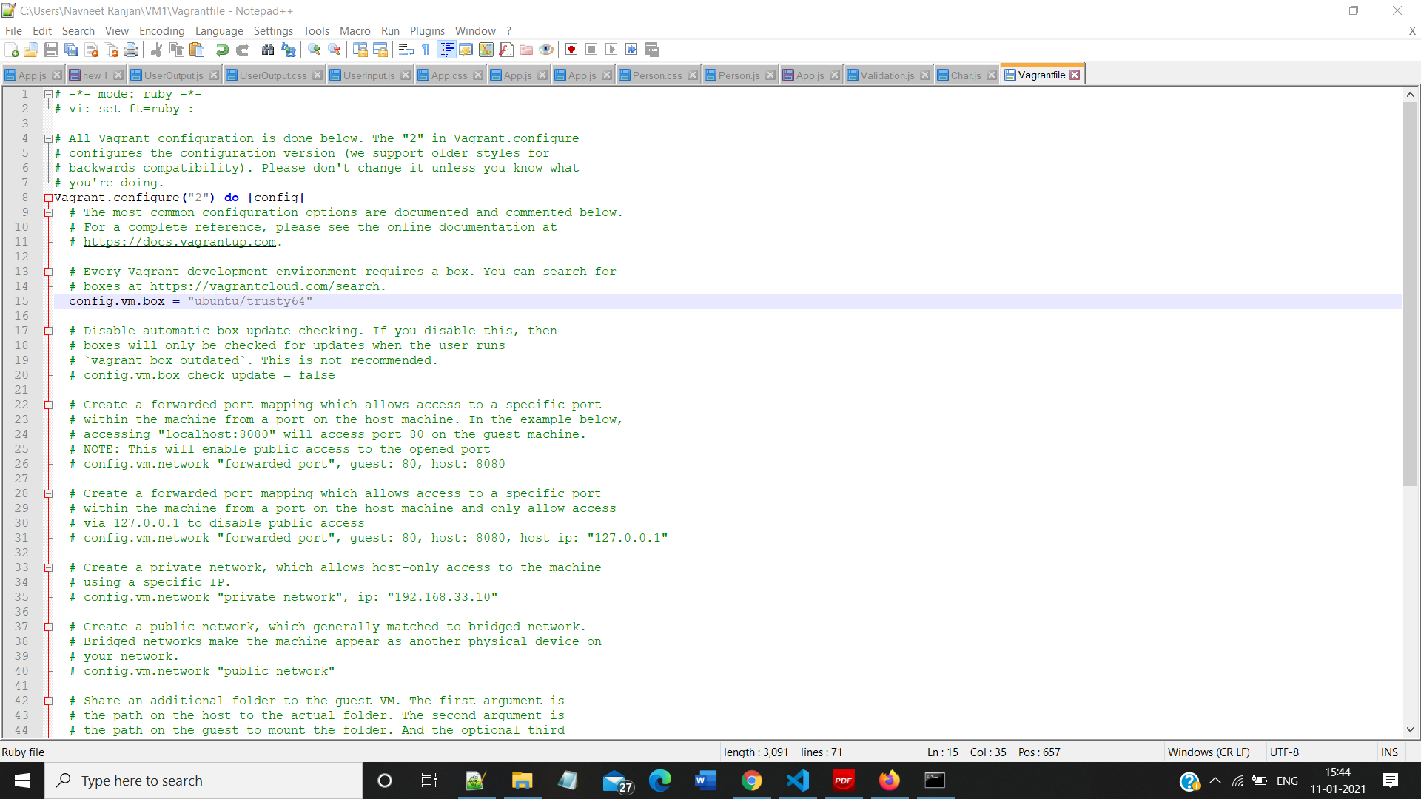

**Step 4: Run the Vagrant up Command**

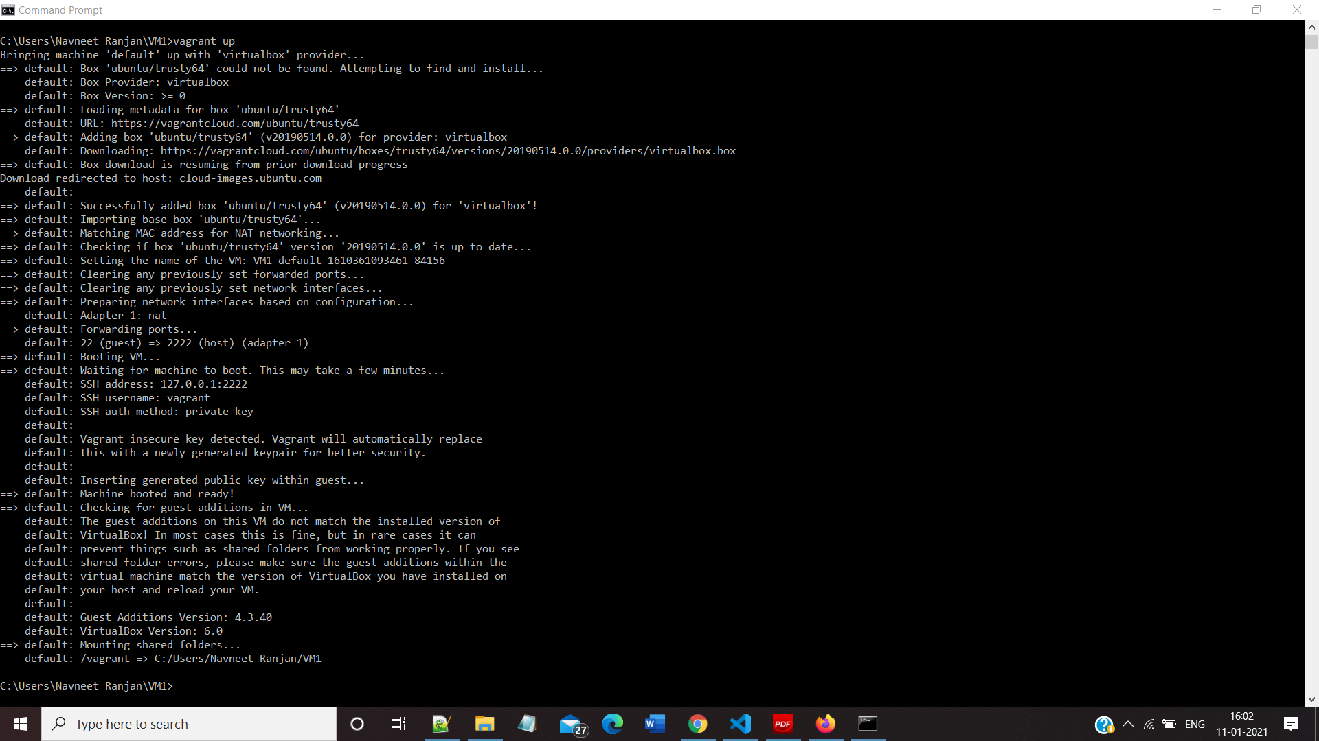

**Step 5:Run the following Commands**

**1>Vagrant ssh(To access the Virtual Machine)**

**2)Vagrant halt(To halt the Virtual Machine)**

**3) Vagrant destroy(To halt the Virtual Machine)**

**Vagrant SSh**

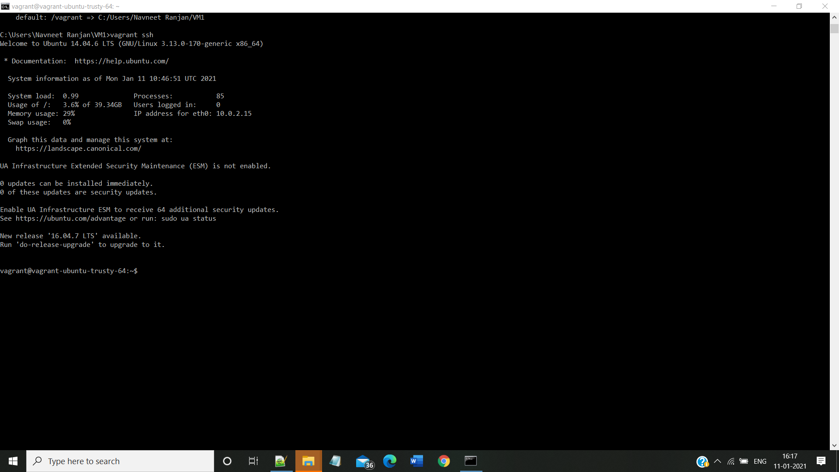

**Vagrant halt**

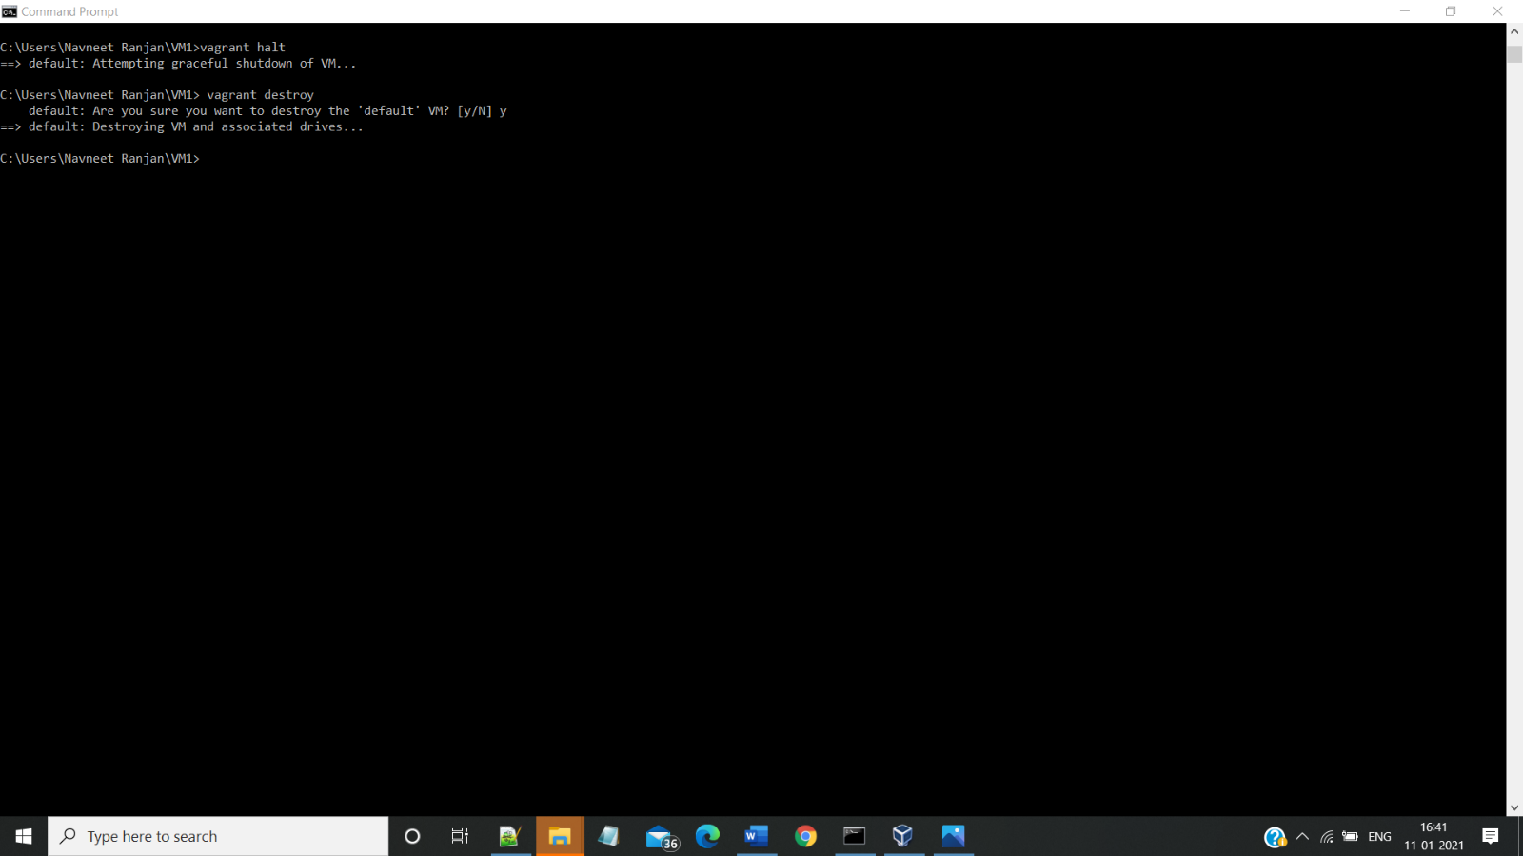

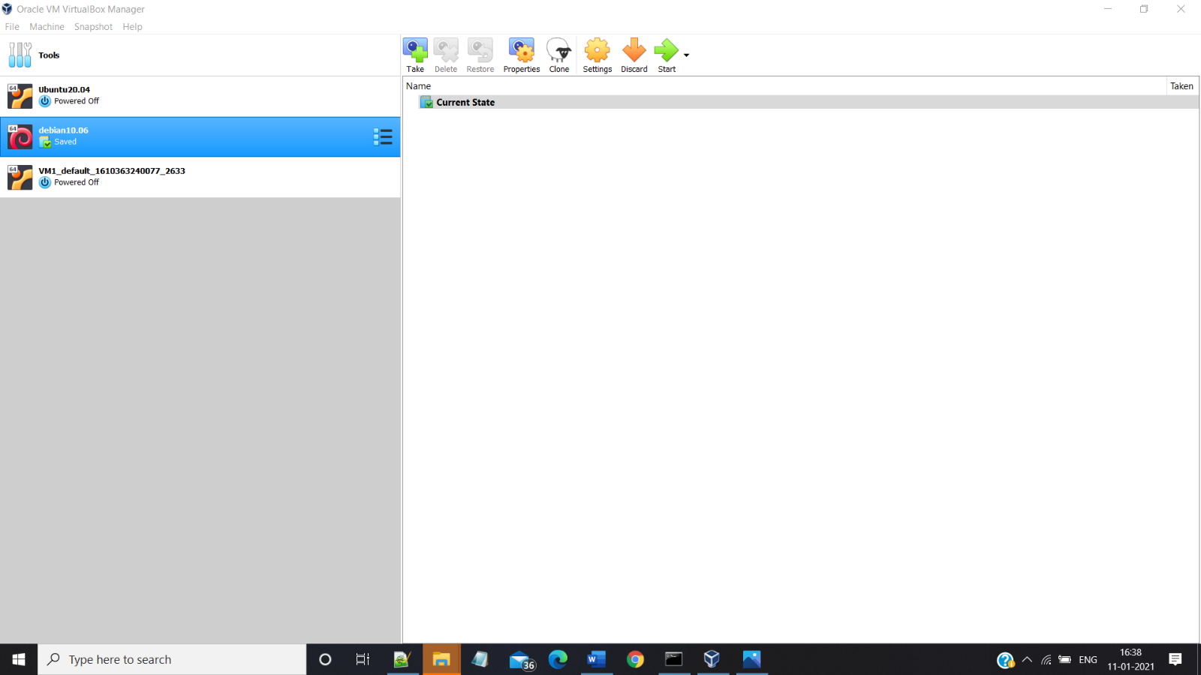

**Vagrant Destroy (Destroys the running instance of the VM)**

