**Experiment-2**

**Docker Volumes**

**1:Run the Command docker --version and docker volume ls**

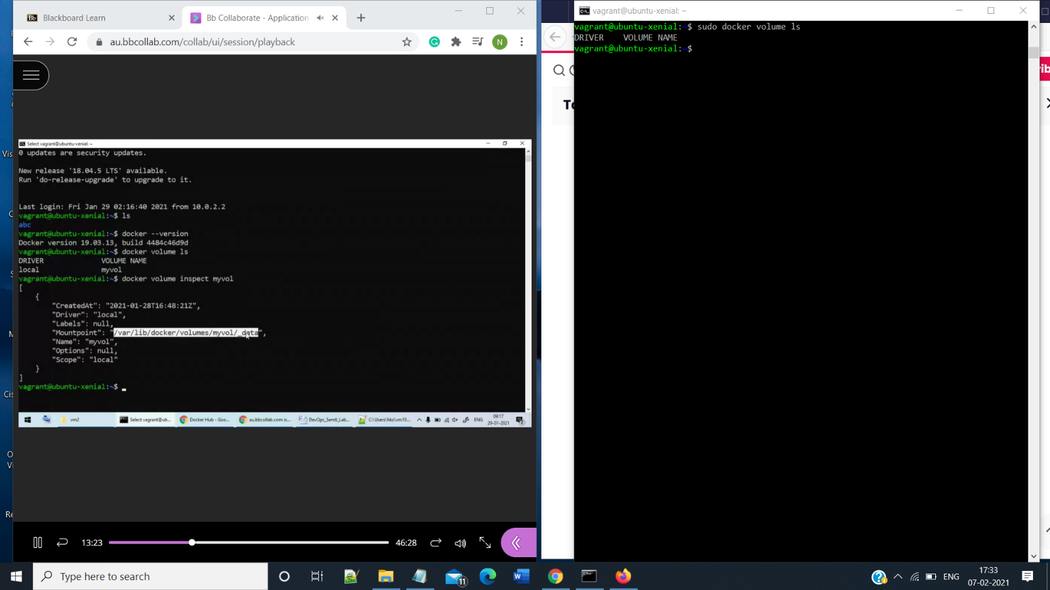

**2:Create a Volume and run command docker volume inspect <volumeName>**

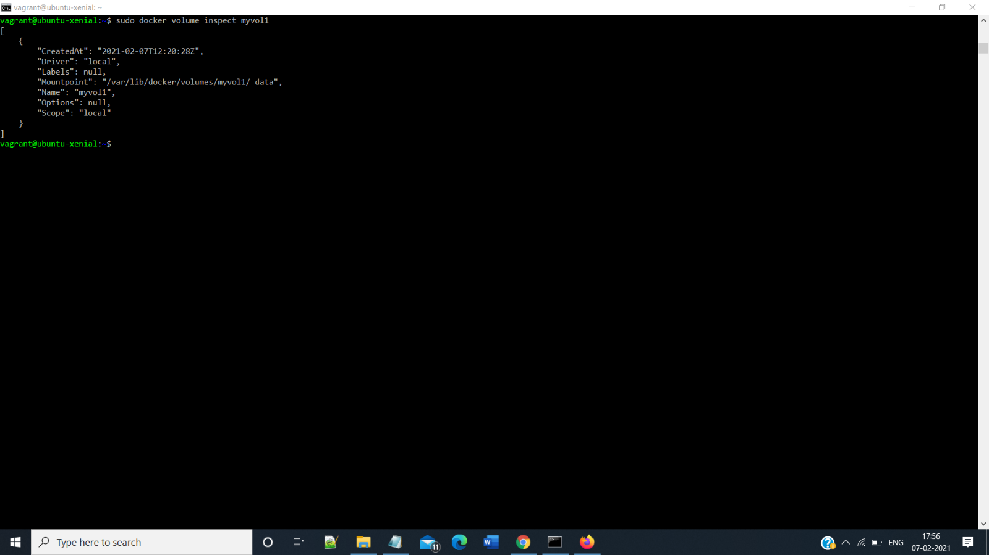

**3:Attach the Volume to the Container by using docker run -it -v and Create two text files**

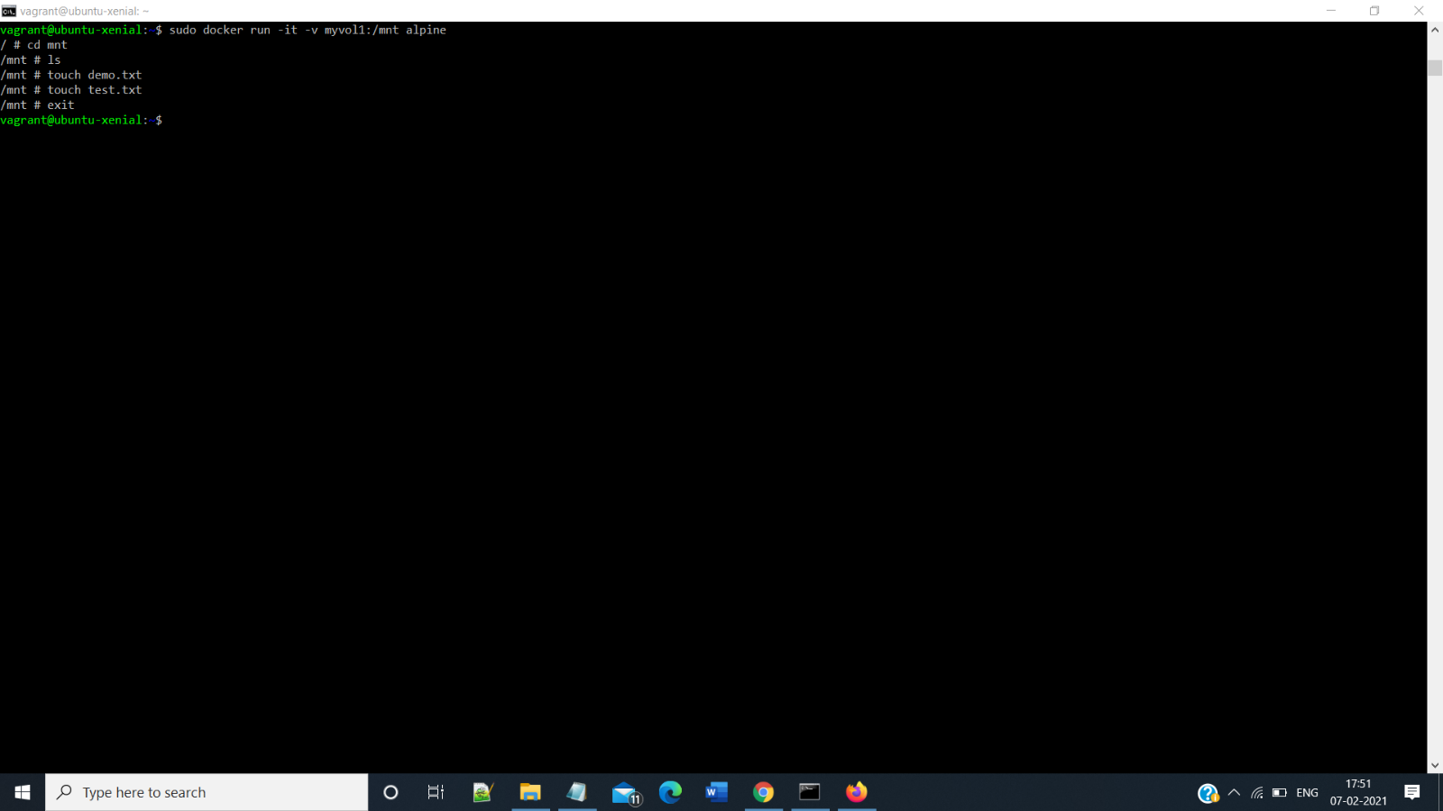

**4:Run Another Container and Attach the same Volume as Created earlier**

