**Experiment-4**

**Aim :To create a Docker Image and Push the Image to dockerHub**

**1>Create a dockerFile and Write Following Commands inside the dockerFile**

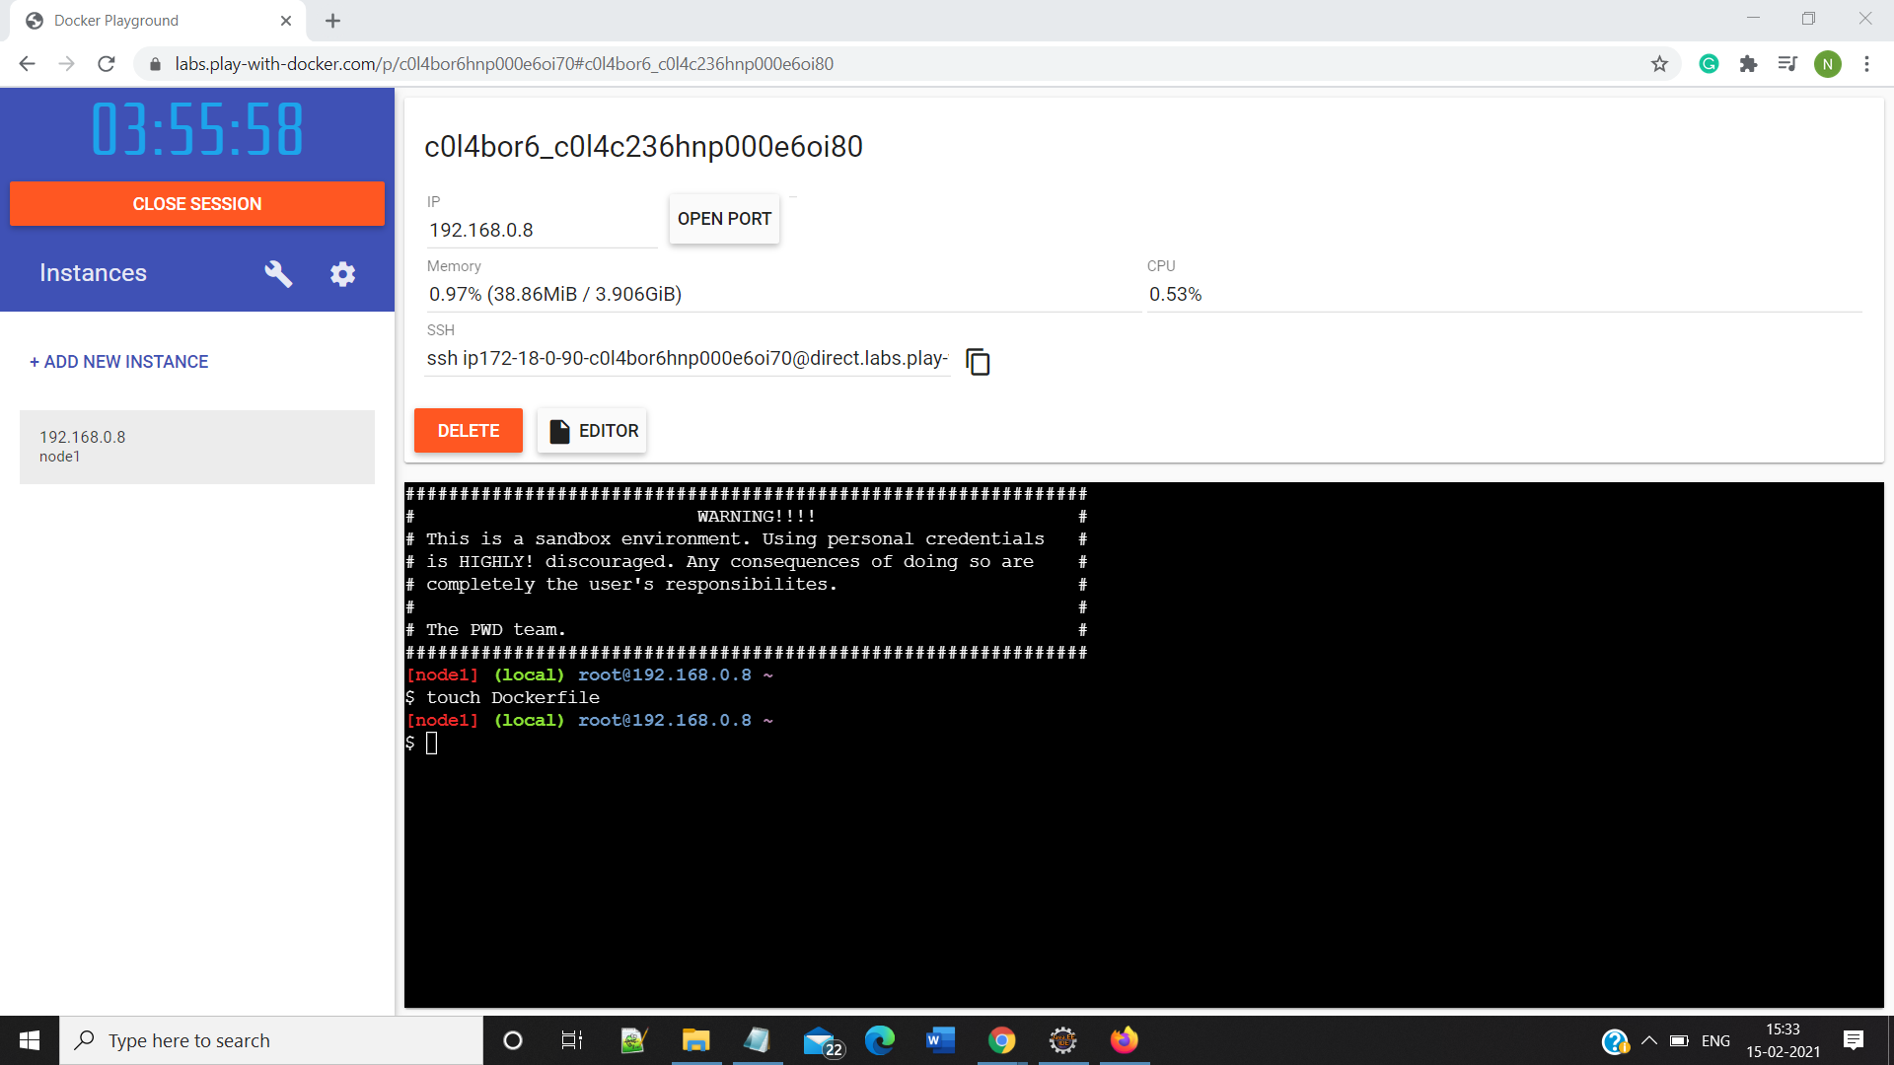

; 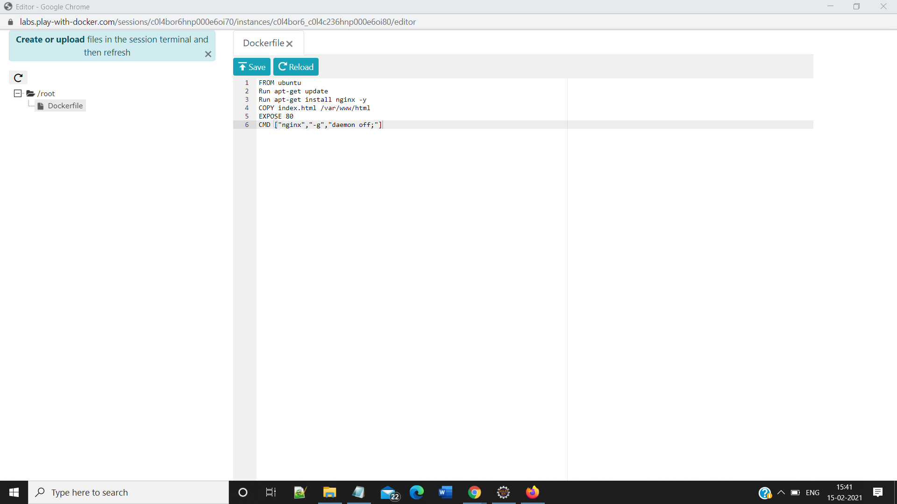

**2>Create a file index.html inside root directory(Same directory as of dockerFile)**

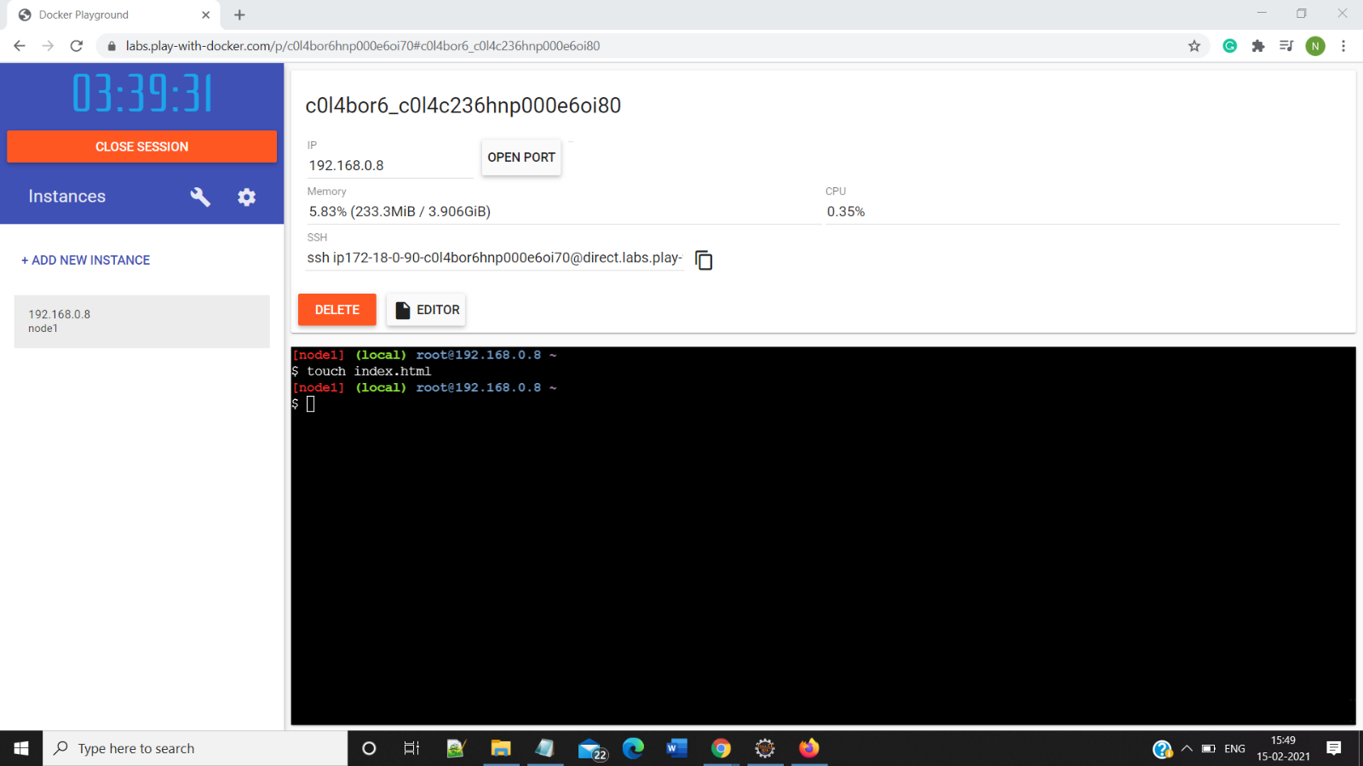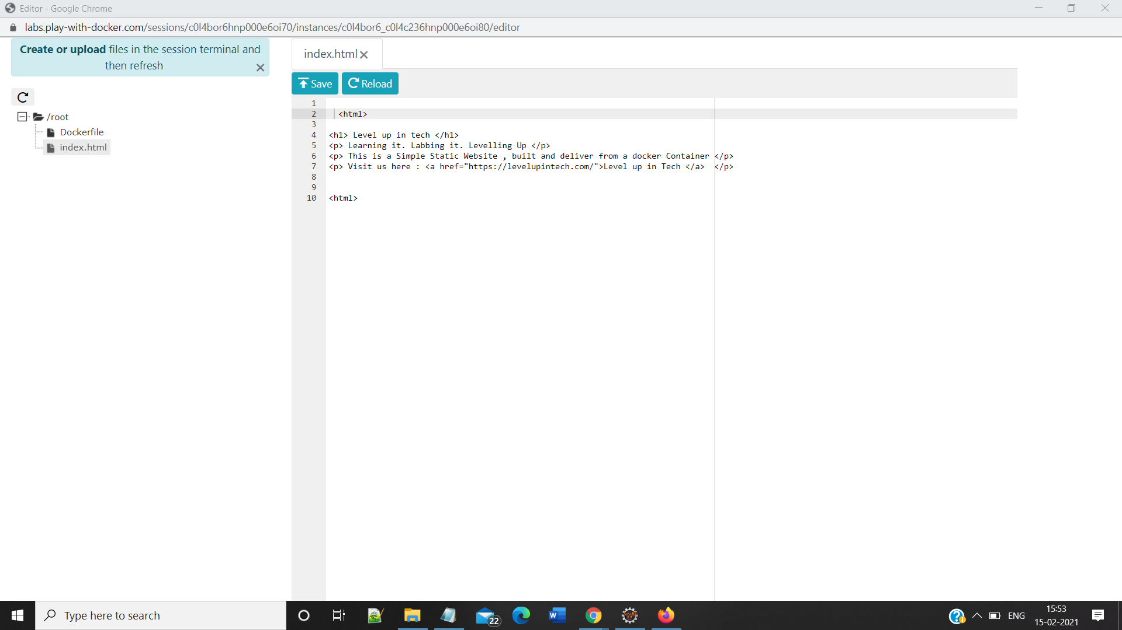

**3> Run the Command docker build**

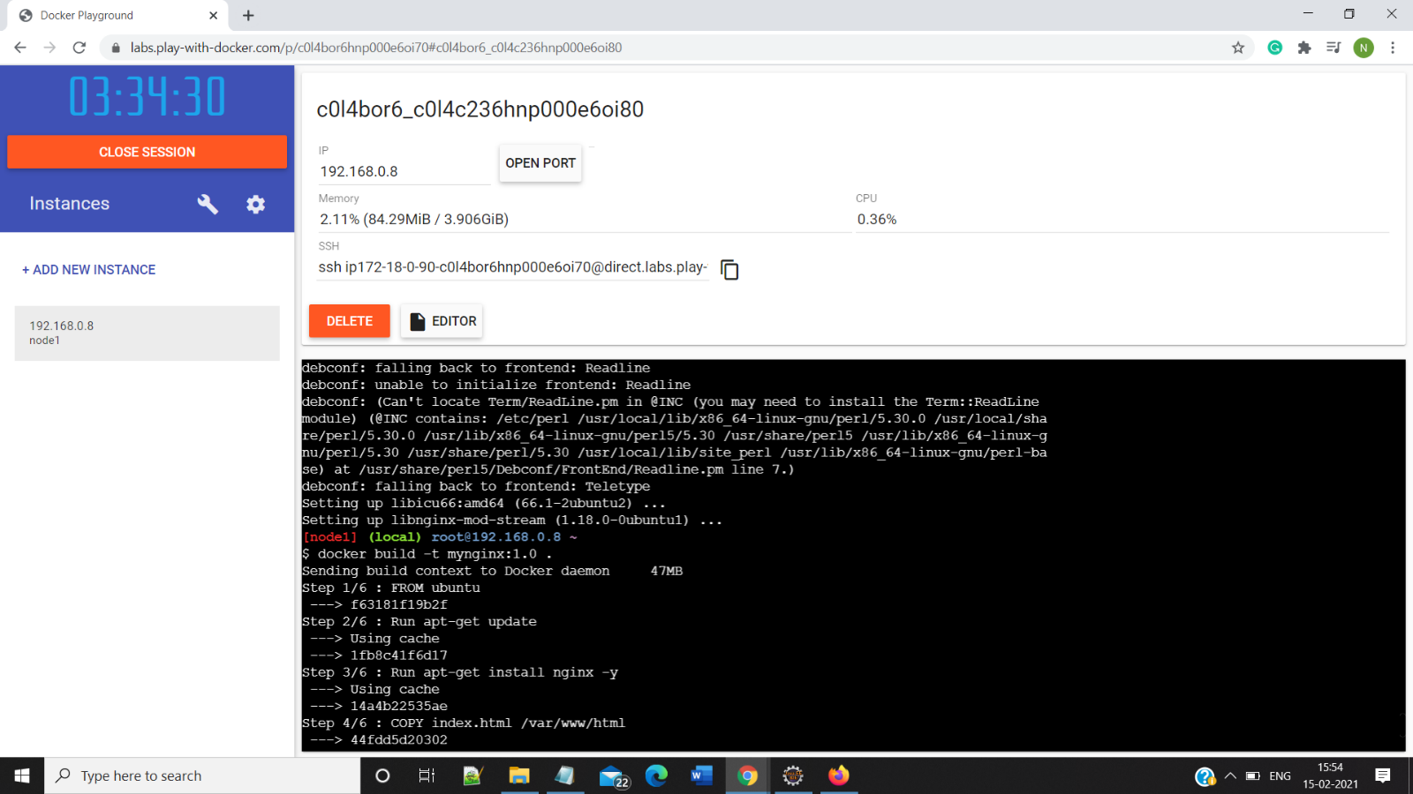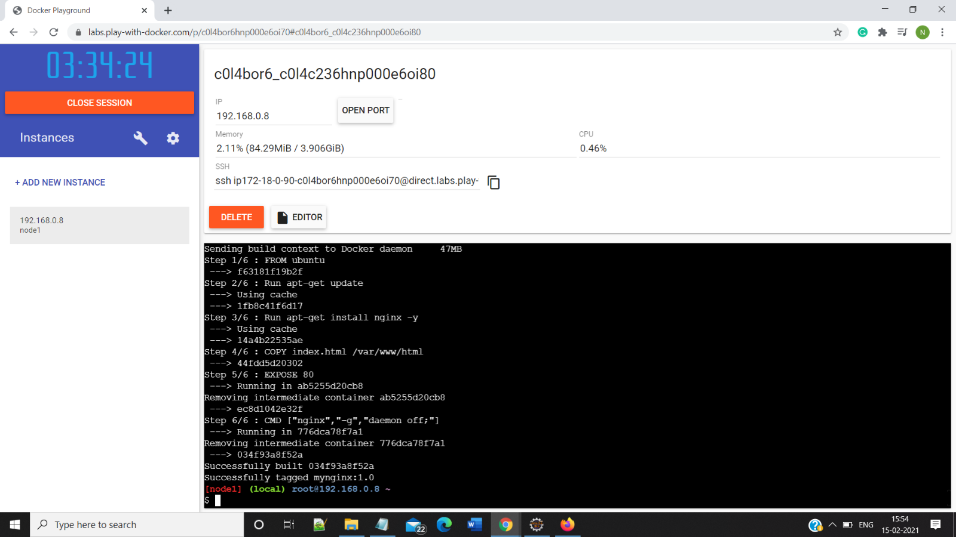

**4> Run the Command docker run -d <id of the Image>**

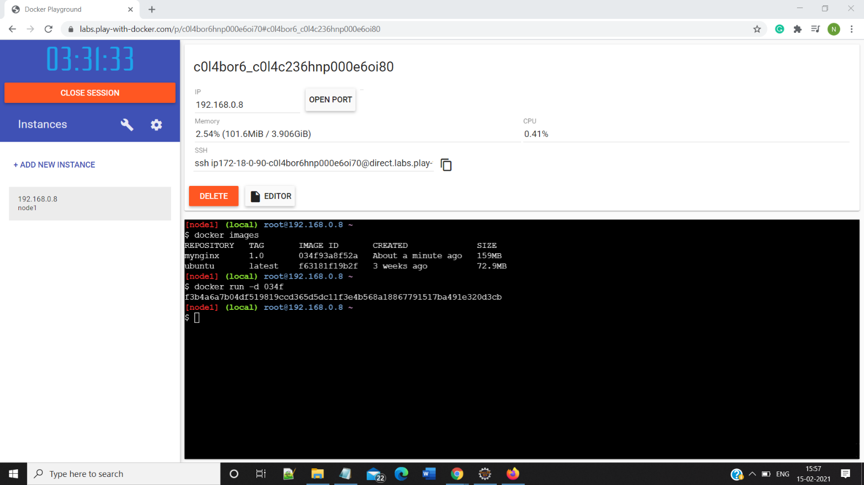

**5>Login to the dockerHub**

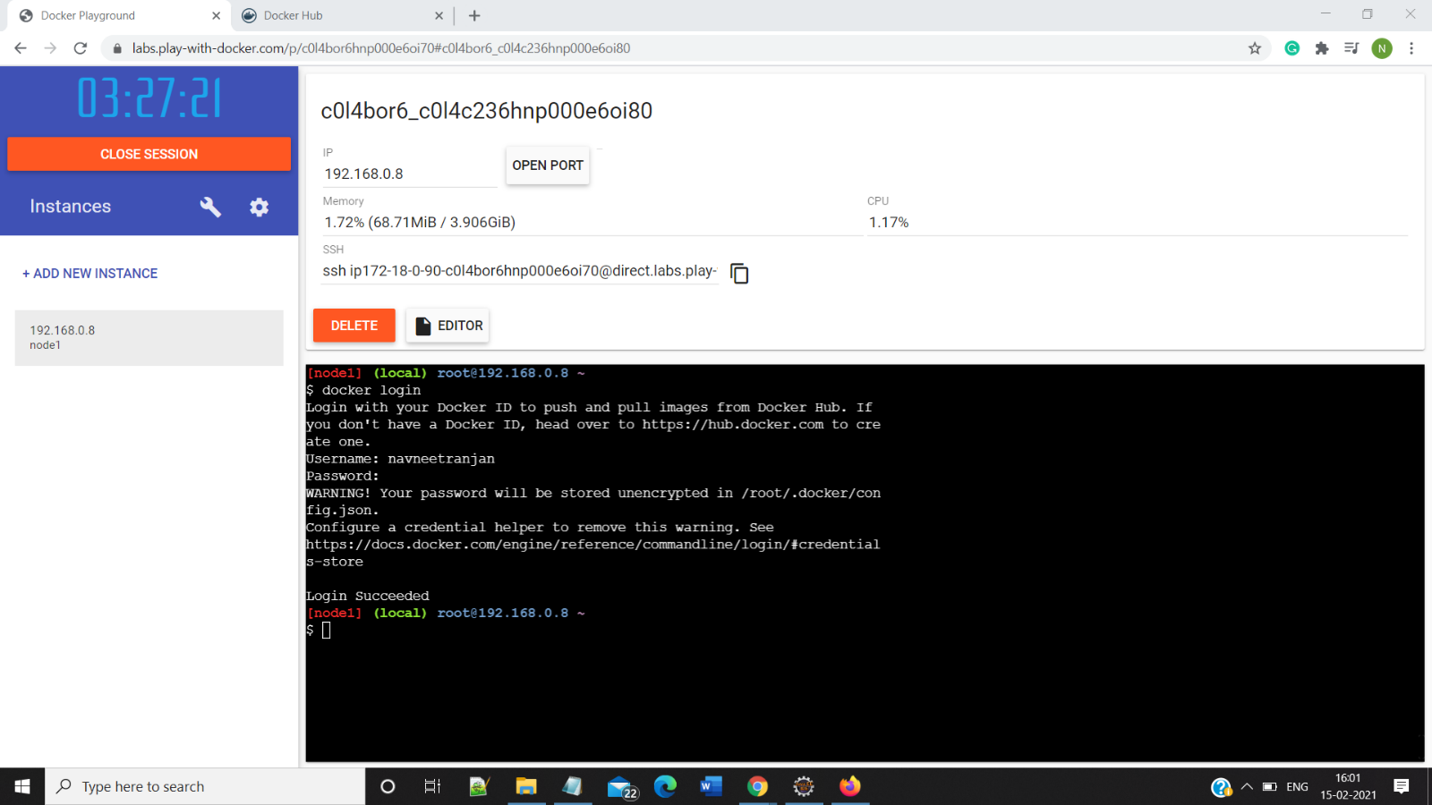

**6>Push the Image on docker Hub Using Dockerhub**

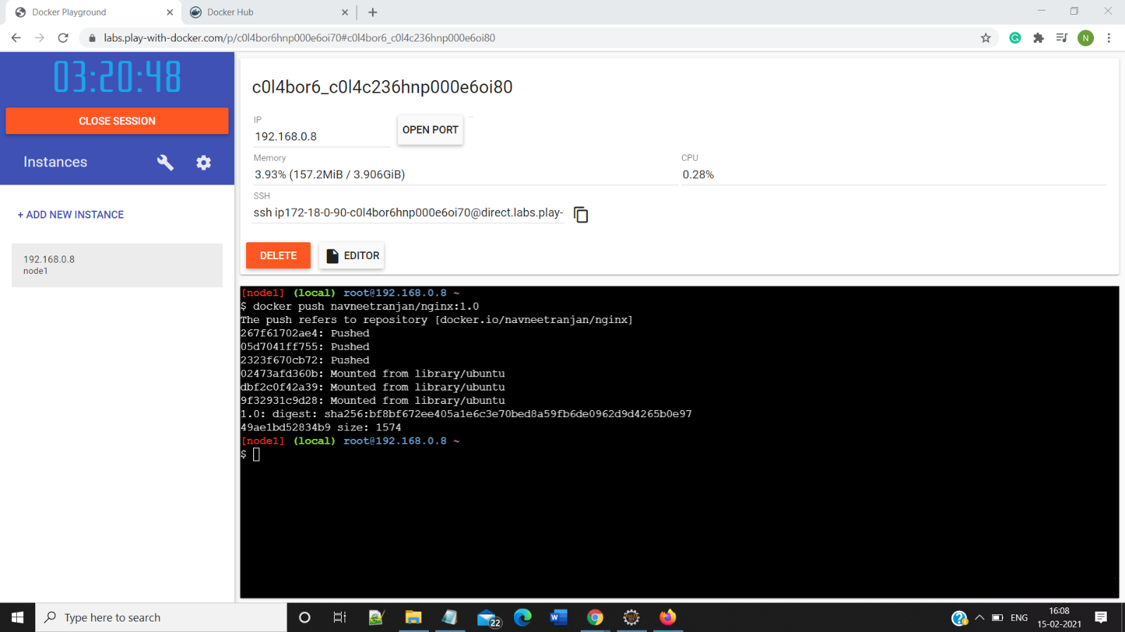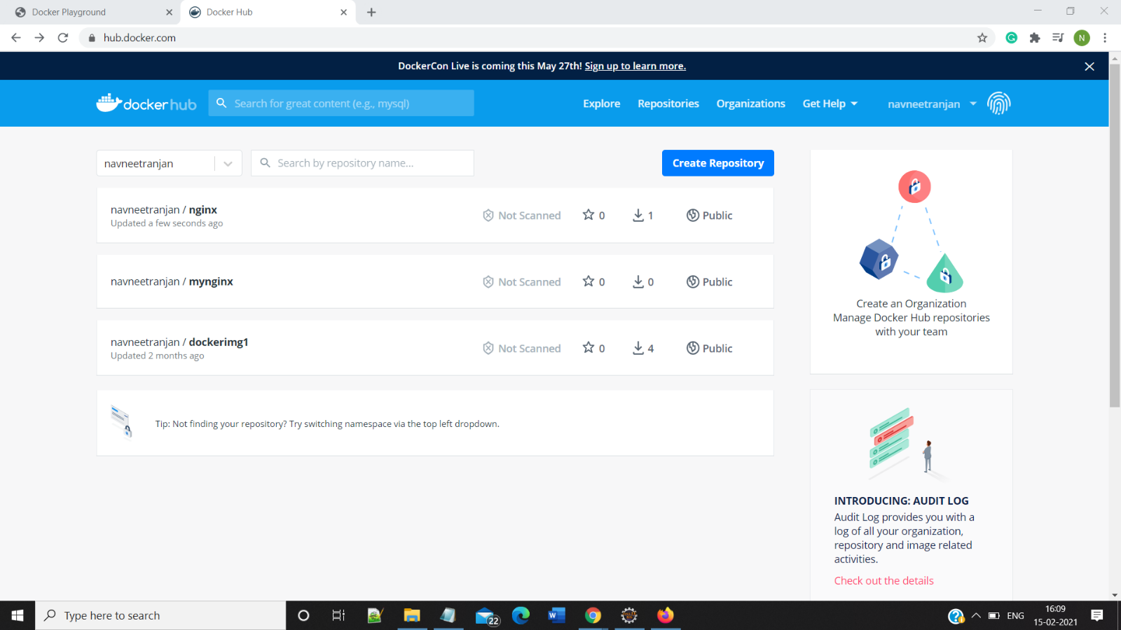

**7> Run the dockerImage**

