**Experiment-10**

**Aim:-** Working with Metadata,Log File using Docker

1> Adding single label

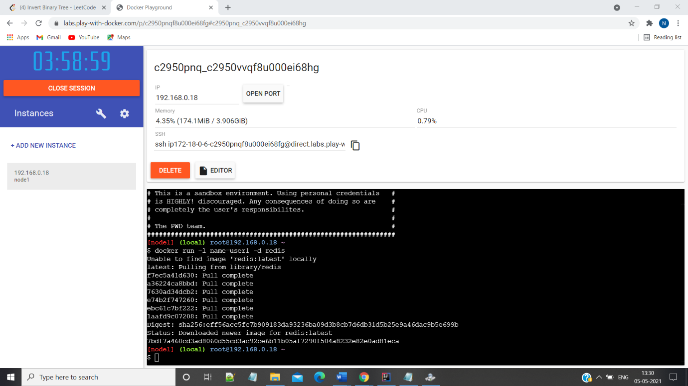

2>Inspecting

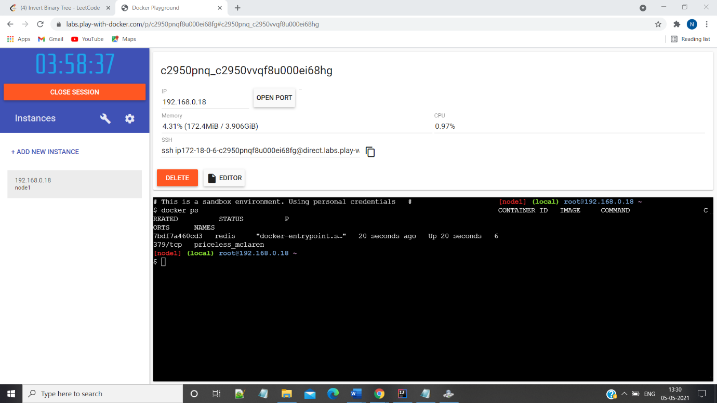

3>Adding multiple labels

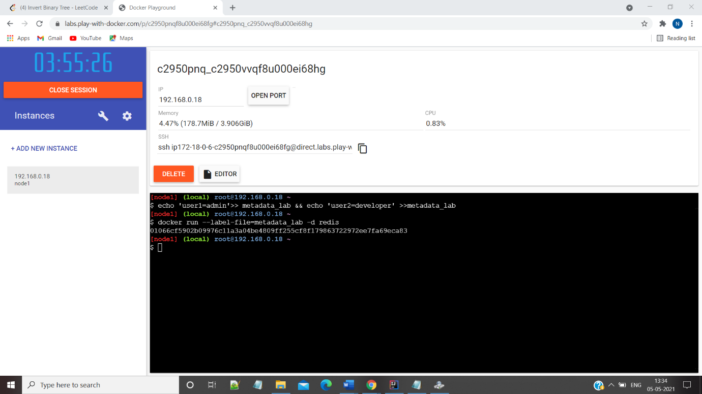

4>Filtering

