**Experiment – 5**

**Aim:** Understanding Docker Compose

1. Creating docker-compose.yml and evs.env

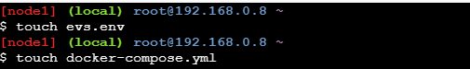

1. Writing the contents of file

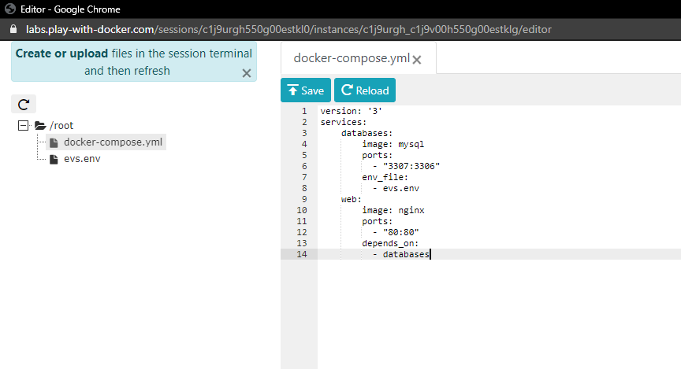

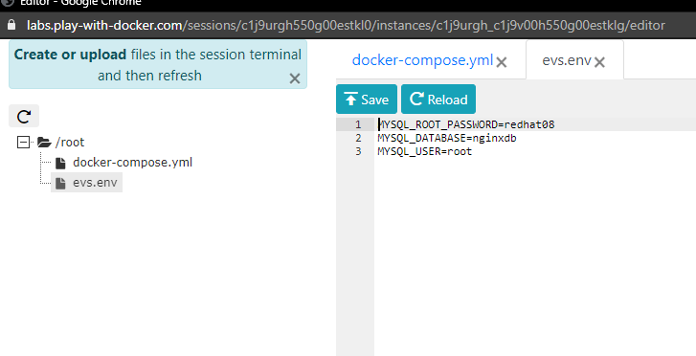

1. Running the command

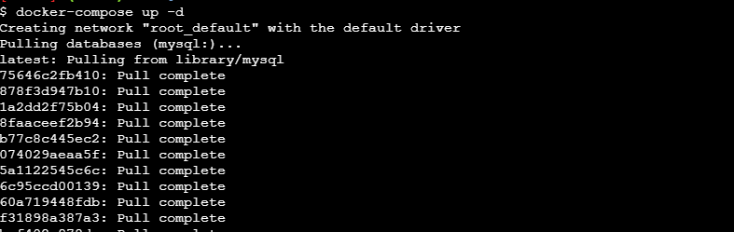

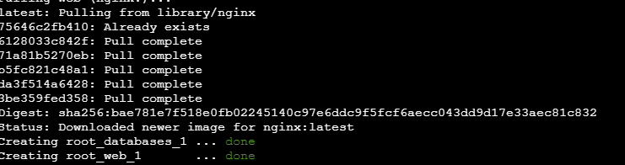

1. Running “docker ps”

