

**UNIVERSITY OF PETROLEUM & ENERGY STUDIES**

**Dehradun**

**APPLICATION**

**CONTAINERIZATION**

**Name: Navneet Ranjan**

**Course: B. TECH CSE DevOps (2018-22)**

**Roll no.: R171218066**

**Sapid: 500067951**

**Experiment-8**

**Aim:- Deploying a Service using Kubernetes**

**Step 1:**Run the minikube start command to initialize a

Cluster this will make a cluster with a single node

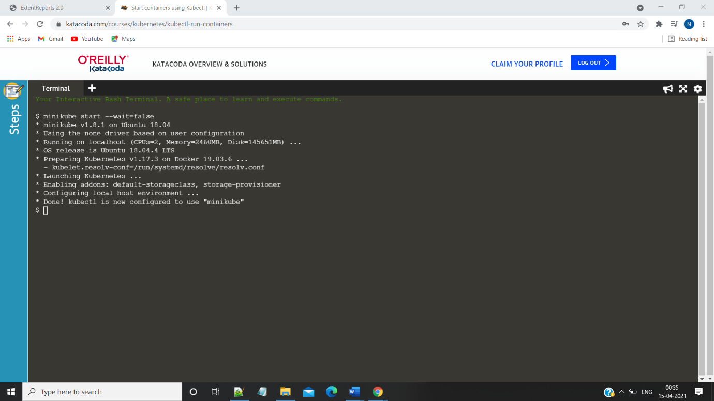

**Step2:**run the kubectl get nodes

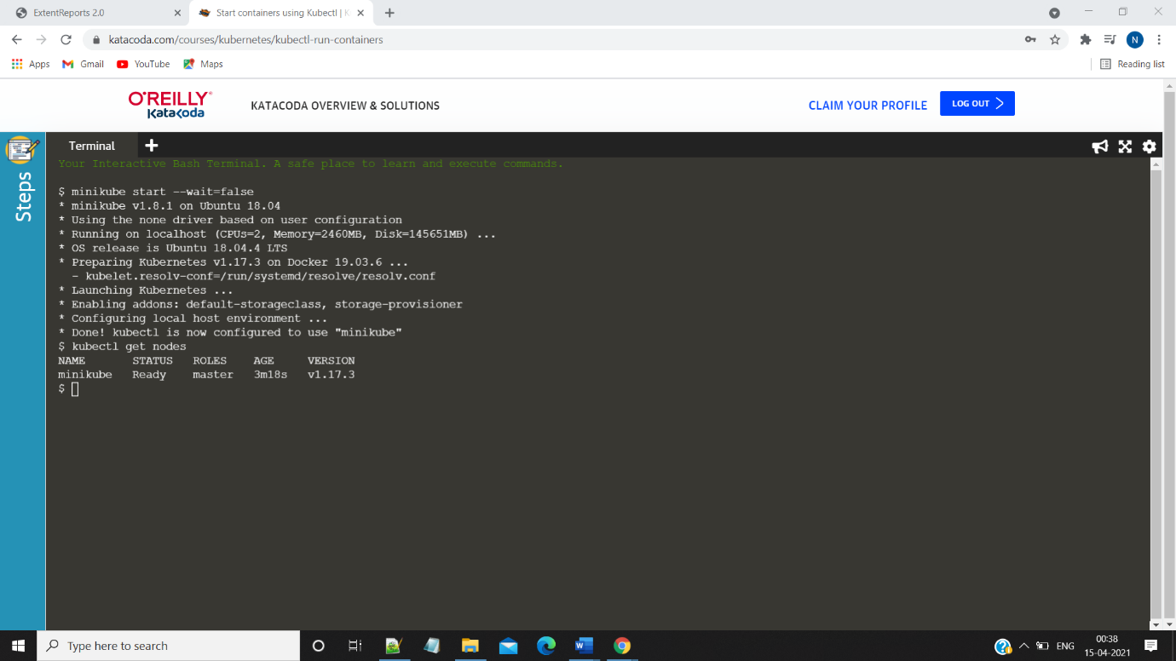

**Step 3:**Run the kubectl run command to deploy a service

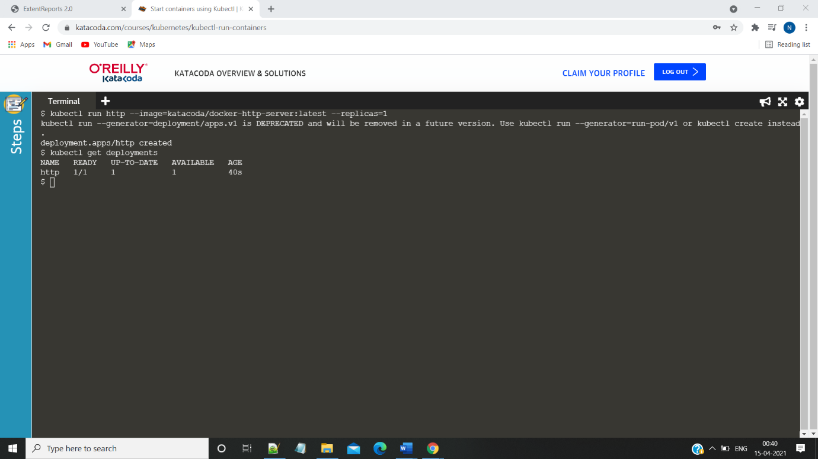

**Step4:**run the kubectl describe deployment command

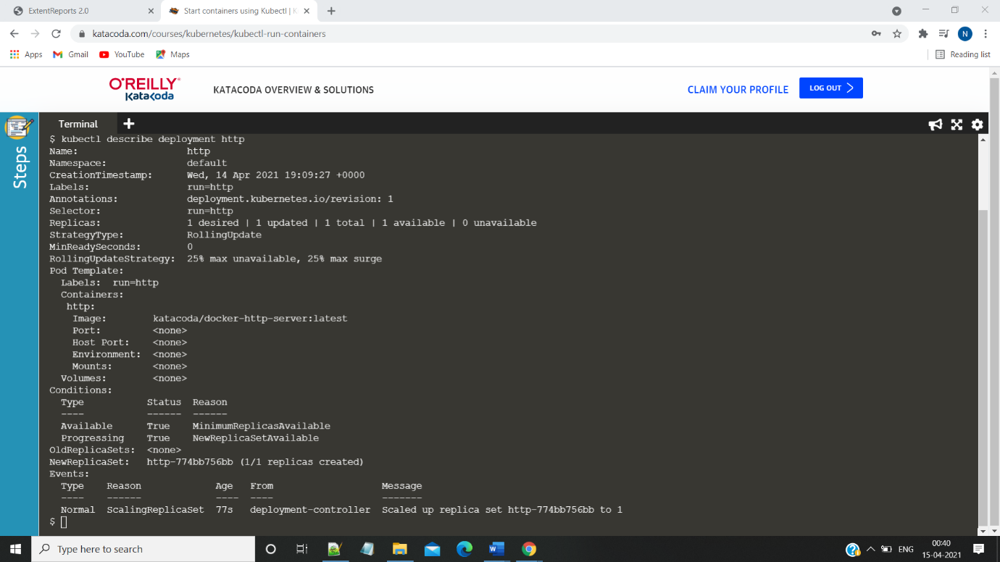

**Step5:** run the expose deployment command to expose the port and run the curl command subsequently

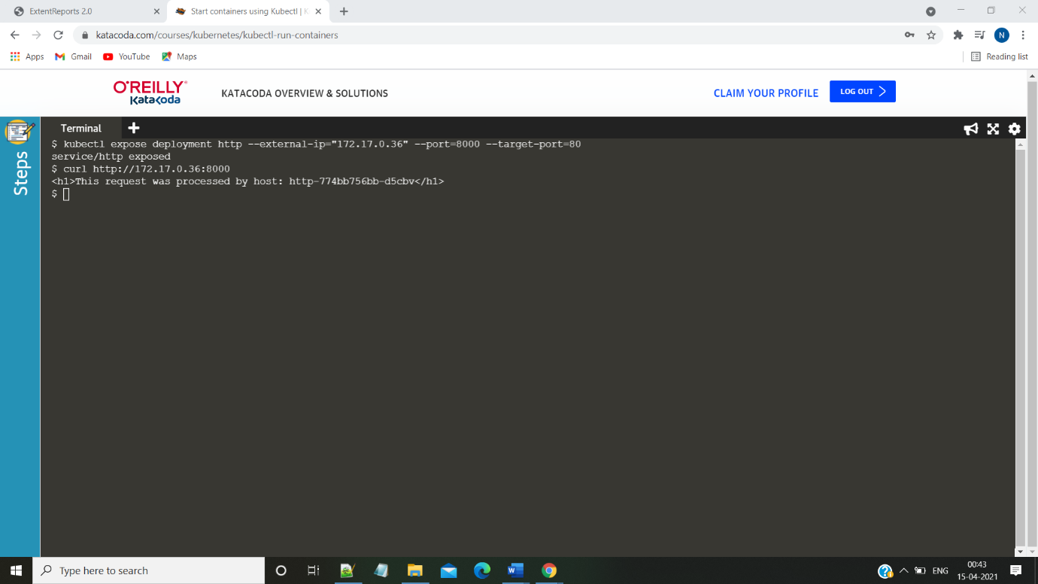

**Step 6: Run the kubectl get svc command**

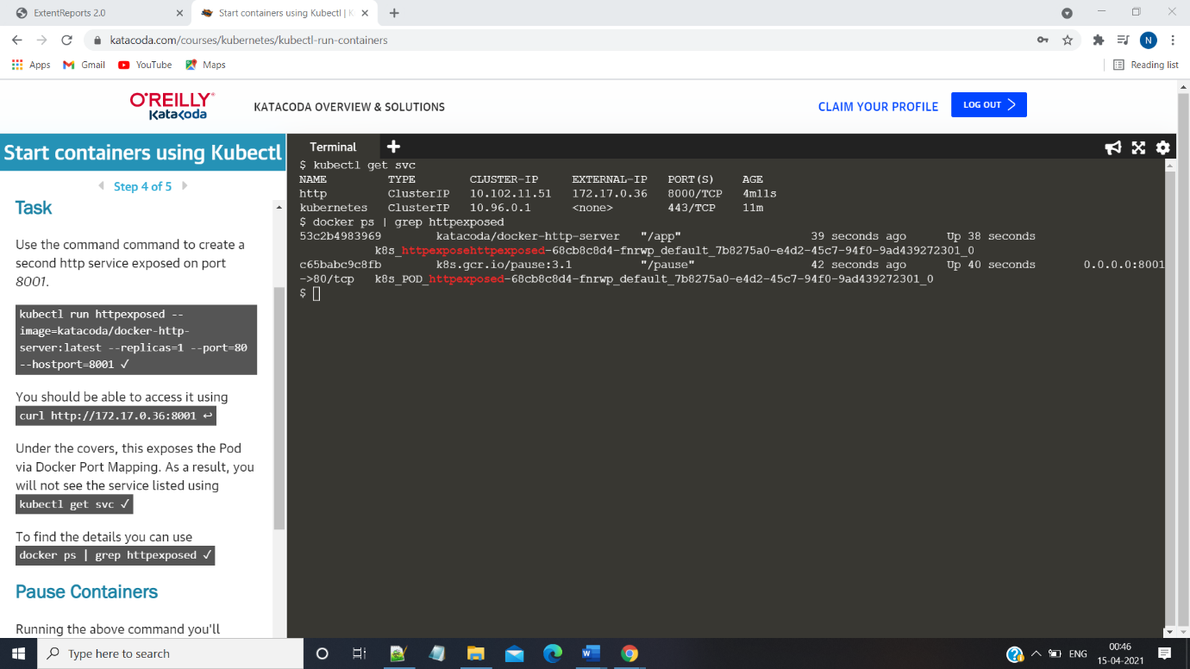

**Step 7:** run the kubectl scale –replicas command to scale the replicas of the deployment

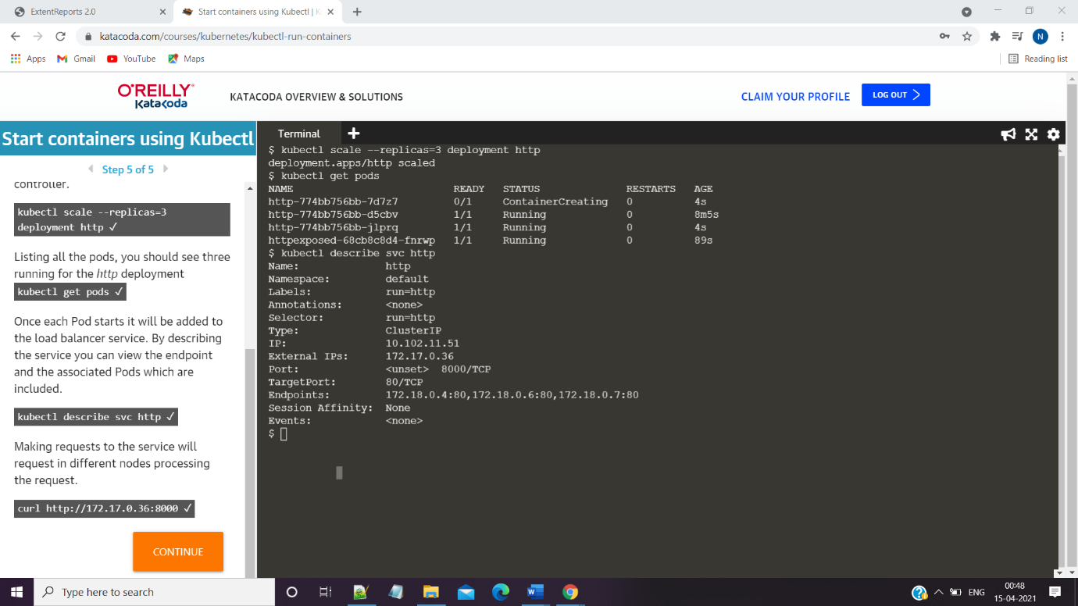

**Part-II**

**Aim:Kubernetes UI**

**Step1:**Run the minikube start version

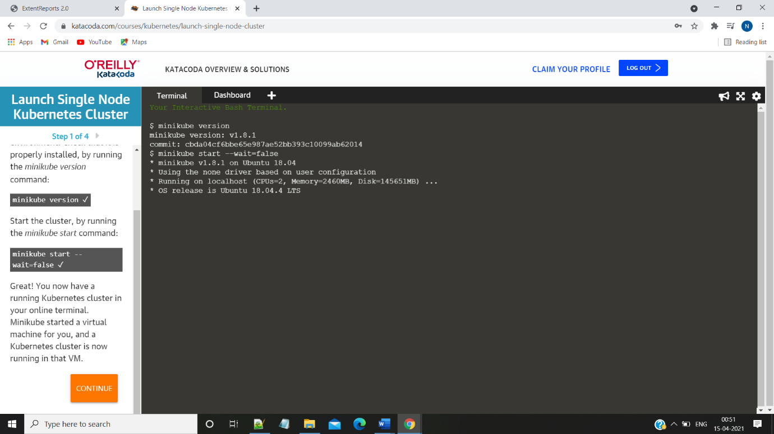

**Step2:** Run the minikube addons enable dashboard command &

Kubectl get pods command

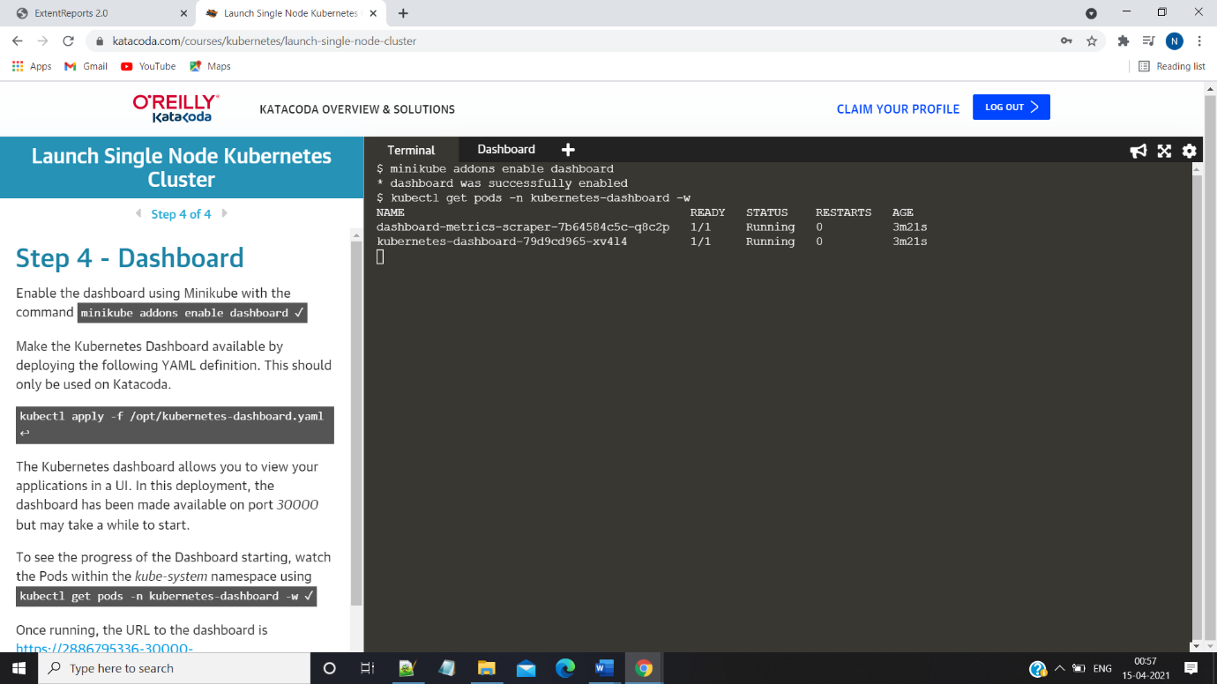

**Step3:See the deployments inside the UI**

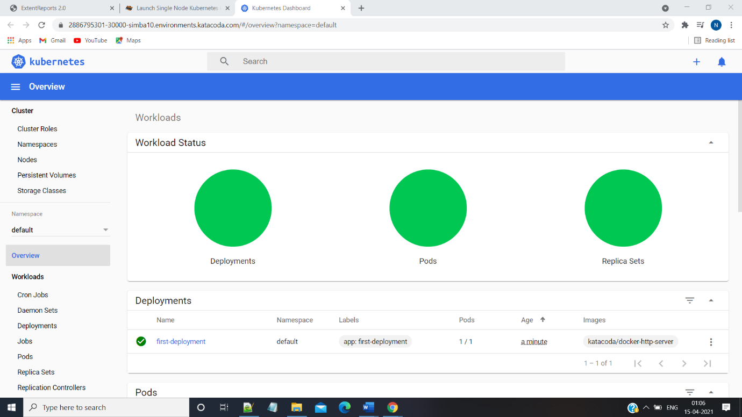

**Step4:Deploy another service and Check for changes inside the ui**

