**Experiment 9**

**Aim:** Build Docker Image using .Dockerignore file.

1) Checking the contents of dockerfile

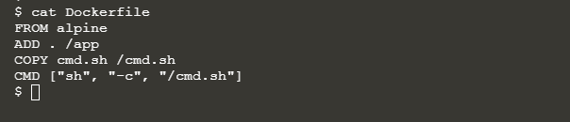

2) Building image

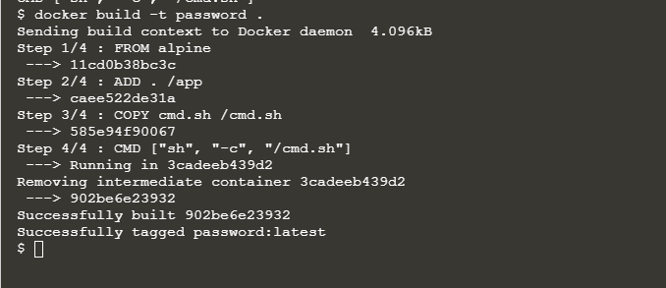

3) Checking the app folder

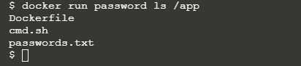

4) Ignoring the password file and checking the app folder

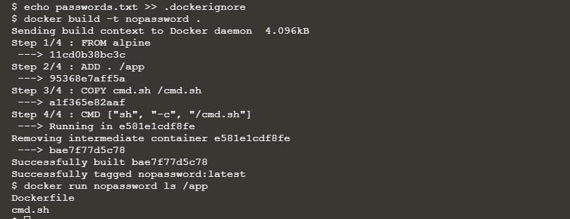

5) Adding a large file

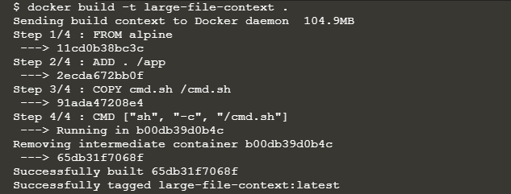

6) Ignoring the big file and building image

