Application Containerization

Name: Piyush Vishnoi,

Roll No: R171218071

**Experiment - 11**

**Docker Restart Policy to ensure uptime**

Here it is a special container which outputs a message and then exits with code 1 to simulate a crash. Launching an instance using the following command

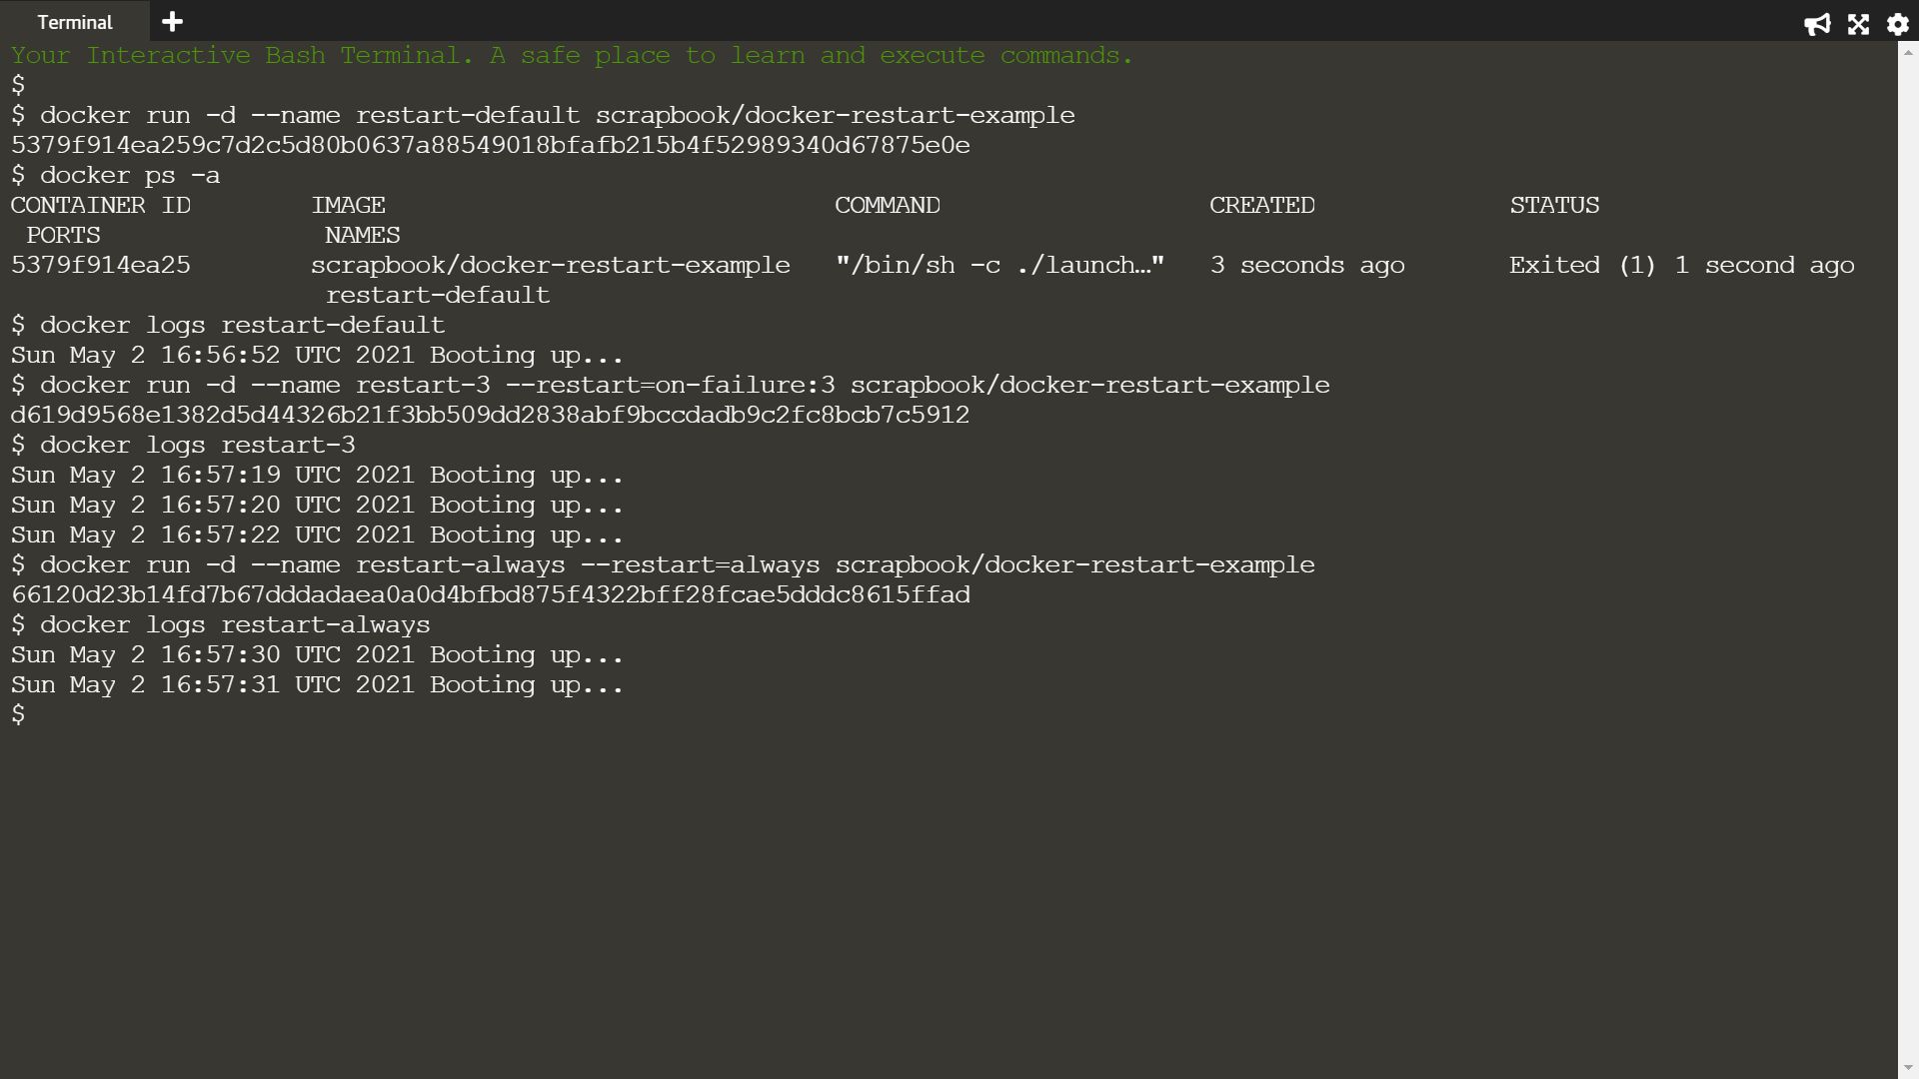

List all the containers, including stopped, to see the container has crashed



The logs will output a message, which indicates information to diagnose the issue.



In the example below, Docker will restart the container three times before stopping.



Using the always flag to automatically restart the container when it crashes

