Application Containerization

Name: Piyush Vishnoi,

Roll No: R171218071

**Experiment - 12**

**Installing Minikube**

Installing minikube by using chocolatey package manager

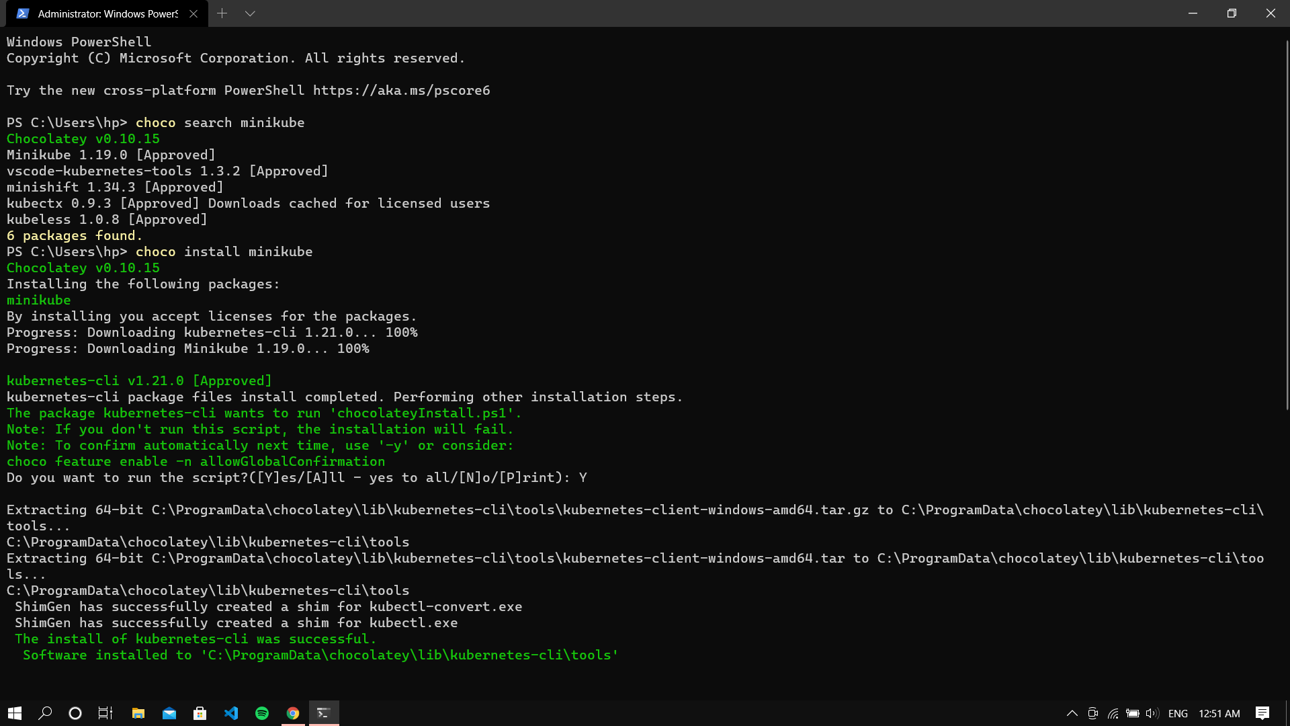

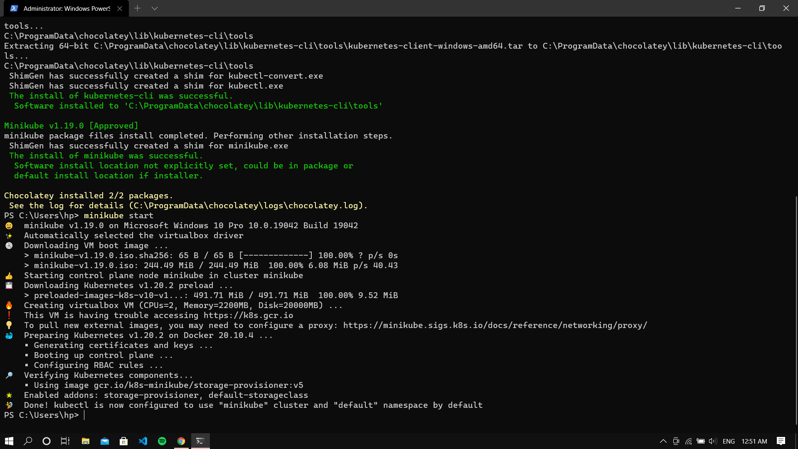

Starting minikube

