Application Containerization

Name: Piyush Vishnoi

Roll No: R171218071

Experiment - 9

Docker Metadata & Labels

This command assigns a label called user with an ID to the container. This would allow us to query for all the containers running related to that particular user

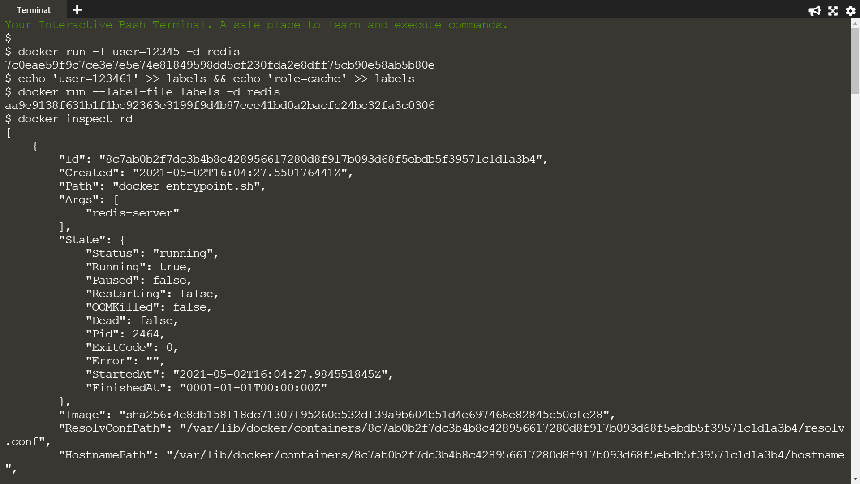

1st command creates two labels in the file, one for the user and the second assigning a role and in 2nd command, the --label-file=<filename> option will create a label for each line in the file



Providing the running container's friendly name or hash id and querying all of it's metadata



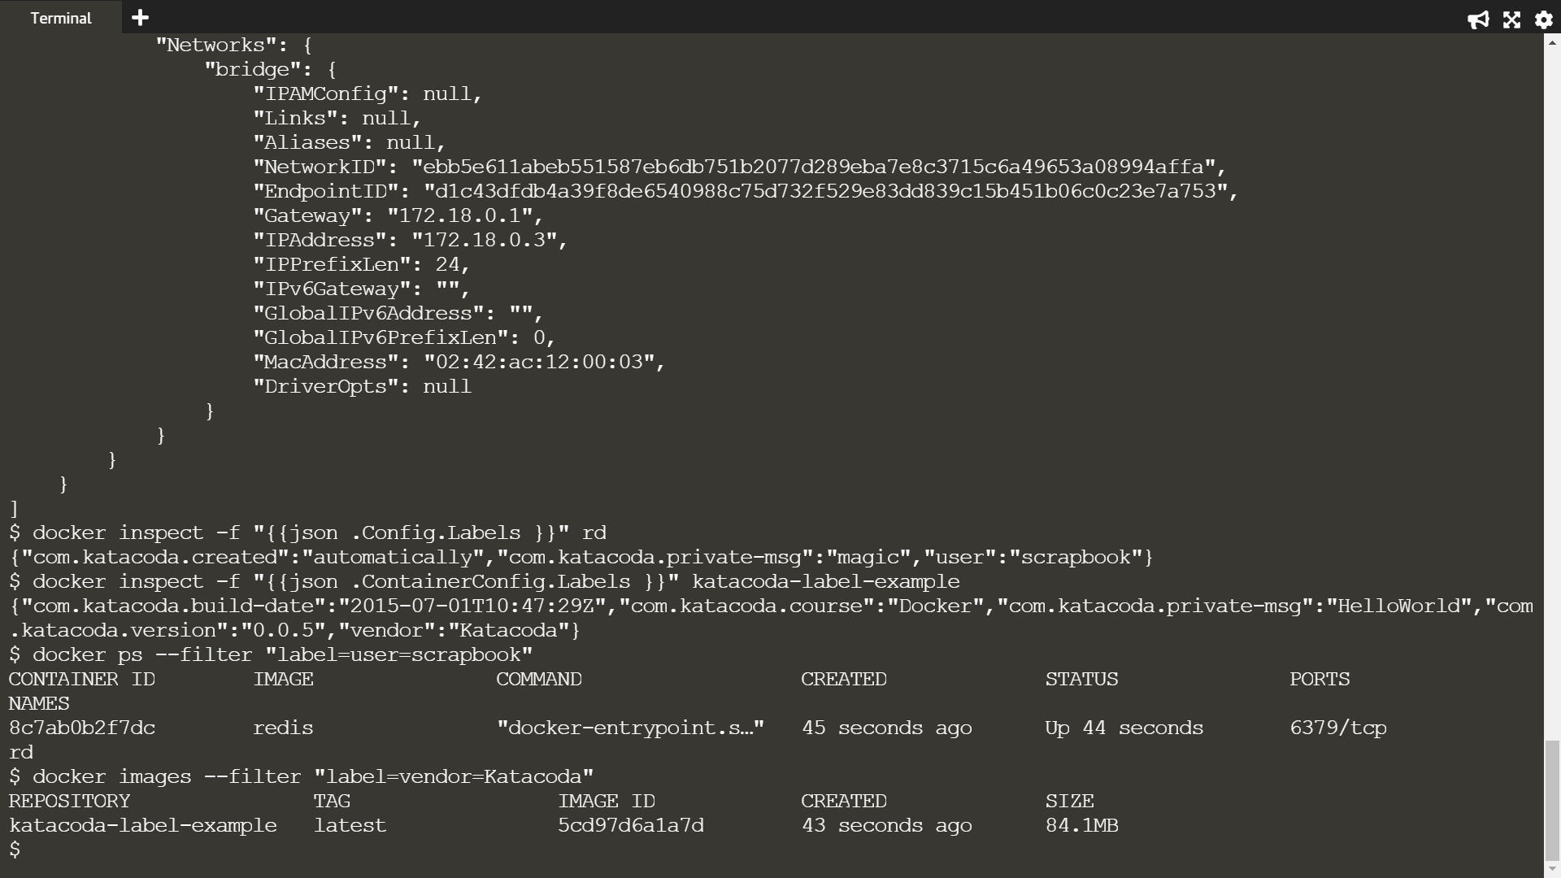

Using the -f option filtering the JSON response to just the labels section we're interested in



Inspecting images works in the same way however the JSON format is slightly different, naming it ContainerConfig instead of Config



The query below will return all the containers which have a user label key with the value katacoda.



The same filter approach can be applied to images based on the labels used when the image was built.

