

# Lab Experiment – 4

**To create Docker image using Dockerfile and pushing to Docker Hub**

# To create Docker image using Dockerfile and pushing to Docker Hub

* Creating a directory using mkdir command, here “mkdir dockerfile” and changing to it using cd command. Since our goal is to create an image containing webserver, we have to copy a html file with some contents, here “index.html”.

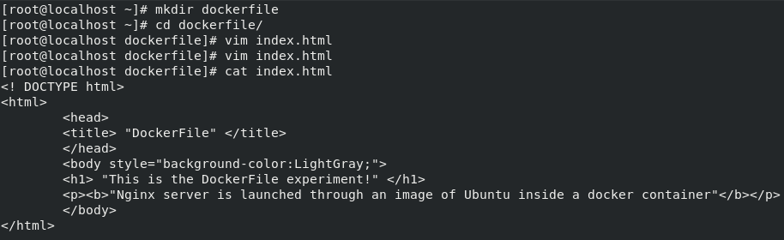

* Logging in to the DockerHub account using the command “docker login”.

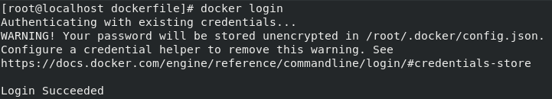

* Creating a docker file and the image which we are creating is on top of ubuntu OS, so we use “FROM” keyword to fetch Ubuntu image. After that, we update the yum repository of the container using “RUN” keyword. Setting an environment variable using “ENV” keyword, setting DEBIAN_FRONTEND as noninteractive. Installing nginx webserver using “RUN” keyword and assigning “daemon off;” in the nginx config file using “RUN” keyword. Copying the index.html file using “COPY” keyword and exposing the 80-port using “EXPOSE” keyword. And after all that for starting services we use the “CMD” keyword.

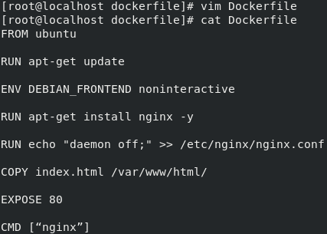

* Creating the image from Dockerfile using the command docker build.

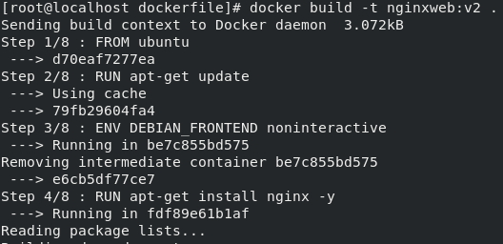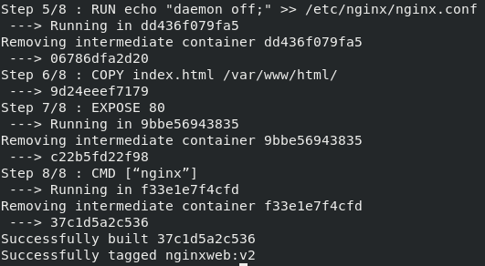

* After it is built successfully, we can see the image using docker images.

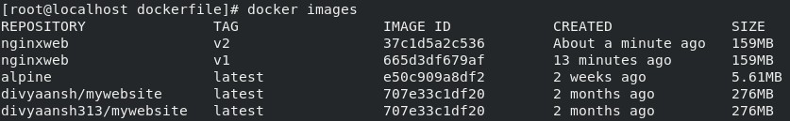

* Running a container using this image with -p option to attach a port to the container for accessing the webserver.

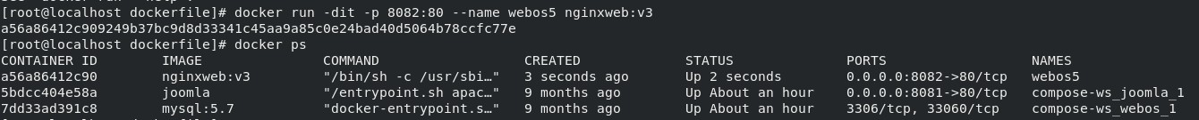

* Checking if the webserver is working fine from the browser.

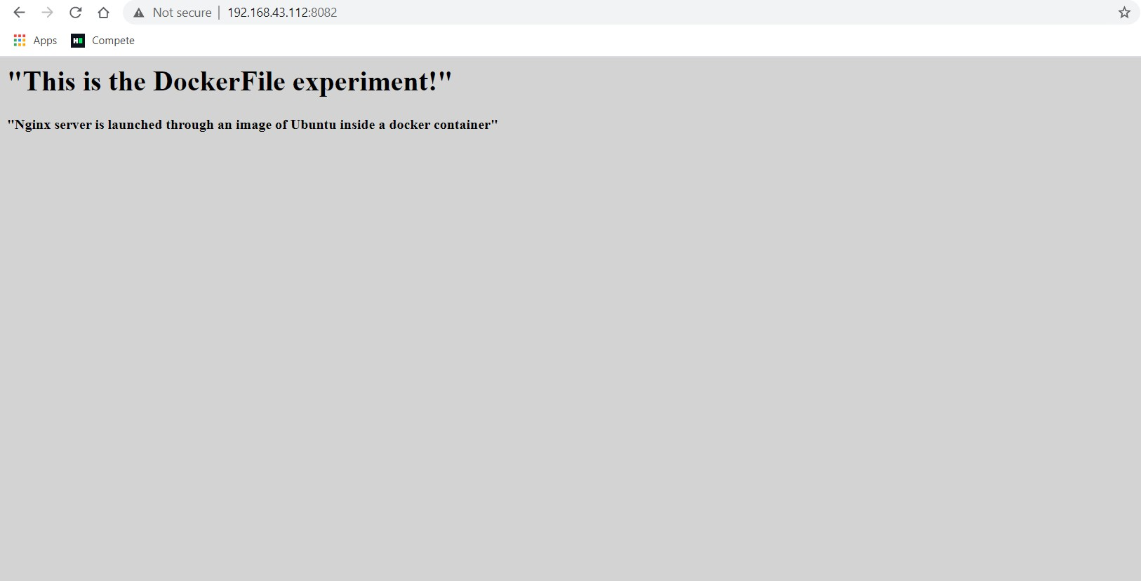

* Tagging the file appropriately using the command “docker tag” and pushing it to the Dockerhub repository using the command “docker push”.
* Checking the image in the DockerHub.

