Experiment no – 07

STEP 1: Initialize the swarm using the command ‘docker swarm init’. Now run the command shown in the output in the other terminal to appoint it as a worker.

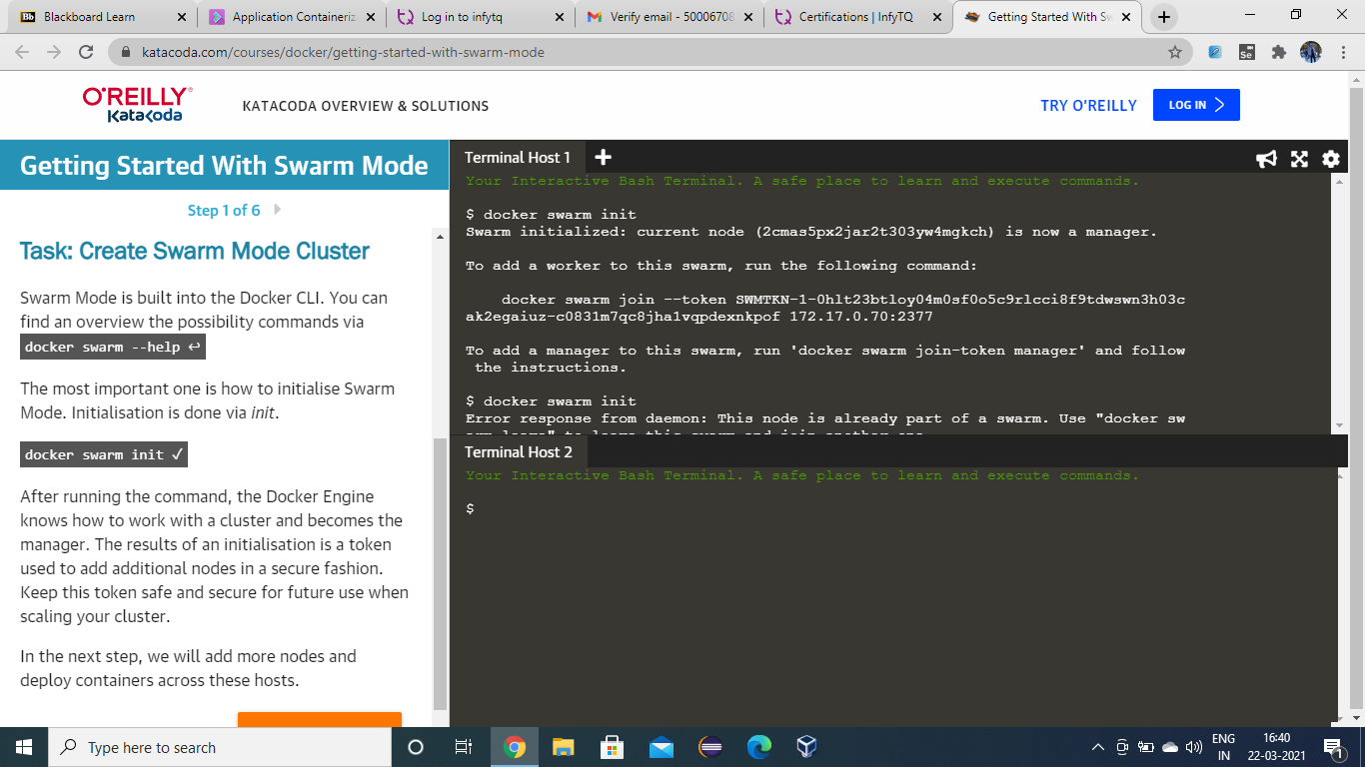

STEP 2: Run the command ‘docker node ls’ in the master node to view all the nodes in the swarm.

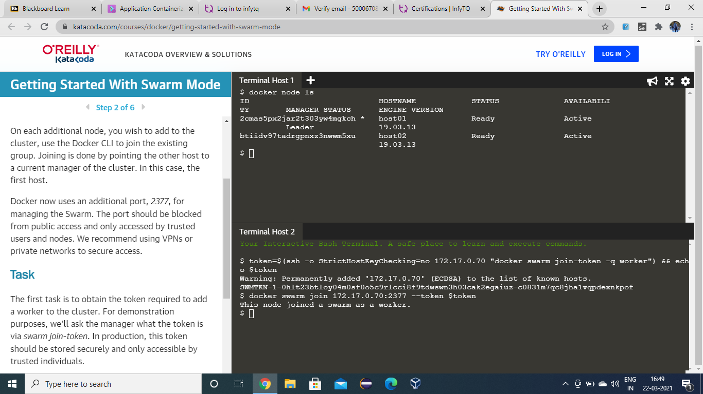

STEP 3: Now create a network named Skynet using the command ‘docker network create -d overlay skynet’ and list all the available networks using the command ‘docker network ls’.

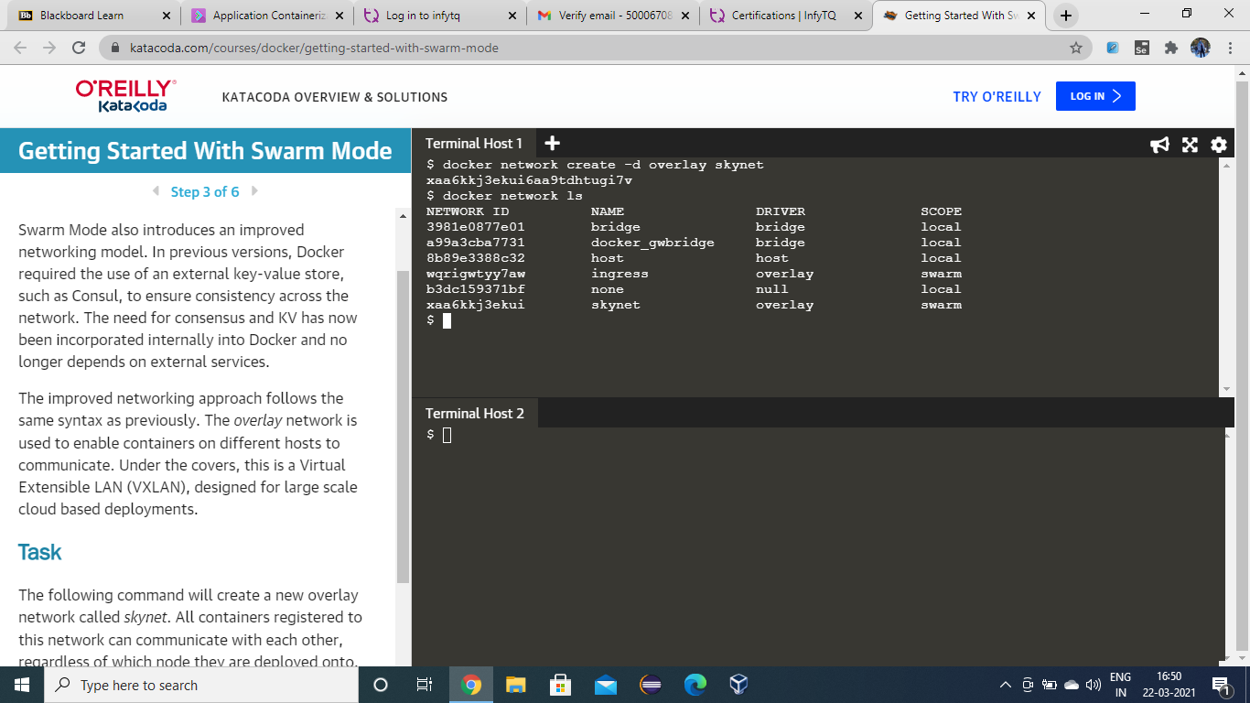

STEP 4: Check and list the services using the command ‘docker services ls’. As of now, there aren’t any services available so the command doesn’t have any listing.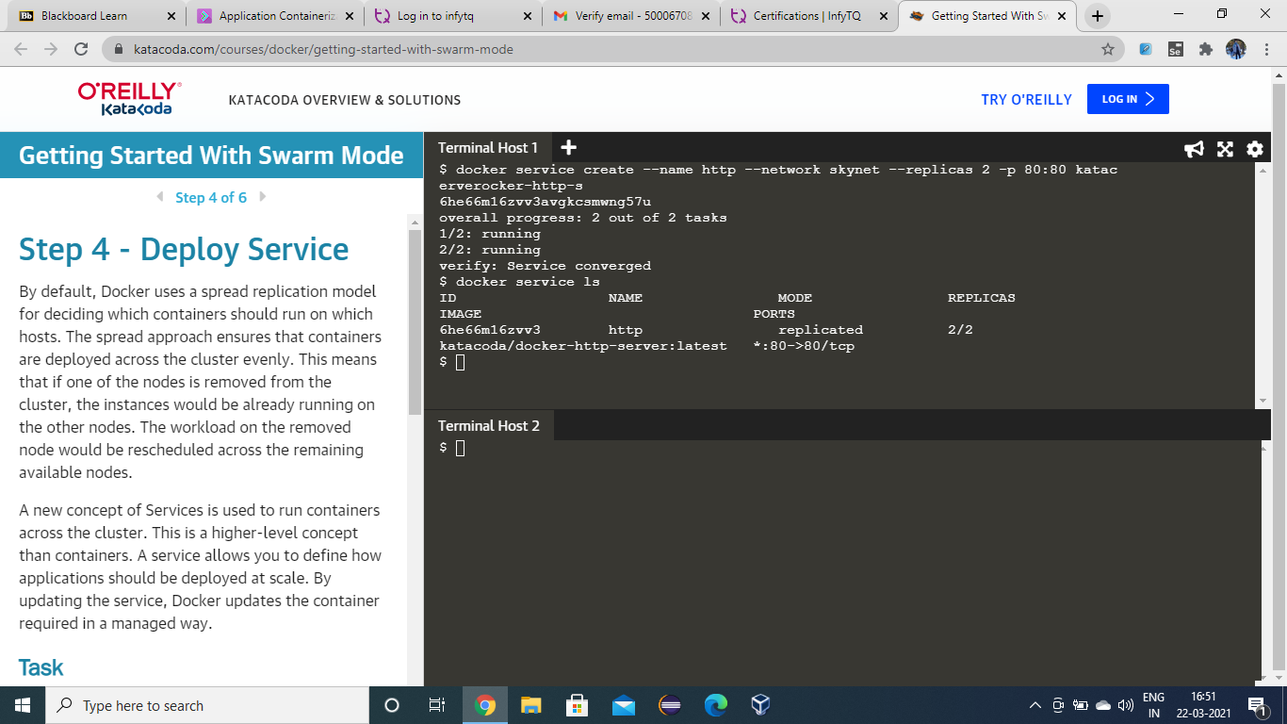

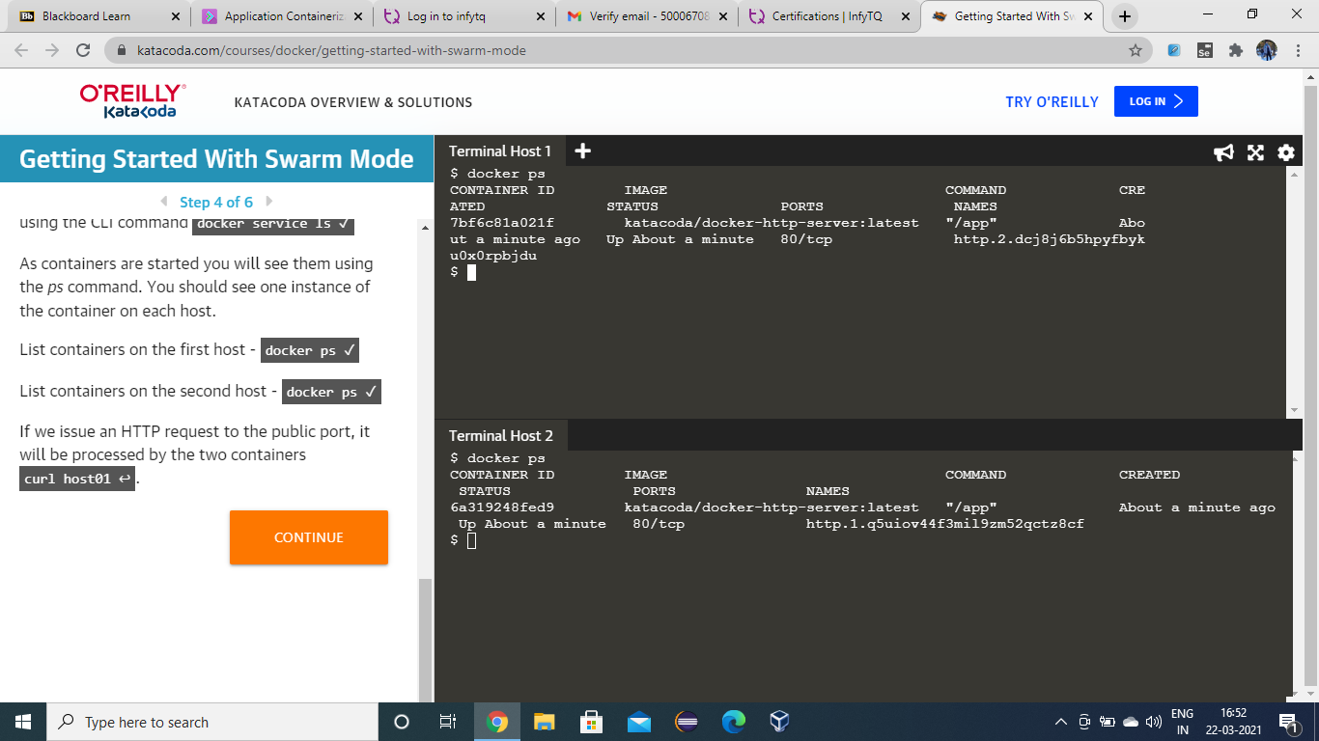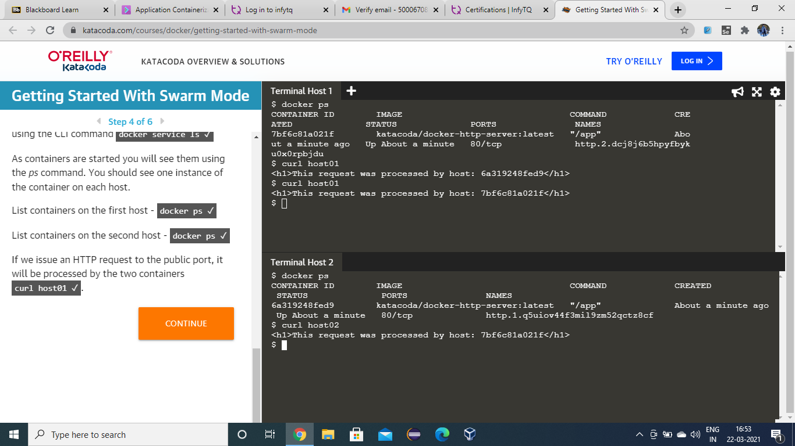

STEP 5: Use the command ‘docker service create --name http --network skynet --replicas 2 -p 80:80 katacoda/docker-http-server’ here we are creating 2 replicas and assigning them to the nodes 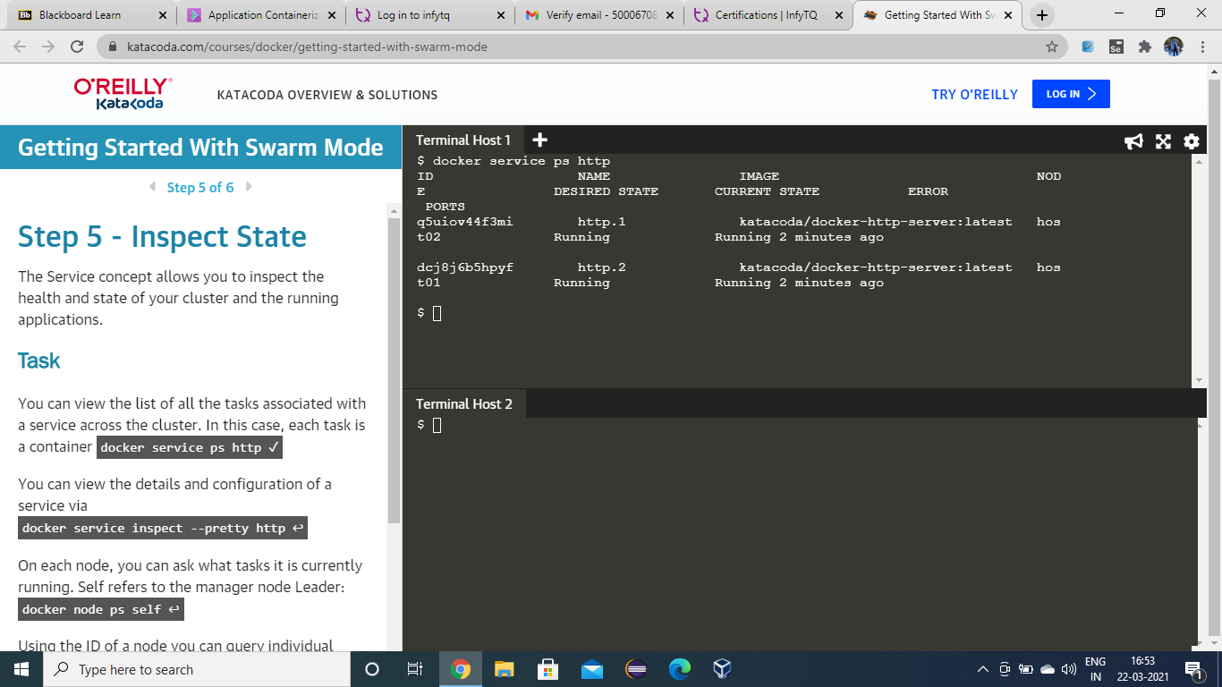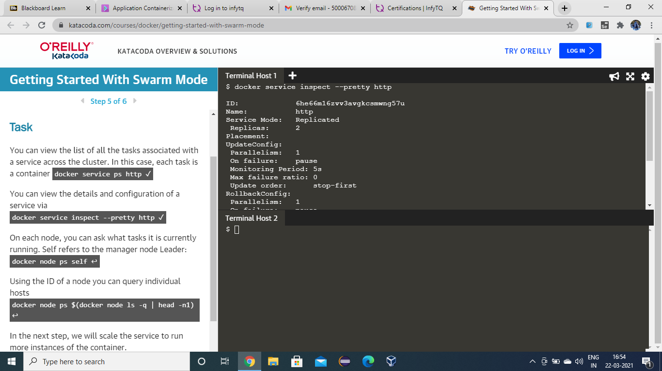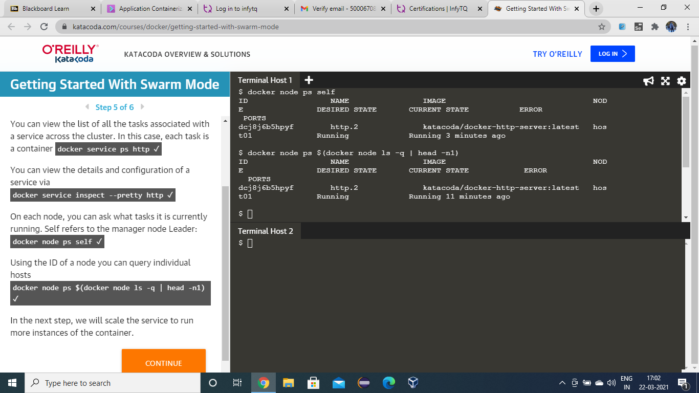

STEP 6: Once the service creation is complete, run the command ‘docker service ls’ to list the recently created service.

