**Name: Piyush Vishnoi**

**Roll no:R171218071**

**Sapid:500067083**

Lab Experiment-1

Step-1: Install vagrant and run vagrant --version on cmd

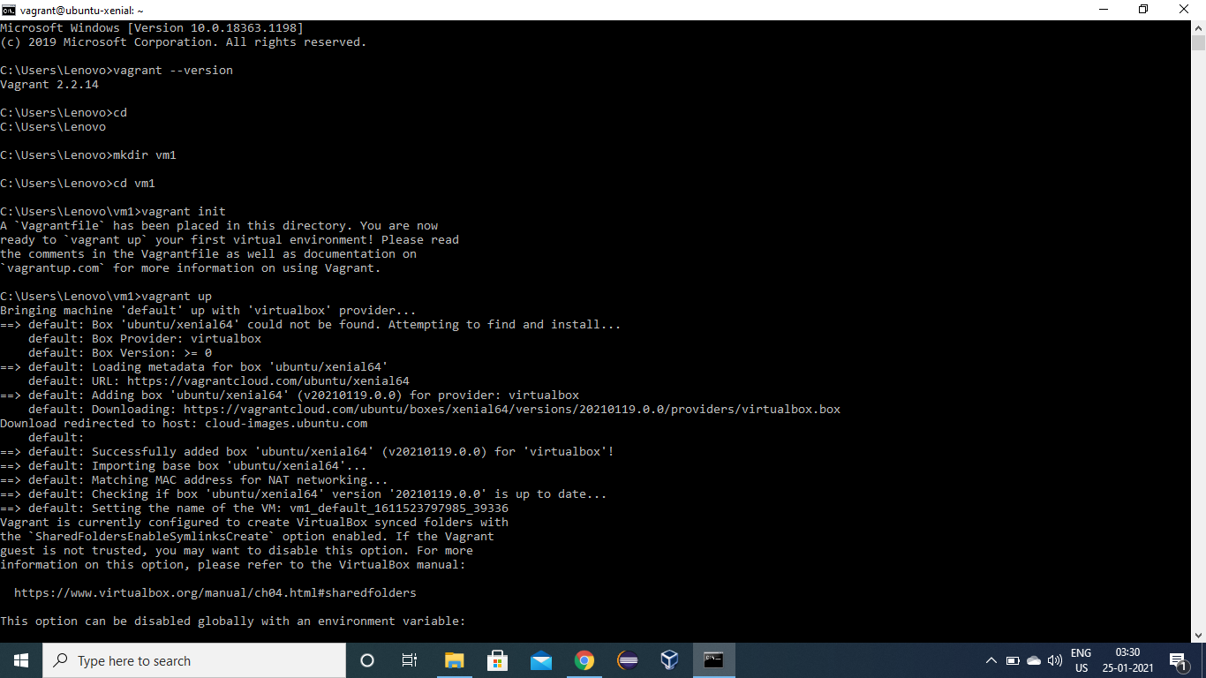

Step-2: Create folder and get into folder using cmd



Step-3: run vagrant init command



Step-4: edit VagrantFile and write config.vm.box=”Ubuntu/xenial64” and save it.

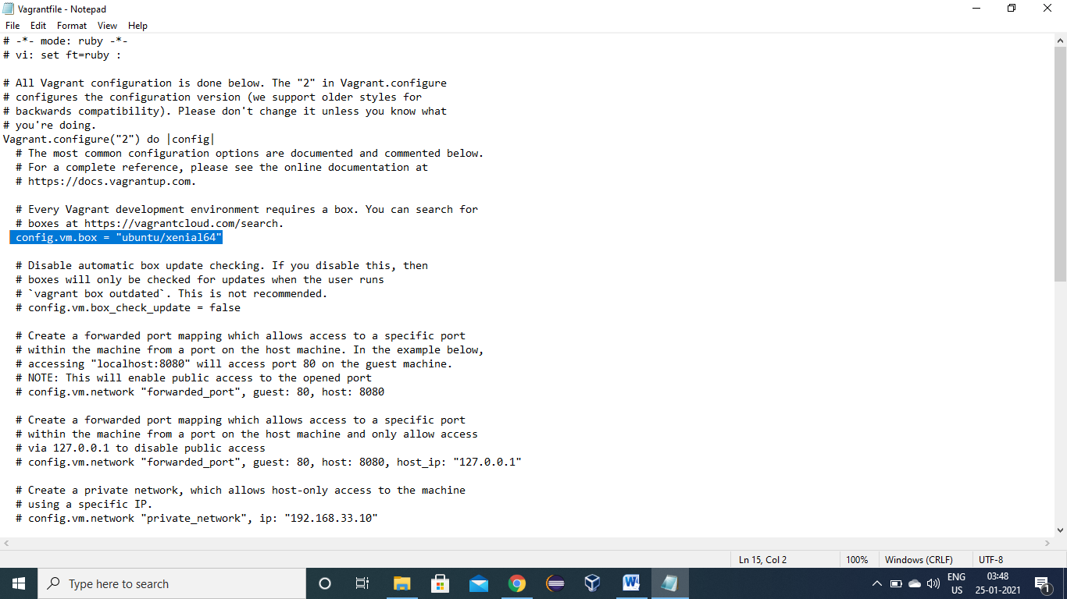

Step-5: run vagrant up command

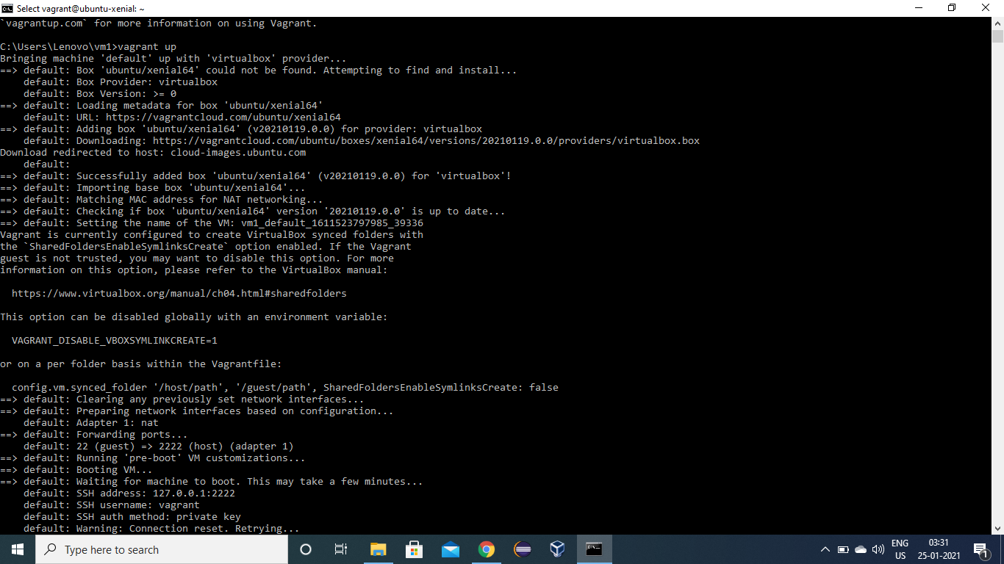

Step-6: run vagrant ssh command

