**Name: Piyush Vishnoi**

**Roll no:R171218071**

**Sapid:500067083**

Lab Experiment-2

Docker Volume

Step 1: Install docker in Ubuntu and run docker –version and run hello-world image

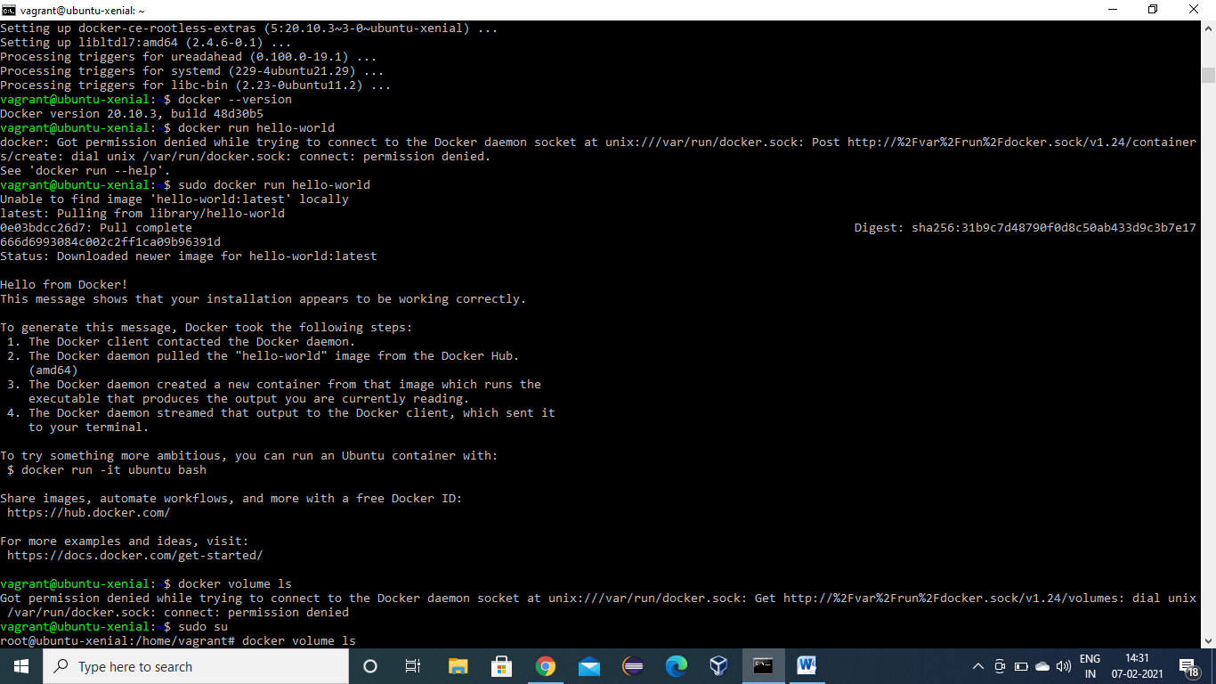

Step 2: Pulling alpine image and running it

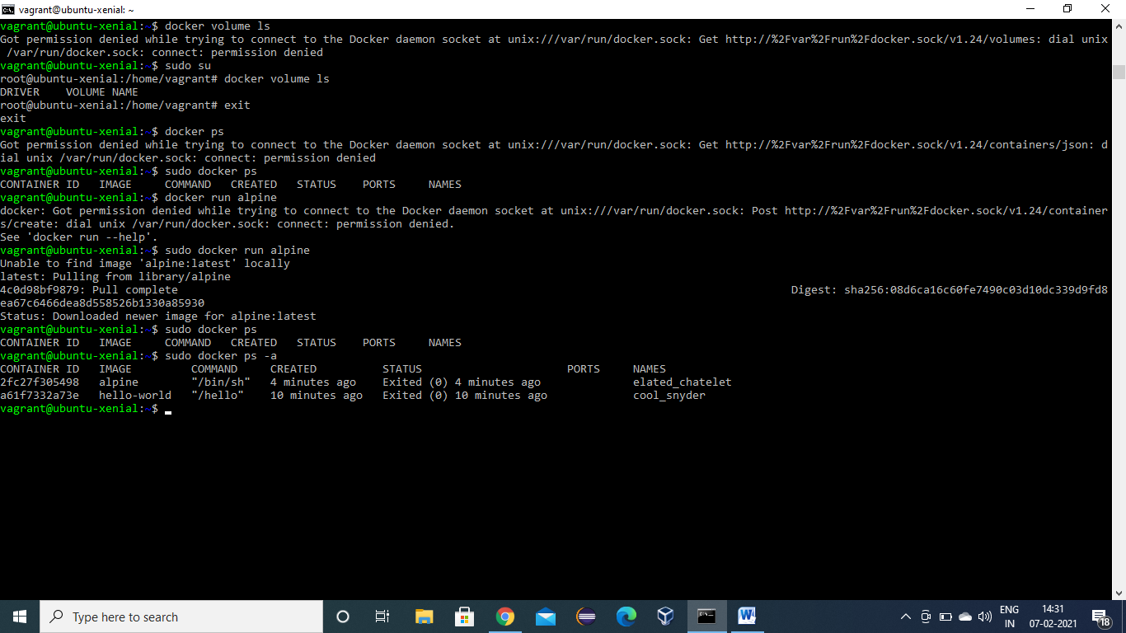

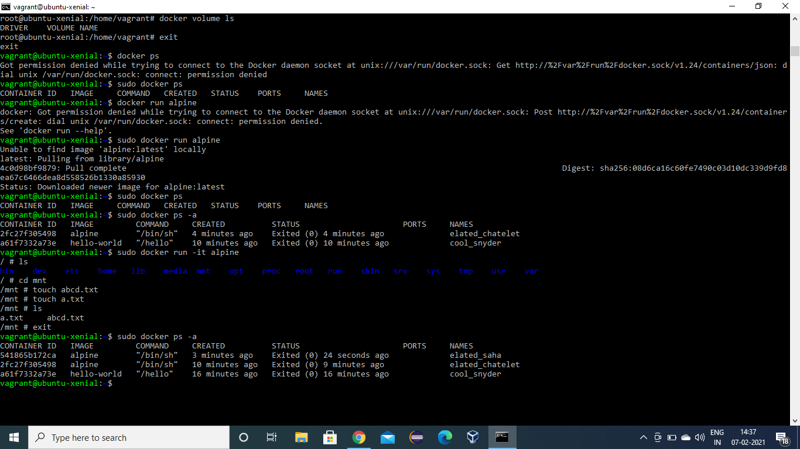

Step 3: creating volume named as myvol1 and connecting it with mnt folder of alpine image .Here this volume will act as central repository for containers which are connected to it.

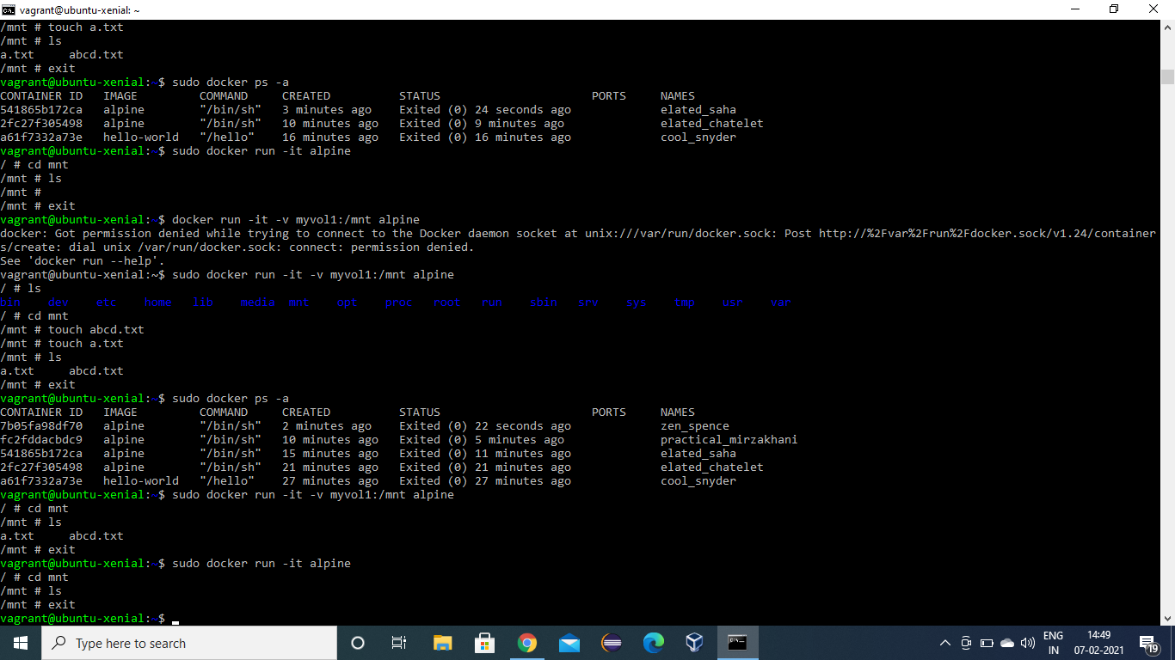

Listing all volumes and inspecting them.

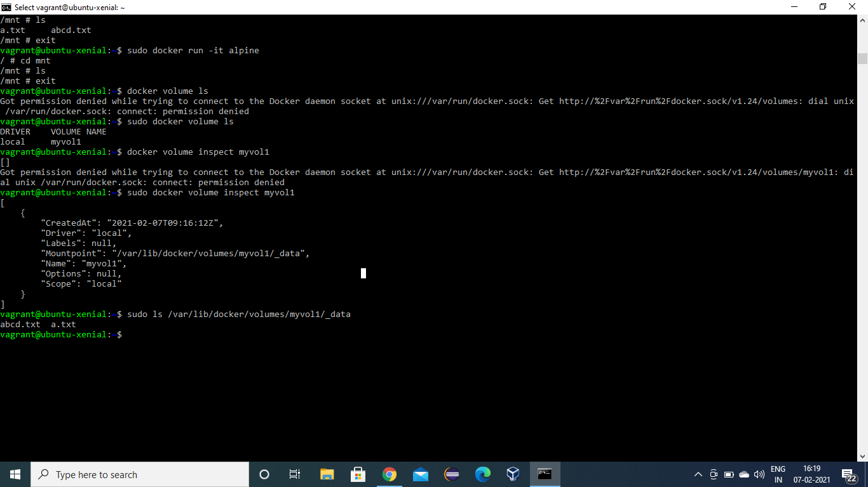

Step 4: Making container named as c1 connecting it with myvol1 and use it as a backup to recover files even after exiting from container.

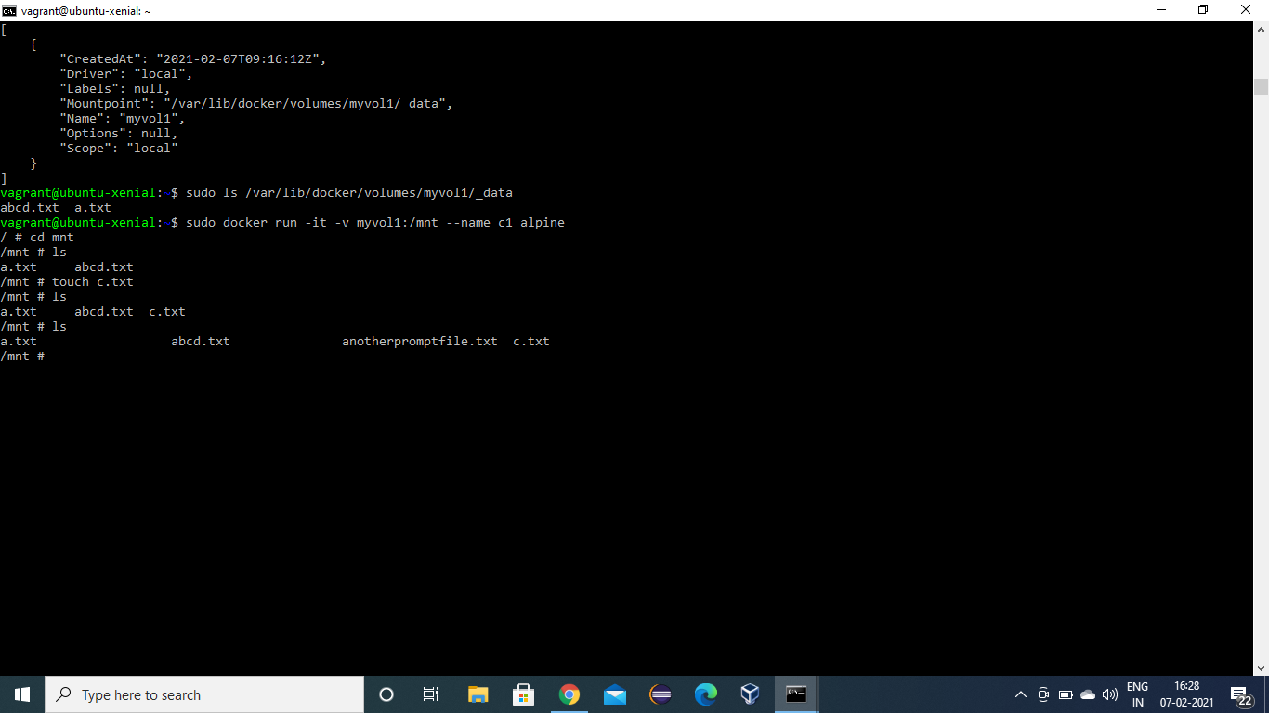

Step 5: Open another terminal and Make another container named as c2 ,in connection with volume myvol1, and it will contain files of c1 as well.

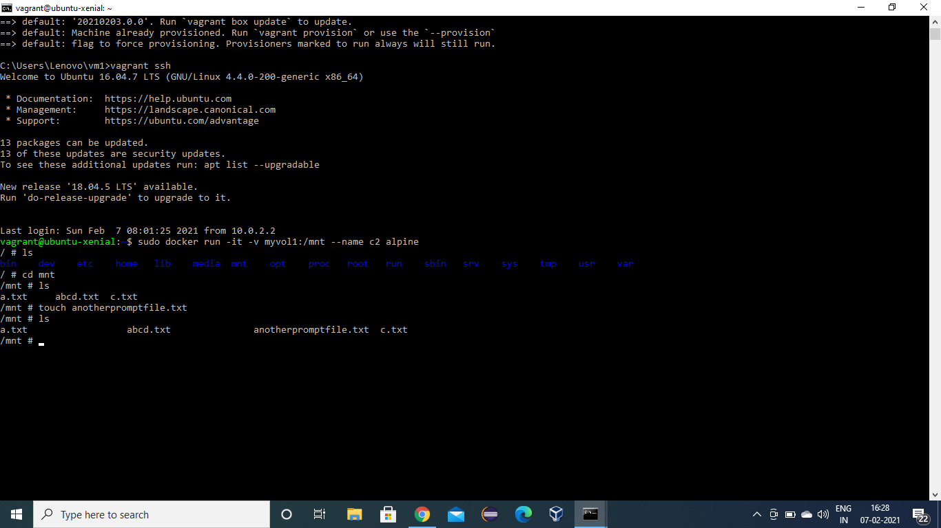

Step 6: pulling Ubuntu image and running it by making connection with myvol1 and making a file in its var folder.

Here we get all files of container c1 and c2.

Run command touch fileubuntucontainer.txt in var folder.

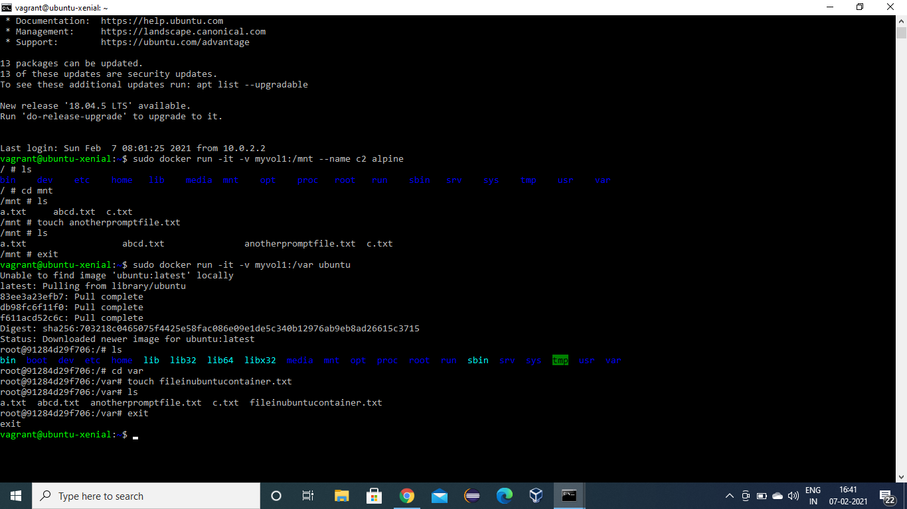

Step 7: check myvol1 in its local folder on our system, we will get all files of container c1, c2 and of Ubuntu image.

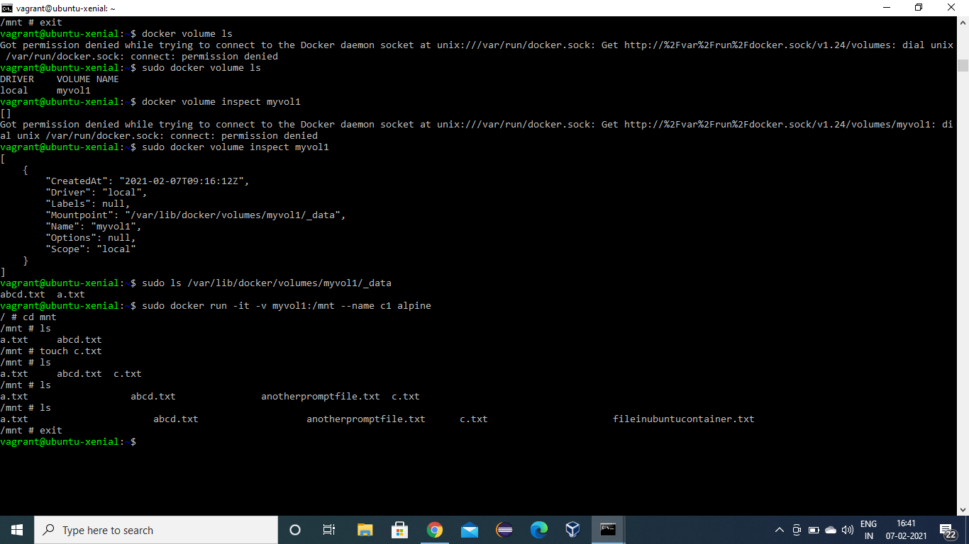

Step 8: we can even delete this volume and data deleted.

