**Name: Piyush Vishnoi**

**Roll no:R171218071**

**Sapid:500067083**

Lab Experiment-3

Creating networks between containers

Step 1: to create new network , Run command

docker network create <network-name>

Container named as redis is created and it will run in background because of --d option in command

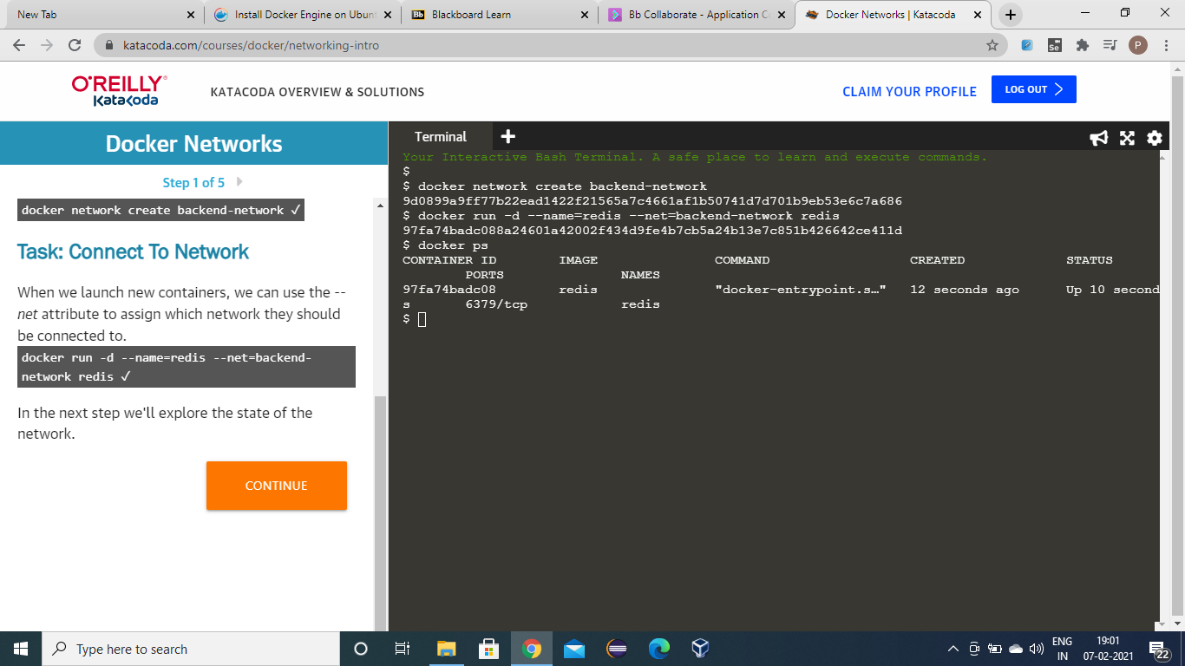

Step 2: docker run –net=backend-network alpine caat /etc/resolv.config

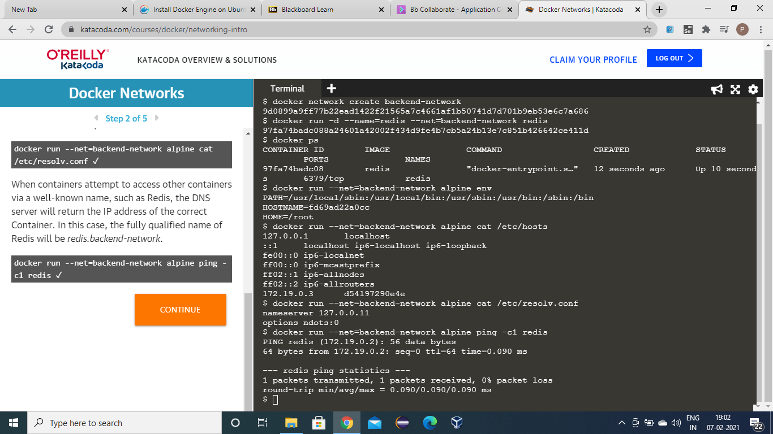

docker run –net=backend-network alpine ping – c1 redis

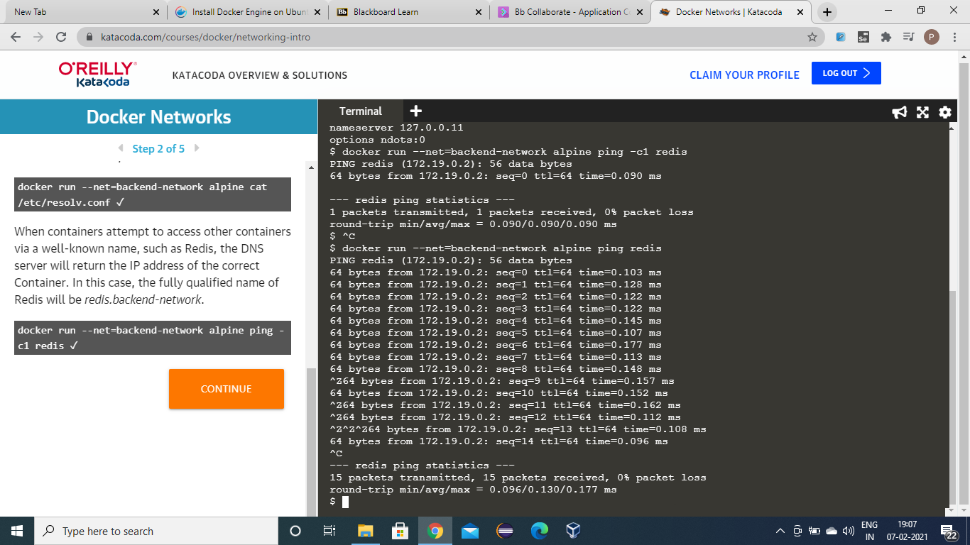

Step 3: connecting two containers by pinging another one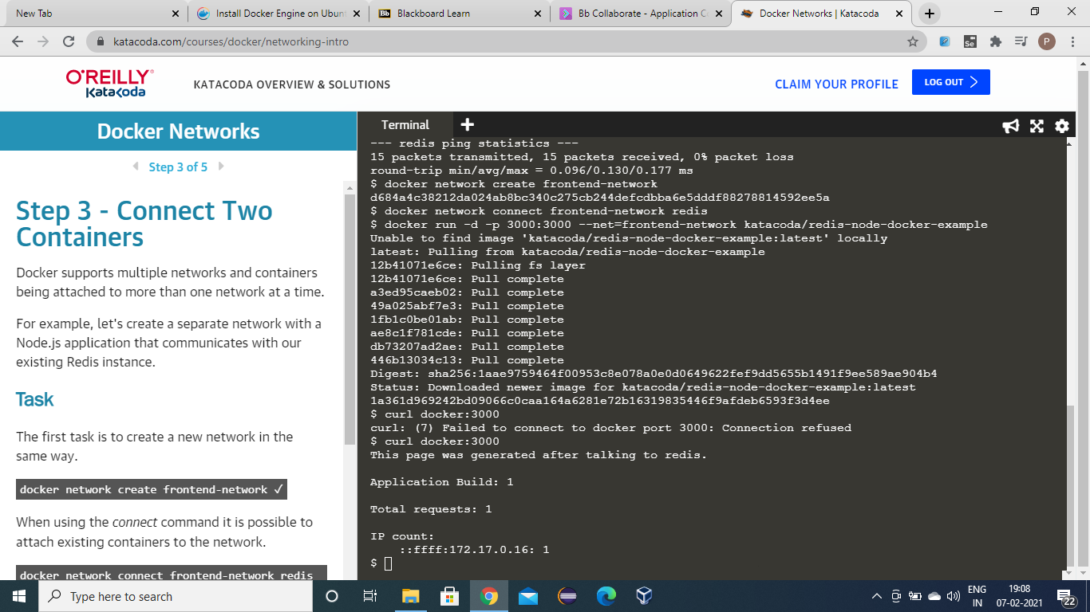

Step 4: making alias(making another id or name) of a container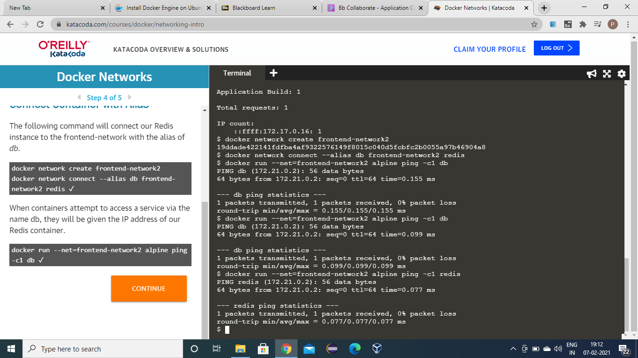

Step 5: inspecting network and disconnecting conatiners with network.

