**Lab Experiment-4**

* **Creating a Docker image and pushing it to Dockerhub.**

In this experiment, we will create a customized Docker image and then push it to the Docker hub repository.

The steps that need to be followed are:

1. Create a Docker file with the name “Dockerfile” and add the code shown below in it.

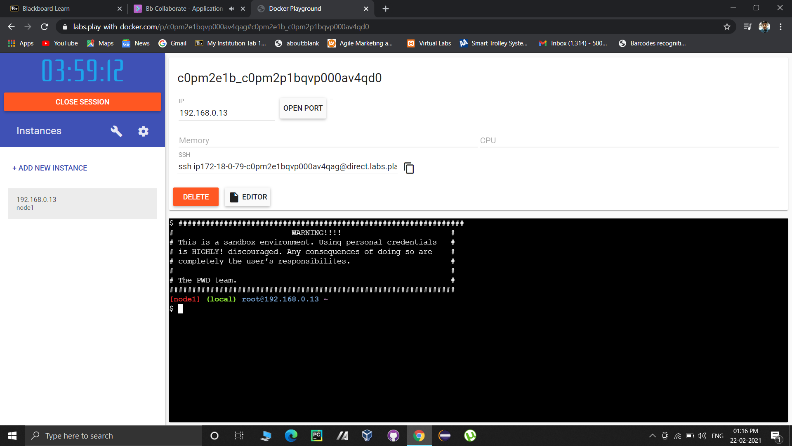

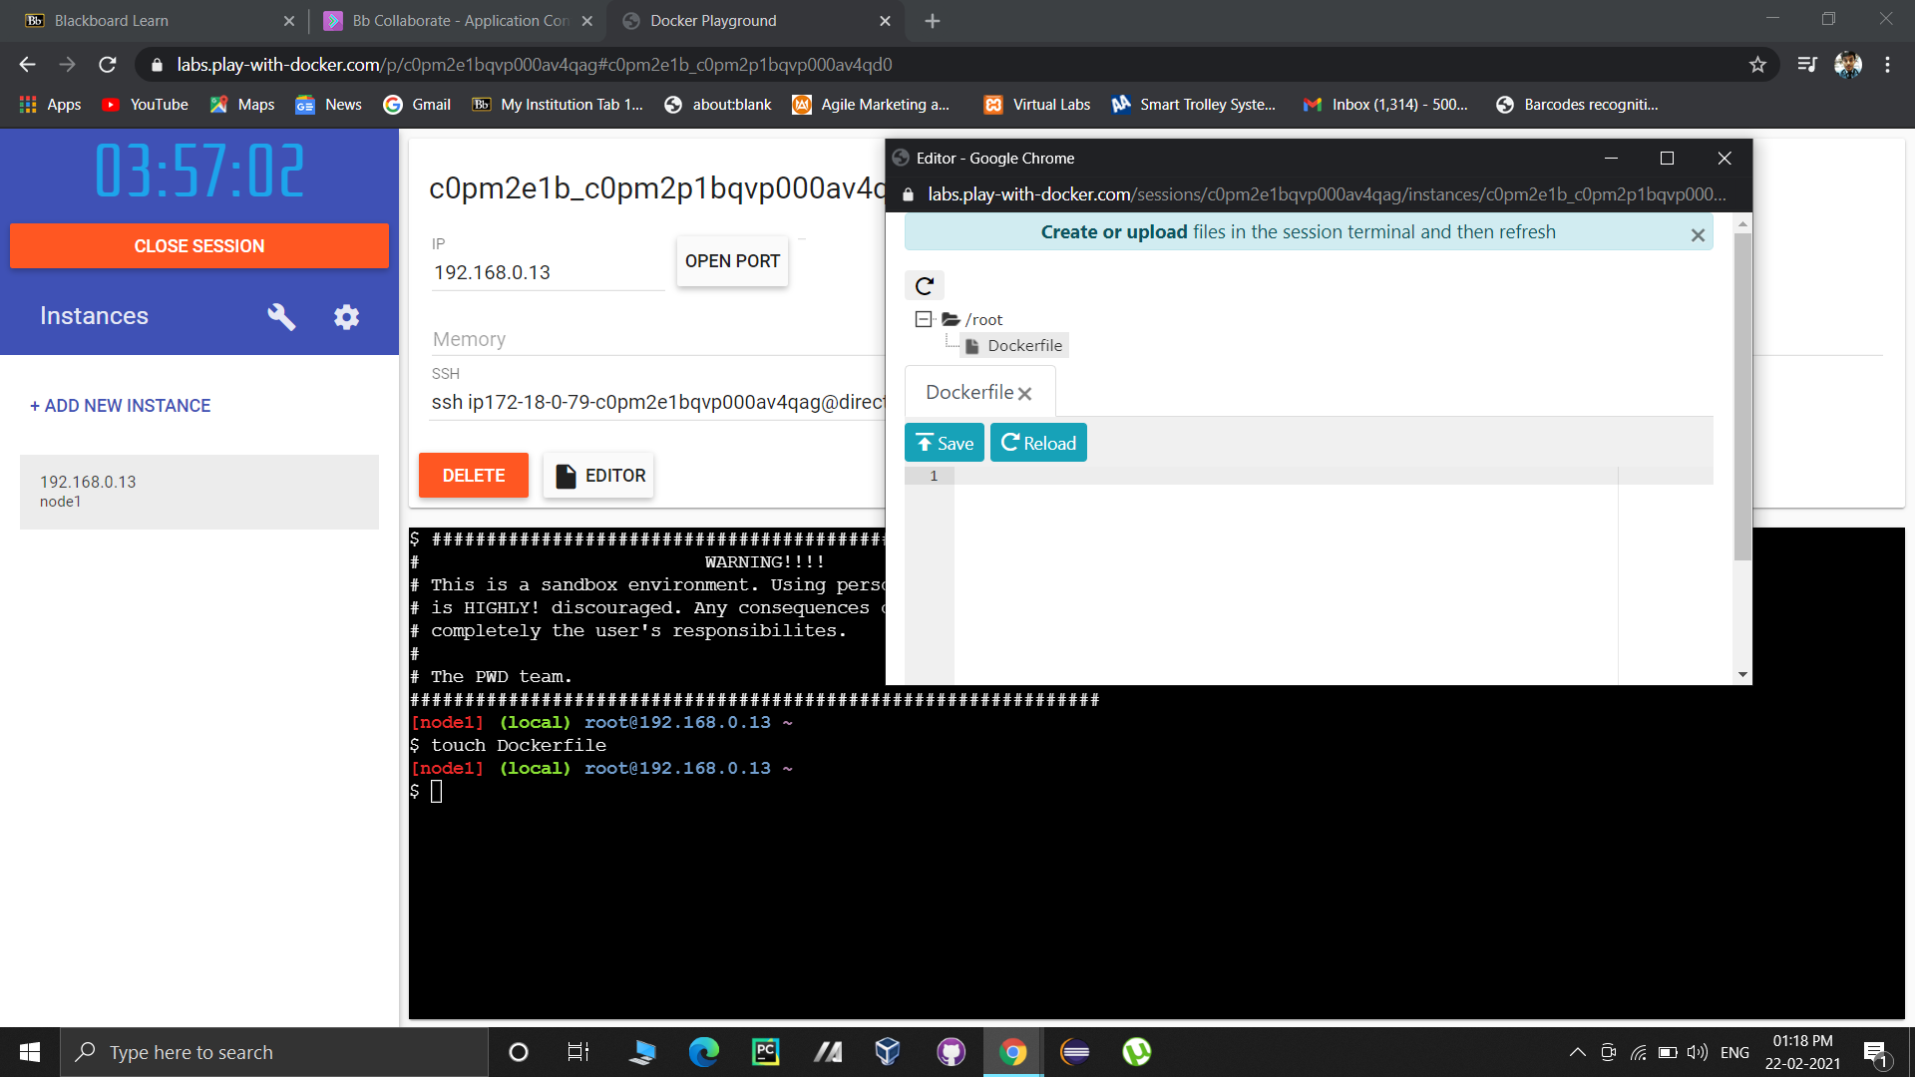

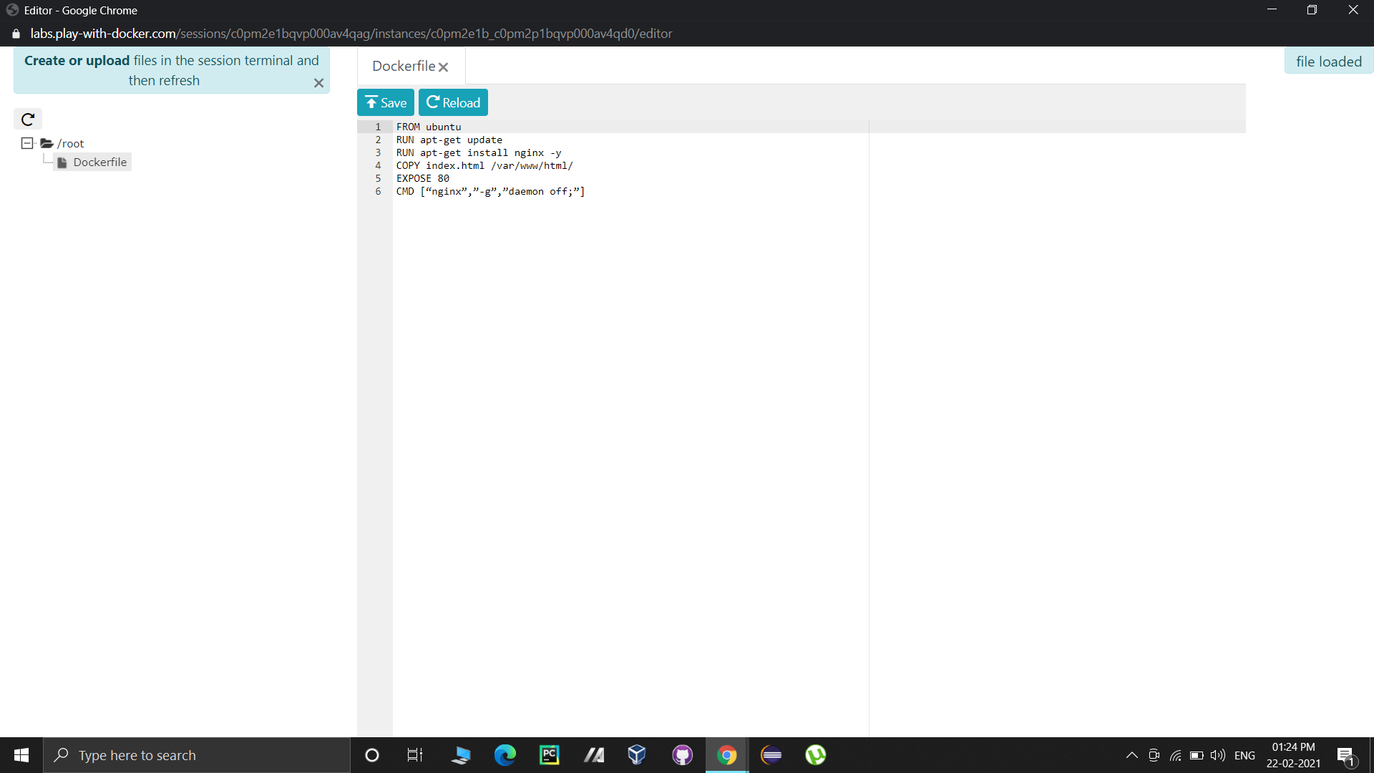

This code will execute in layers as follows:

Layer 1: Ubuntu image will be used as base OS image.

Layer 2: The image will be updated.

Layer 3: Nginx will be installed on the Ubuntu Image.

Layer 4: Configuration file of Nginx will be altered to set daemon off.

Layer 5: A file named index.html will be copied from current directory to /var/www/html.

Layer 6: Port 80 of the container will be exposed.

Layer 7: Nginx will be started.

2. Create another file named index.html and add some basic webpage code in it.

3. Now we are ready to build an image using this dockerfile.

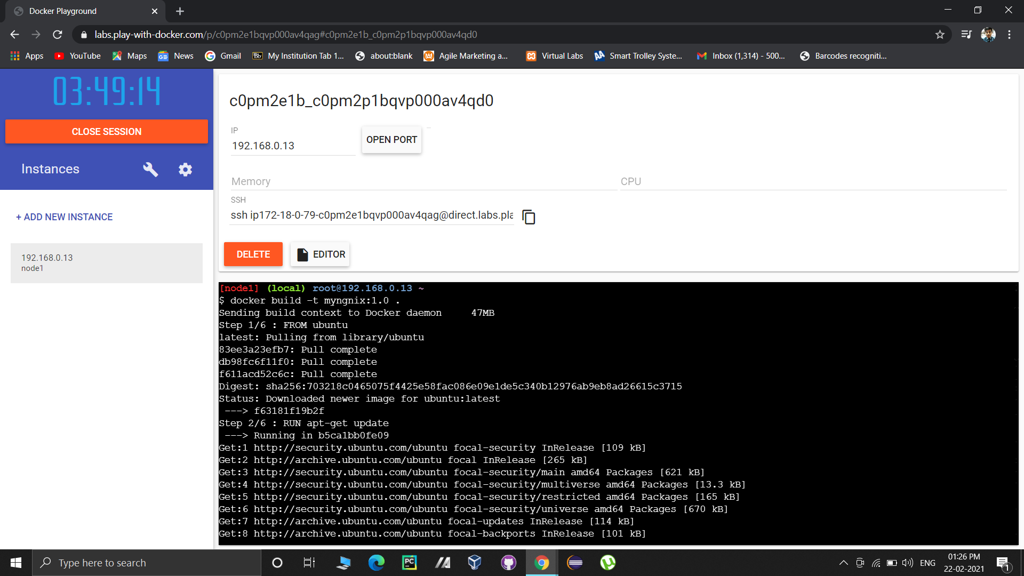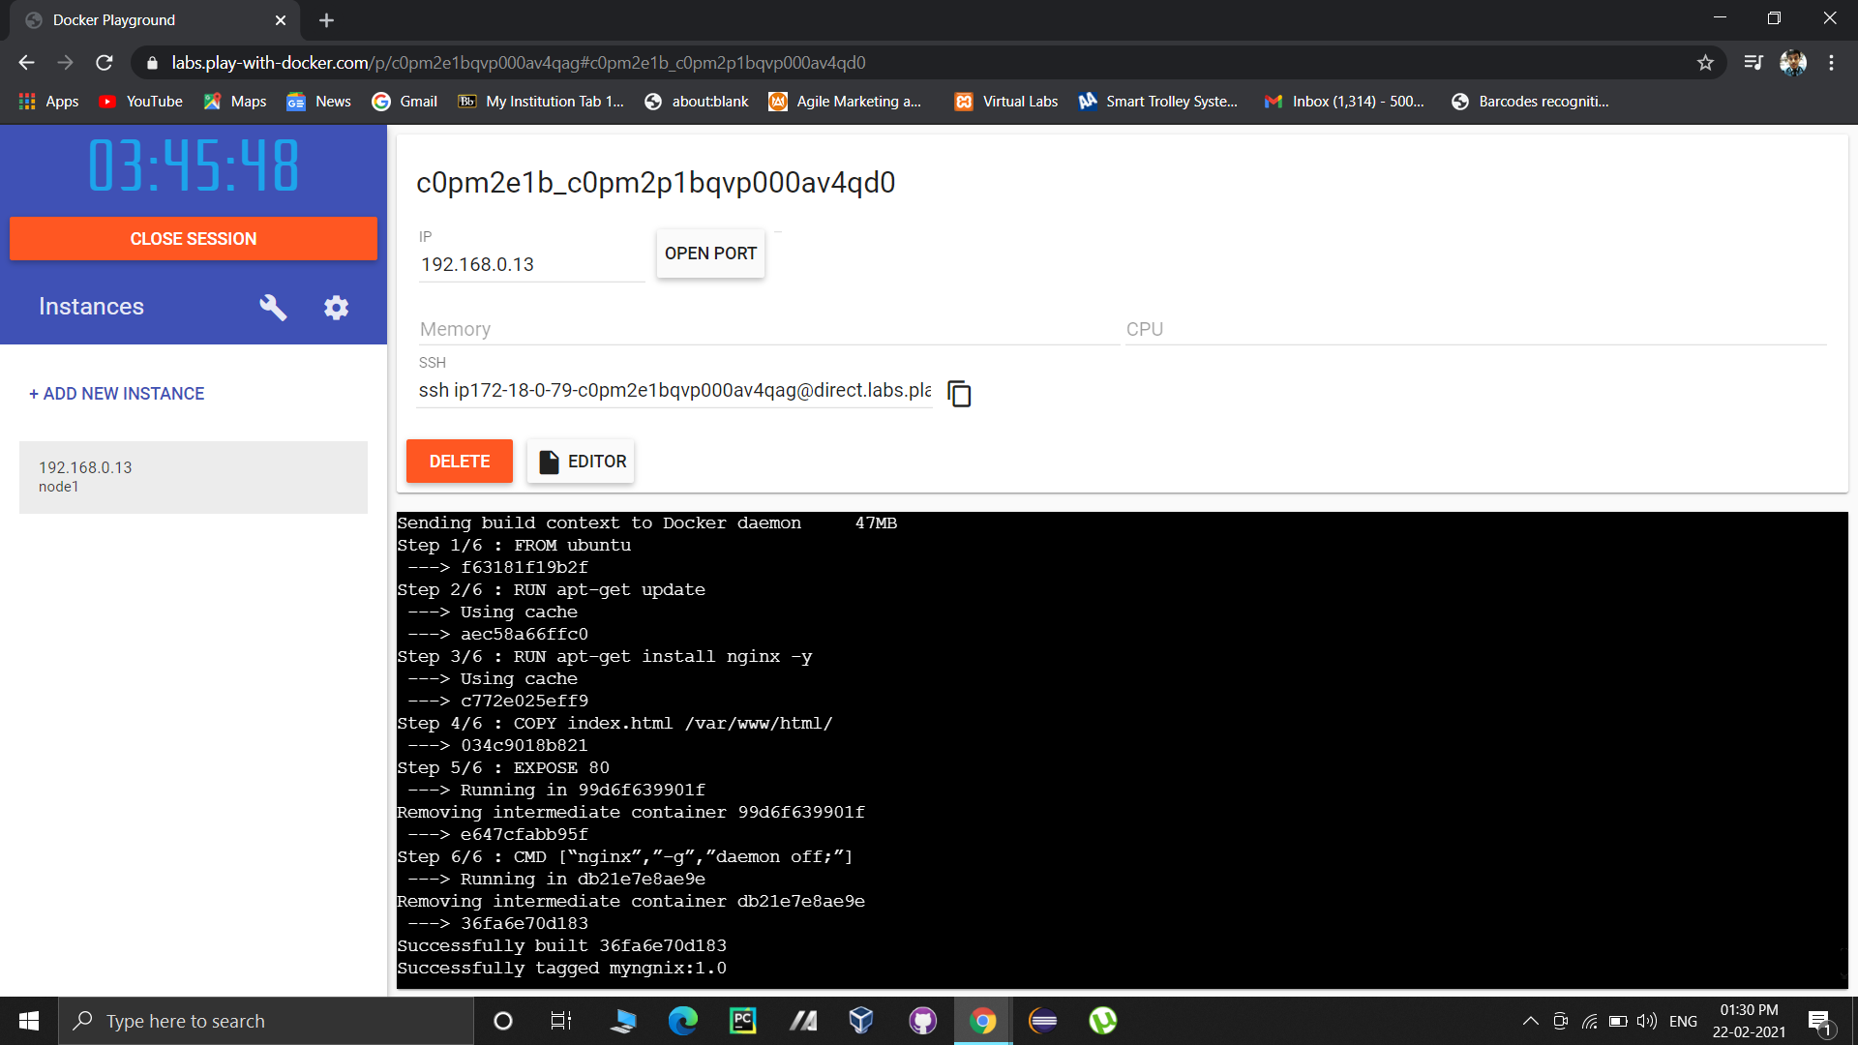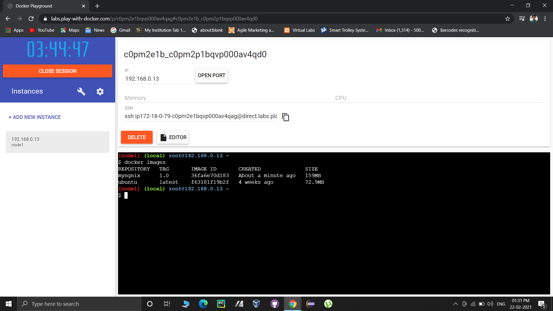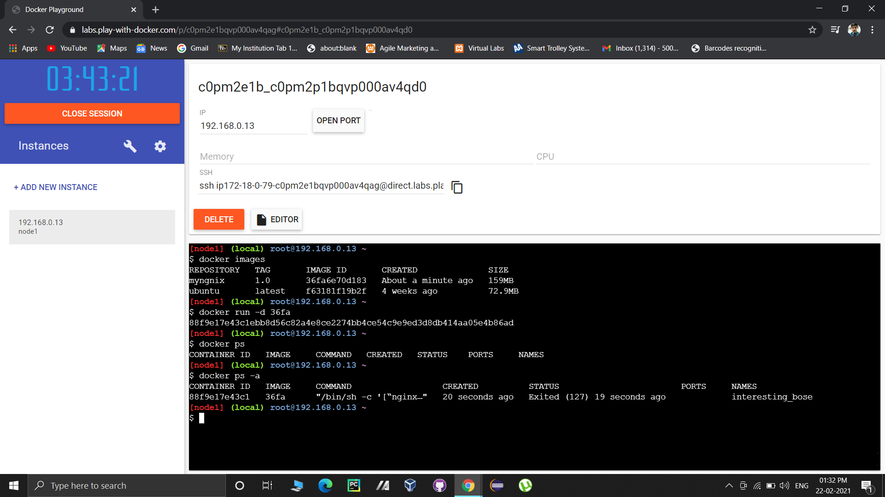

You will see the layers specified in the Dockerfile being executed as steps.

After successful execution of the steps specified in the Dockerfile, you will see a success message and the image will be built.

4. Now we will create a repository on Docker hub as follows:

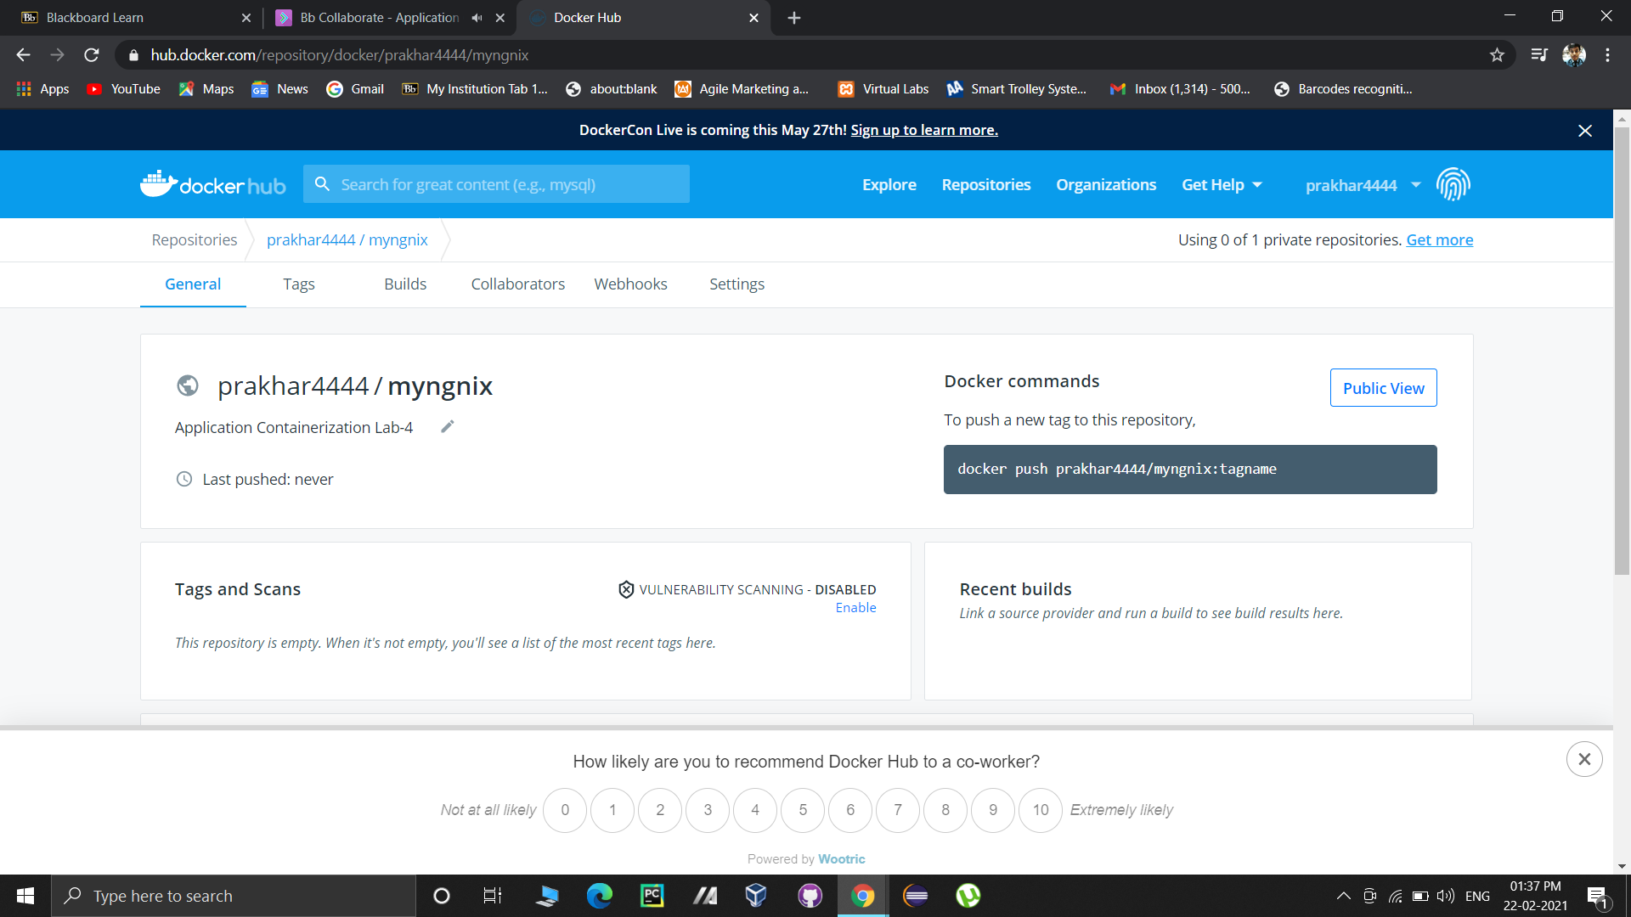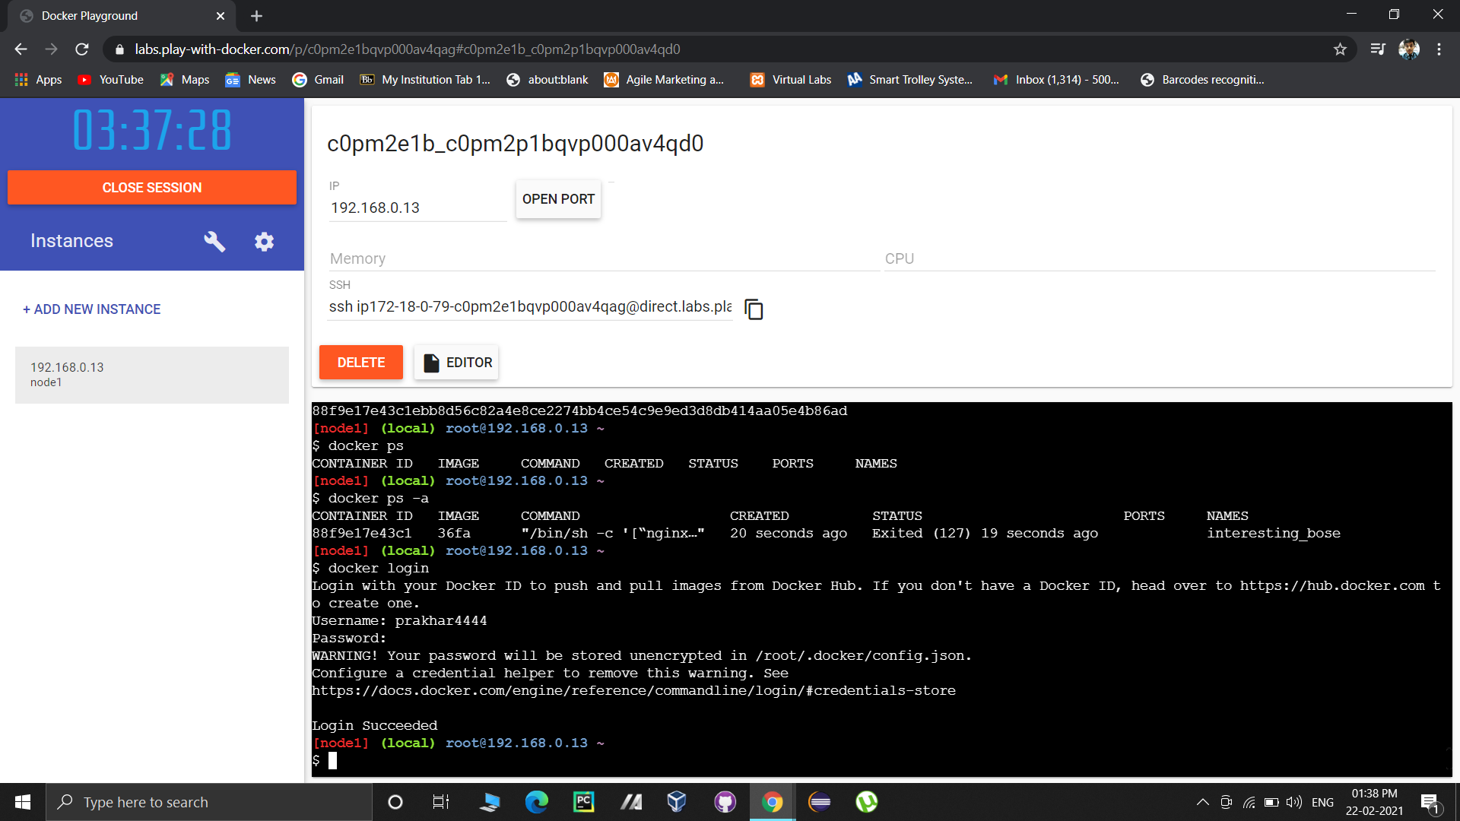

5. Now we will provide a tag to our image.

Command syntax: docker tag <image-id><repository-with-tag>

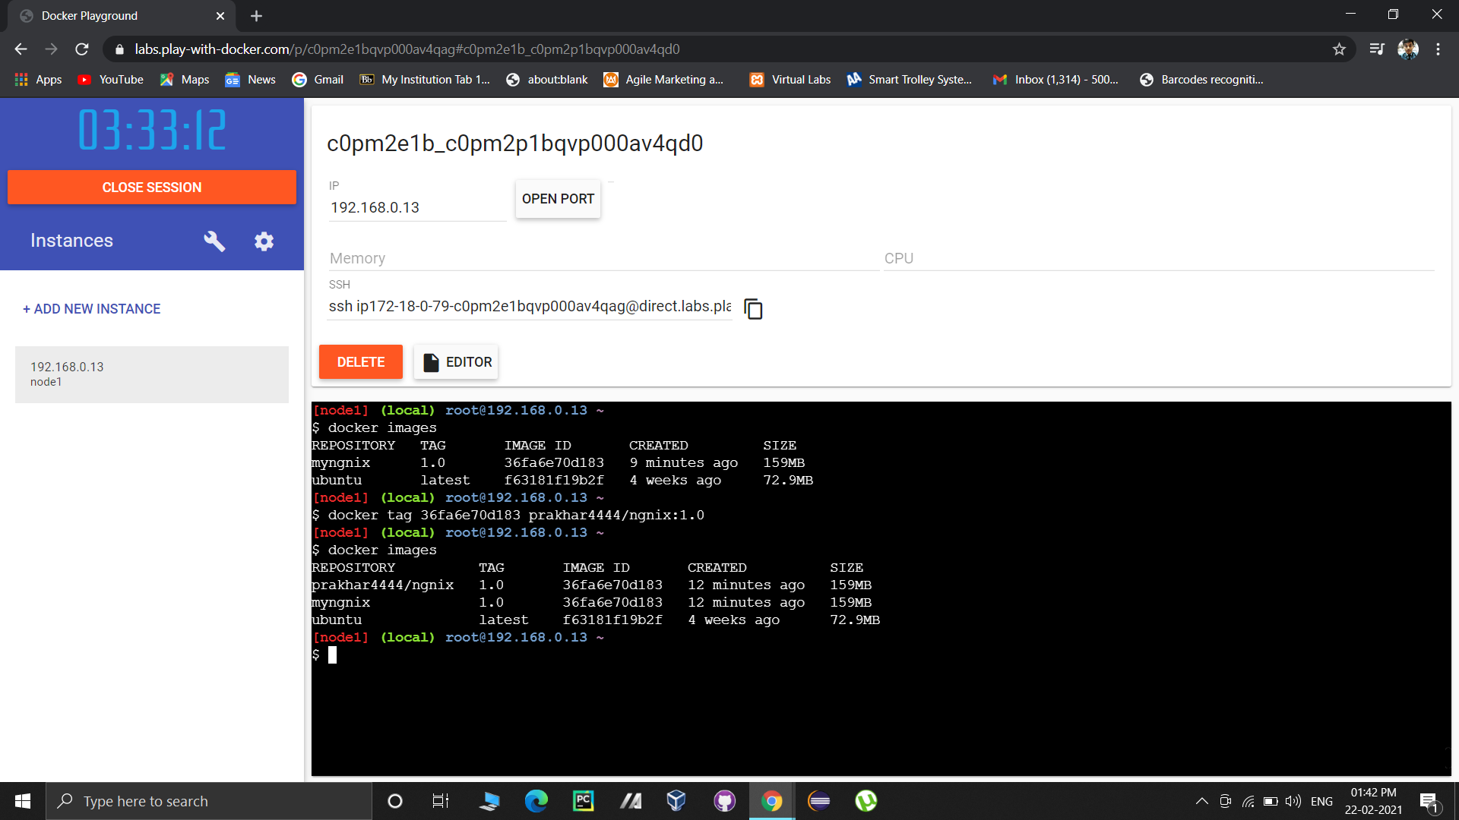

6. Login to your docker hub account.

Command: docker login



7. Push the image on docker hub.

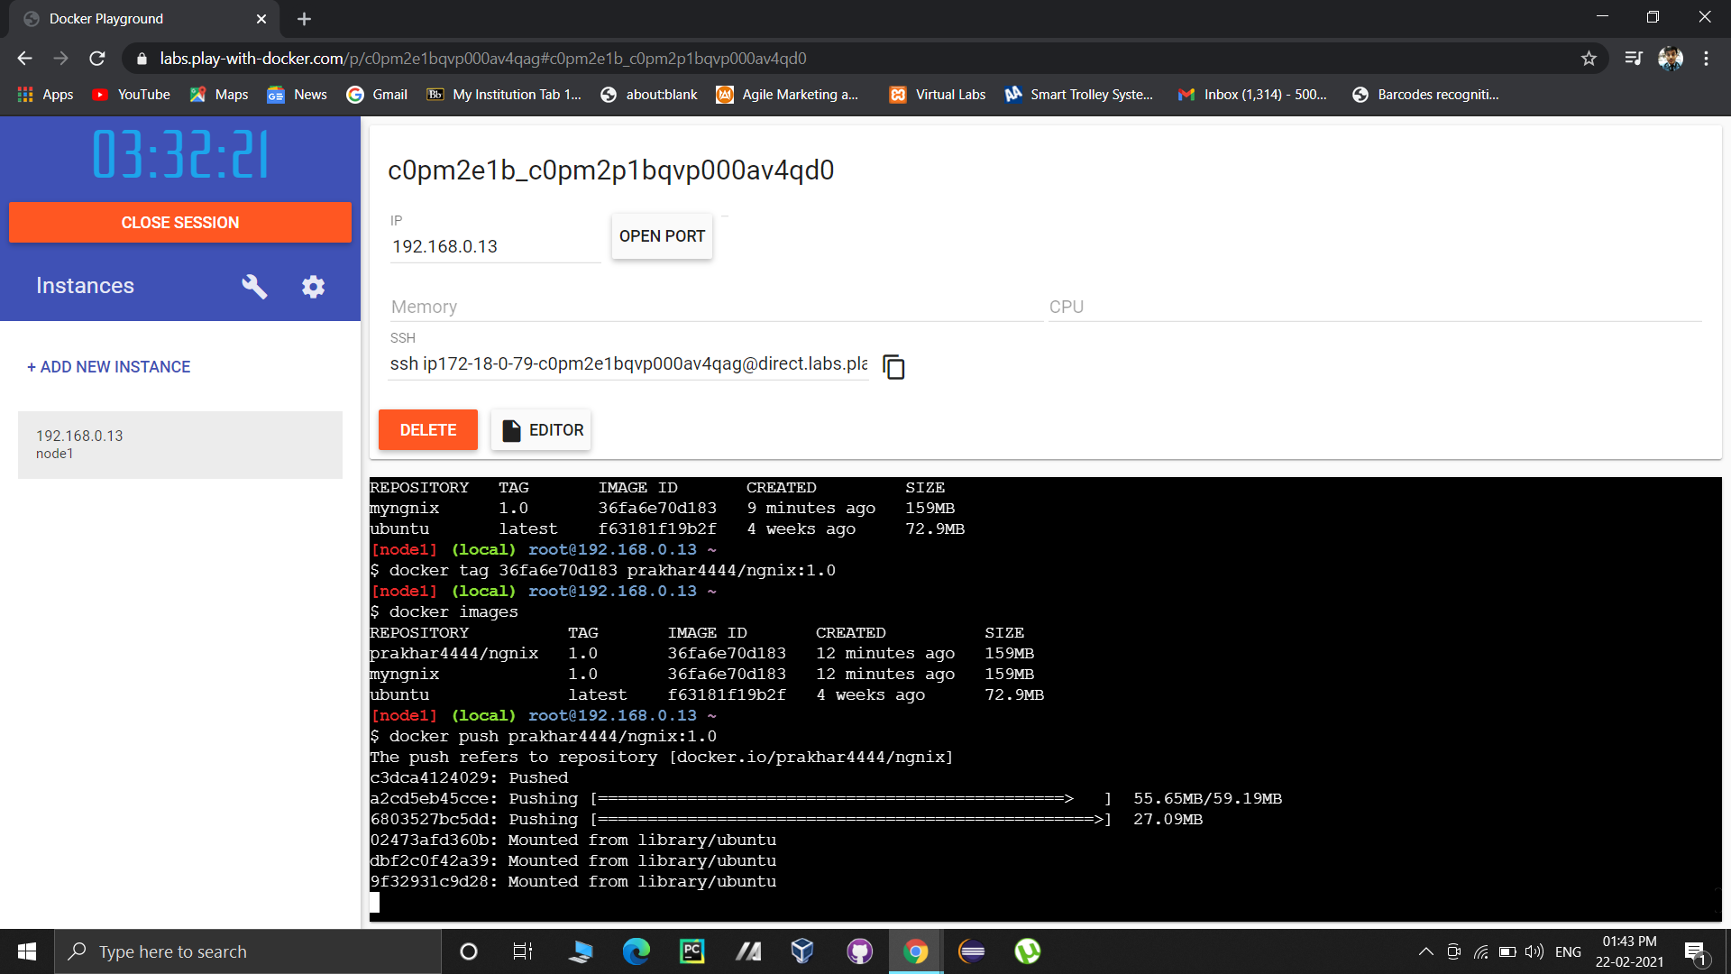

The image will be visible on the repository.

