**Experiment 7**: Create Docker Swarm Cluster

1. Initialize the swarm using the command ‘docker swarm init’. Now run the command shown in the output in the other terminal to appoint it as a worker.

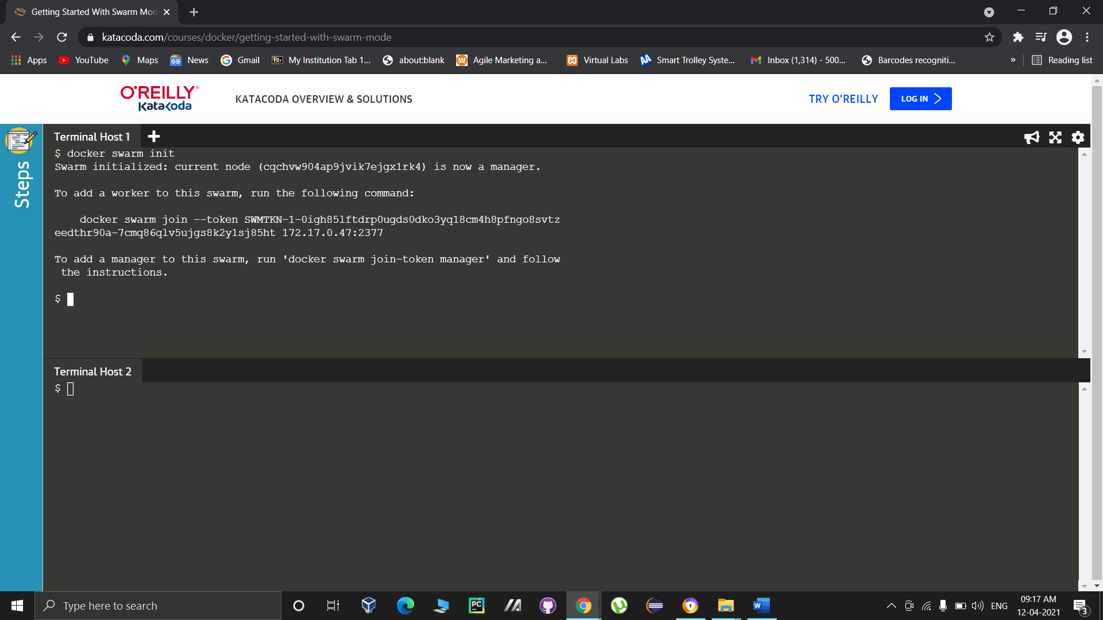

1. Run the command ‘docker node ls’ in the master node to view all the nodes in the swarm.

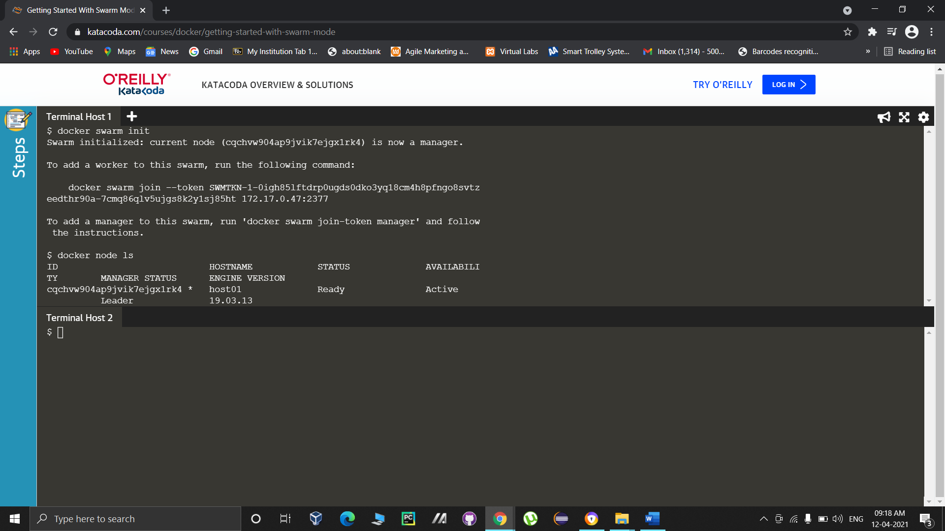

1. Now create a network named Skynet using the command ‘docker network create -d overlay skynet’ and list all the available networks using the command ‘docker network ls’.

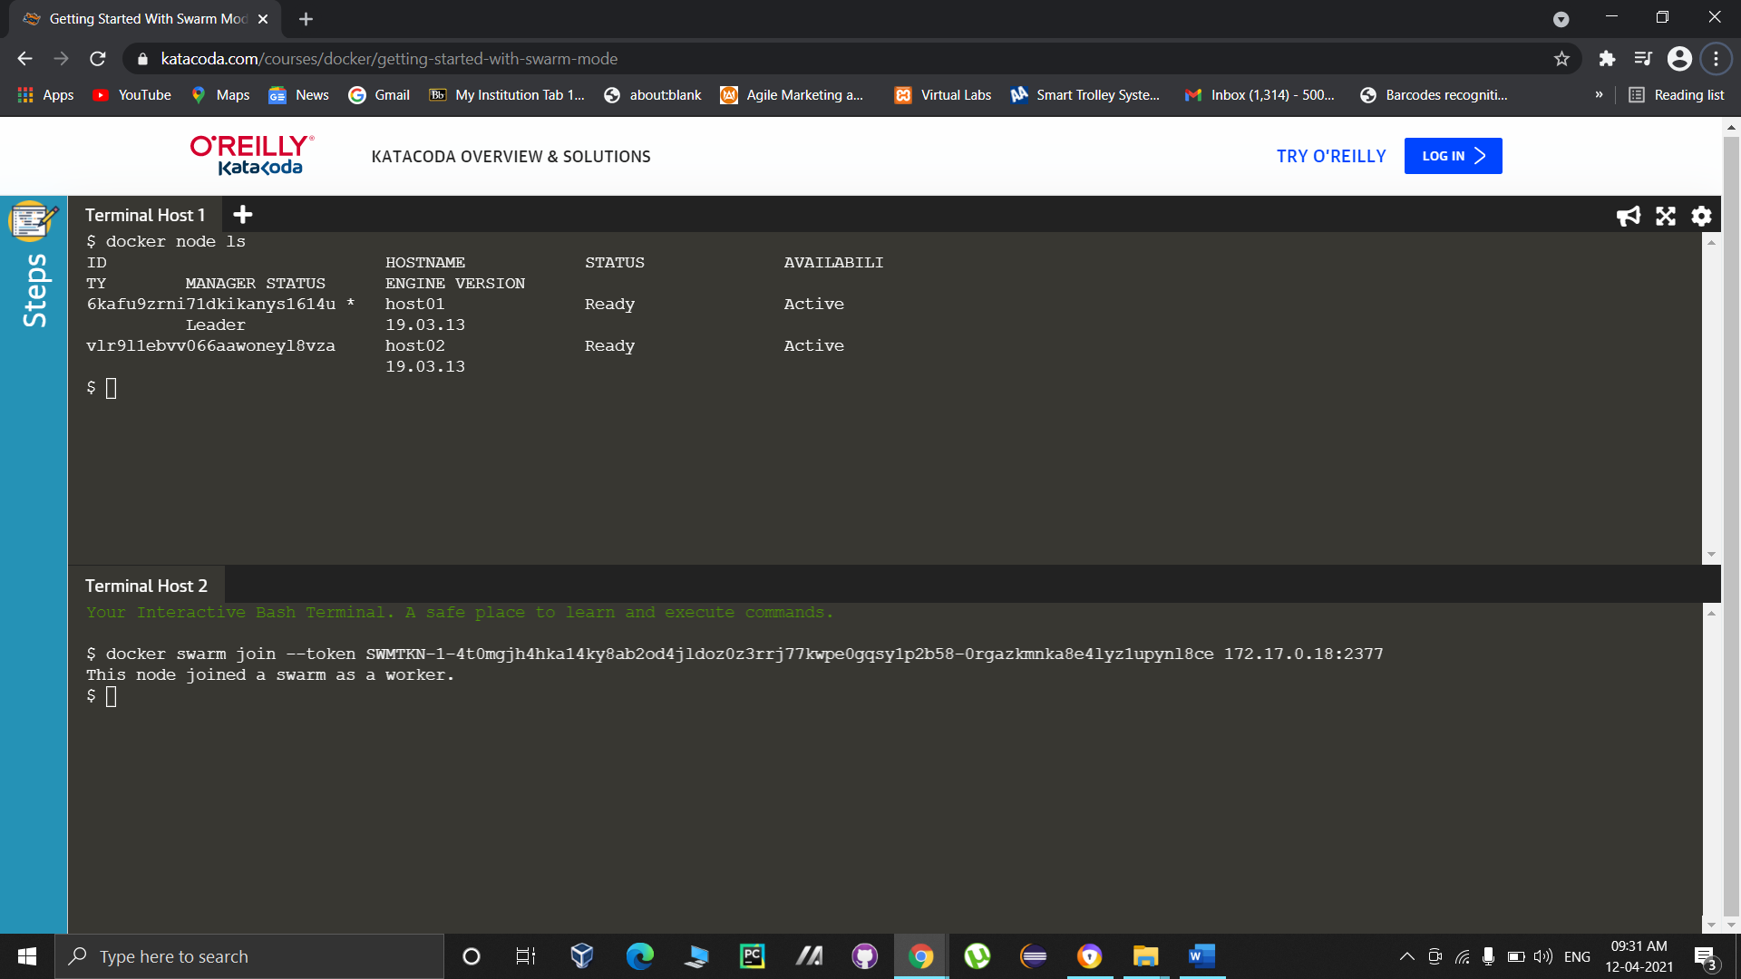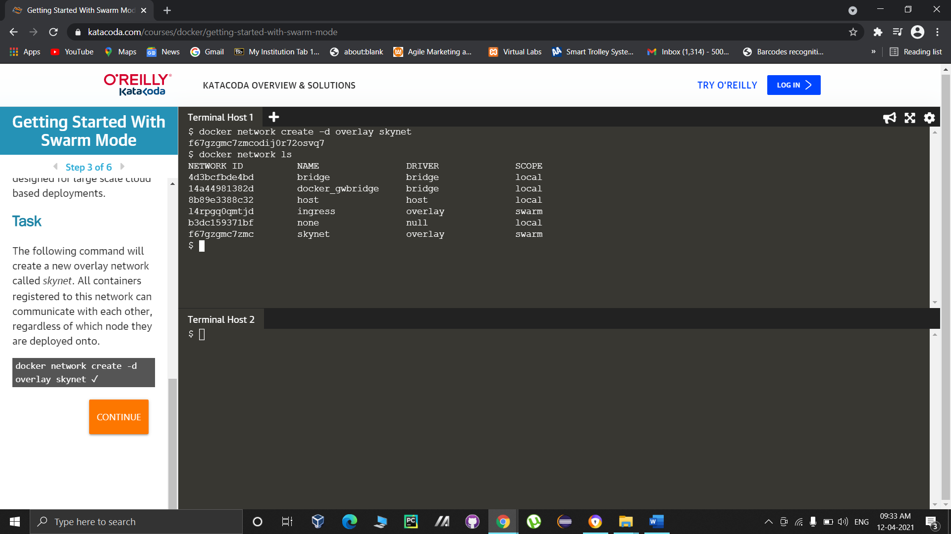

1. Check and list the services using the command ‘docker services ls’. As of now, there aren’t any services available so the command doesn’t have any listing.

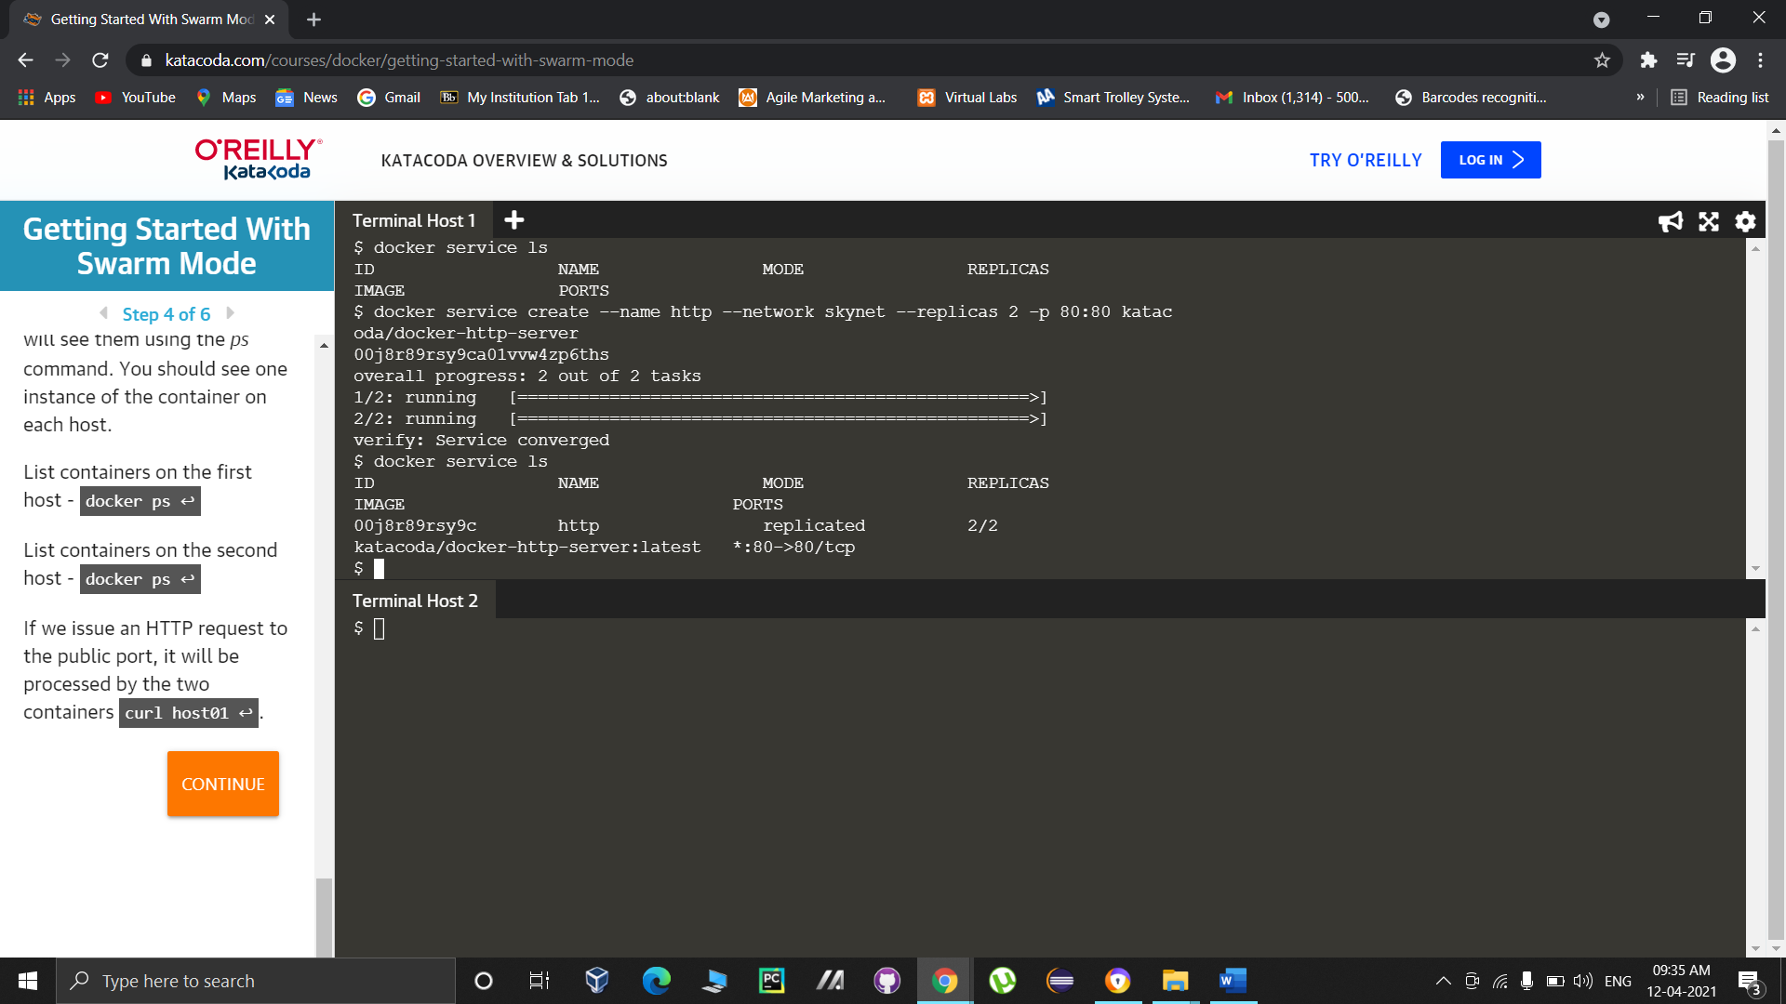

1. Use the command ‘docker service create --name http --network skynet --replicas 2 -p 80:80 katacoda/docker-http-server’ here we are creating 2 replicas and assigning them to the nodes.

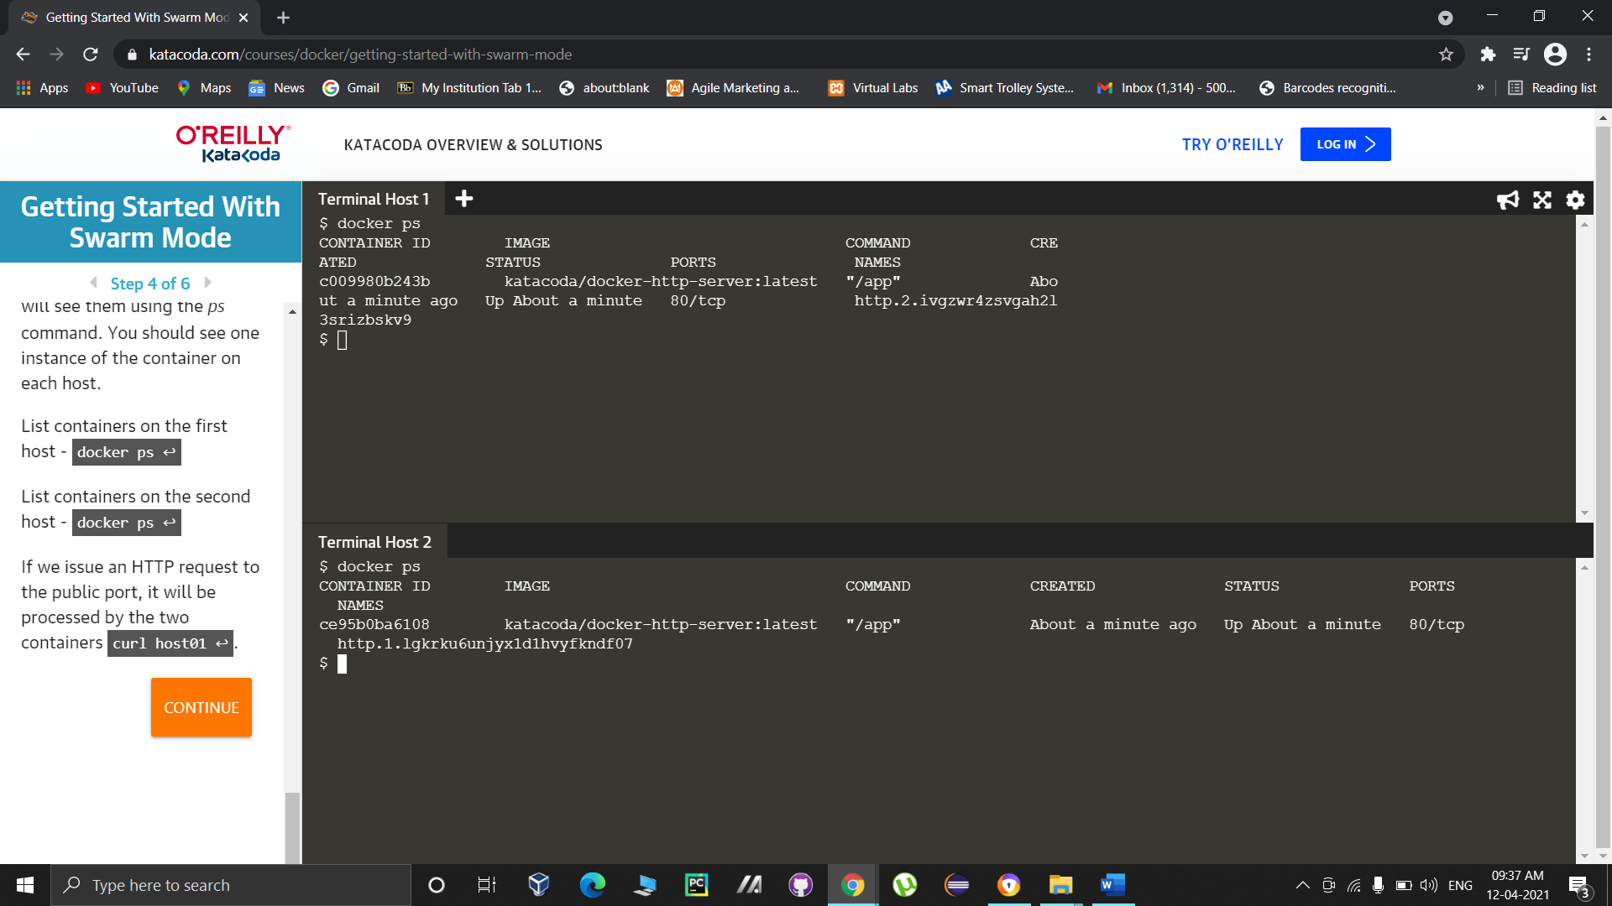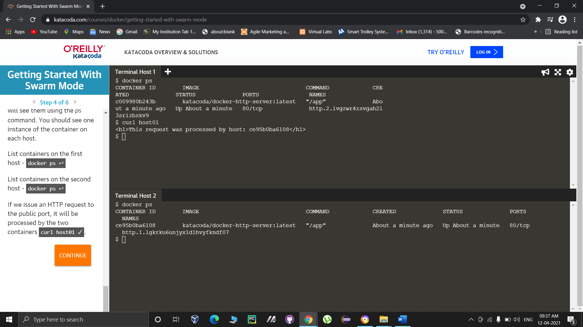

1. Once the service creation is complete, run the command ‘docker service ls’ to list the recently created service.

