**Name:** Prashasti Gupta

**Roll No:** R171218077

**SAP:** 500068493

**Experiment - 02**

**Aim:** To use the concept of Docker Volume.

**Steps:**

1. Running a docker container.

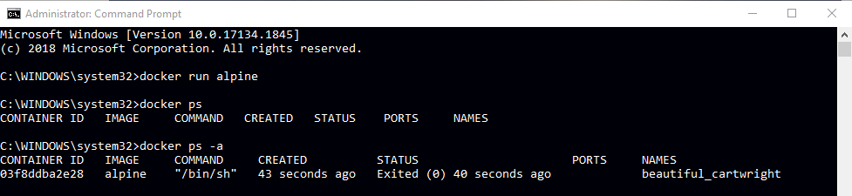

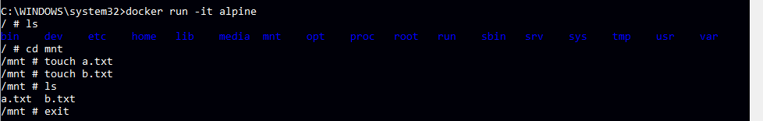

2. Creating a volume and linking to a specific directory.

3. Creating a file in that directory.

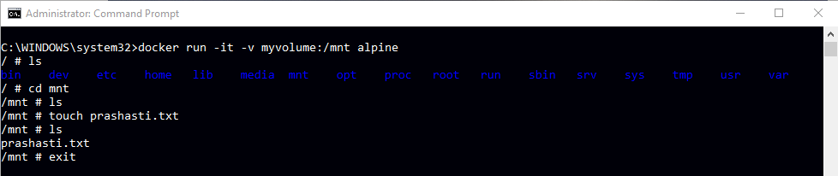

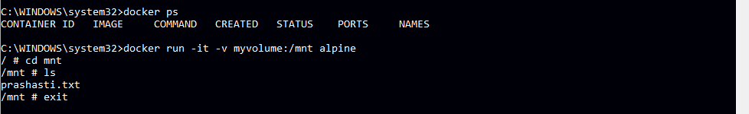

4. Running “docker volume ls”.

5. Running “docker volume inspect”.

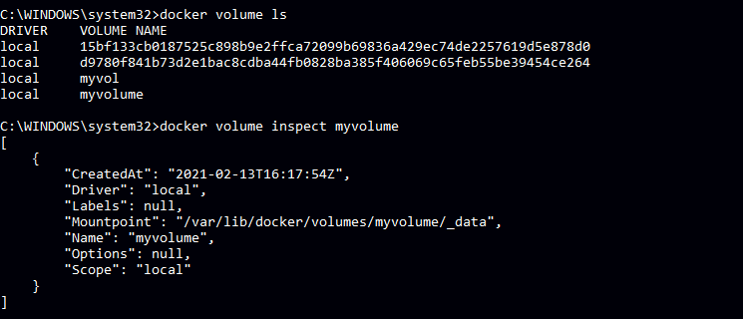

6. Checking for the created file at the mount point.

7. Running second container to link to the same volume.

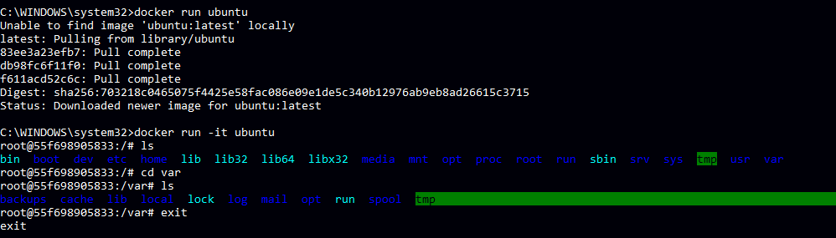

8. Creating a second file in another directory.

9. Again checking the mount point to see both the files.

