**Experiment - 03**

**Aim:** To understand networking in Docker.

**Steps:**

1. Creating a network

2. Linking a container with the network

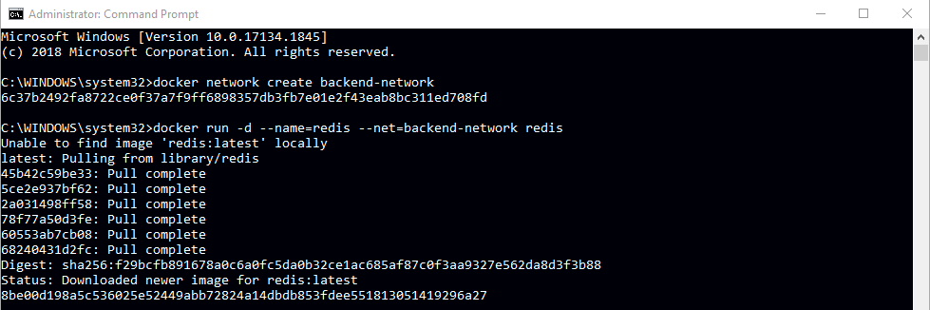

3. Running ping command

4. Creating second network

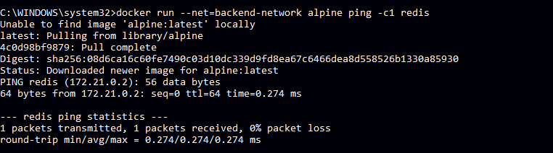

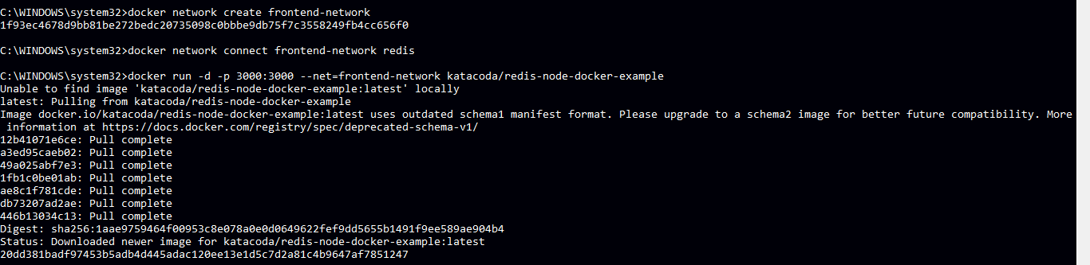

5. Linking second network with another container and verify connectivity.



6. Working with alias and inspecting the network.

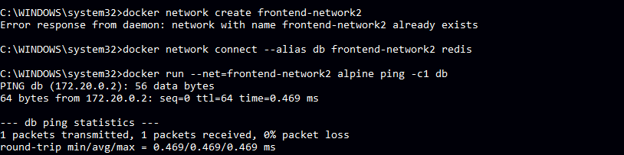

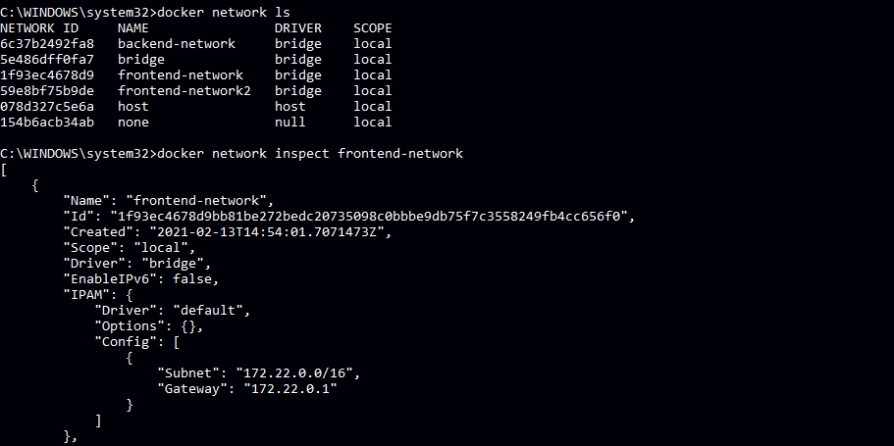

7. Disconnecting a network

