**Experiment - 04**

**Aim:** Dockerfile - Containerizing application, Building Images, Tagging, Publishing.

**Steps:**

1. Create a dockerfile

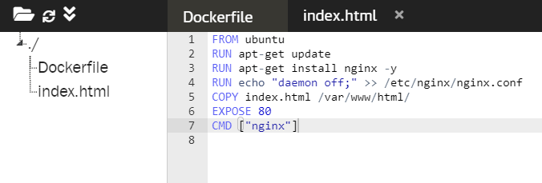

1. Create index.html

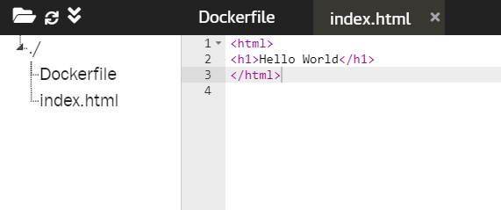

1. Building the docker image from Dockerfile

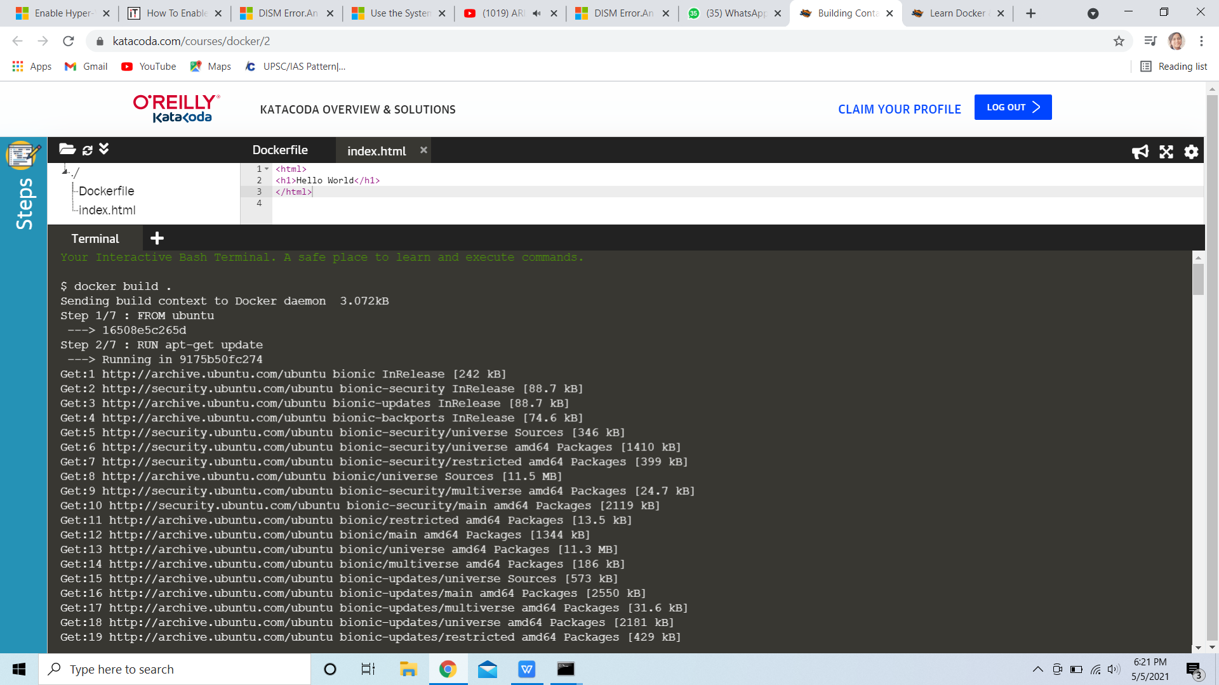

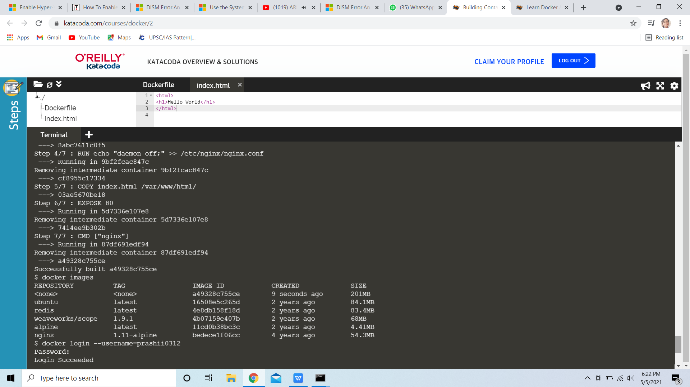

1. Logging in to Docker Hub. Tagging the image and then pushing it to Docker Hub.

