**Experiment - 06**

**Aim:** To understand Docker links.

**Steps:**

1. Open the terminal and run a postgres container.

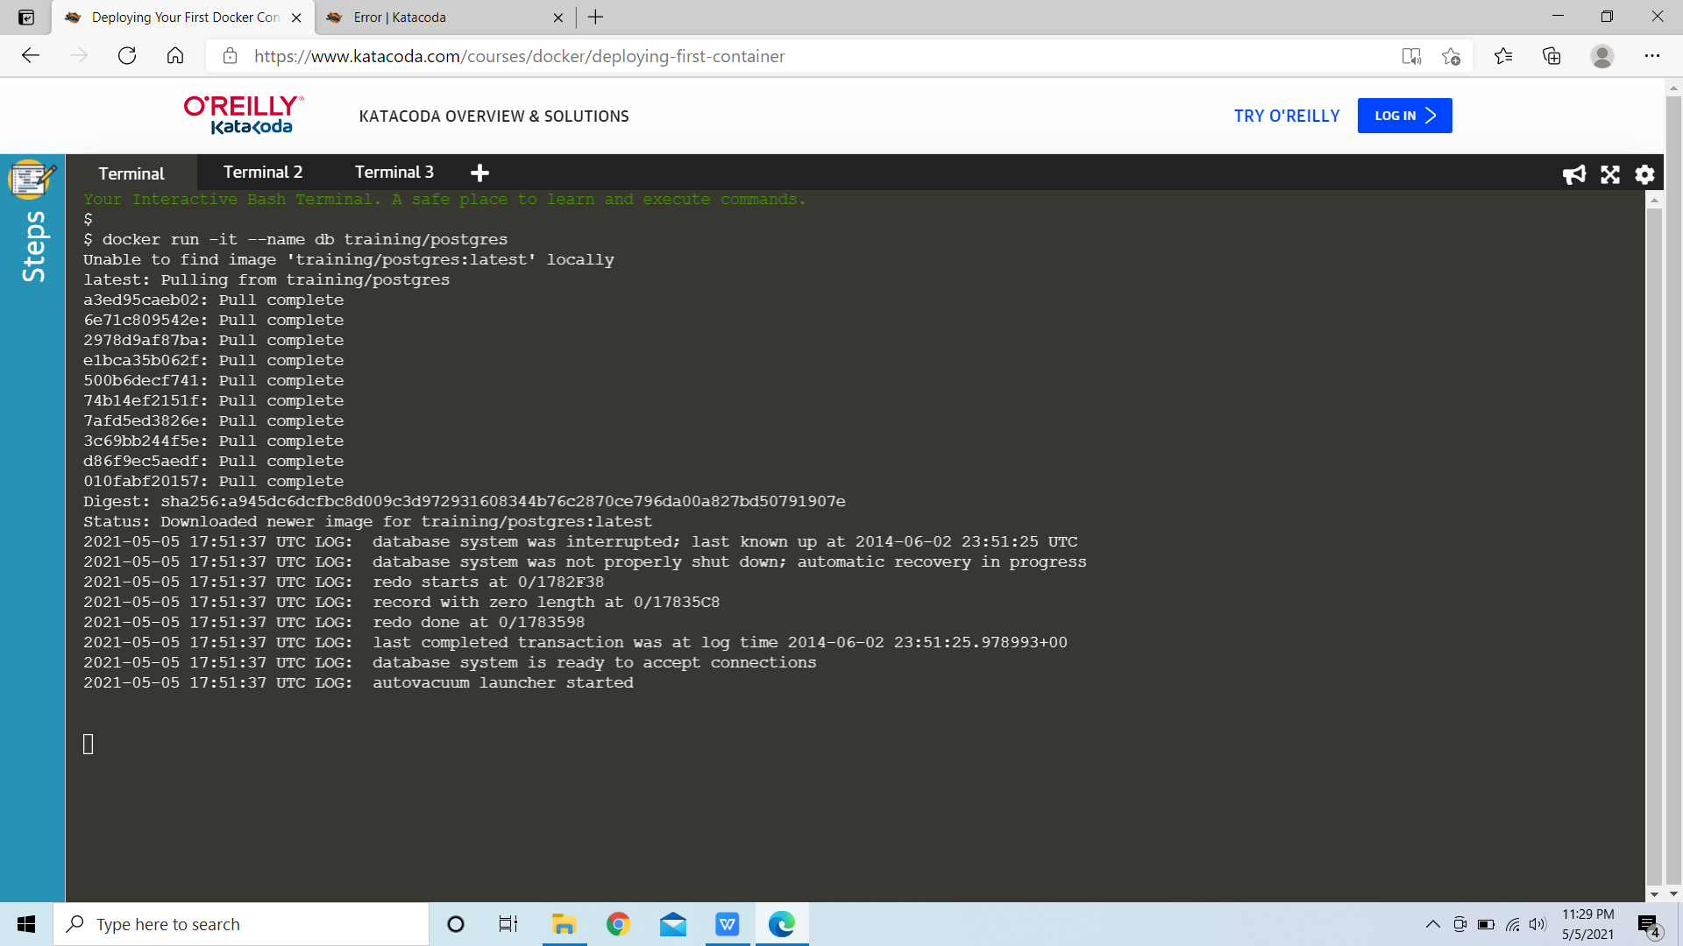

1. Run another container of image webapp linking it with the db container we just created.

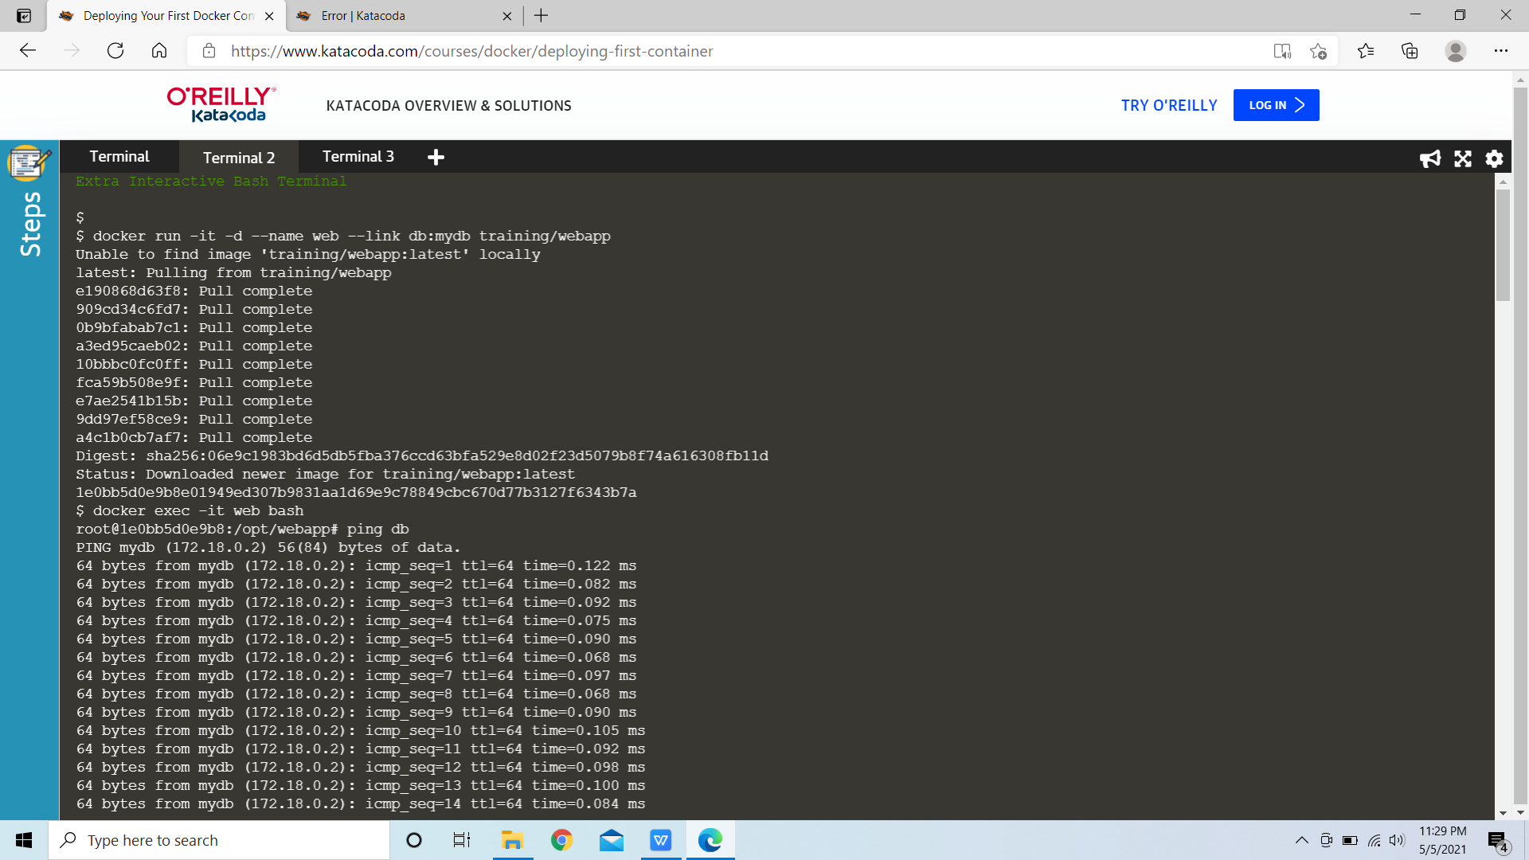

1. Switch to the terminal of the container by using ‘docker exec -it web bash’. After logging, ping the container with which we linked the current container.



4. Now run another container without linking it to any of the previous containers and check all the containers with the command ‘docker ps’.

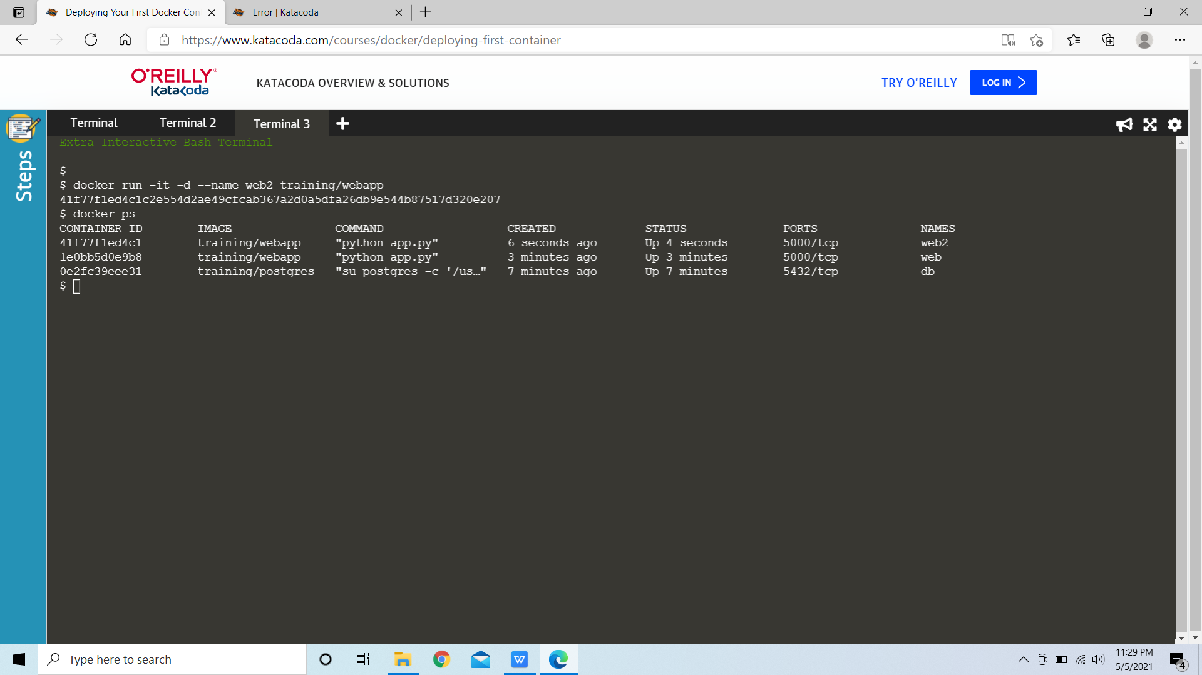

5. Login to the container again with which we ran the ping command once and try pinging the newly created container, the ping command will fail because the container isn’t linked with the other container.

