**Experiment - 07**

**Aim:** To understand Docker swarm.

**Steps:**

1. Open two terminals one being the master and the other being the slave.
2. Check if the swarm is active or not by running the command ‘docker node ls’.

Terminal 1 -

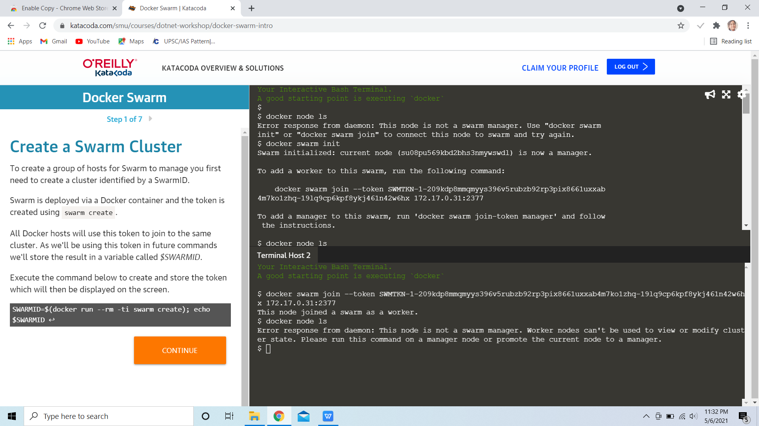

1. Activate the swarm using the command ‘docker swarm init’.
2. We can connect the other terminal as a worker to the master by running the command in the second terminal.

Terminal 1 -



Terminal 2 -



1. Again run the command ‘docker node ls’ to view all the nodes in the swarm we just activated.

Terminal 1 -

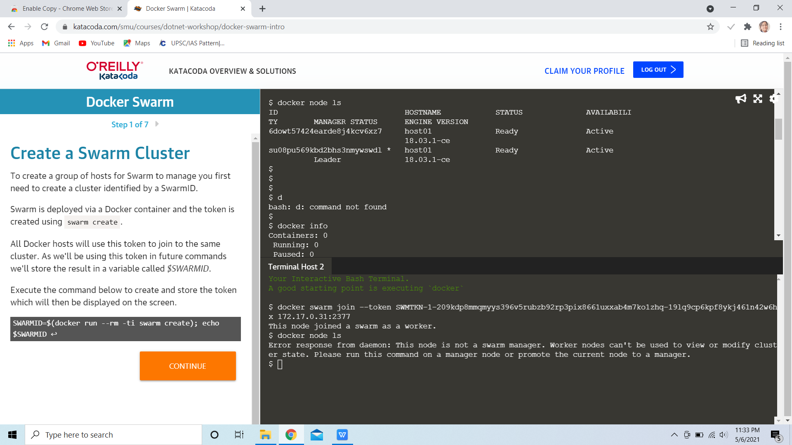

Terminal 2 -



1. We can check all the details of the swarm and the nodes by running the command ‘docker info’.

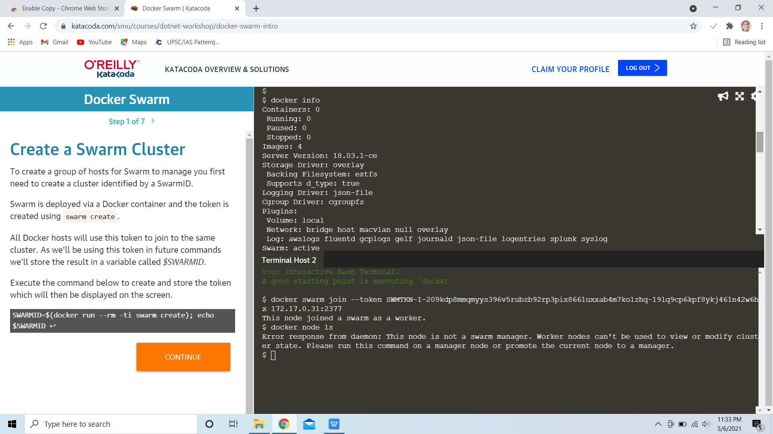

1. To remove a node from the swarm we use the command ‘docker swarm leave --force’ if the node is a manager and ‘docker swarm leave’ if it’s a worker node.

