**Experiment - 08**

**Aim:** To understand Docker Ignore.

**Steps:**

1. View the Dockerfile.

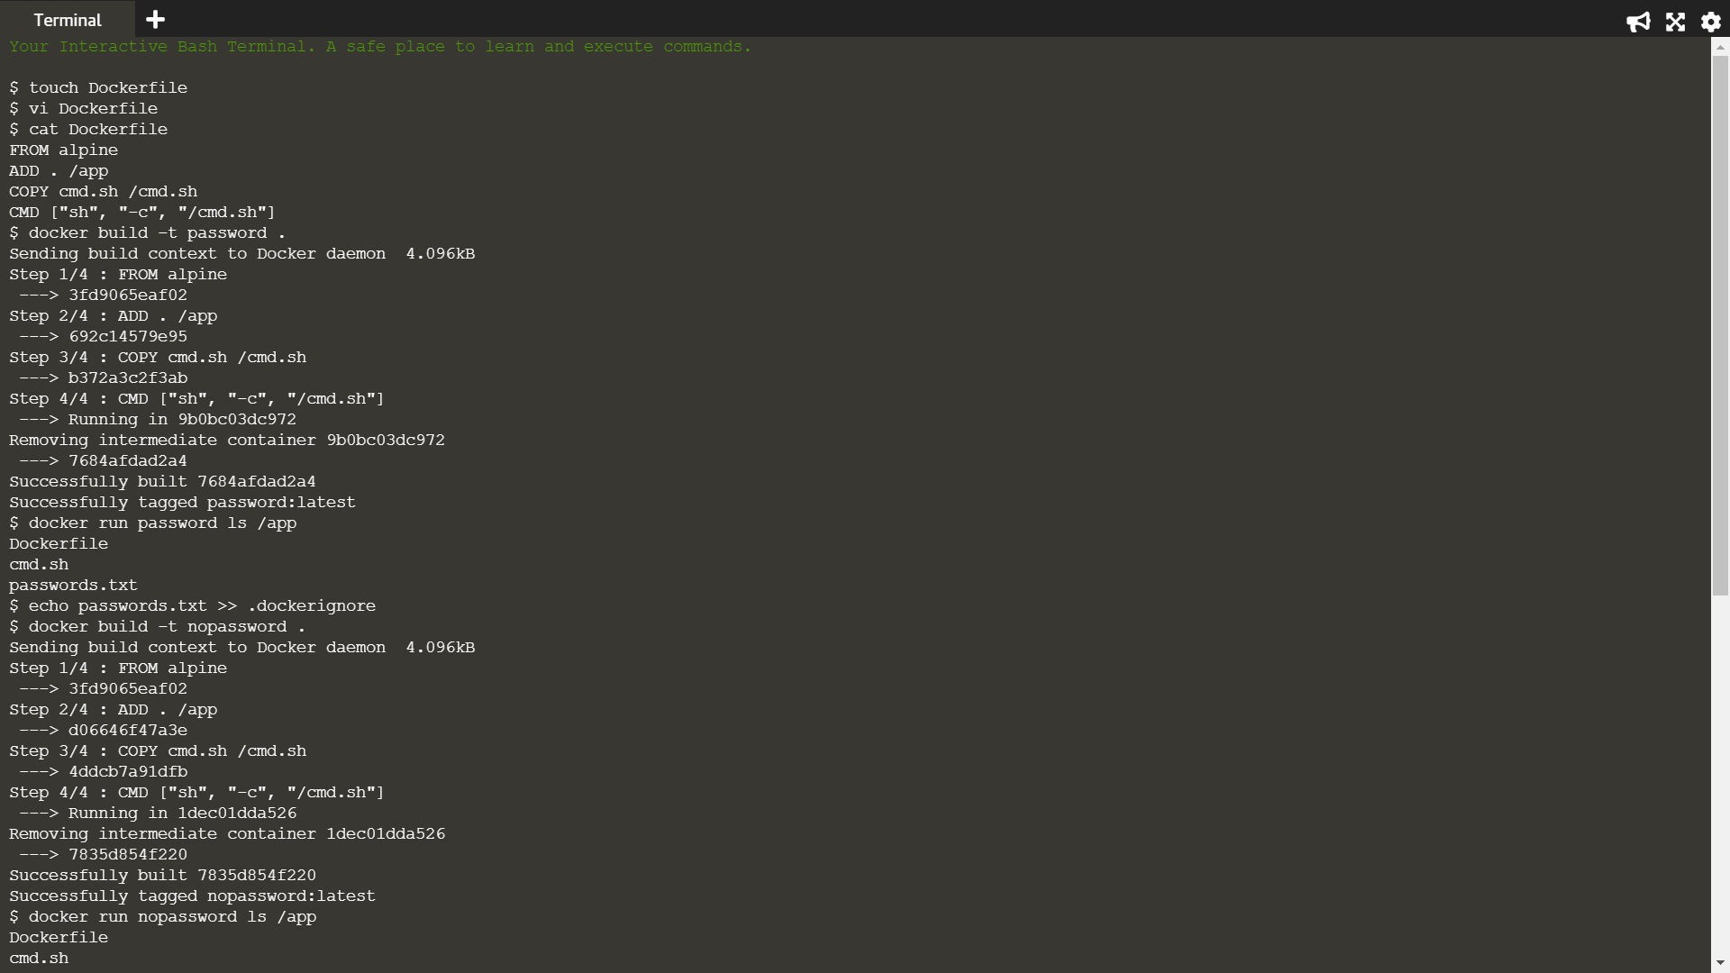

1. Build the docker image from Dockerfile.



1. Check the output.



1. The following command would include passwords.txt in the .dockerignore file to ensure that it didn't accidentally end up in a container. After that build the image.



1. Check the output.

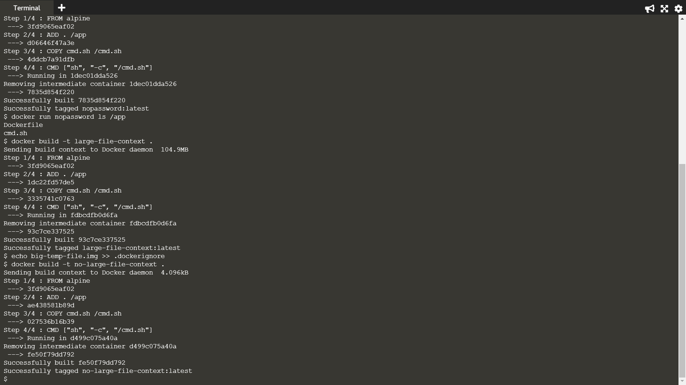

1. Pushing large files while building image.



1. Using dockerignore to stop 100M files from getting pushed when building the image.

