**Experiment - 09**

**Aim:** To understand Docker Metadata and Labels.

**Steps:**

1. Assign a label called user with an ID to the container. This would allow us to query all the running containers which are related to that particular user.

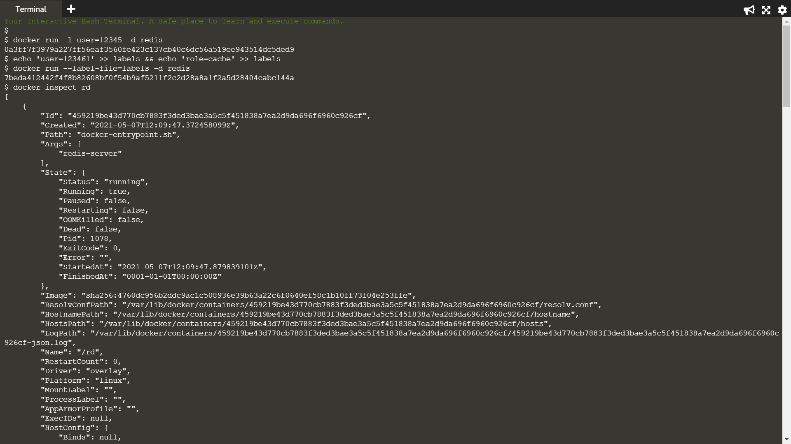

1. Create two labels in the file, one for the user and the second assigning a role.

The --label-file=<filename> option will create a label for each line in the file.



1. Provide a friendly name or hash id to the running container and then its metadata.



1. Use the -f option for filtering the JSON response to just the labels section we're interested in.

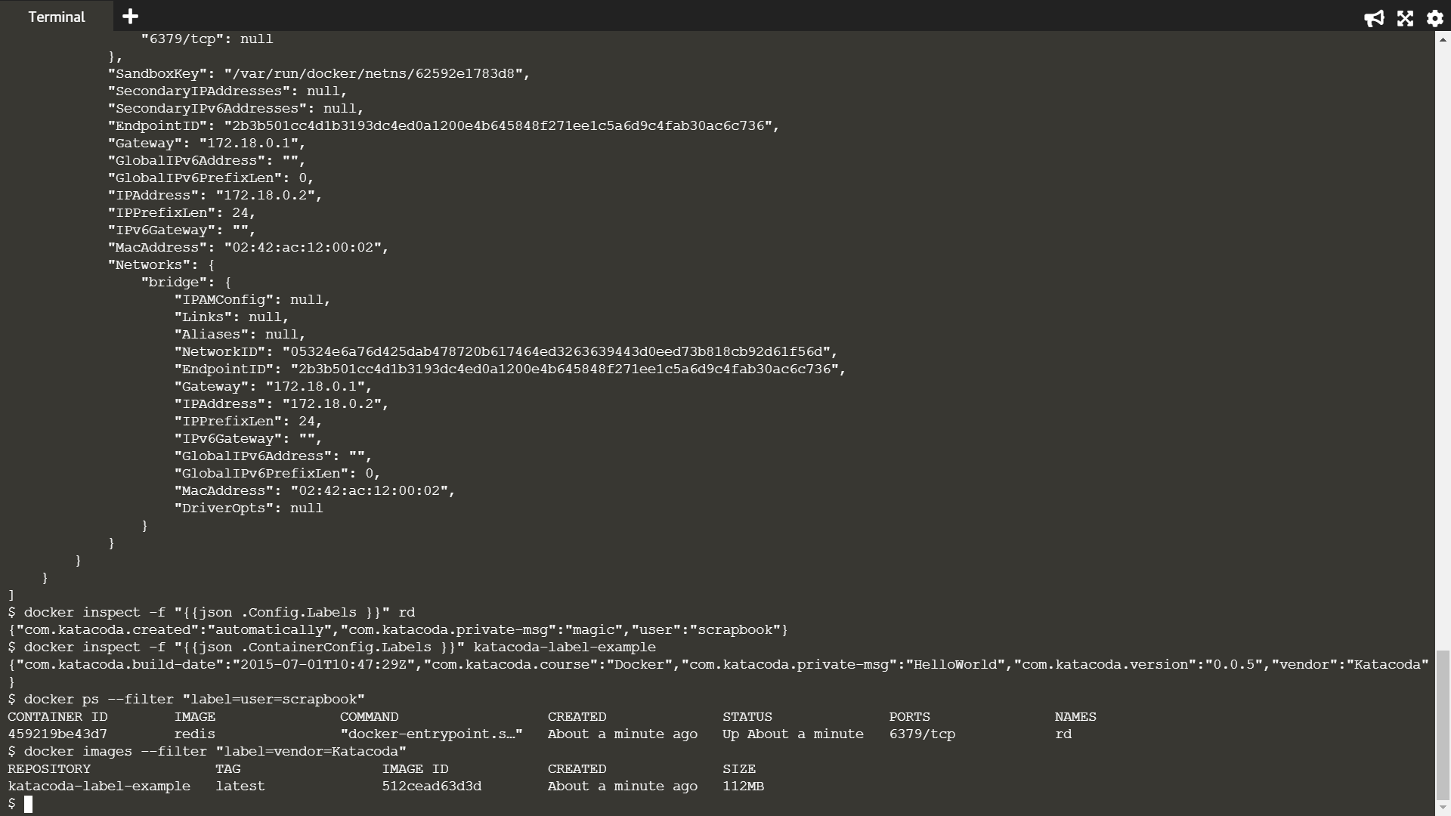

1. Inspecting images works in the same way however the JSON format is slightly different, naming it ContainerConfig instead of Config.



1. Run a query to return all the containers which have a user label key with the value katacoda.



1. The same filter approach can be applied to images based on the labels used when the image was built.

