**Experiment - 10**

**Aim:** Managing log files in Docker.

**Steps:**

1. In the background, there is an instance of Redis running with the name redis-server. Using the Docker client, we can access the standard out and standard error outputs.

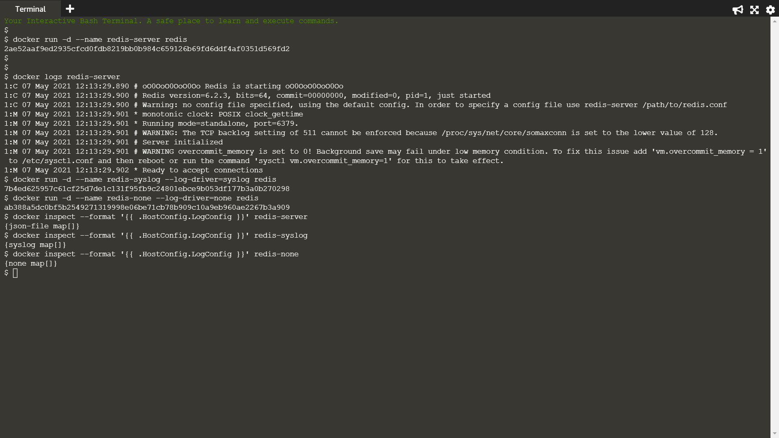

1. We will then redirect the redis logs to syslog.



1. When the container is launched, no output will be logged when we set log-driver to none.



4. Output the LogConfig section for each of the containers.

