**Experiment - 11**

**Aim:** To understand Docker Restart Policy to ensure uptime.

**Steps:**

1. Here it is a special container which outputs a message and then exits with code 1 to simulate a crash. We will launch an instance.

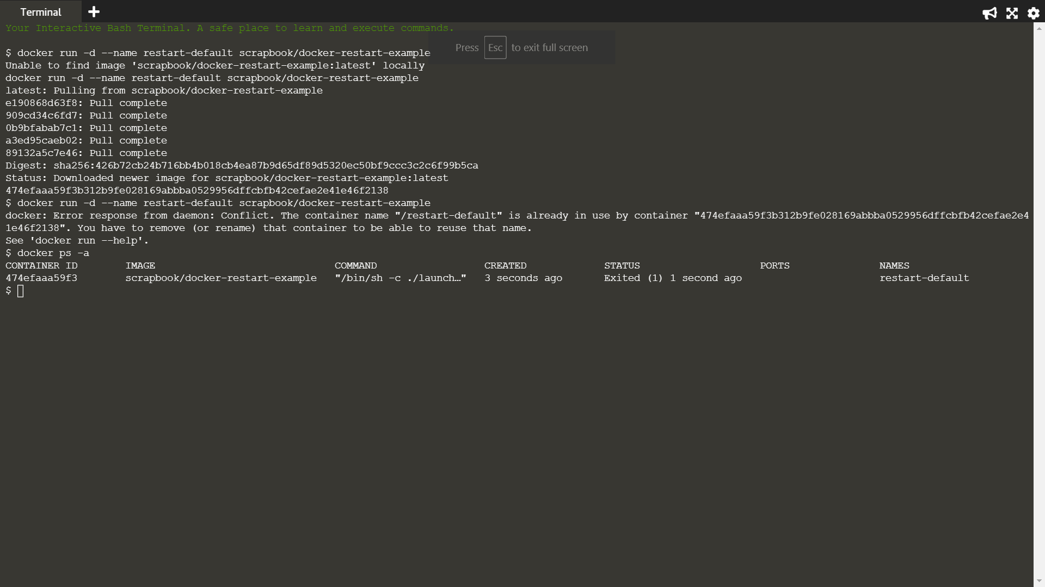

1. List all the containers, including stopped ones, to see if the container has crashed.

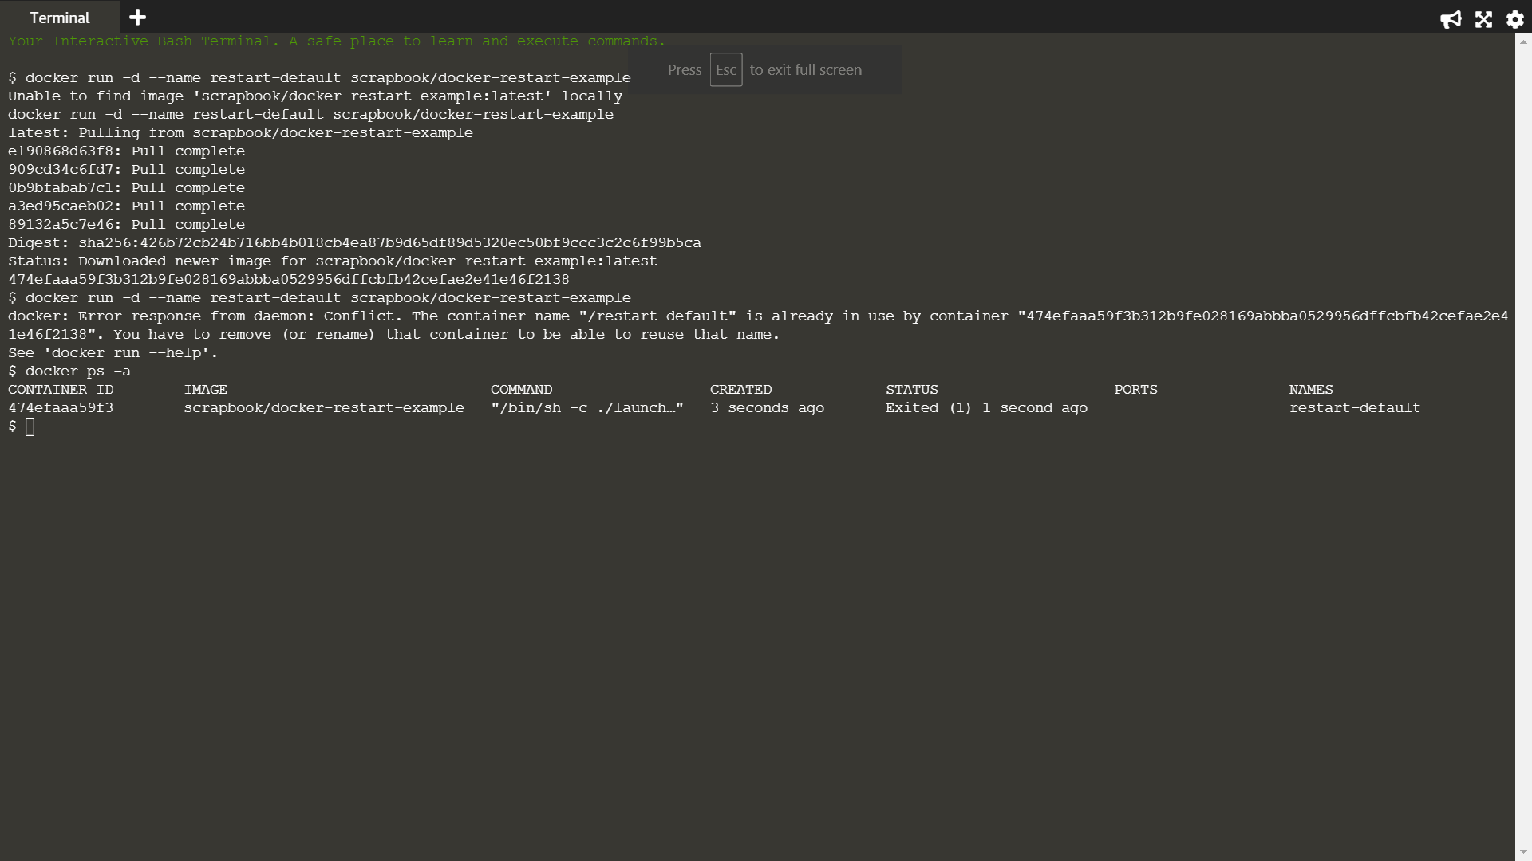

1. The logs will output a message, which indicates information to diagnose the issue.

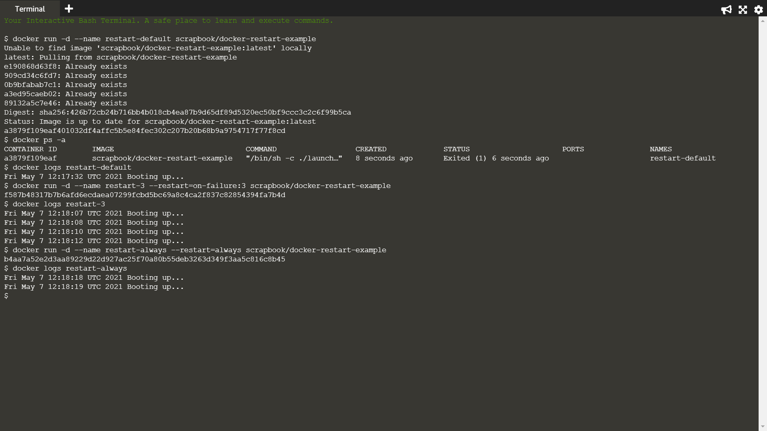

1. In the example below, Docker will restart the container three times before stopping.



1. Use the always flag to automatically restart the container when it crashes.

