

**EXPERIMENT-10**

**NAME- RAJAT PANWAR**

**SAP ID - 500069414**

**ROLL NO- R171218080**

**BATCH- B.TECH(CSE-DEVOPS), B2**

**SUBMITTED TO:-**

**MR. HITESH KUMAR SHARMA**

**AIM-** Ignoring file during build

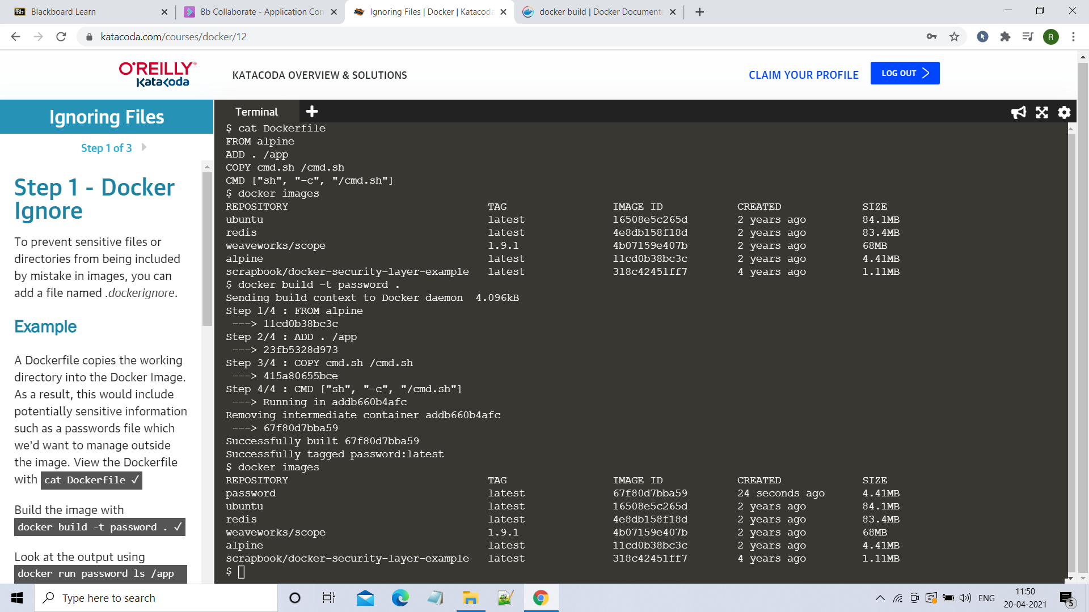

Here we can see when we run container before ignoring the file and after ignoring the file **password.txt** file has completely ignored.

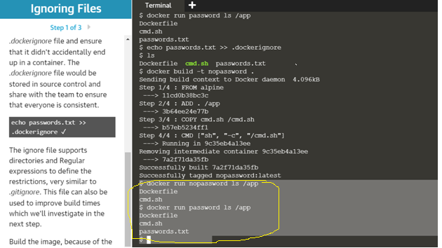

Here we can see the file size if we build a docker image with out ignoring that the size of file is 104.9MB .

If we this after ignore the .dockerignore file the file size is 4.096KB.

