EXPERIMENT-7

NAME- Rajat panwar

ROLL NO- R171218080

SAP ID- 500069414

BATCH- B.Tech(CSE-DEVOPS)

SUBMITTED TO-

MR. HITESH KUMAR SHARMA

AIM- Docker linking and swarm

Run a container in deteched mode which name is “*db*” from image

“training/postgres”.

COMMAND -

$ docker run -it -d --name db training/postgres

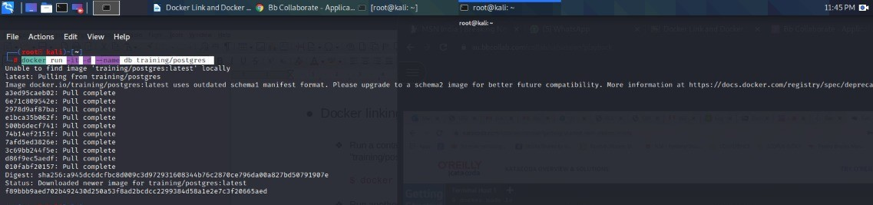

Run another container in deteched mode with the name of “web” form images “training/webapp” and link with “db” with alias “mydb“. And check the running container list with the help of docker ps command

COMMAND :-

$ docker run –it –d –name web –link db:mydb training/webapp

$ docker ps

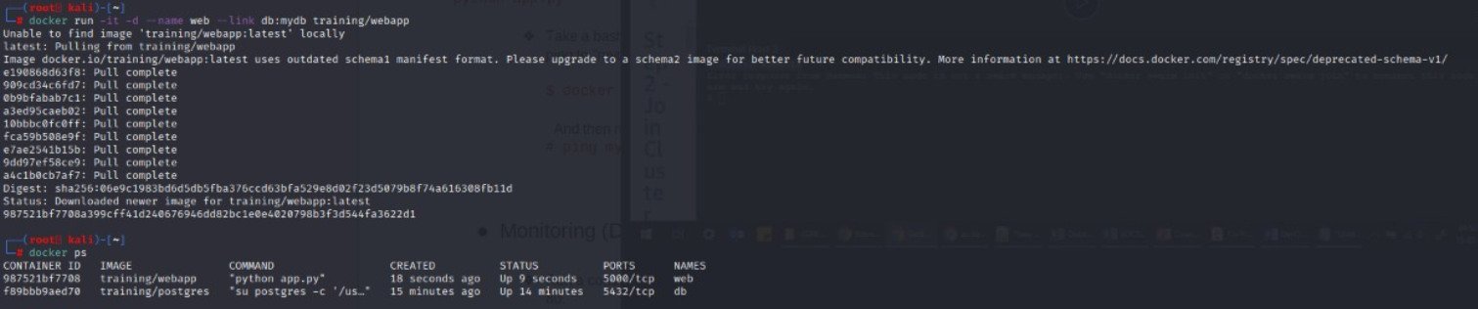

After that we will go inside the bash terminal of “web” container and ping with “db” container to know that our container have linked or not with each other.

COMMAND:

$ docker exec –it web bash

$ ping db

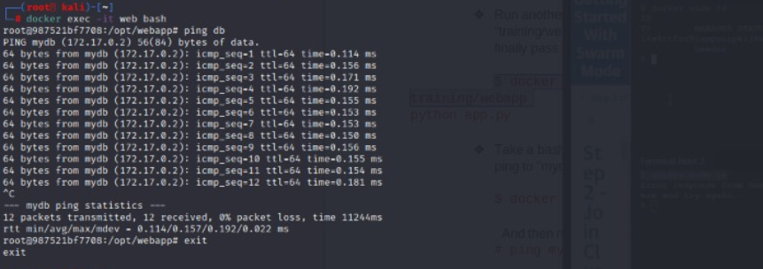

After that if pinging has started than our container have inked if not container has not linked.

For example we create a new container with the name “db1” and take bash terminal but we will not use the link command than ping command will not work

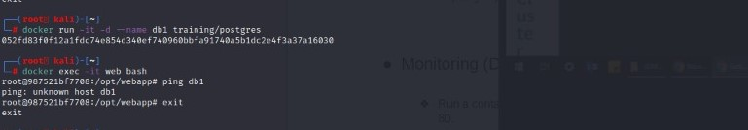

NOTE-- IN THIS SENERIO WEB IS DEPENDENT ON DB BUT DB IS NOT DEPENDENT ON WEB. REVERSE IS NOT TURE

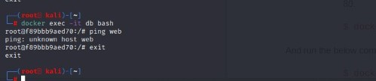

2] CREATE A SWARM

A Docker Swarm is a group of either physical or virtual machines that are running the Docker application and that have been configured to join together in a cluster.

The activities of the cluster are controlled by a swarm manager, and machines that have joined the cluster are referred to as nodes.

--🡪 In this we need two terminal . In this we will make master 1st terminal and other terminal work as worker

IN this there is no any node

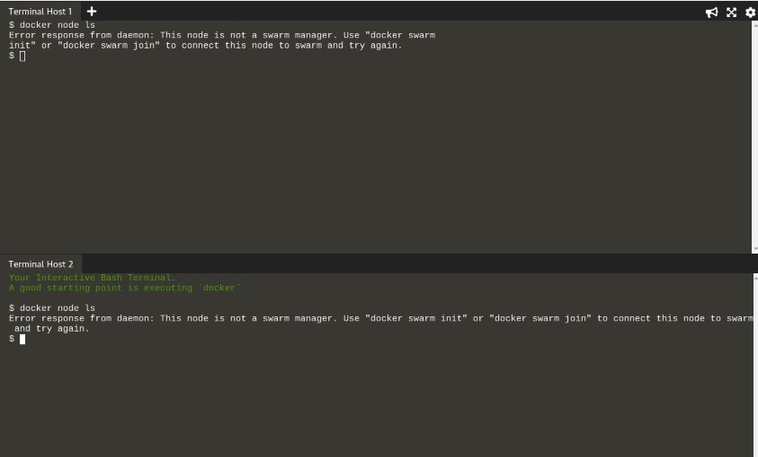

After that we will create a new swarm with the help of this command:

And we will make 1st trerminal as a master

COMMAND – $ docker swarm init

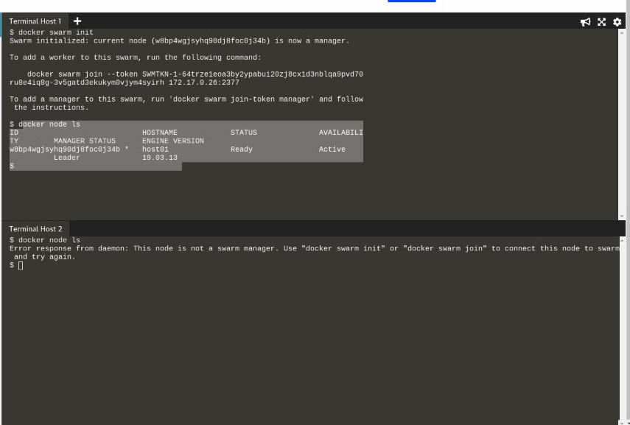

We can see that 1st terminal is master but in 2nd there is no node

So now we make worker 2nd terminal.

With the help of this command

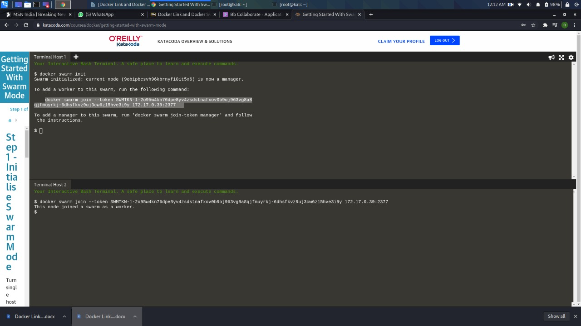

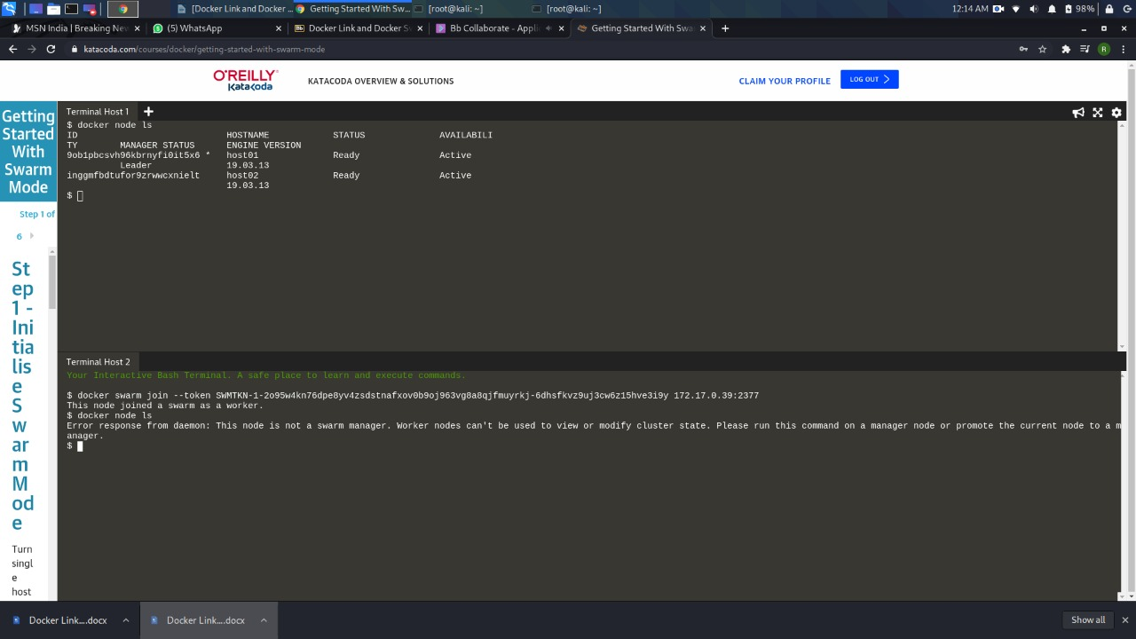

now 2nd terminal will work as a worker