

**EXPERIMENT-5**

**NAME- RAJAT PANWAR**

**SAP ID- 500069414**

**ROLL NO- R171218080**

**COURSE- B.TECH[CSE-DEVOPS]**

**SUBJECT- APPLICATION CONTAINERIZATION LAB**

SUBMITTED TO:-

MR. HITESH KUMAR SHARMA

**AIM-** Create your own docker image and push on dockerhub.

Firstly we create the “**Dockerfile**” and “**index.html**” file and write the code inside that both file.

----DOCKERFILE----

FROM ubuntu

RUN apt-get update

RUN apt-get install nginx -y

COPY index.html /var/www/html/

EXPOSE 80

CMD [“nginx”,”-g”,”daemon off;”]

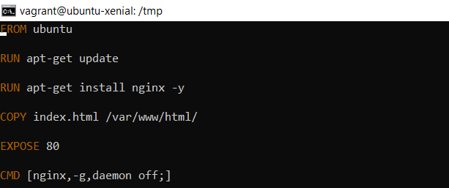

--INDEX.HTML—-

<html>

<h1>Level Up In Tech</h1>

<p> Learning it. Labbing it. Leveling Up</p>

<p>This is a simple static website, built and deliver from a docker container</p>

<p>Visit us here: <a href="levelupintech.com">Level Up In Tech</a></p>

</html>

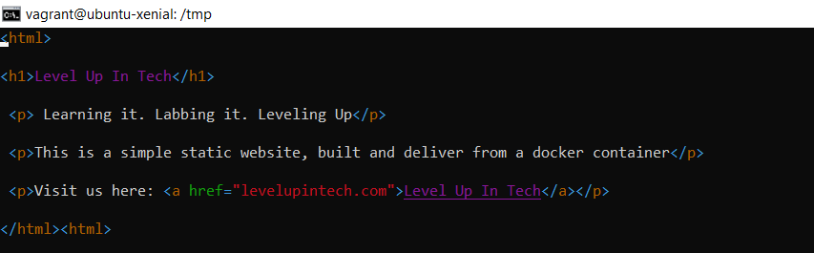

To allow the users to build their own images :-

Sudo docker build –t nginx1:1.0 .

-t 🡪 mention a tag to the image

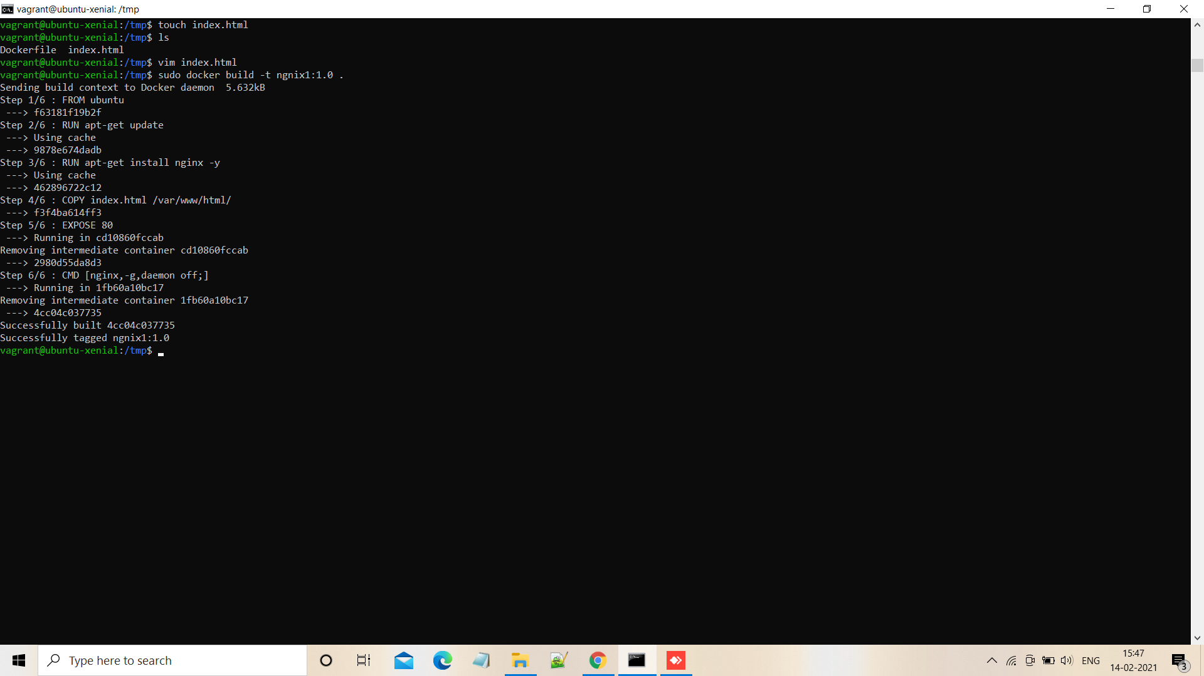

And now we create a docker image which name is “**ngnix1**”

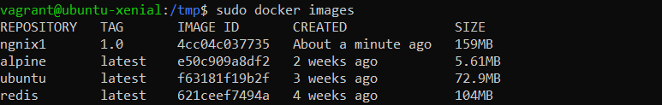

After that we will create a repository on dockerhub

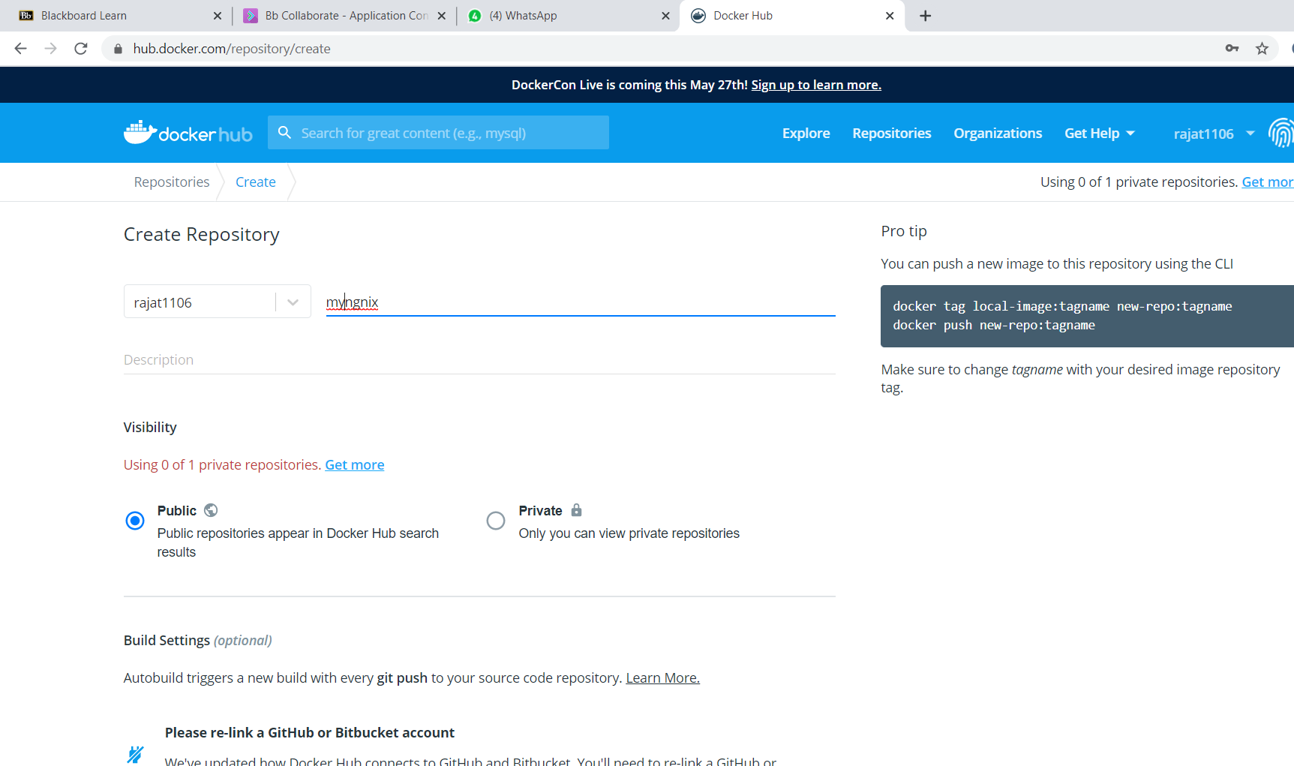

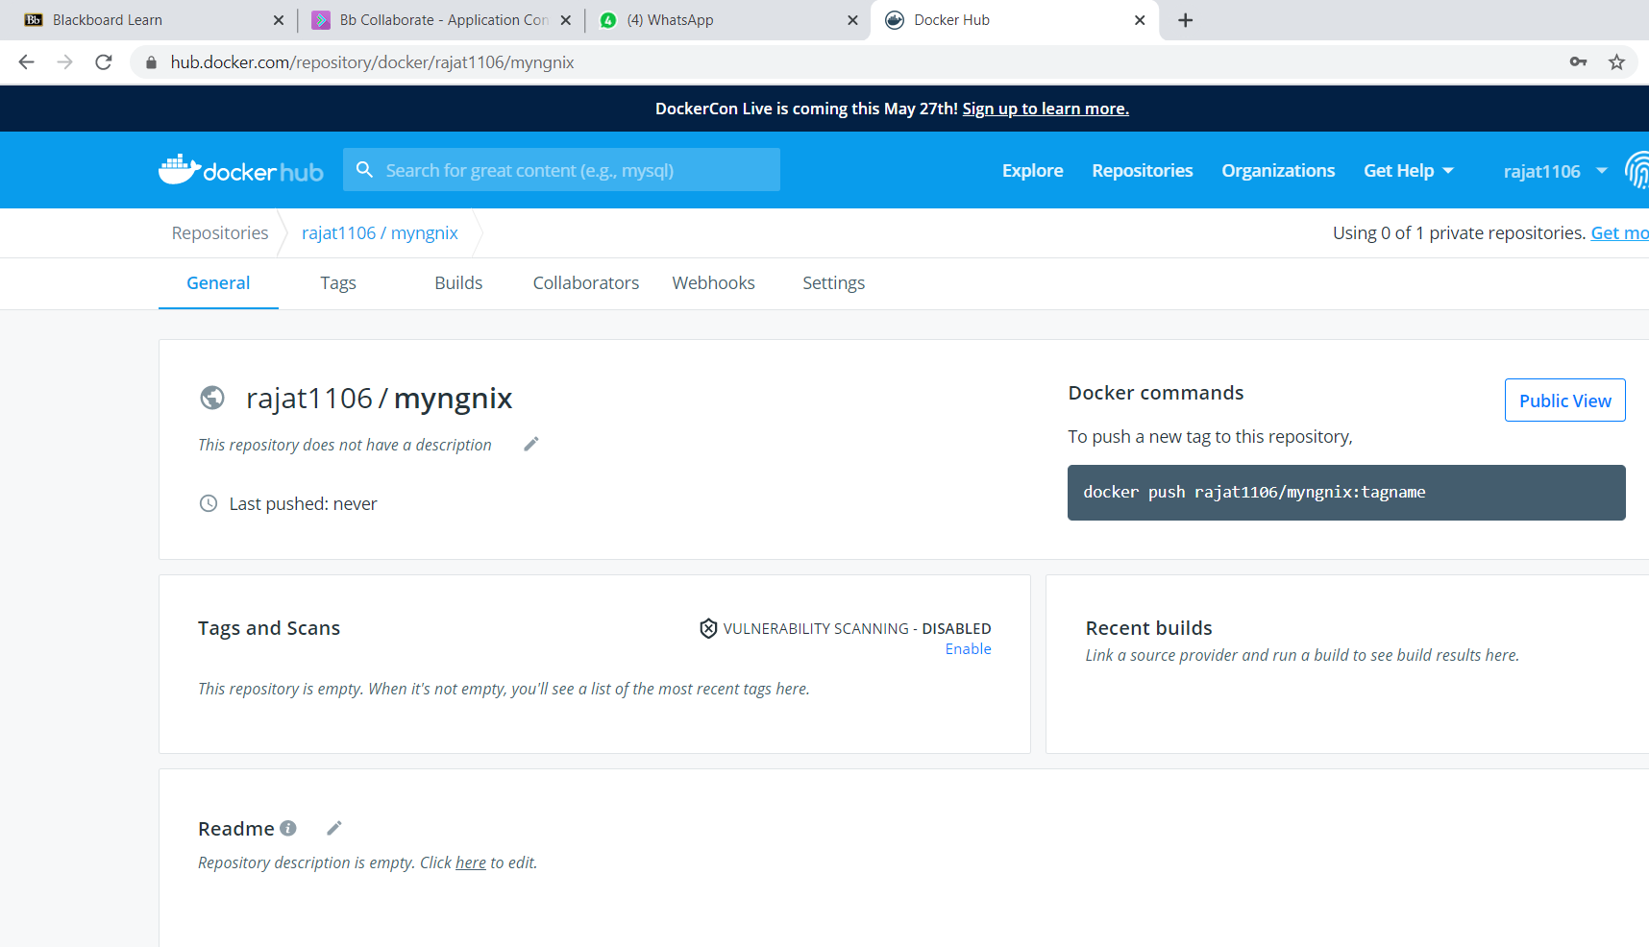

And connect your machine with dockerhub with the help of this command-

$ docker login

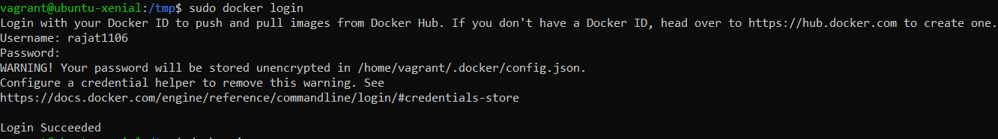

* DOCKER TAG--:

And after that we will change the name of our image with the help of this command-

$ docker tag “**container id**” and “**dockerhub id**”/“**image name**”:version

EXAMPLE- docker tag cc0f rajat1106/nginx:1.0

This method allows one to tag an image to the relevant repository.

This command create two images with same id-

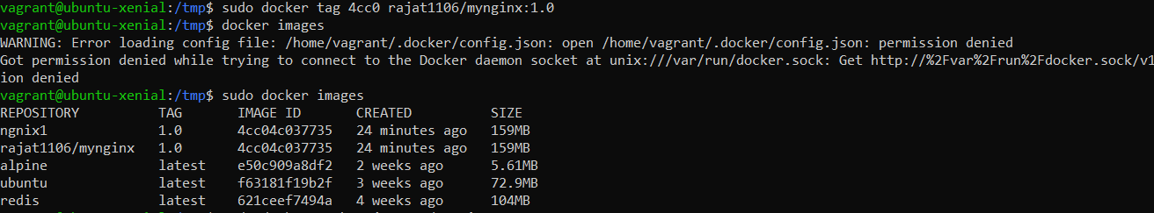

**DOCKER PUSH:-**

We will push our image on docker hub with docker push

$docker push “***repository name***” with dockerhub id:

EXAMPLE-- $ docker push rajat1106/mynginx:1.0

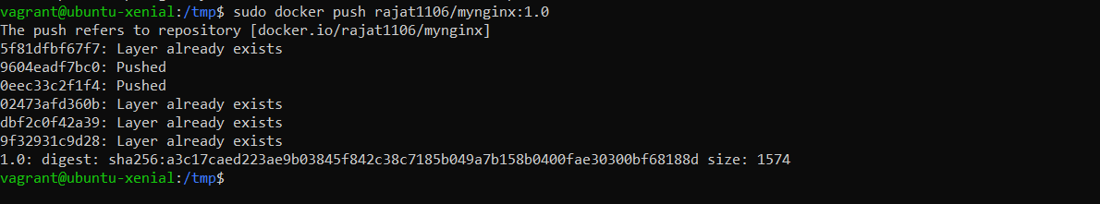

After that we will go on dockerhub and refresh our docker hub page and we will get their image like this:-

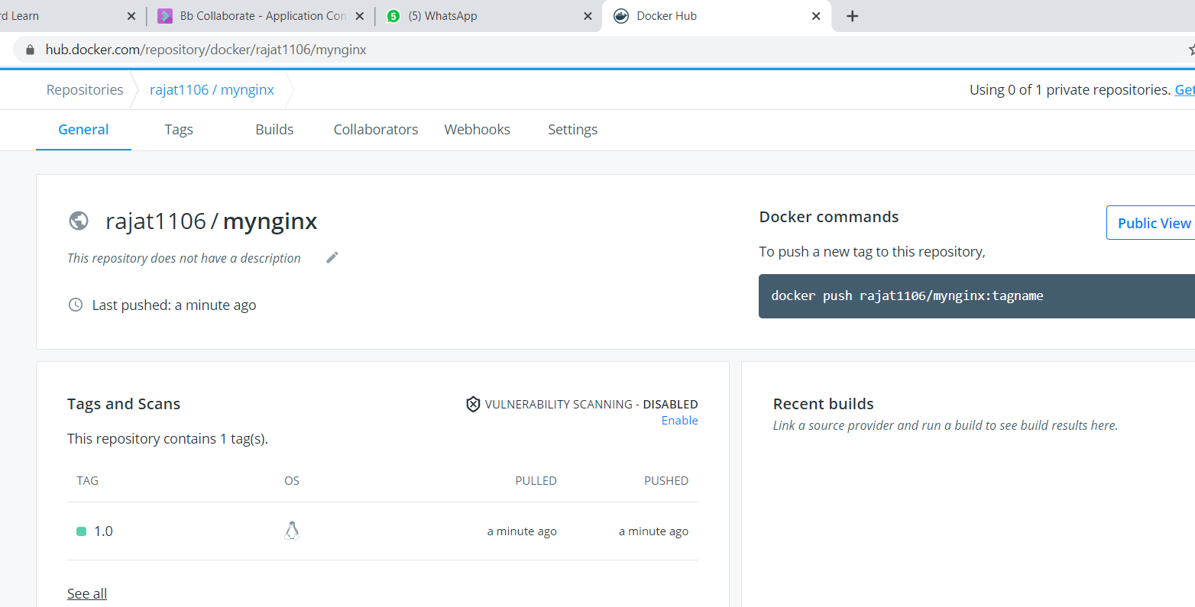

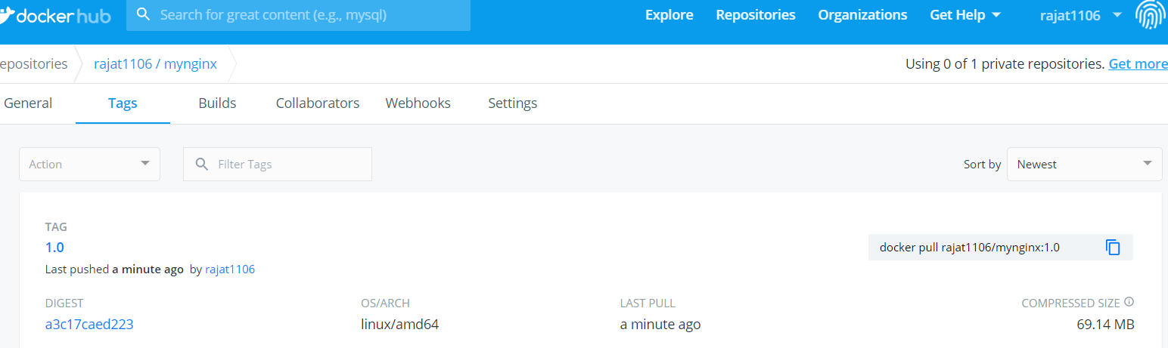

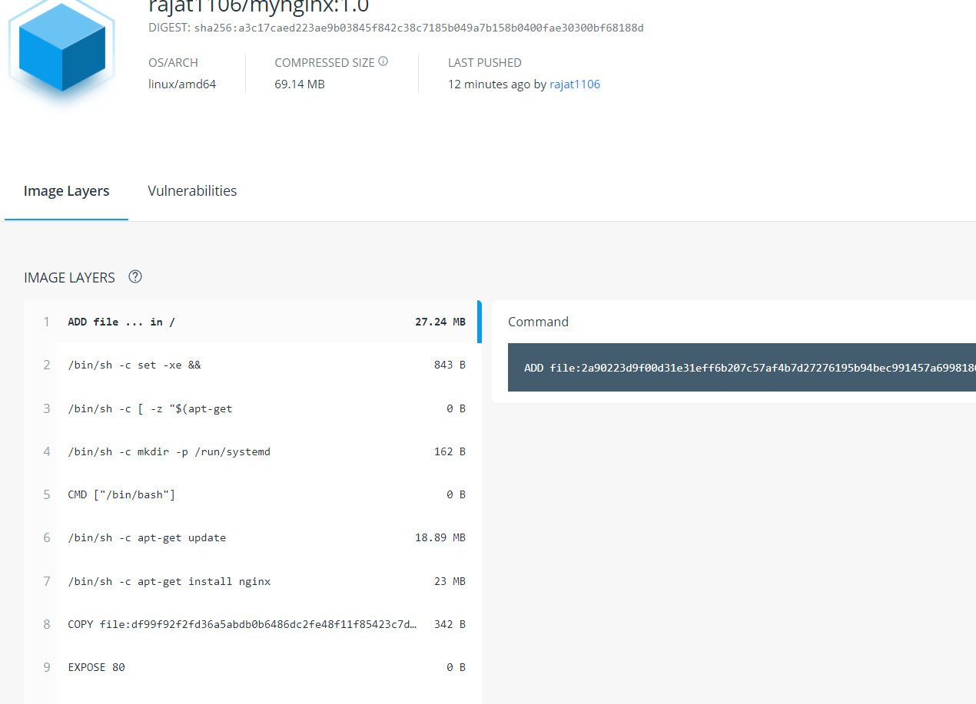

Now we will use this image on our local machine with the help pf this command and we assign a port number and execute the on our browser:-

COMMAND-- $ sudo docker run –d –p 80:80 rajat1106/mynginx:1.0

after run this command we will check that our container is run or not with the help of this command:-

**COMMAND🡪** $ docker ps

And search on search bar of your browser

localhost:80 because we assign 80 port so we have to write 80 and second 80 take from our index.html file.

and you will get that page which code we wrote tha code ***index.html*** file

