EXPERIMENT-2

NAME- RAJAT PANWAR

ROLL N0- R171218080

SAP ID – 500069414

SUBJECT- APPLICATION CONTAINERIZATION

**SUBMITTED TO:-**

**MR. HITESH KUMAR SHARMA**

1. **COMMAND-: docker search redis**

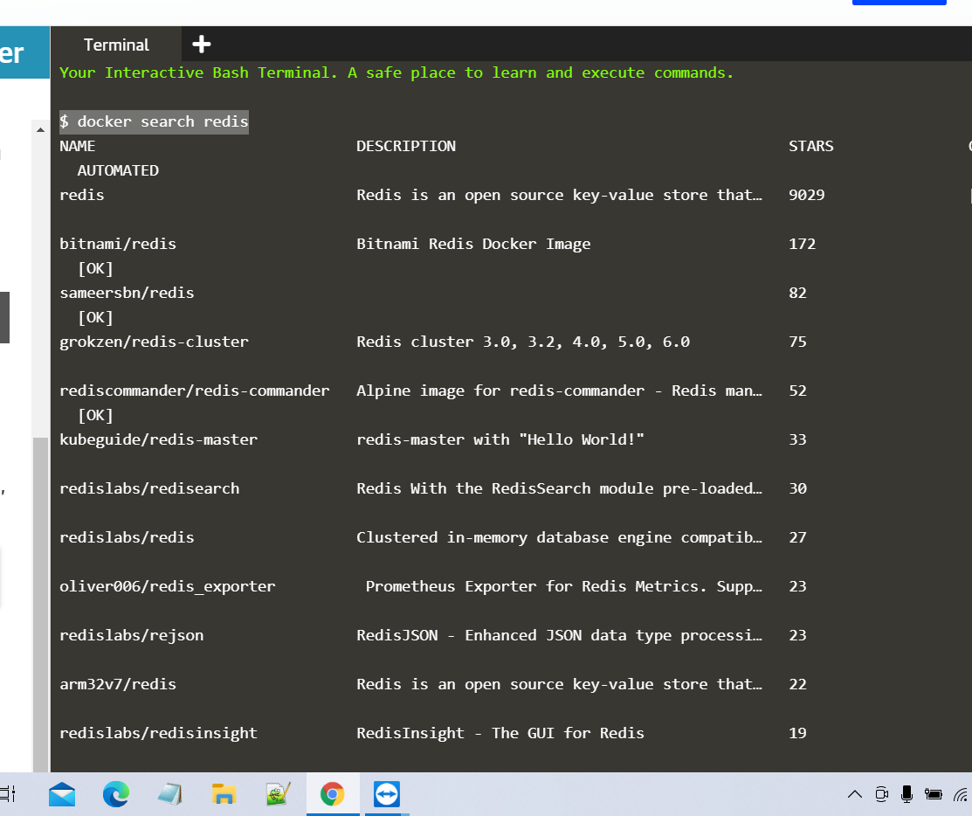

1. **COMMAND-: docker run –d redis**

