

**UNIVERSITY OF PETROLEUM & ENERGY STUDIES**

**Dehradun**

**Application Containerization**

**Experiment 1**

**Name: Shashwat Kumar**

**Course: B-Tech CSE DevOps (2018-22)**

**Roll number: R171218093**

**Sap ID: 500068392**

**Vagrant**

**Creating Virtual Machines using Vagrant**

* Install Vagrant by downloading the binaries from the following site:

<https://www.vagrantup.com/downloads>

* Open terminal/Command Prompt and check that vagrant is running using the command:

vagrant –version

* Create a new folder and traverse to that folder:

mkdir VM1

cd VM1

* Initialize the vagrant in the directory so created using the following command:

vagrant init

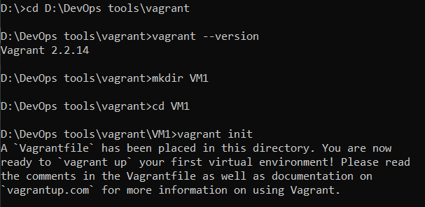

* Open the Vagrantfile that was created
* Change the “config.vm.box” attribute to “ubuntu/xenial64”
* Save the file

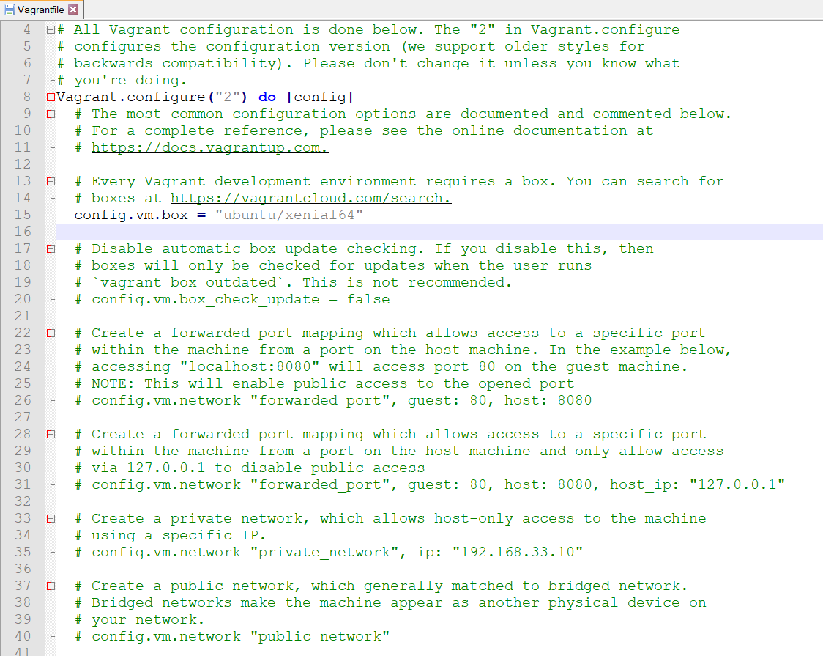

* To up the virtual machine, use the command:

vagrant up

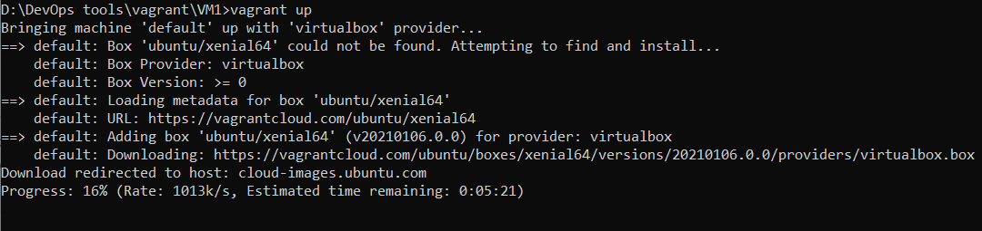

* Vagrant downloads the “Xenial64” VM if not found locally and starts it using the Virtual Box or VMWare

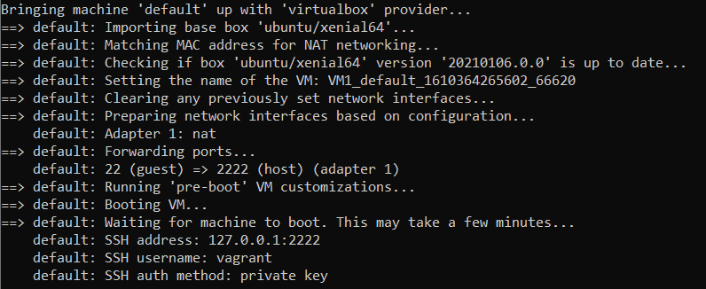

* The Virtual Box or VMWare will show the running Xenial64 VM once it starts successfully

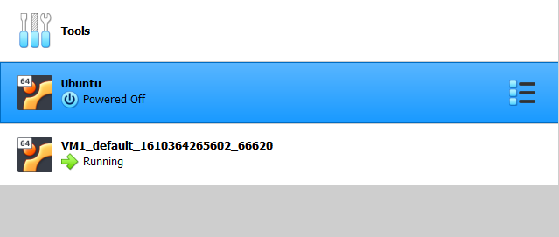

**Login and SSH into the VM**

* If the vagrantfile setting was set to run the VM in an interactive mode, the following window of VM will also start

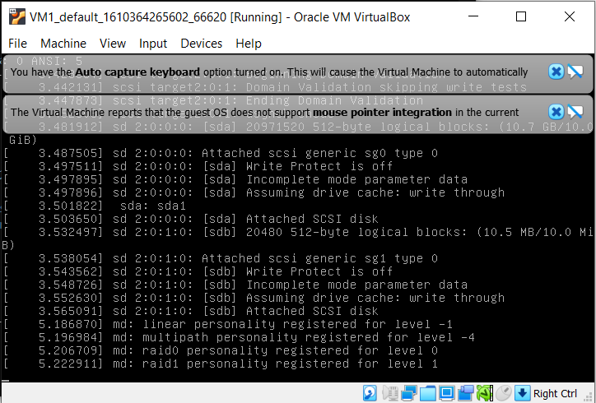

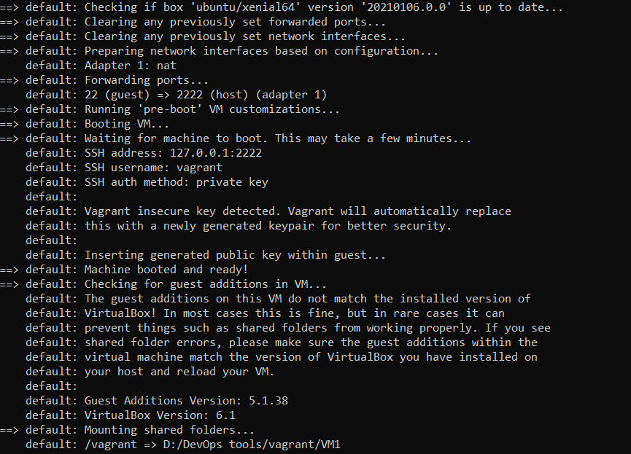

* The VM once started successfully, will look like the following
* It can then be login using the Xenial64 root username and password

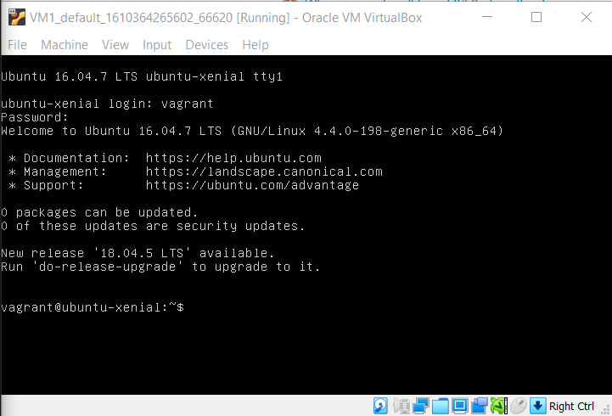

**Halt and Destroy the VM**

* To stop the running VM use the following command:

vagrant halt

* To delete the VM infrastructure from the local machine use the following command:

vagrant destroy

