

**UNIVERSITY OF PETROLEUM & ENERGY STUDIES**

**Dehradun**

**Application Containerization**

**Experiment 2**

**Name: Shashwat Kumar**

**Course: B-Tech CSE DevOps (2018-22)**

**Roll number: R171218093**

**Sap ID: 500068392**

**Docker Volume**

**Running Containers with Docker Volumes**

* Create a redis image with the name “redis1” and having a persistent volume connected to home directory of the container:

docker run -d –name=redis1 /mnt/d/alpine:/home/ redis redis:latest

* Enter into the running redis container using the command:

docker exec -it redis bash

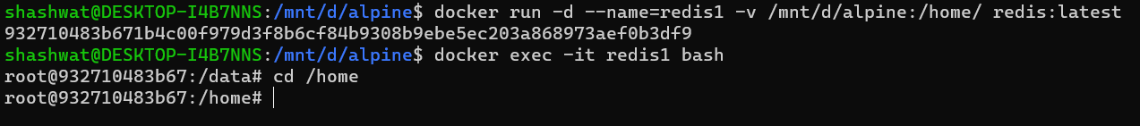

* A new directory is created on the local machine which gets connected to the running container

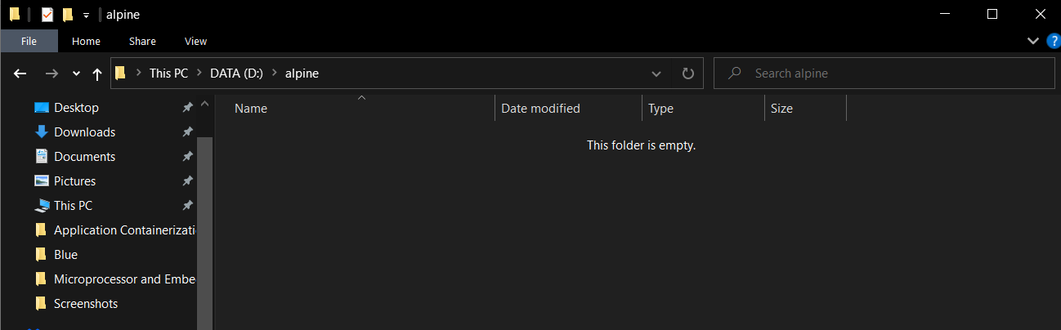

**Data persistence with Docker Volumes**

* Create sample files in the connected directory of running container “redis1”

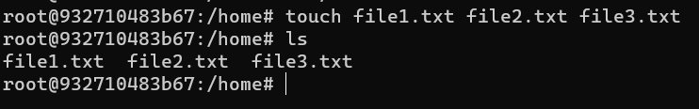

* The new files also show up on the local machine inside the created volume

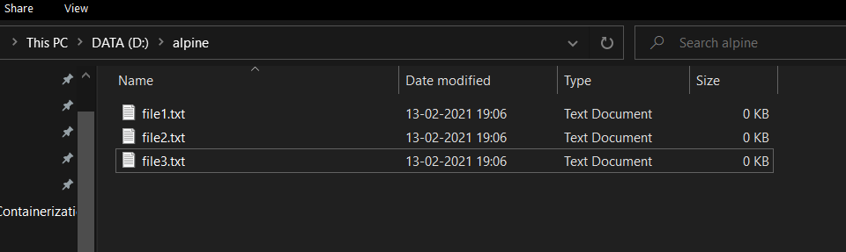

* Write some content into one of the files inside the running container

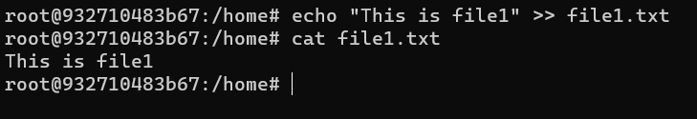

* The content also reflects on the files on the local machine

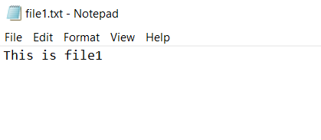

**Data sharing between containers using volumes**

* Check which container is running using the following command:

docker ps



* Create a new redis container with name “redis2” sharing the same volume as “redis1” using the command:

docker run -d –name=redis2 /mnt/d/alpine:/home/ redis redis:latest

* Check the running containers using the command:

docker ps

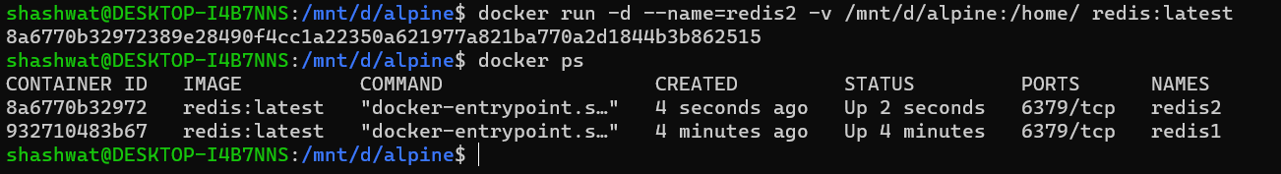

* Enter into an interactive bash shell of “redis2” using the command:

run exec -it redis2 bash

* Check that the same files exist inside of its home directory as well

