

**UNIVERSITY OF PETROLEUM & ENERGY STUDIES**

**Dehradun**

**Application Containerization**

**Experiment 6**

**Name: Shashwat Kumar**

**Course: B-Tech CSE DevOps (2018-22)**

**Roll number: R171218093**

**Sap ID: 500068392**

**Docker Linking and Monitoring**

**Creating docker containers and linking them**

* Run a container in detached mode with name "db" from image "training/postgres

docker run -it -d --name db training/postgres

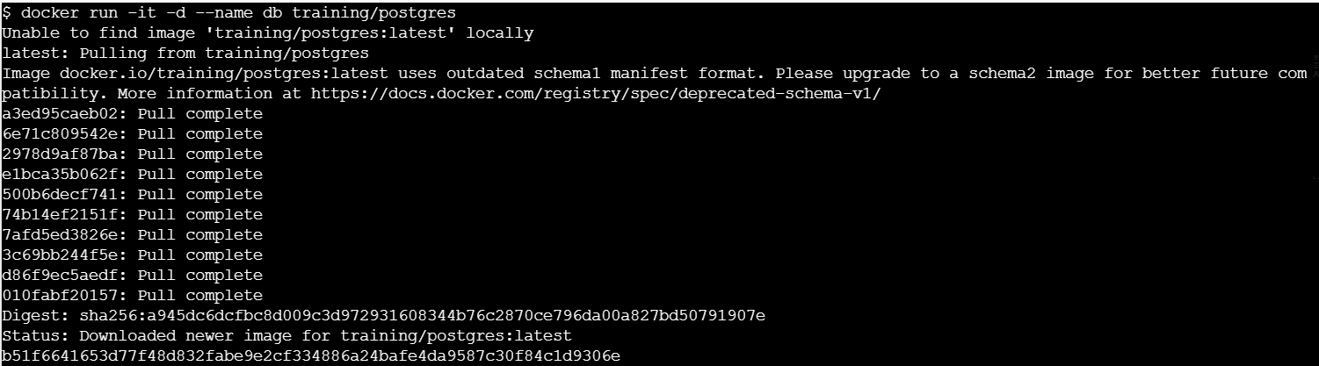

* Run another container in detached mode with name "web" from image "training/webapp", link container "db" with alias "mydb" to this container and finally pass an inline command "python app.py" while running container

docker run -it -d -–name web -–link db:mydb training/webapp   
python app.py

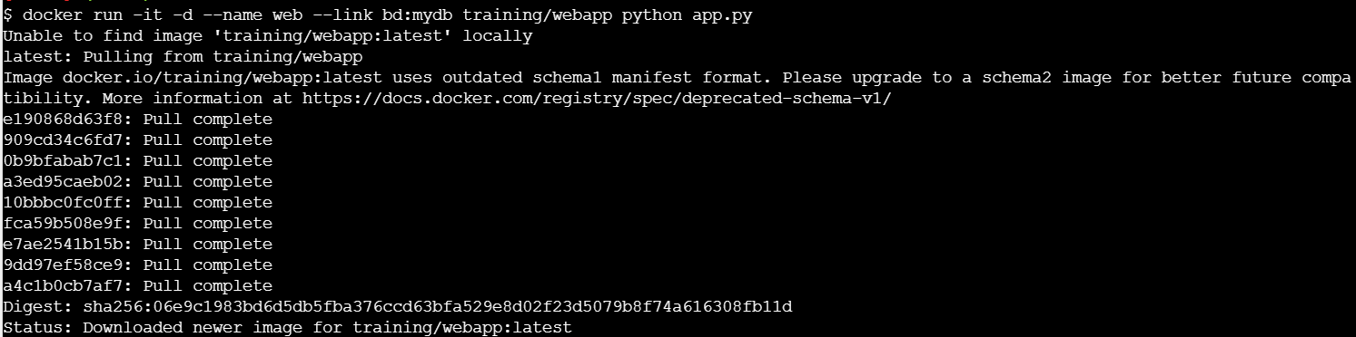



* Take a bash terminal in "web" container and Test container linking by doing a ping to "mydb” and then use the ping command to run it

docker exec -it web bash

ping mydb

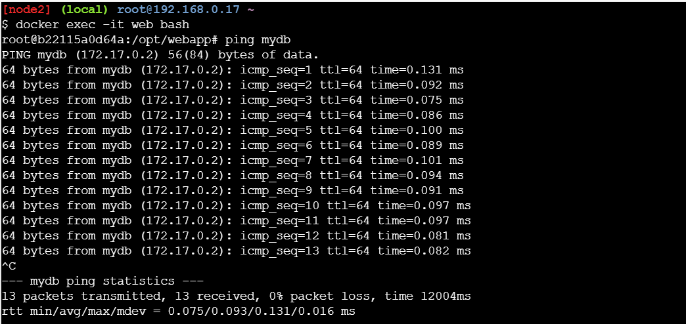

**Creating docker containers and linking them**

* Run a container from nginx image and map container port 80 to system port 80.

docker run -it -d -p 80:80 nginx

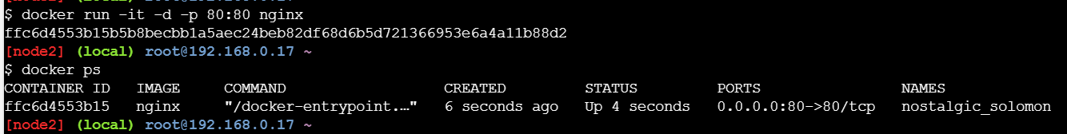

* And run the below command to see the stats of running container and monitor them

docker stats

