Submitted by – Shrikant Lal

Roll Number- R171218099

Sap- 500069167

Lab Experiment 5

1. Create a container db

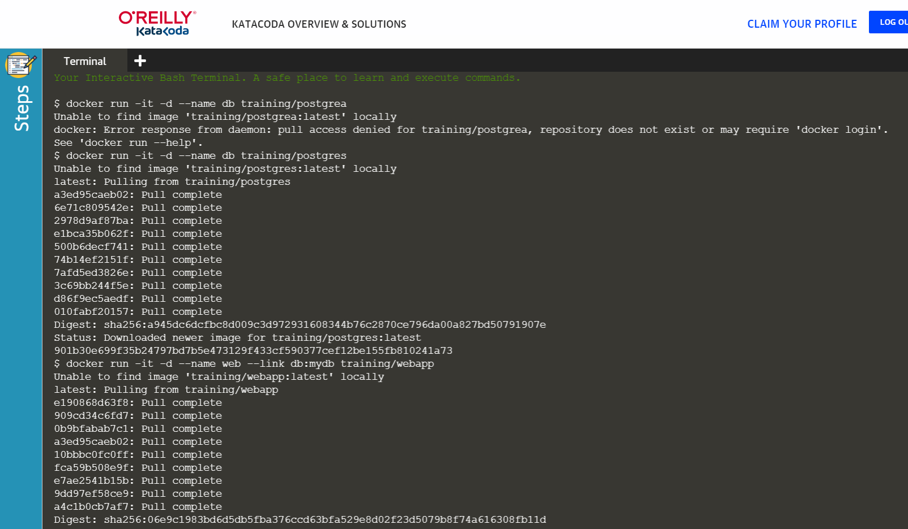

1. Run the container using the following command

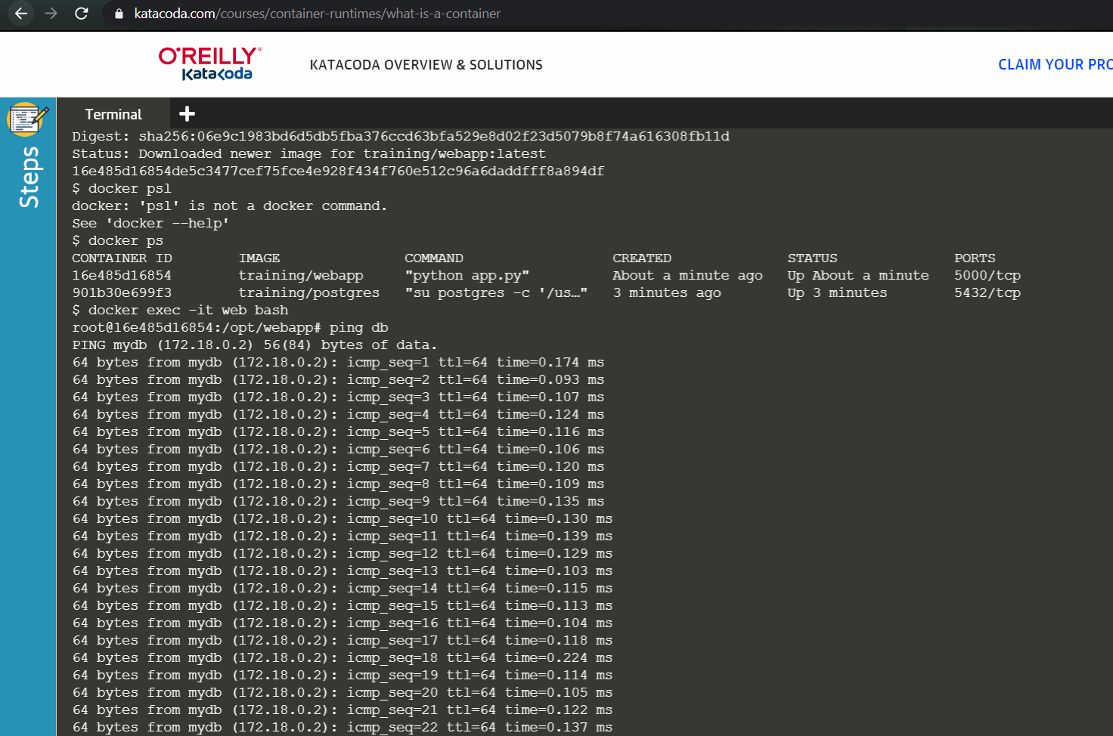

1. Create another container and ping it to the previous container

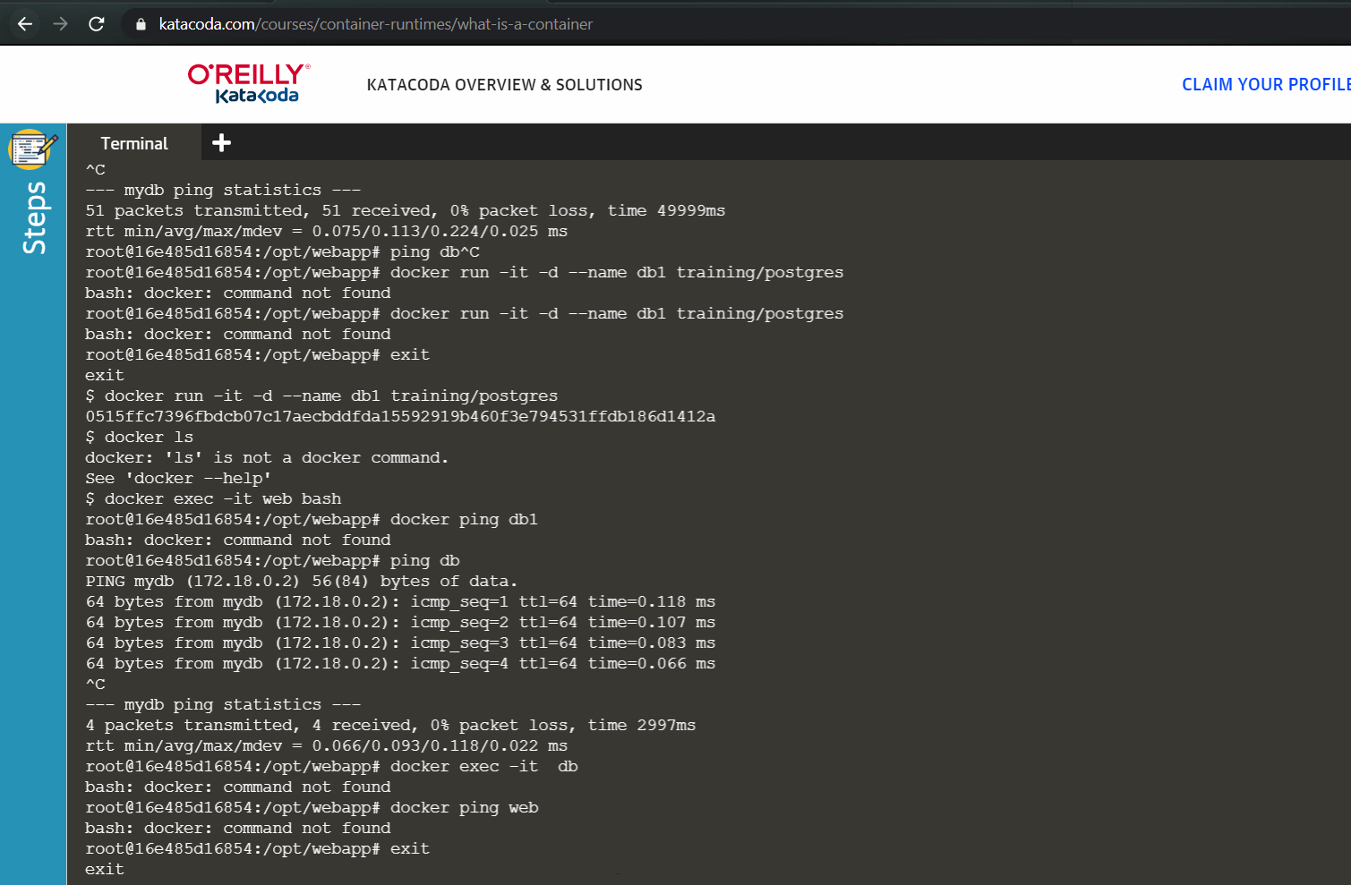

Docker Swarm

1. Run the command Docker swarm init to create the master

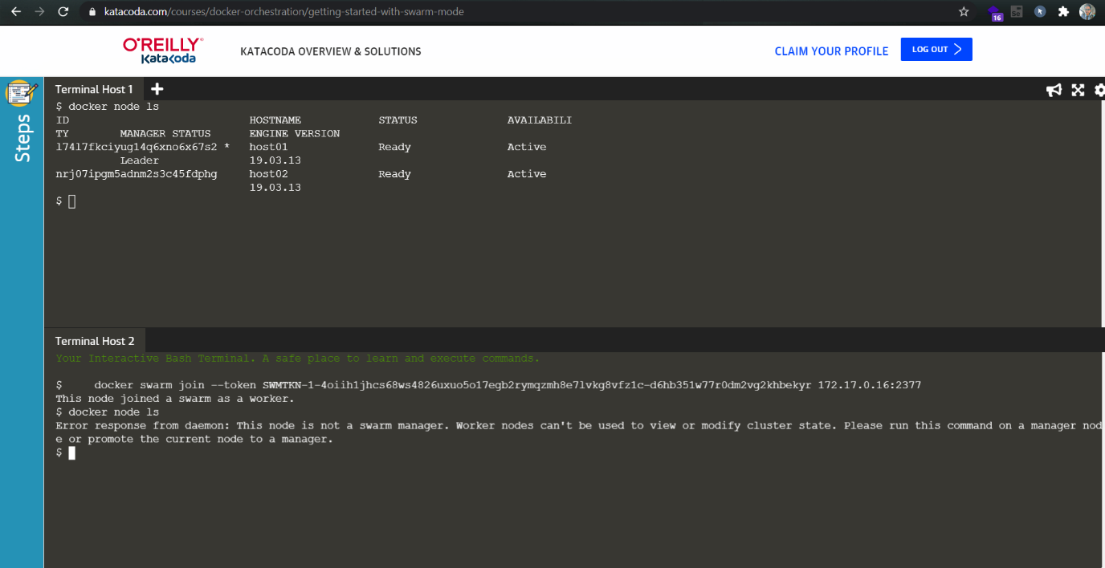

1. Run the command docker swarm join to make the 2nd terminal worker

Confirm it sing the command docker node ls

