**Submitted by- Shrikant Lal**

**Roll no.- R171218099**

**Sap-500069167**

**Experiment-6**

1. Initialize swarm using docker init.

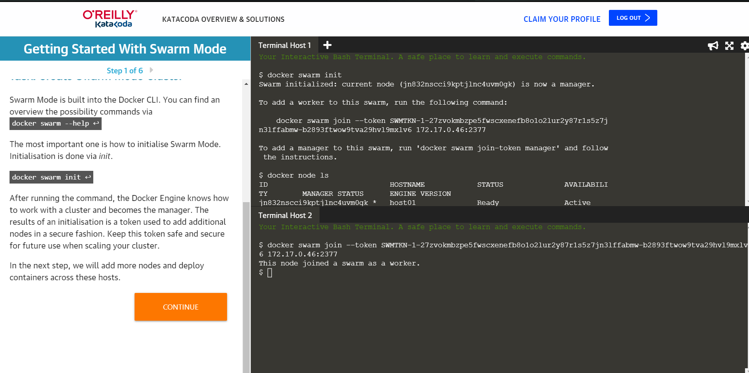

1. Create service in docker.

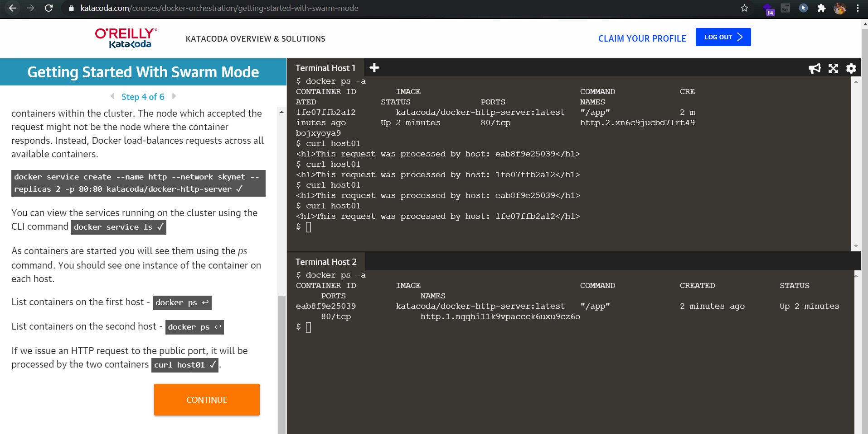

1. Check the running services using command.

Docker services ls.

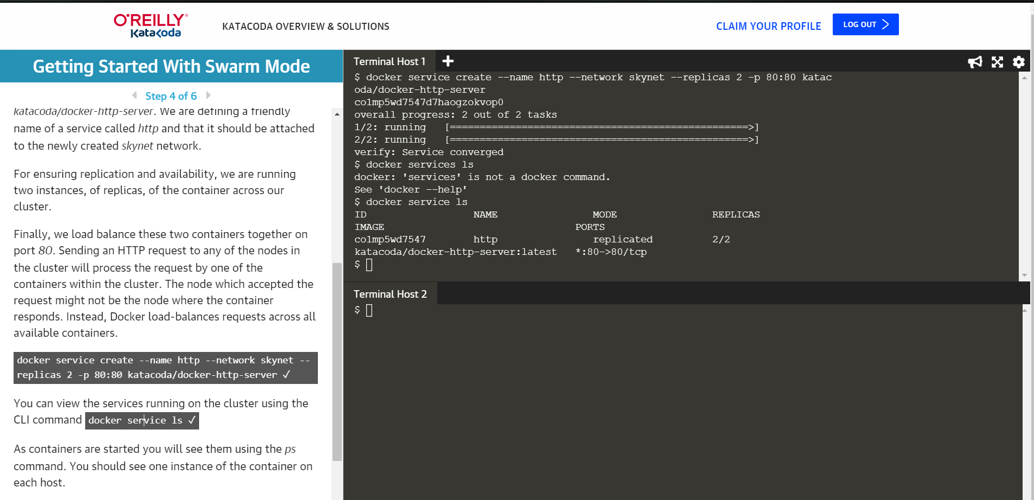

1. Create network in docker.

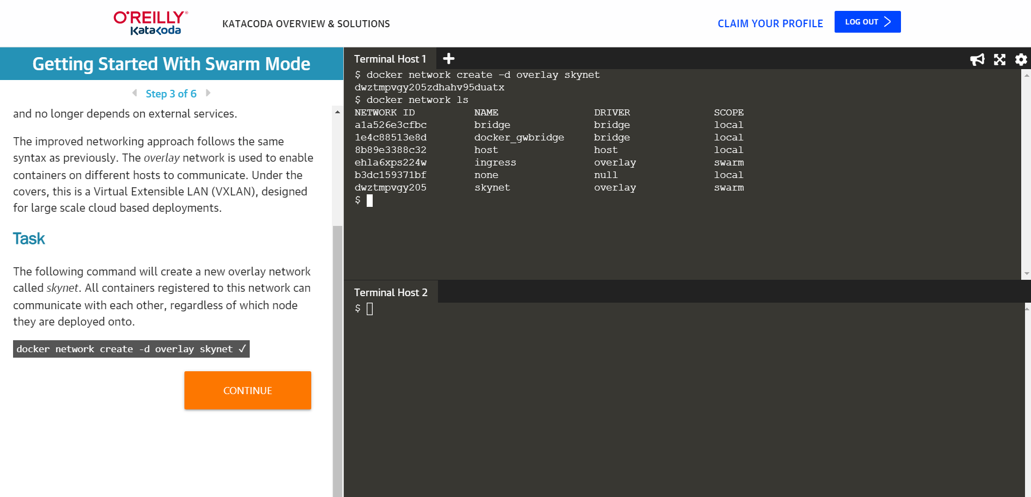

1. Docker service http : to check the running http services.

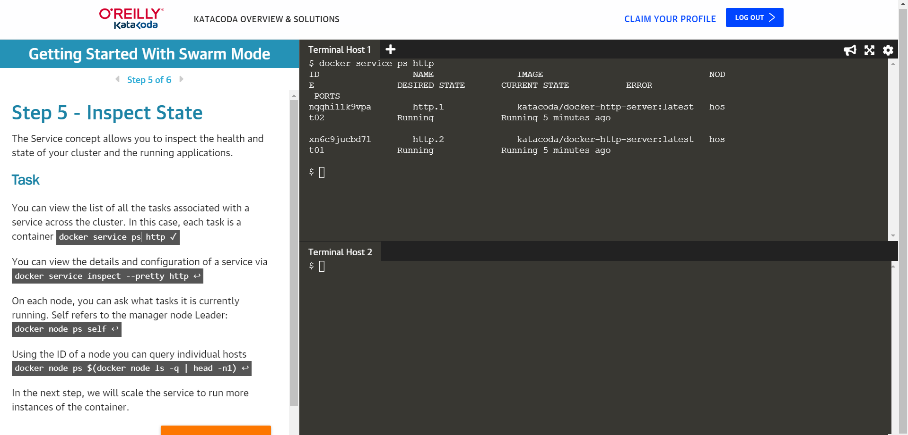

1. Docker service http pretty to get the detail about running services.

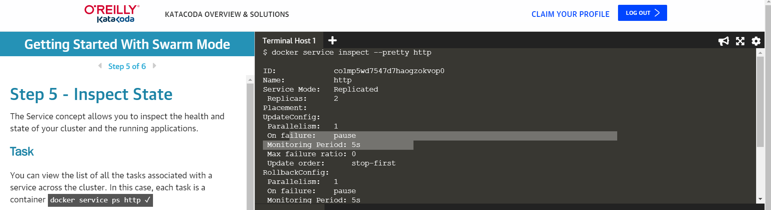

1. Docker scale http=5 : command to create 5 replica of http service.

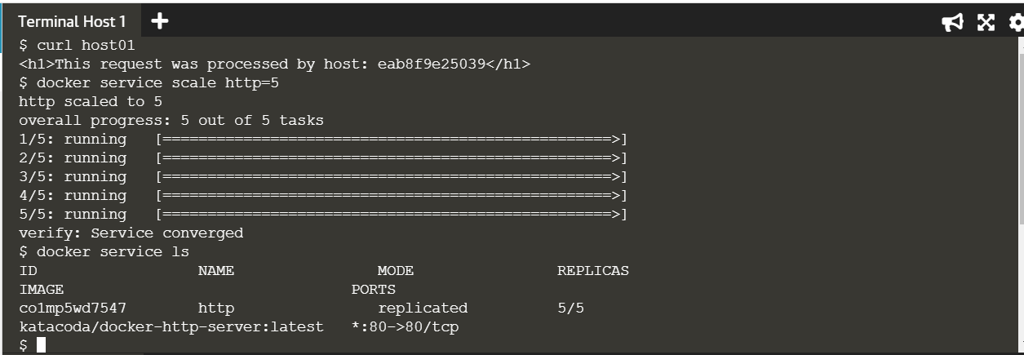

1. Docker ps self: to see the services running in host.

