**Submitted by- Shrikant Lal**

**Roll- R171218099**

**Sap-500069167**

Experiment 7

1. Download minikube and start kubectl

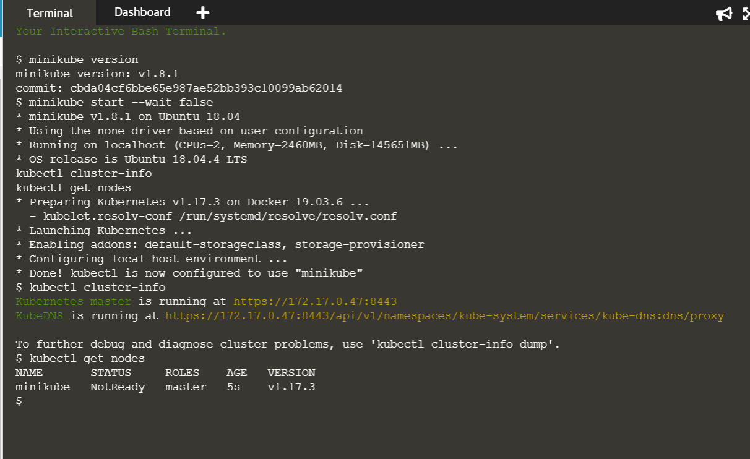

1. Launch the deployment using command kubectl run http --image=katacoda/docker-http-server:latest --replicas=1

View status of deployment kubectl get deployments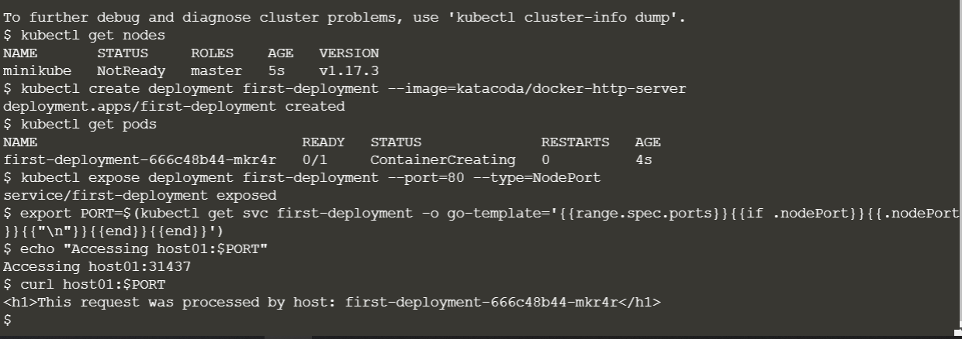

1. Expose the port and ping the port using the following command.

kubectl expose deployment http --external-ip="172.17.0.22" --port=8000 --target-port=80

curl <http://172.17.0.22:8000>

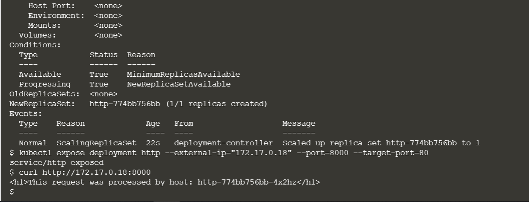

1. Similarly create the second node.

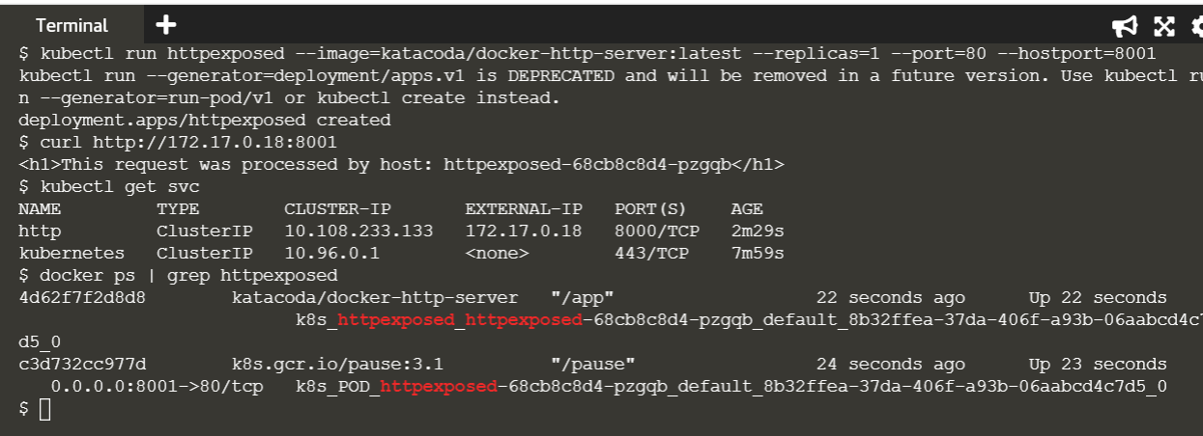

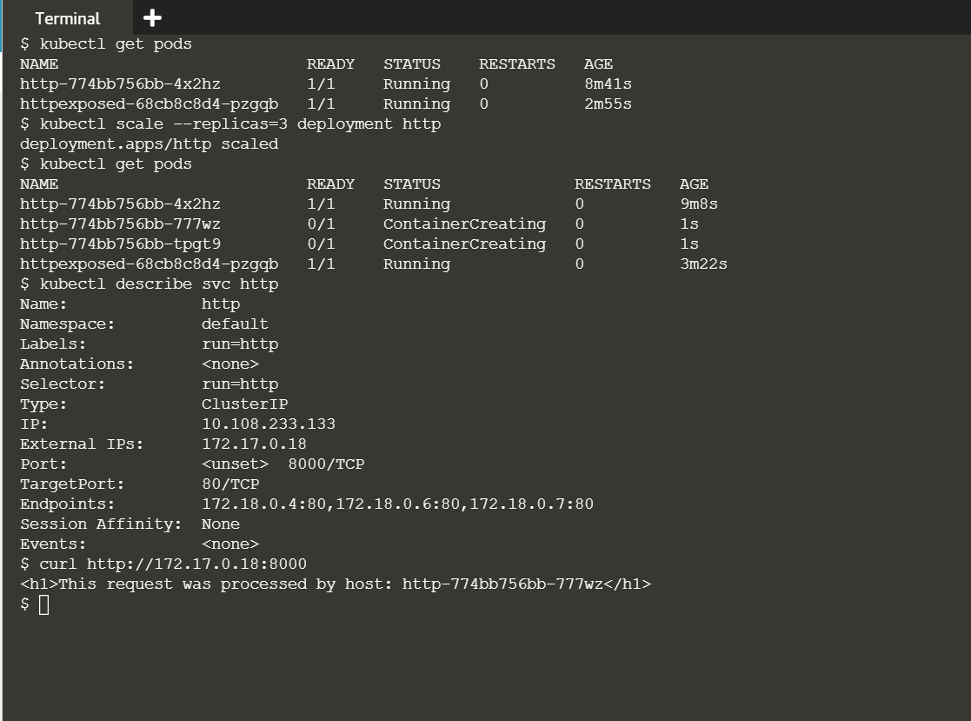

Launching cluster using minikube

1. Start minikube using the following commands



1. Deploy the container to the following cluster



1. Enable the dashboard and view the pods.

