**Experiment 1**

1. Create a folder and go into it then run **vagrant init** command.

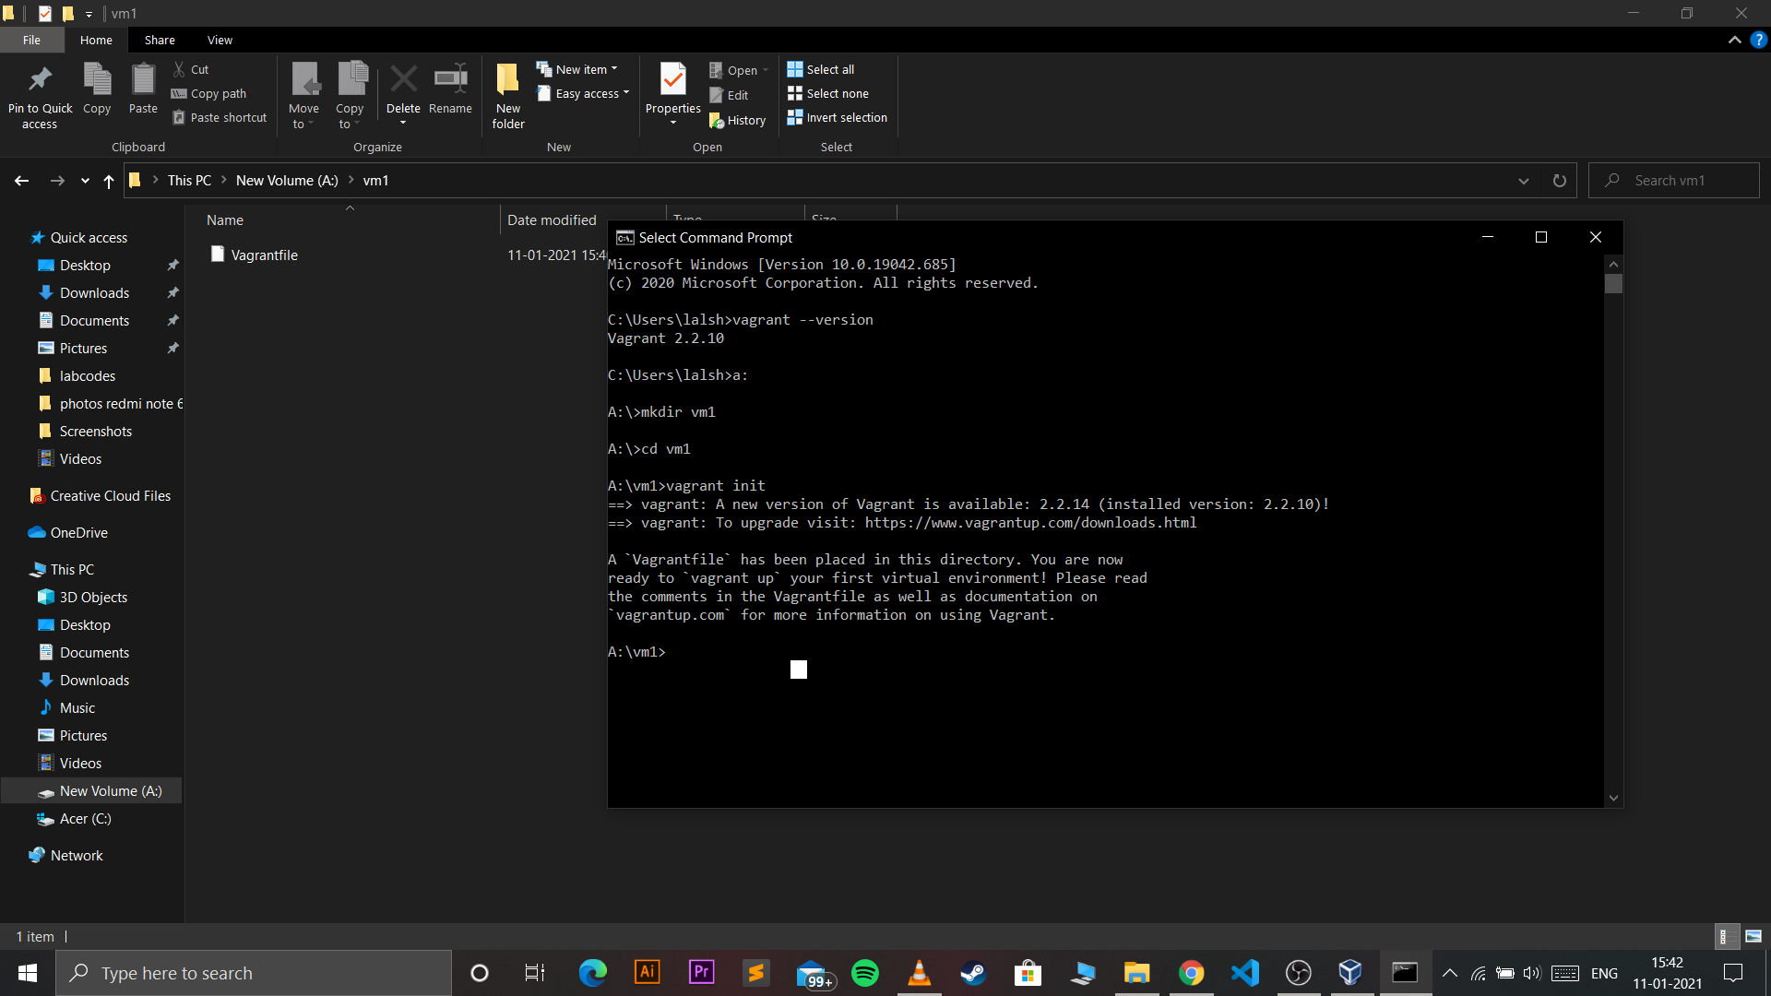

1. Change config.vm.box setting in vagrantfile

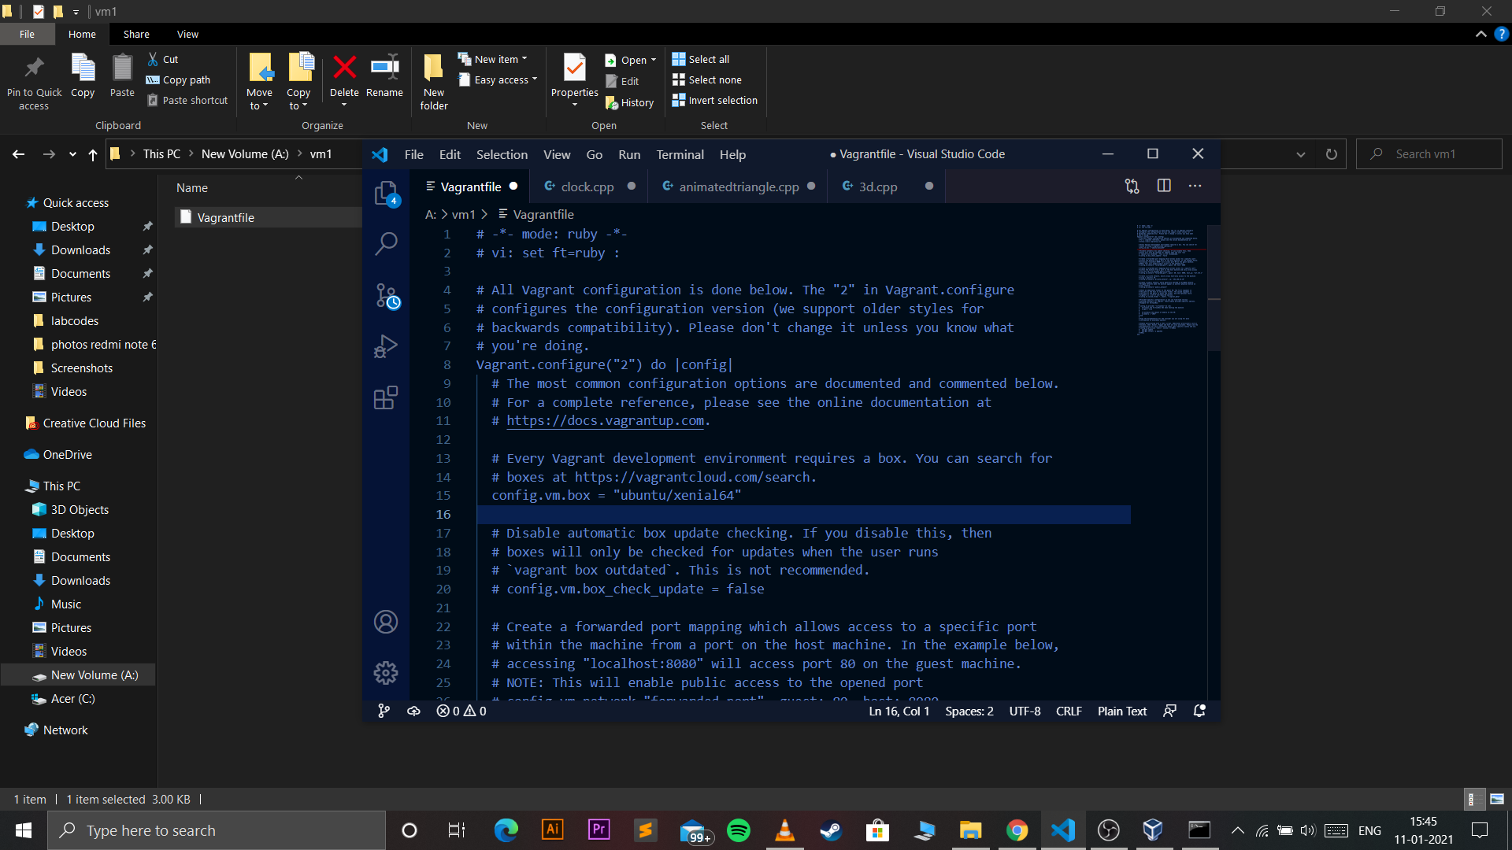

1. Run the command **vagrant up** in cmd.

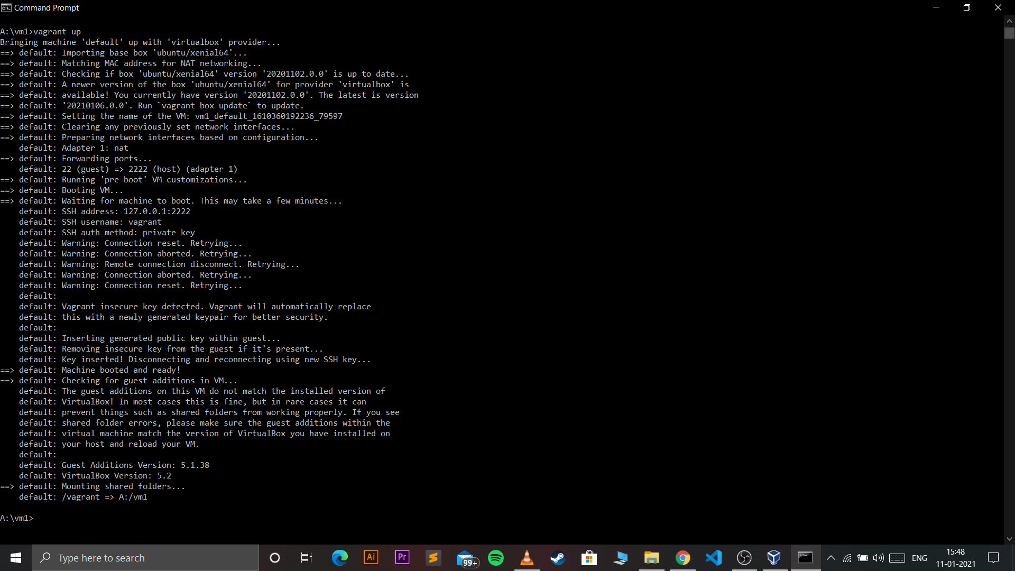

1. Run the command **vagrant ssh** and your vagrant image is up and running.

