Application Containerization Lab

**Name : Prakhhar Tandon**

**Roll No : R171218115**

Experiment – 1

(Setting up a virtual machine on Vagrant)

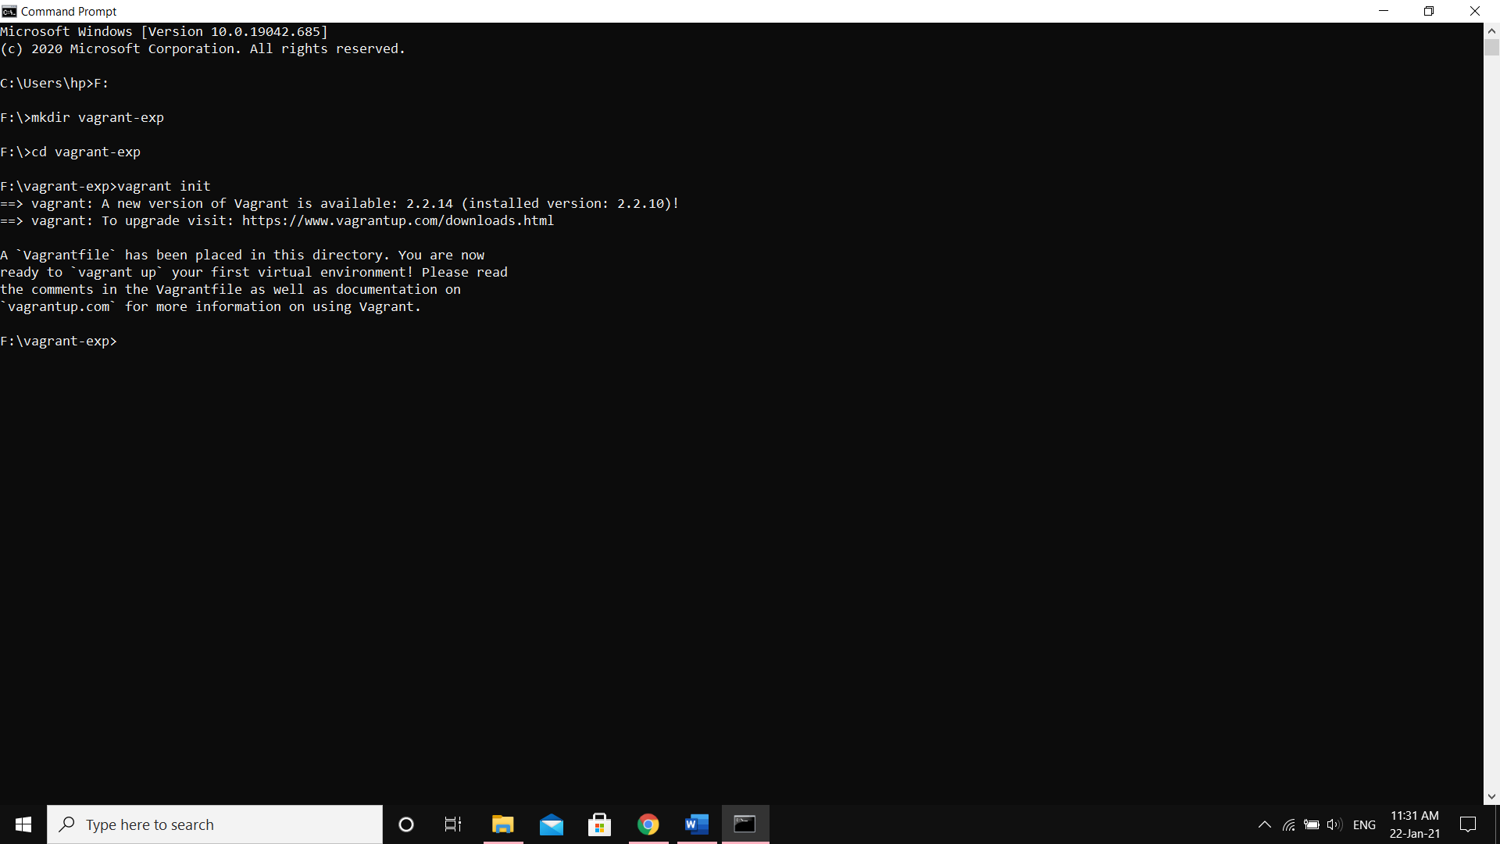

Making Vagrantfile in the directory

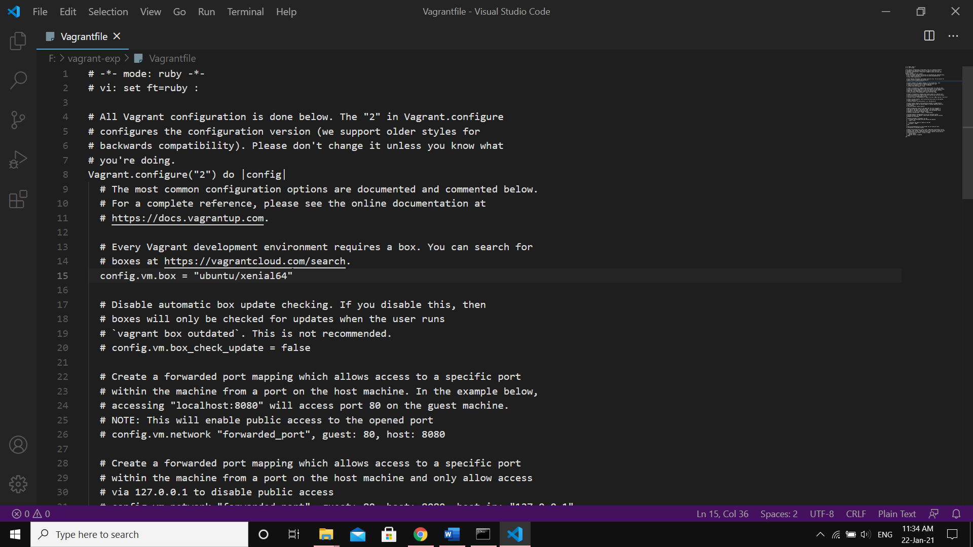

Configuring the Vagrantfile for required VM

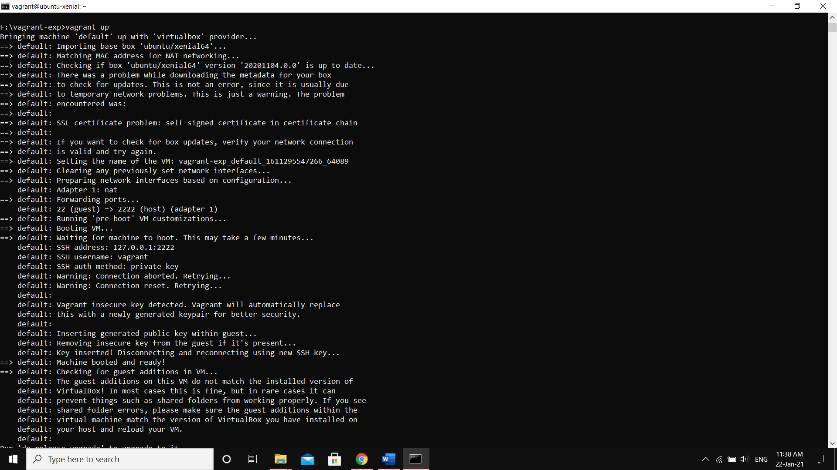

Configuring VM according to Vagrantfile

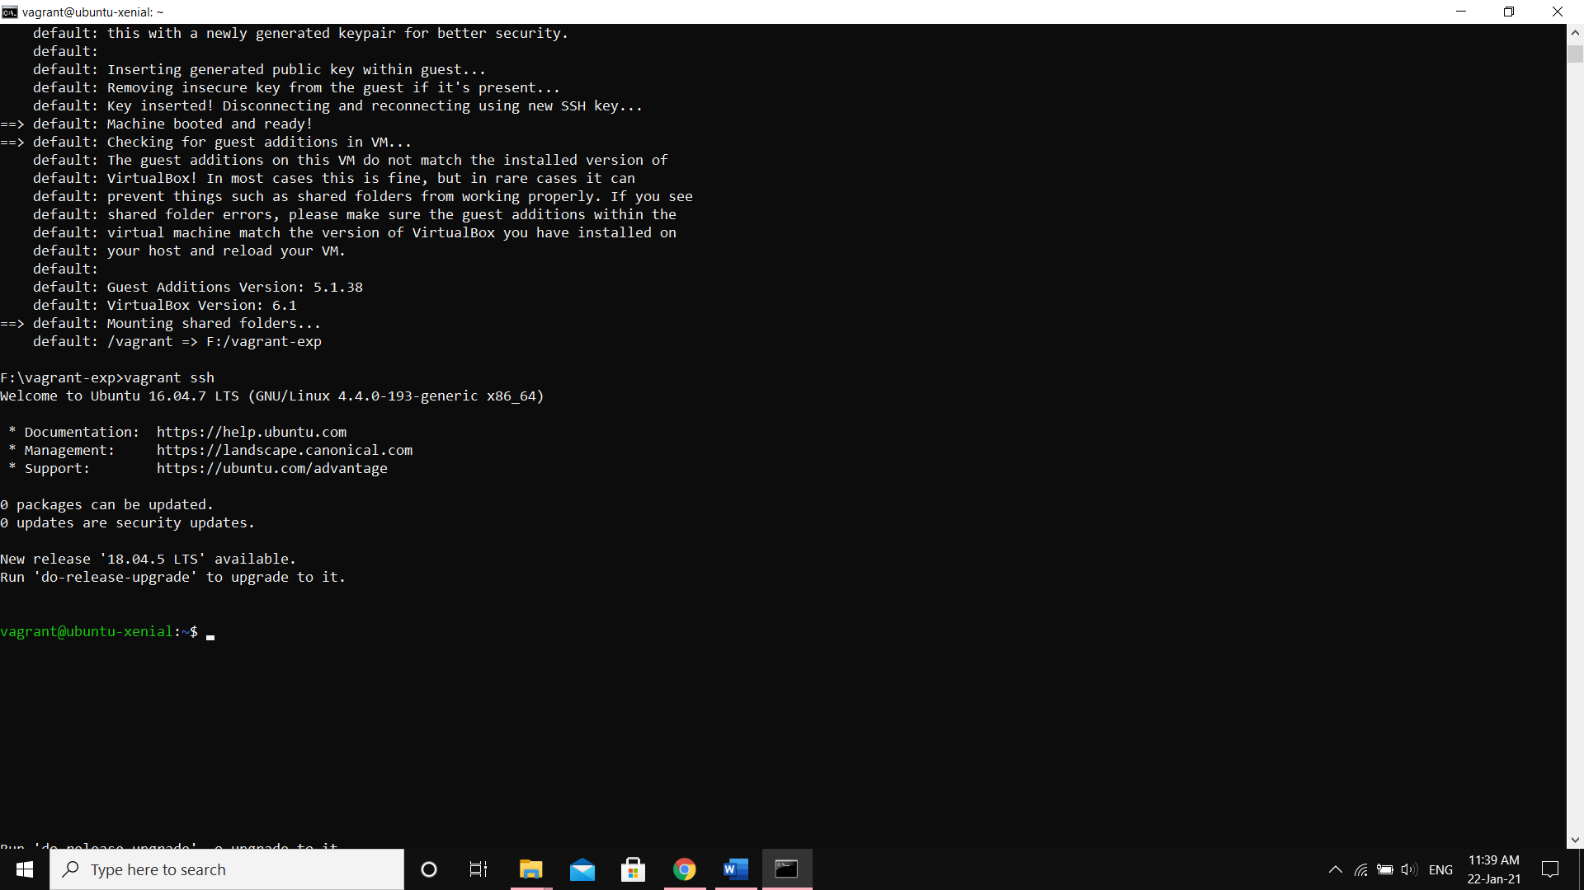

Starting the Virtual Machine

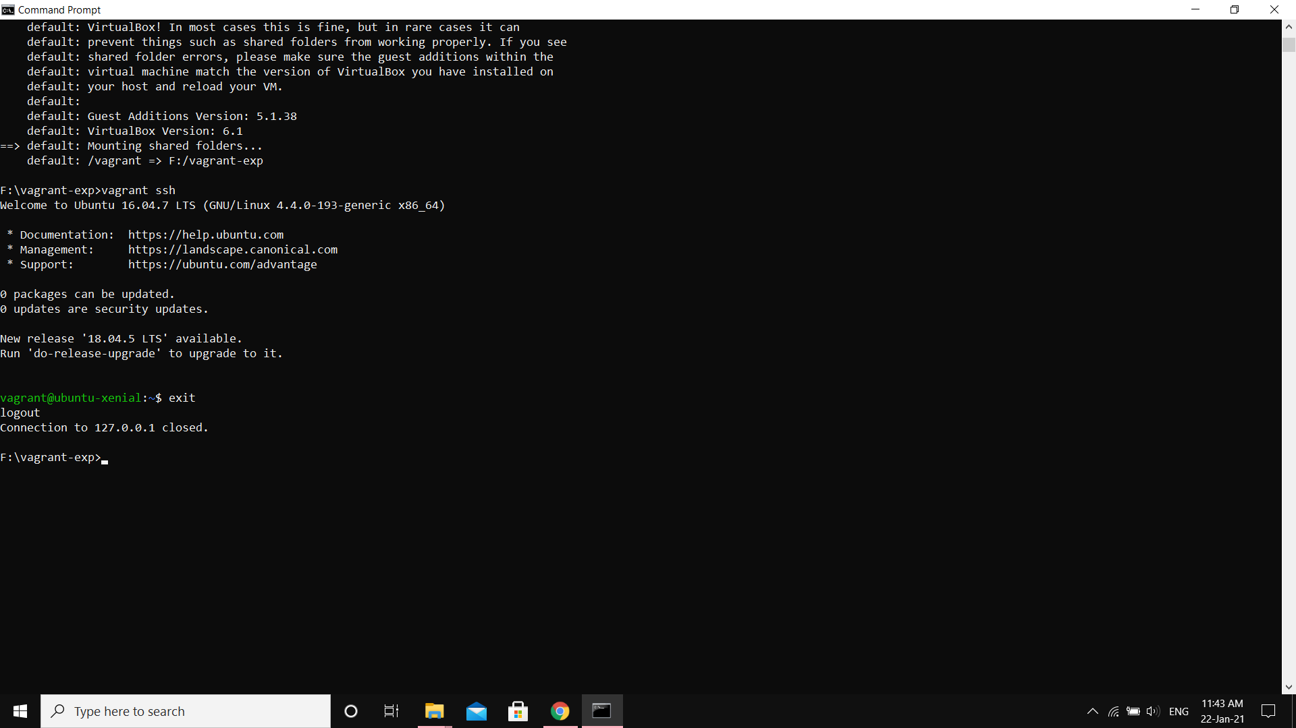

Exiting the Virtual Machine