Name: Kushagra Bansal

Roll_No: 116

Sap_ID: 500067414

**Experiment No. 13**

**Prepare and Implement Docker Container Restart Policy**

So, in this experiment, we are focussing on restart policy in Docker Container. It is performed using Katacoda environment.

* Docker considers any containers to exit with a non-zero exit code to have crashed. By default, a crashed container will remain stopped.
* Depending on your scenario, restarting a failed process might correct the problem. Docker can automatically retry to launch the Docker a specific number of times before it stops trying.
* Finally Docker can always restart a failed container, in this case, Docker will keep trying until the container it is explicitly told to stop.

**Follow these steps below:**

1. Launch an instance using the following command:

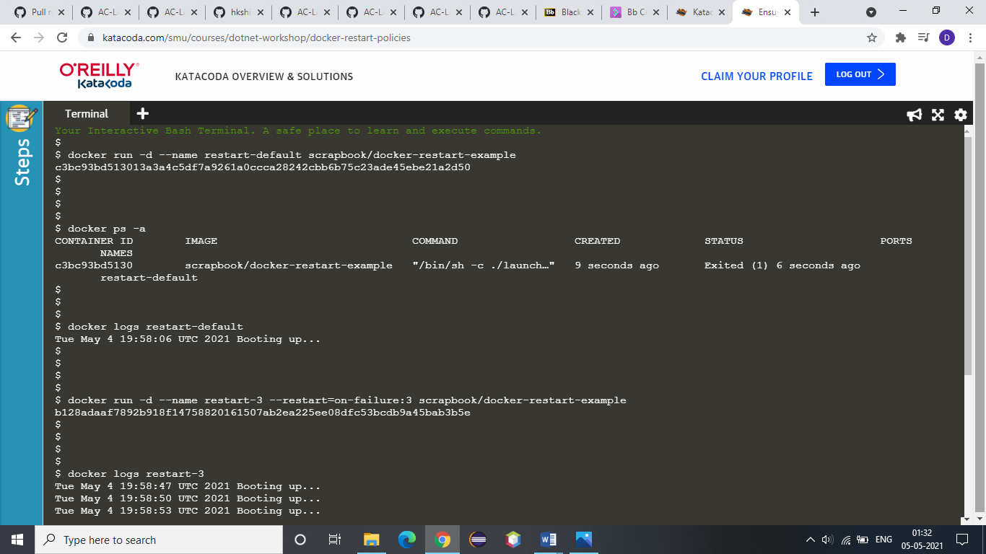

2. If you list all the containers, including stopped, you will see the container has crashed.



3. While the logs will output our message, which in real-life would hopefully indicate information to help us diagnose the issue.



4. In the example below, Docker will restart the container three times before stopping.



5. By checking the logs, the above example is clear that it will restart 3 times.



6. Use the always flag to automatically restart the container when is crashes for example:

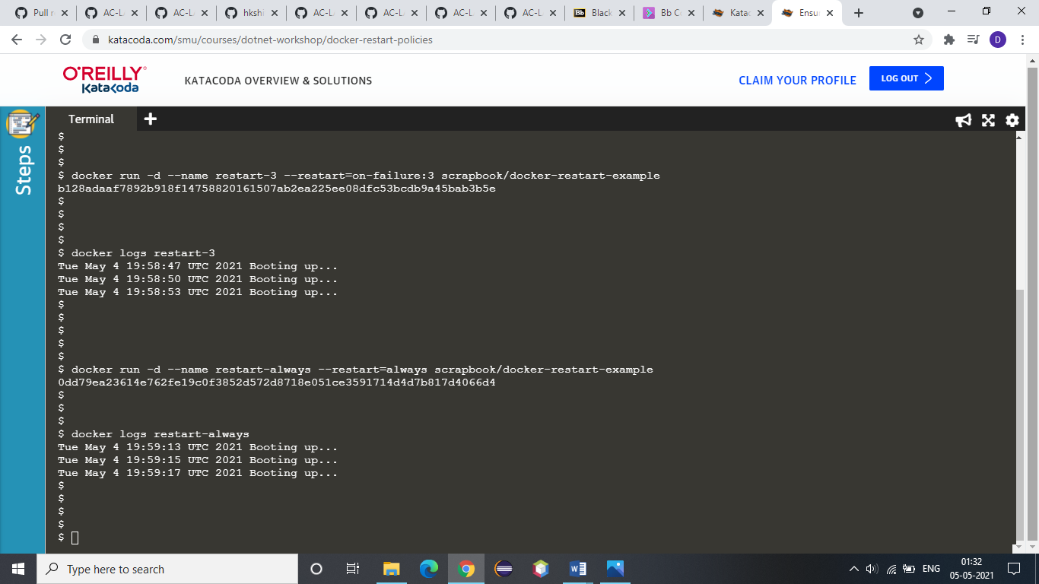

7. You can view the restart attempting via the log as below:

