**Name:- Abhishek Singh**

Roll.No:- R171218120

SAP_ID:- 500067726

Topic:- Vagrant

Semester:-6

# 1. Playing with Vagrant

## Installing Vagrant

To install Vagrant on your Ubuntu system, follow these steps:

* We need to install Virtualbox first which will work as a hypervisor  
  $ sudo apt install virtualbox
* Now, we will install vagrant  
  $ sudo apt install vagrant
* Verify the vagrant installation

$ vagrant –version

## Creating basic vagrant box using VirtualBox virtualization

* Create the project directory and switch to it with:

mkdir ~/first-vagrant

cd ~/first-vagrant

Note:- In my case folder name is “VM_1”.

* The next step is to initialize a new Vagrant file using the vagrant init

$ vagrant init

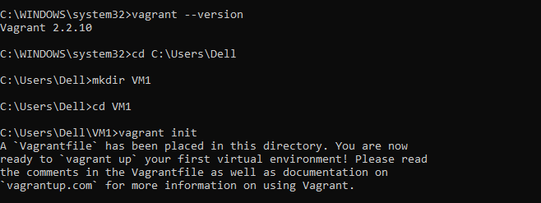

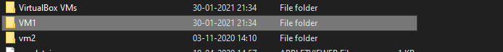

* You can open the Vagrant file, read the comments and make adjustments according to your needs.

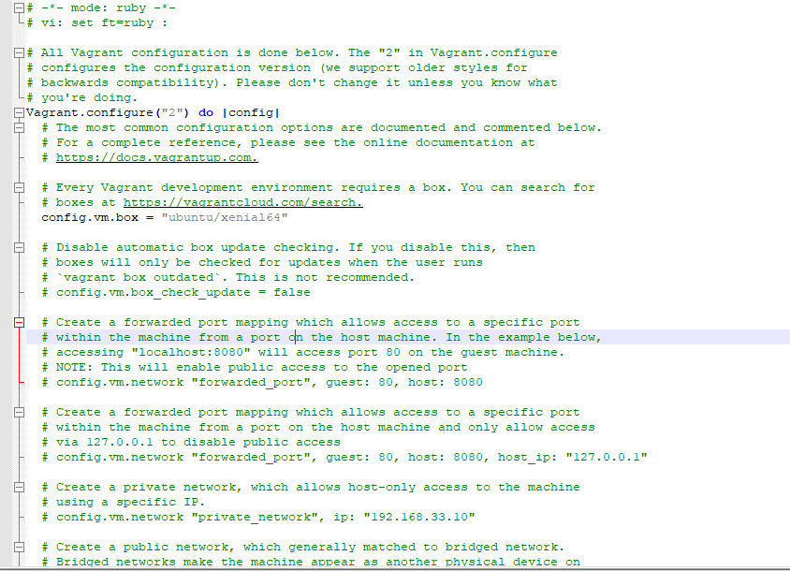

* Now we can run the vagrant

$ Vagrant up

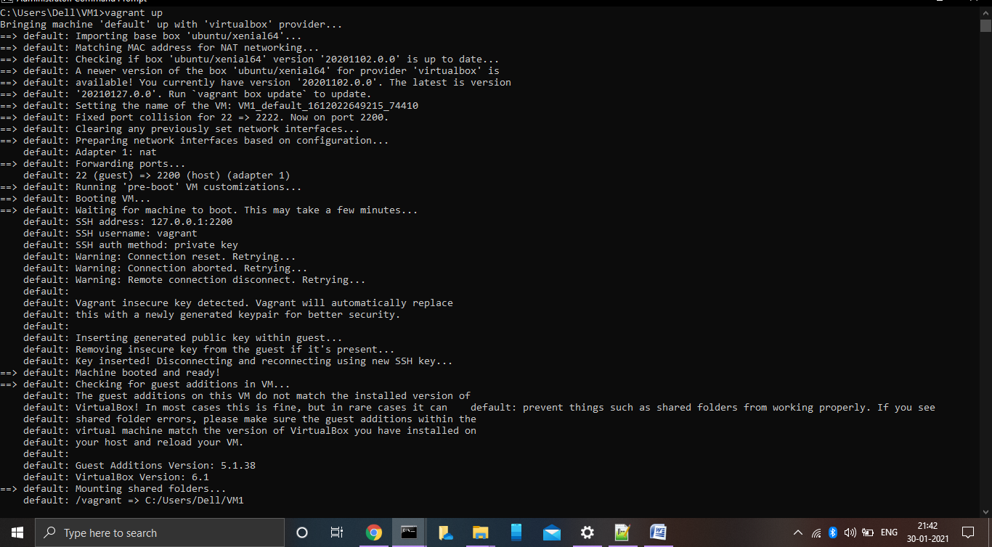

* To ssh into the virtual machine simply run:  
  $ Vagrant ssh  
  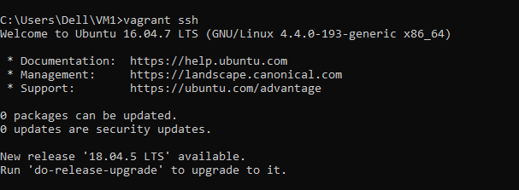
* You can stop the virtual machine with the following command:  
  $ Vagrant halt

* To destroy the vagrant machine run the below command

$ Vagrant destroy

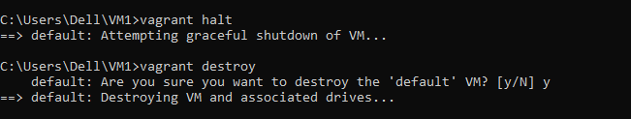

# 2. Understanding Vagrant File

## Configuration your Sandbox

* Configuring CPU resources in Vagrant  
  To customise the cpu resources to be used by your VM you need to update few parameters in Vagrantfile.  
  config.**vm**.**provider** "virtualbox" **do** **|**v**|**

v.**cpus** **=** 2

**end**

* Configuring network resources in Vagrant  
  To customise the network resources to be used by your VM you need to update few parameters in Vagrantfile.  
  Vagrant.**configure**("2") **do** **|**config**|**

config.**vm**.**network** "private_network", ip: "192.168.50.4",

virtualbox__intnet: **true**

**end**

* Configuring memory resources in Vagrant  
  To customise the memory resources to be used by your VM you need to update few parameters in Vagrantfile.  
  config.**vm**.**provider** "virtualbox" **do** **|**v**|**

v.**memory** **=** 1024

**end**

* Provisioning a shell script in Vagrant  
  In this scenario, we will setup apache server on boot using a shell script named **provision.sh**, which will look something like this:  
  #!/usr/bin/env bash

echo "Installing Apache and setting it up..."

apt-get update >/dev/null 2>&1

apt-get install -y apache2 >/dev/null 2>&1

rm -rf /var/www

ln -fs /vagrant /var/www

With the shell script created, the next step is to configure Vagrant to use the script. Add the following line somewhere in the Vagrantfile:

config.**vm**.**provider** "virtualbox" **do** **|**v**|**

Config.**vm**.**box =** ”precise64”  
Config.**vm**.**forward_port** 80.8080  
config.**vm**.**provision** "shell" **path:**”provision.sh”  
**end**