**Experiment -3**

**Name- Abhishek Singh**

**Roll No. R171218120**

**SAP ID – 500067726**

**Subject- Application Containerization**

* **Go to the Terminal and Run Your Vagrant**

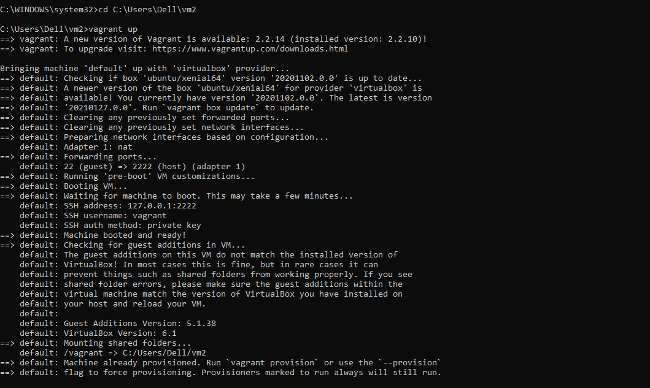

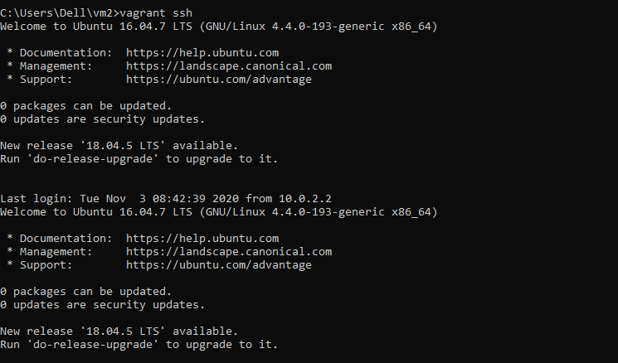

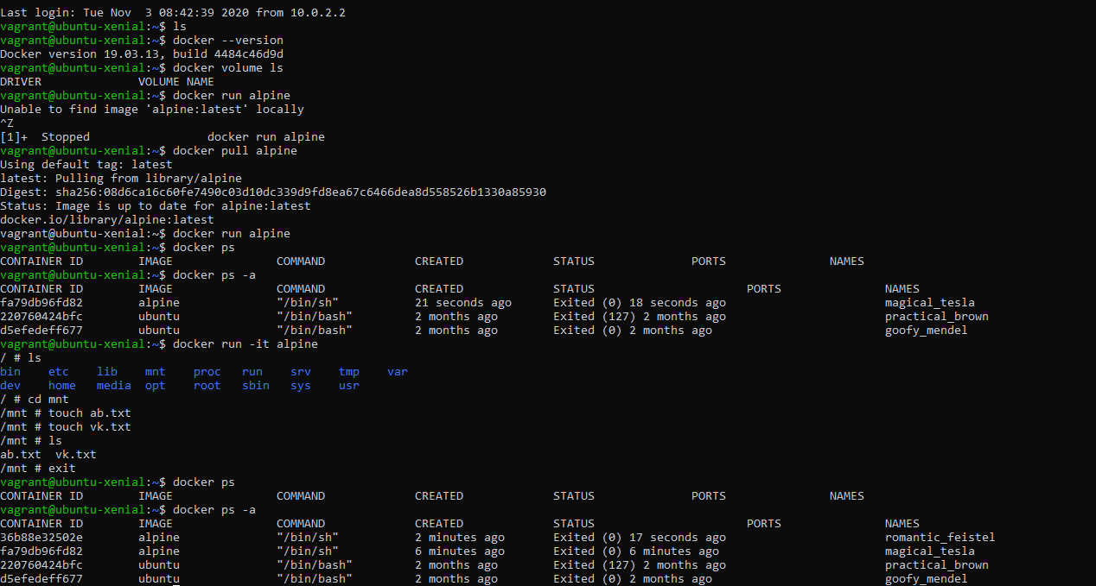

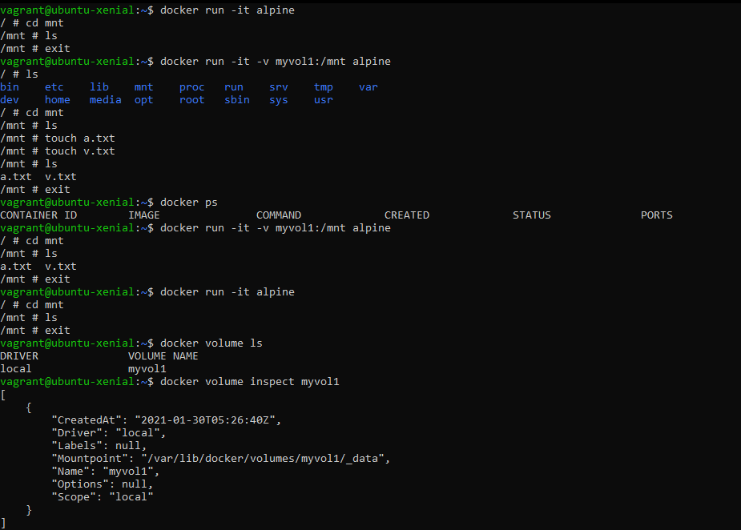

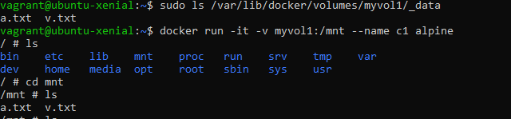

* **GO TO ANOTHER TERMINAL**

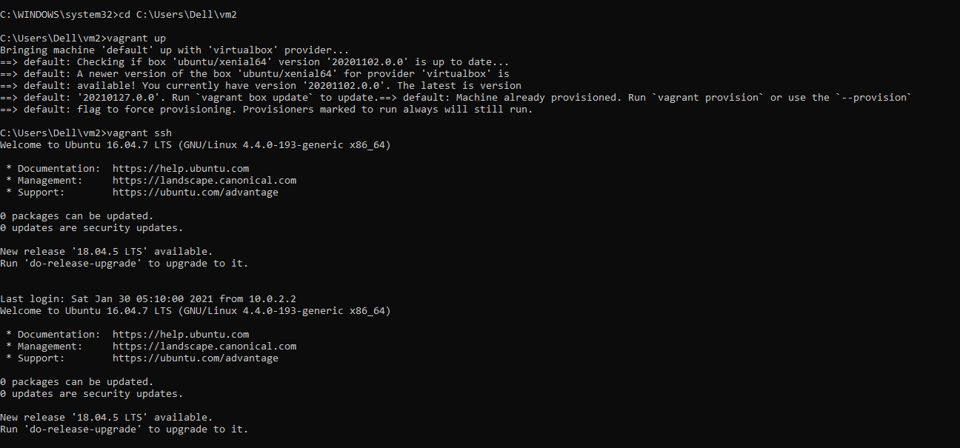

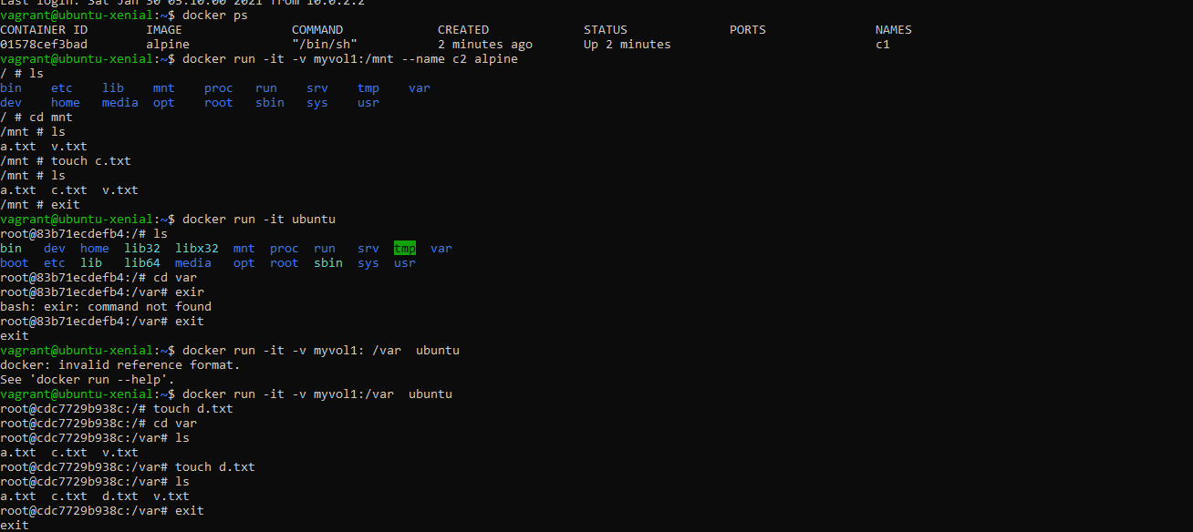

* Do “ls” on 1st :- see both terminal are interconnected as we do changes in Volume in terminal it shows on another also

