**Name – Abhishek Singh**

**Roll. No – R171218120**

**SAP ID – 500067726**

**Subj**ect **– Application Containerization**

*EXPERIMENT***– *CREATE SWARM CLUSTER***

* Initialize the Swarm Cluster into one of the terminal or virtual machine by using the following command.

$ docker swarm init

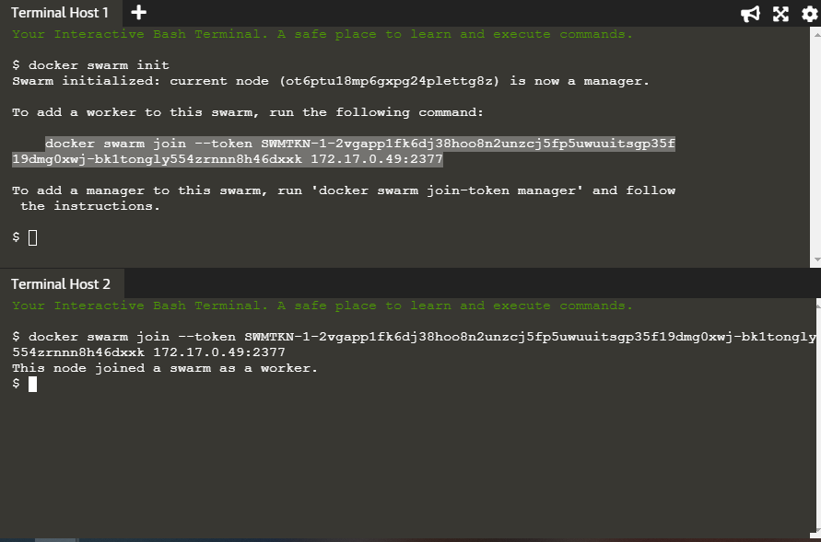

* ***Join the Cluster : -***

To add a worker to this swarm, run the following command to join the node to this swarm.

$ docker swarm join --token SWMTKN-1- 0b6h2cp95dsn8z9wm95fvdcz6eces9xvh3bia88nnvuv5xdml4- egk39ze15rw3qhage7kd40vdn 172.17.0.82:2377



* To see that how many nodes are joined in this Cluster by using the following command.

$ docker node ls

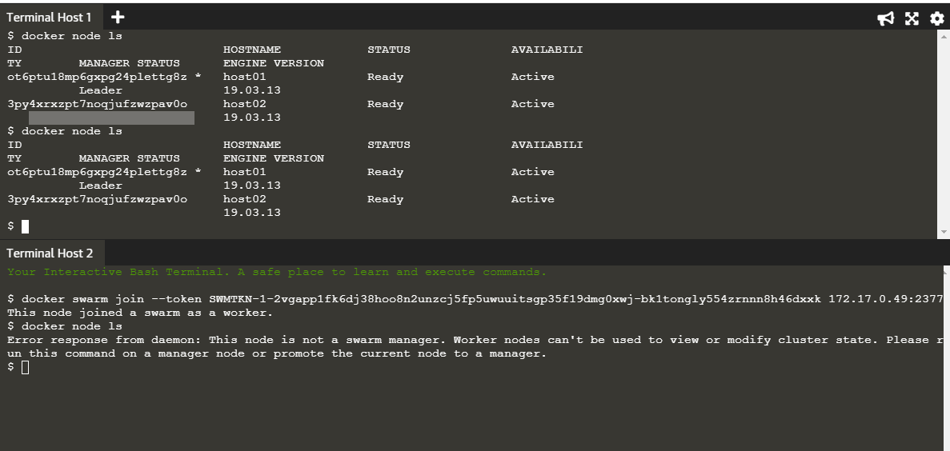

* The following command will create a new overlay network called ***skynet*.** All containers registered to this network can communicate with each other, regardless of which node they are deployed onto.

$ docker network create -d overlay Skynet

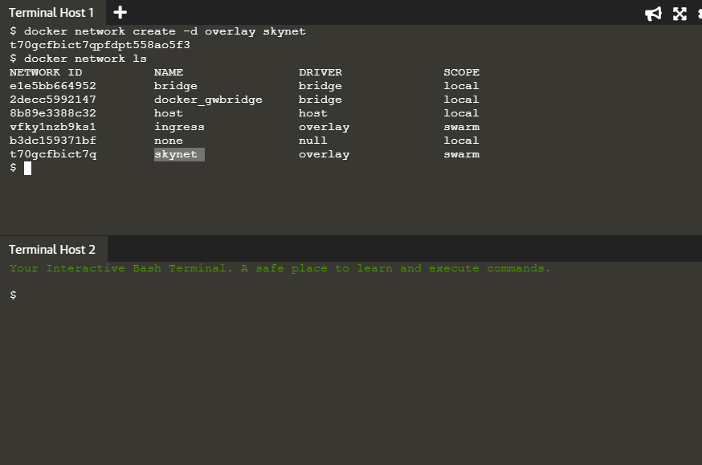

* Now we are deploying the Docker Image ***katacoda/docker-http-server*.** We are defining a friendly name of a service called *http* and that it should be attached to the newly created ***skynet*** network.

$ docker service create --name http --network skynet --replicas 2 -p 80:80 katacoda/docker-http-server

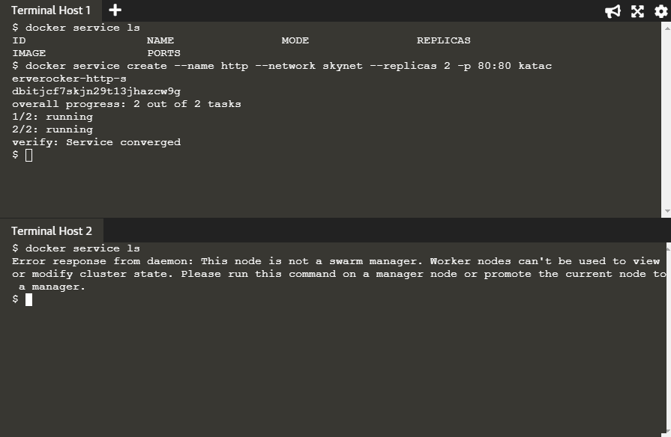

* You can view the services running on the cluster using the CLI command.

$ docker service ls

As containers are started you will see them using the ***docker ps*** command. You should see one instance of the container on each host.

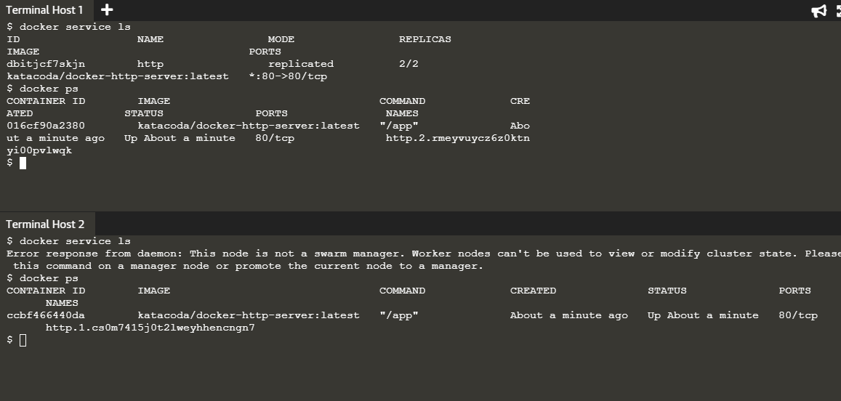

* If we issue an HTTP request to the public port, it will be processed by the two containers.

$ curl host01

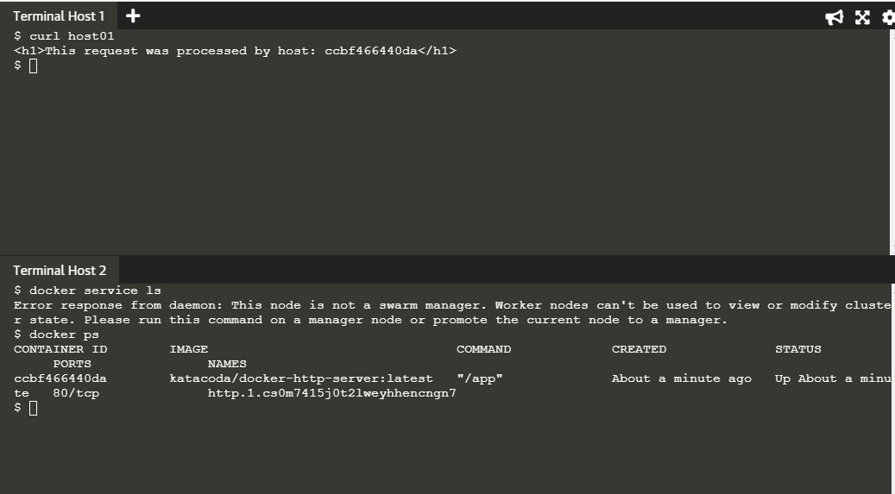

* You can view the list of all the tasks associated with a service across the cluster. In this case, each task is a container.

$ docker service ps http

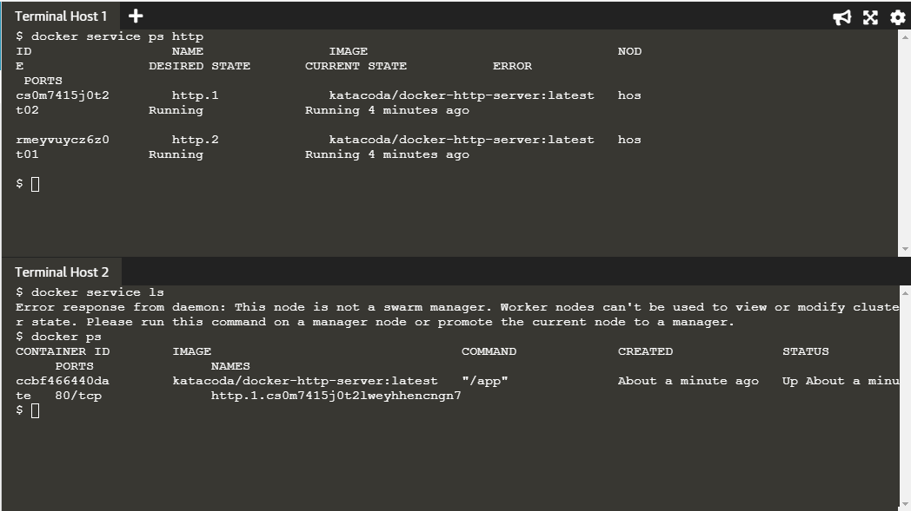

* You can view the details and configuration of a service via

$ docker service inspect --pretty http

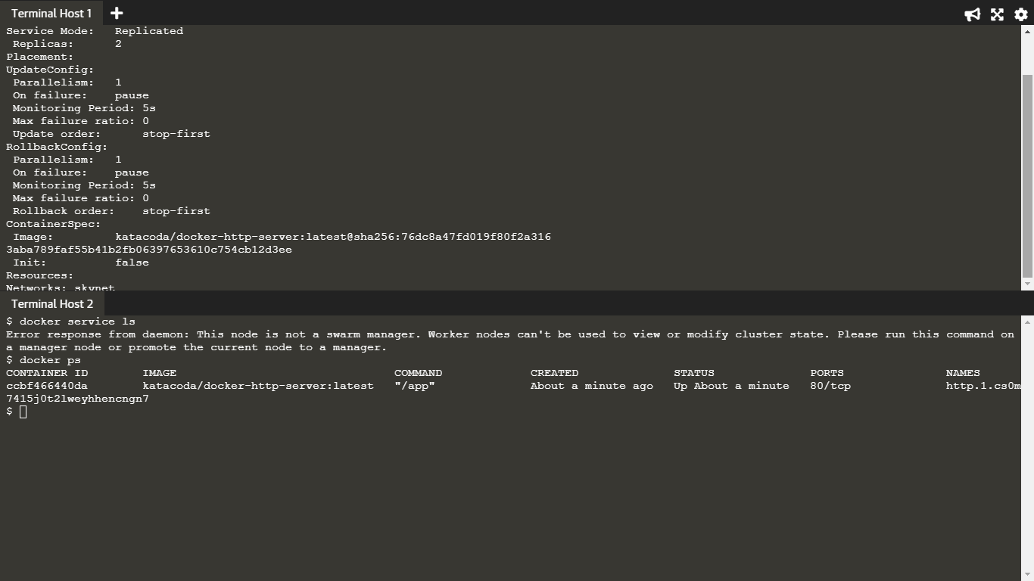

* On each node, you can ask what tasks it is currently running. Self refers to the manager node Leader:

$ docker node ps self

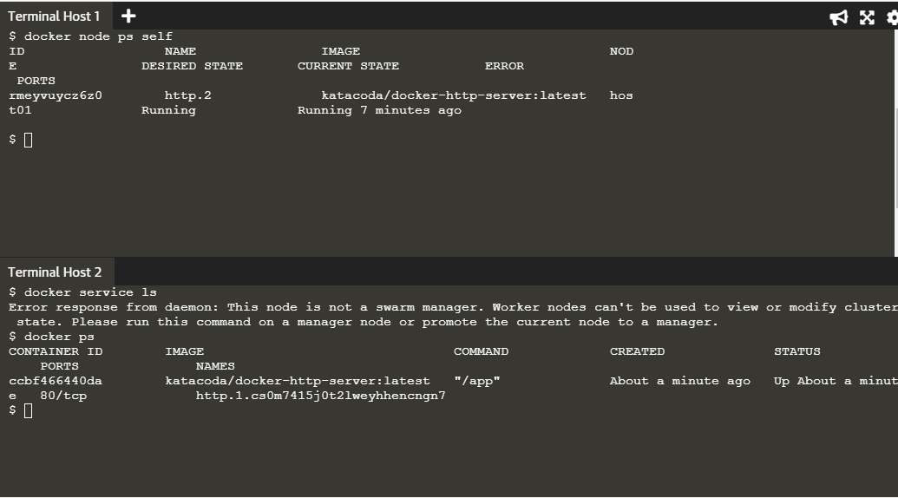

* Using the ID of a node you can query individual hosts.

$ docker node ps $(docker node ls -q | head -n1)

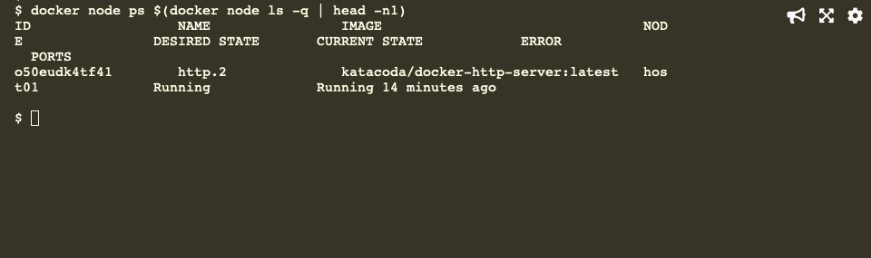

* The command below will scale our *http* service to be running across five containers.

